# 1. Introduction

Graphics areas:

-modeling

-rendering

-animation

-user interaction

-VR

-visualization

-image processing

-3D scanning

-computational photography

Major applications:

-video games

-cartoons

-visual effects

-animated films

-CAD/CAM

-simulation

-medical imaging

-image visualization

## 3. Raster Images

raster devices

gamma correct

RGB color

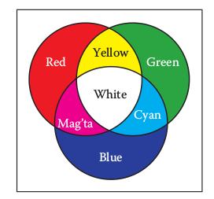

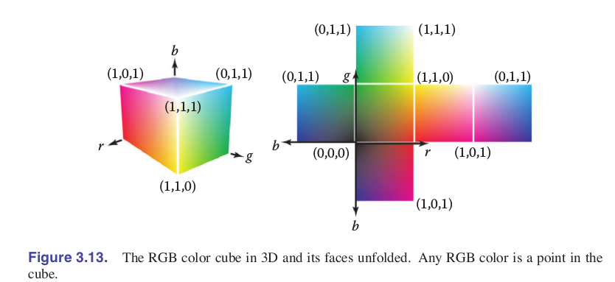

Alpha compositing



## 4. Ray Tracing

## Rendering

## -object-order

## -image-order

## Basic Ray Tracer:

## -ray generation

## -ray intersection

## -shading

## 