The Architecture of HandyMen Server

The HandyMen server is deployed in AWS cloud servers, with the main application deployed in EC2(Elastic Compute Cloud) and database in RDS (Relational Database Service). With AWS’s secure solutions and 99.99% availability, HandyMen server can run stably for 24 hours per day and 7 days per week. Also, with AWS’s load balancer and Elastic beans, the handy men server can be automatically scaled out to multiple instances during heavy load time after correct configuration in the AWS EC2 console.

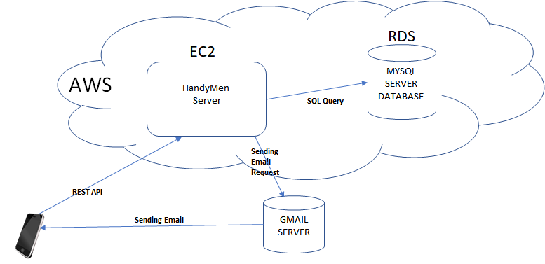

Diagram: HandyMen Server Deploy Diagram

The basic functions of HandyMen server consist of querying from database, providing REST APIs including file uploading and downloading, and sending email notifications. Accordingly, the components of HandyMen server involve the following parts. The internal components of the HandyMen server are HandyMen Service Module, Spring JDBC, Spring MVC Framework, Tomcat and Apache HttpServer. It also has two external components, MySql and Gmail Service. We choose the Spring framework as the middle ware to handle the database connections and Java Servlet implementation. Spring framework is the most popular modern Java-based enterprise application framework. It hides the differences of various deployment environments and make application focus on its own business logic. Spring JDBC encapsulates most Java JDBC functions including connection establishment and destroy, SQL querying and result set parsing, which makes it easy and safe for applications to process various database operations without making mistakes of the JDBC layer. Its Spring MVC core is based on Model-View-Controller architecture pattern, providing different controllers and view templates for different types of web applications. The application can mainly concentrate on its model design and realization. In addition, it will be very convenient for the application to evolve based on this MVC architecture pattern. For example, if website is needed for the future product, we just need to add a webpage view and use different controllers, without modifying any part about the model module. Also, we use Tomcat and Apache HttpServer to make the processing more efficient. Apache HttpServer is responsible for static information requests, for example downloading files, while Tomcat handles all the dynamic information requests, such as REST APIs. The choice of MySql database is mainly because it is the most widely-used free relational database for web applications. For our project, the relational data is the most suitable one comparing to other NoSql databases. Regarding to mail notification module, since we don’t have our own email server, we choose the GMAIL as our email server, which is pretty reliable and secure.

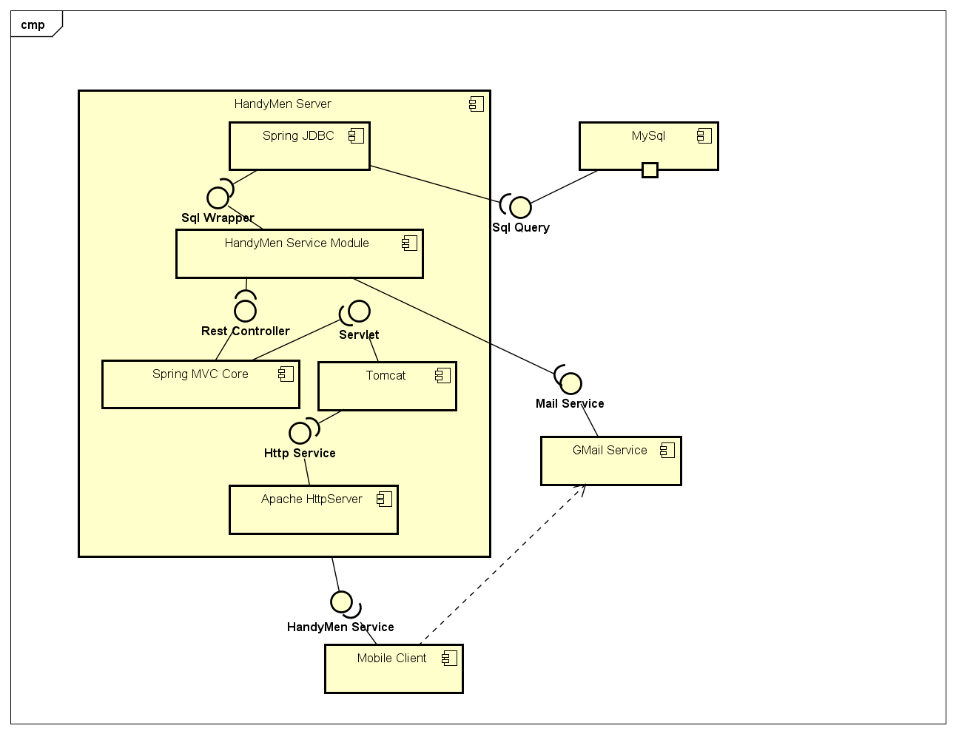

Diagram: HandyMen Server Component Diagram

The architecture types used in the server involves client-server style, pipe and filter style and interpreter style. The client-server style is about that one handy-men server can deal with multiple mobile application clients which may spread anywhere, and they use REST API to communicate. The Handymen Server use pipe and filter style to process different requests. For example, when receiving the user adding review request, the server will first check if it is the valid user, if the review already existing, and then put the review into database. The interpreter style is used by Spring MVC core to parse the URL parameters sent by the clients.