Sigmadraw = params_dr.O_sync_1;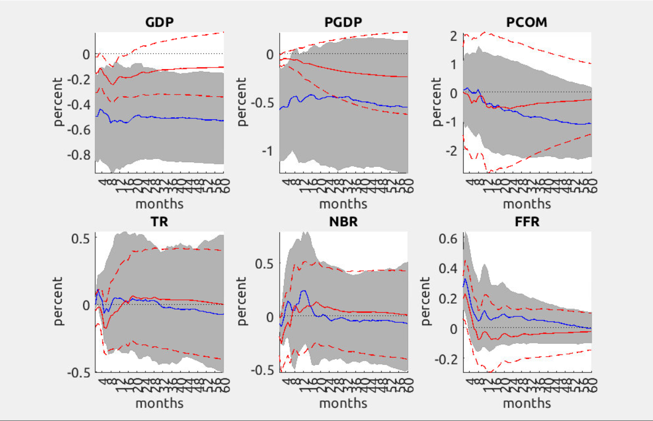

Sigmadraw = params_dr.O_sync_1';

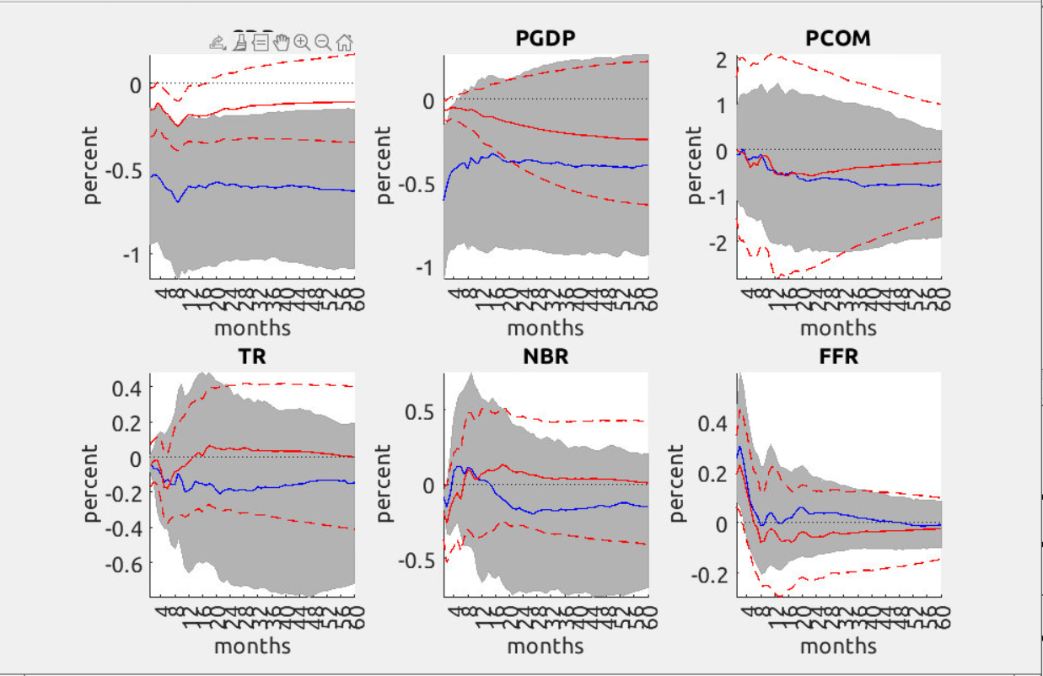

Sigmadraw = params_dr.O_sync_1*params_dr.O_sync_1';

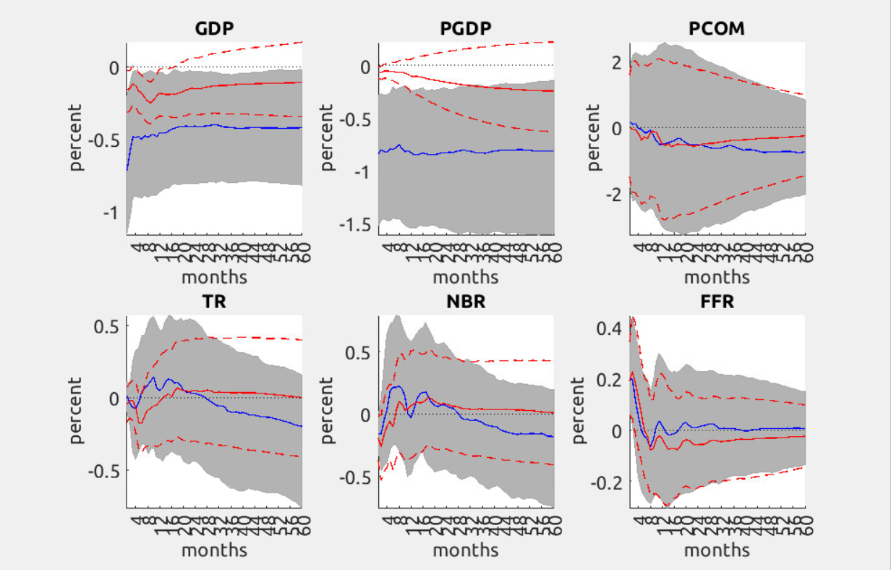

Sigmadraw = params_dr.O_sync_1'*params_dr.O_sync_1;

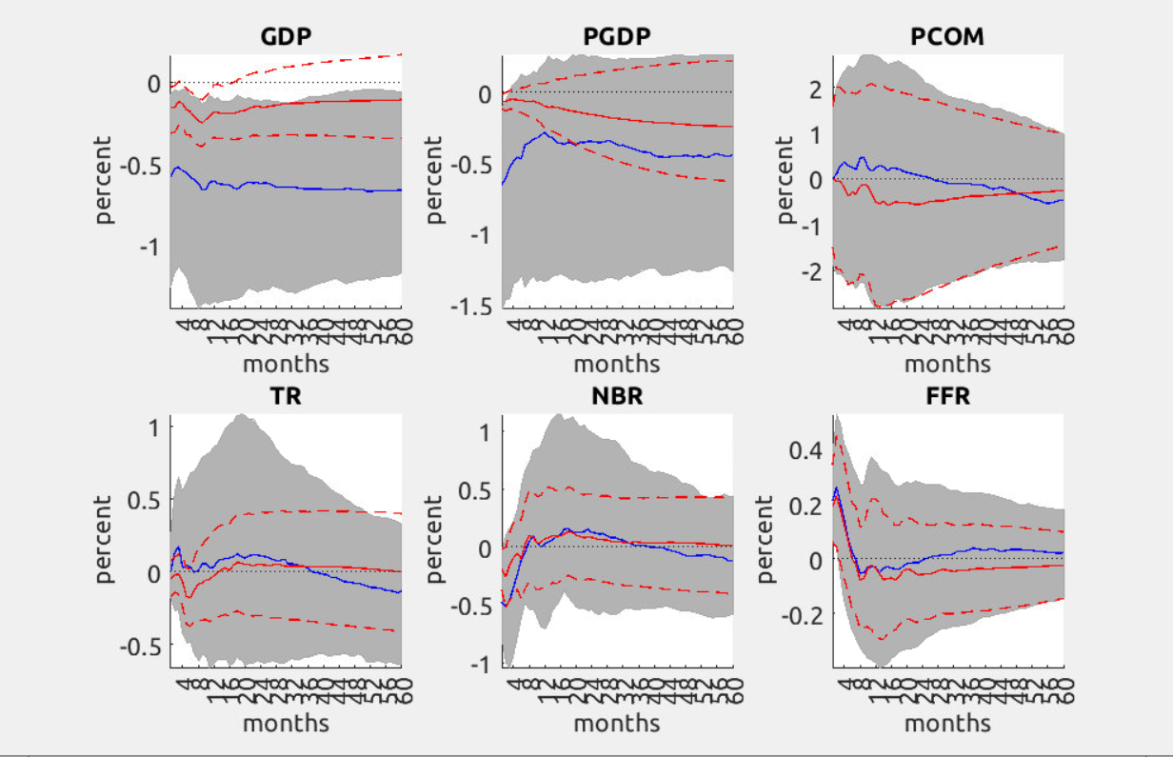

Sigmadraw = (params_dr.O_sync_1)\eye(nvar);

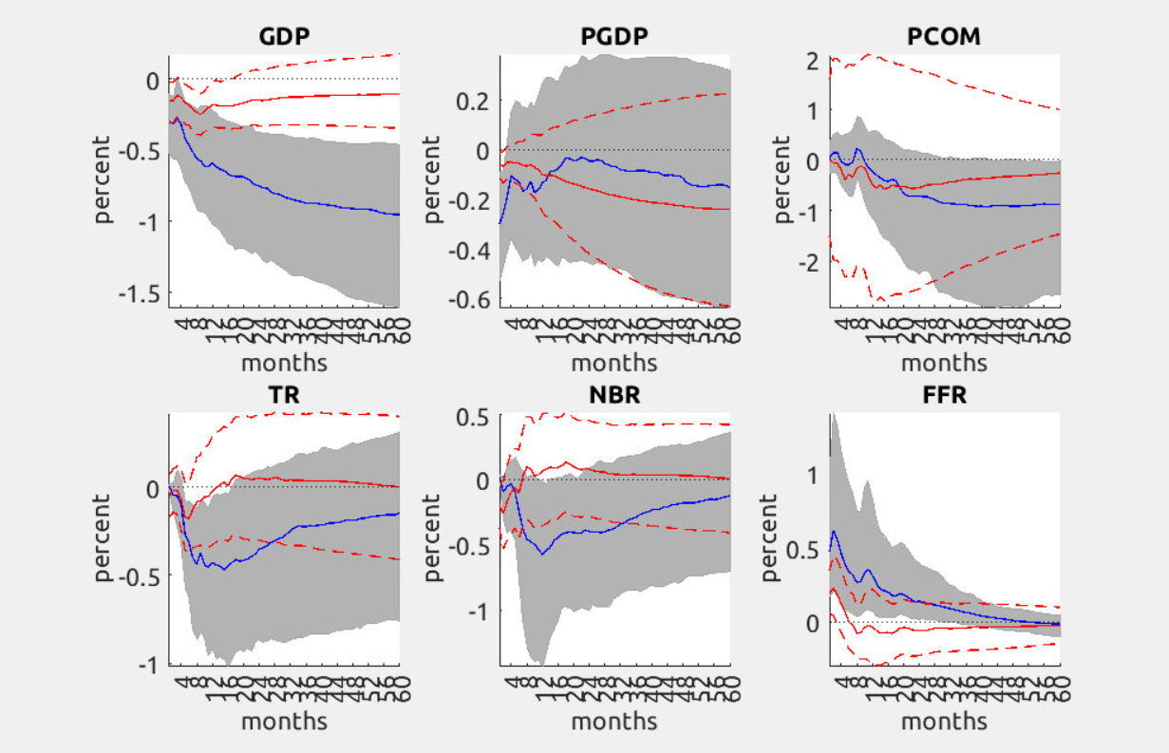

Sigmadraw2 = (params_dr.O_sync_1')\eye(nvar);

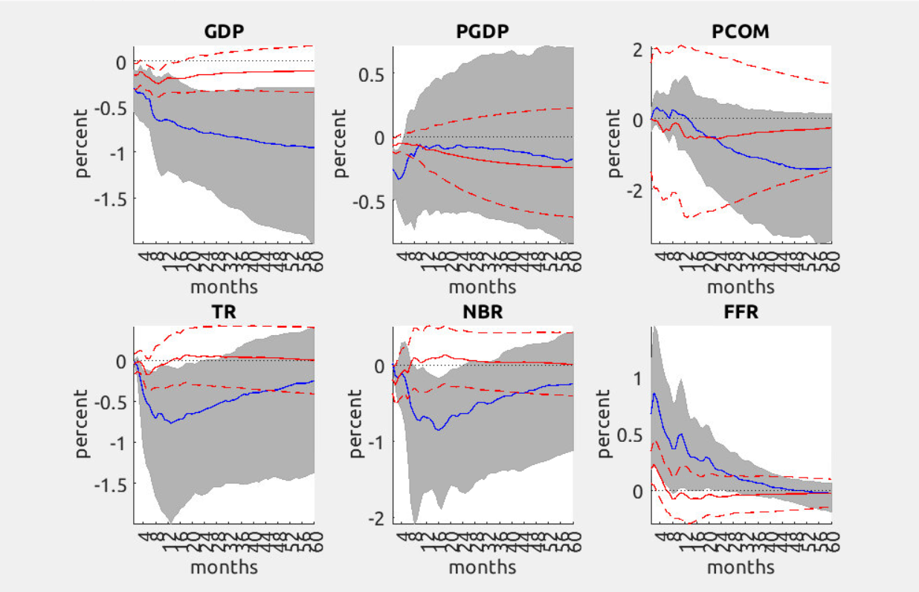

Sigmadraw3 = (params_dr.O_sync_1*params_dr.O_sync_1')\eye(nvar);

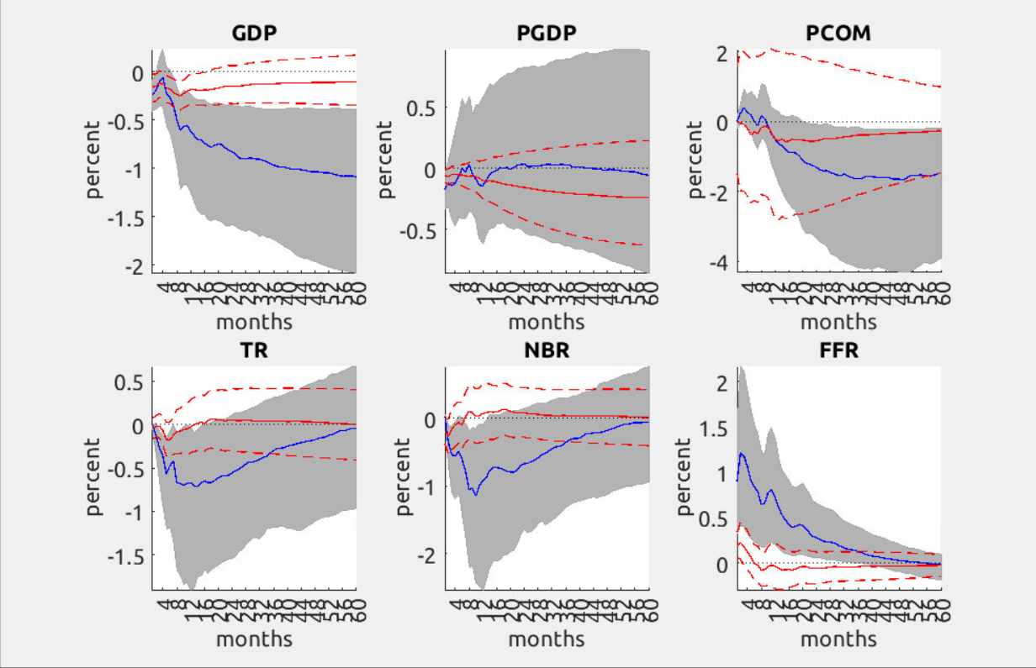

Sigmadraw4 = (params_dr.O_sync_1'*params_dr.O_sync_1)\eye(nvar);

