只求H的最小值，在所有类别样本数据上，结果：强化不同（负相关），弱化相同（或正相关）???

delta_w = -1*delta_x*delta_y



reception_field:7

input_dim_r:28

input_dim_c:28

learn_rate:1

total_epoch:20

samples_count:10)

training epoch: 0 elapse time:49.30 sec

evaluating epoch: 0 elapse time:0.87 sec entropy:[ 345.74429321]

training epoch: 1 elapse time:50.06 sec

evaluating epoch: 1 elapse time:0.87 sec entropy:[ 344.99822998]

training epoch: 2 elapse time:50.09 sec

evaluating epoch: 2 elapse time:1.12 sec entropy:[ 345.41552734]

training epoch: 3 elapse time:50.50 sec

evaluating epoch: 3 elapse time:0.81 sec entropy:[ 345.32025146]

training epoch: 4 elapse time:50.08 sec

evaluating epoch: 4 elapse time:0.89 sec entropy:[ 345.54266357]

training epoch: 5 elapse time:50.23 sec

evaluating epoch: 5 elapse time:0.81 sec entropy:[ 345.52377319]

training epoch: 6 elapse time:50.11 sec

evaluating epoch: 6 elapse time:1.17 sec entropy:[ 345.64248657]

training epoch: 7 elapse time:50.22 sec

evaluating epoch: 7 elapse time:1.09 sec entropy:[ 345.63986206]

training epoch: 8 elapse time:50.34 sec

evaluating epoch: 8 elapse time:1.79 sec entropy:[ 345.20211792]

training epoch: 9 elapse time:50.29 sec

evaluating epoch: 9 elapse time:0.87 sec entropy:[ 345.22393799]

training epoch: 10 elapse time:50.12 sec

evaluating epoch: 10 elapse time:1.15 sec entropy:[ 345.19924927]

training epoch: 11 elapse time:50.22 sec

evaluating epoch: 11 elapse time:1.29 sec entropy:[ 345.66033936]

training epoch: 12 elapse time:50.45 sec

evaluating epoch: 12 elapse time:1.75 sec entropy:[ 346.37258911]

training epoch: 13 elapse time:50.24 sec

evaluating epoch: 13 elapse time:1.29 sec entropy:[ 345.44638062]

training epoch: 14 elapse time:50.17 sec

evaluating epoch: 14 elapse time:0.92 sec entropy:[ 345.75427246]

training epoch: 15 elapse time:50.17 sec

evaluating epoch: 15 elapse time:0.98 sec entropy:[ 345.26367188]

training epoch: 16 elapse time:50.04 sec

evaluating epoch: 16 elapse time:1.40 sec entropy:[ 345.11233521]

training epoch: 17 elapse time:50.12 sec

evaluating epoch: 17 elapse time:0.94 sec entropy:[ 345.25735474]

training epoch: 18 elapse time:50.39 sec

evaluating epoch: 18 elapse time:1.12 sec entropy:[ 345.81176758]

training epoch: 19 elapse time:50.20 sec

evaluating epoch: 19 elapse time:0.98 sec entropy:[ 345.88012695]

==============================================================================

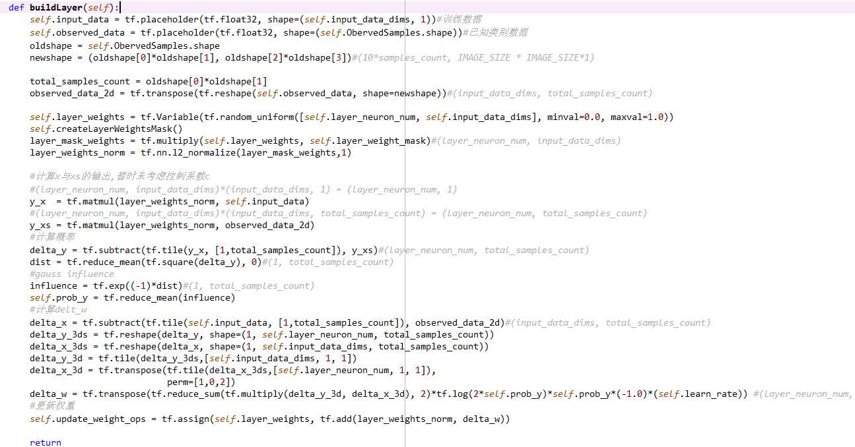

EntropyLayerExperiment...

(reception_field:7

input_dim_r:28

input_dim_c:28

learn_rate:0.001 good

total_epoch:20

samples_count:10)

Extracting data/train-images-idx3-ubyte.gz

Extracting finish!

Sharping Data...

Sharping finish!

Extracting Label data/train-labels-idx1-ubyte.gz

training ...

training epoch: 0 elapse time:49.90 sec

evaluating epoch: 0 elapse time:0.84 sec entropy:[ 9.36735725]

training epoch: 1 elapse time:49.87 sec

evaluating epoch: 1 elapse time:0.97 sec entropy:[ 8.67719555]

training epoch: 2 elapse time:50.43 sec

evaluating epoch: 2 elapse time:0.84 sec entropy:[ 8.45928288]

training epoch: 3 elapse time:49.84 sec

evaluating epoch: 3 elapse time:1.17 sec entropy:[ 8.3844595]

training epoch: 4 elapse time:49.62 sec

evaluating epoch: 4 elapse time:1.01 sec entropy:[ 8.34899807]

training epoch: 5 elapse time:49.48 sec

evaluating epoch: 5 elapse time:0.92 sec entropy:[ 8.32738686]

training epoch: 6 elapse time:49.62 sec

evaluating epoch: 6 elapse time:0.87 sec entropy:[ 8.31193066]

training epoch: 7 elapse time:50.06 sec

evaluating epoch: 7 elapse time:0.84 sec entropy:[ 8.30009365]

training epoch: 8 elapse time:50.01 sec

evaluating epoch: 8 elapse time:0.89 sec entropy:[ 8.2910471]

training epoch: 9 elapse time:50.64 sec

evaluating epoch: 9 elapse time:0.87 sec entropy:[ 8.28410244]

training epoch: 10 elapse time:49.97 sec

evaluating epoch: 10 elapse time:0.98 sec entropy:[ 8.27869129]

training epoch: 11 elapse time:50.34 sec

evaluating epoch: 11 elapse time:0.98 sec entropy:[ 8.27439499]

training epoch: 12 elapse time:50.12 sec

evaluating epoch: 12 elapse time:0.84 sec entropy:[ 8.27093697]

training epoch: 13 elapse time:50.17 sec

evaluating epoch: 13 elapse time:1.45 sec entropy:[ 8.26809406]

training epoch: 14 elapse time:50.08 sec

evaluating epoch: 14 elapse time:0.86 sec entropy:[ 8.26570129]

training epoch: 15 elapse time:49.83 sec

evaluating epoch: 15 elapse time:0.99 sec entropy:[ 8.26357746]

training epoch: 16 elapse time:50.31 sec

evaluating epoch: 16 elapse time:1.06 sec entropy:[ 8.26159859]

training epoch: 17 elapse time:50.19 sec

evaluating epoch: 17 elapse time:0.98 sec entropy:[ 8.2597332]

training epoch: 18 elapse time:50.20 sec

evaluating epoch: 18 elapse time:0.83 sec entropy:[ 8.25801849]

training epoch: 19 elapse time:50.02 sec

evaluating epoch: 19 elapse time:0.89 sec entropy:[ 8.25653744]

