**Moqups**

1. <https://app.moqups.com/WP9GDe9yh0/edit/page/a1b5fce63> - Stopwatch page

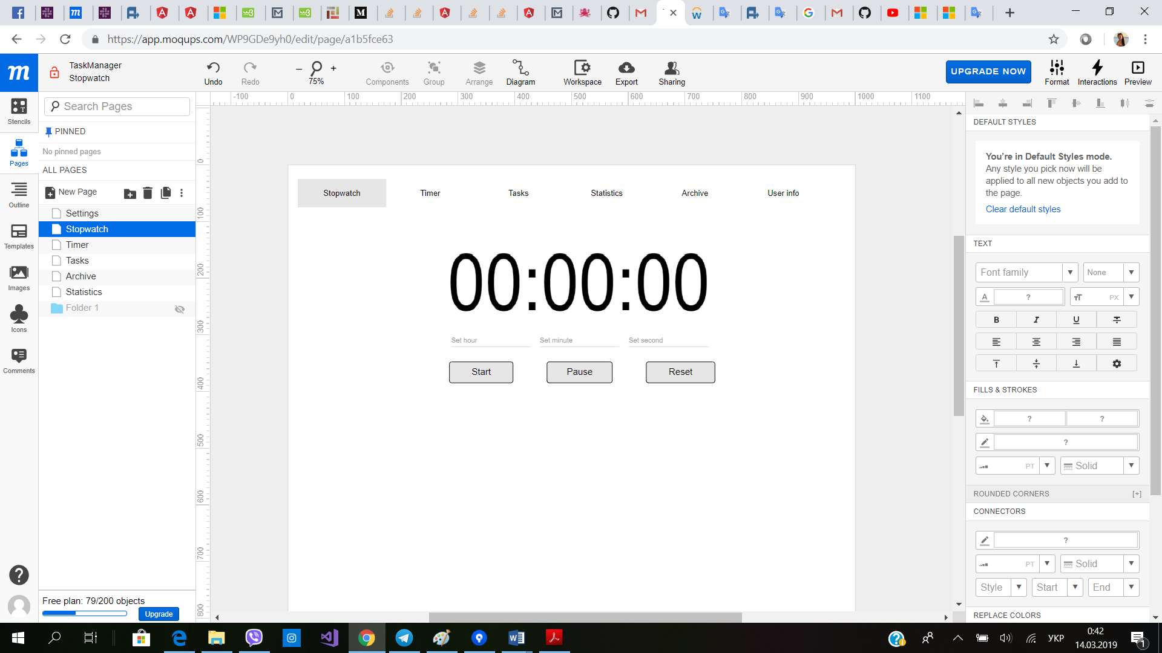

1. <https://app.moqups.com/WP9GDe9yh0/edit/page/a819800ba>

* Timer page

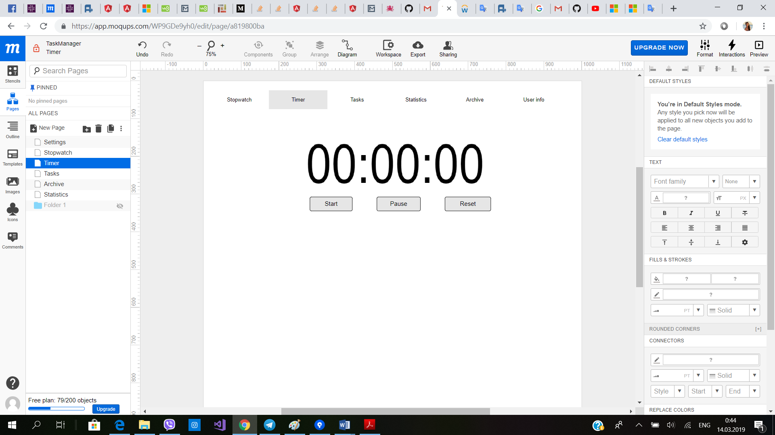

1. <https://app.moqups.com/WP9GDe9yh0/edit/page/aba85ce12> - Statistics page

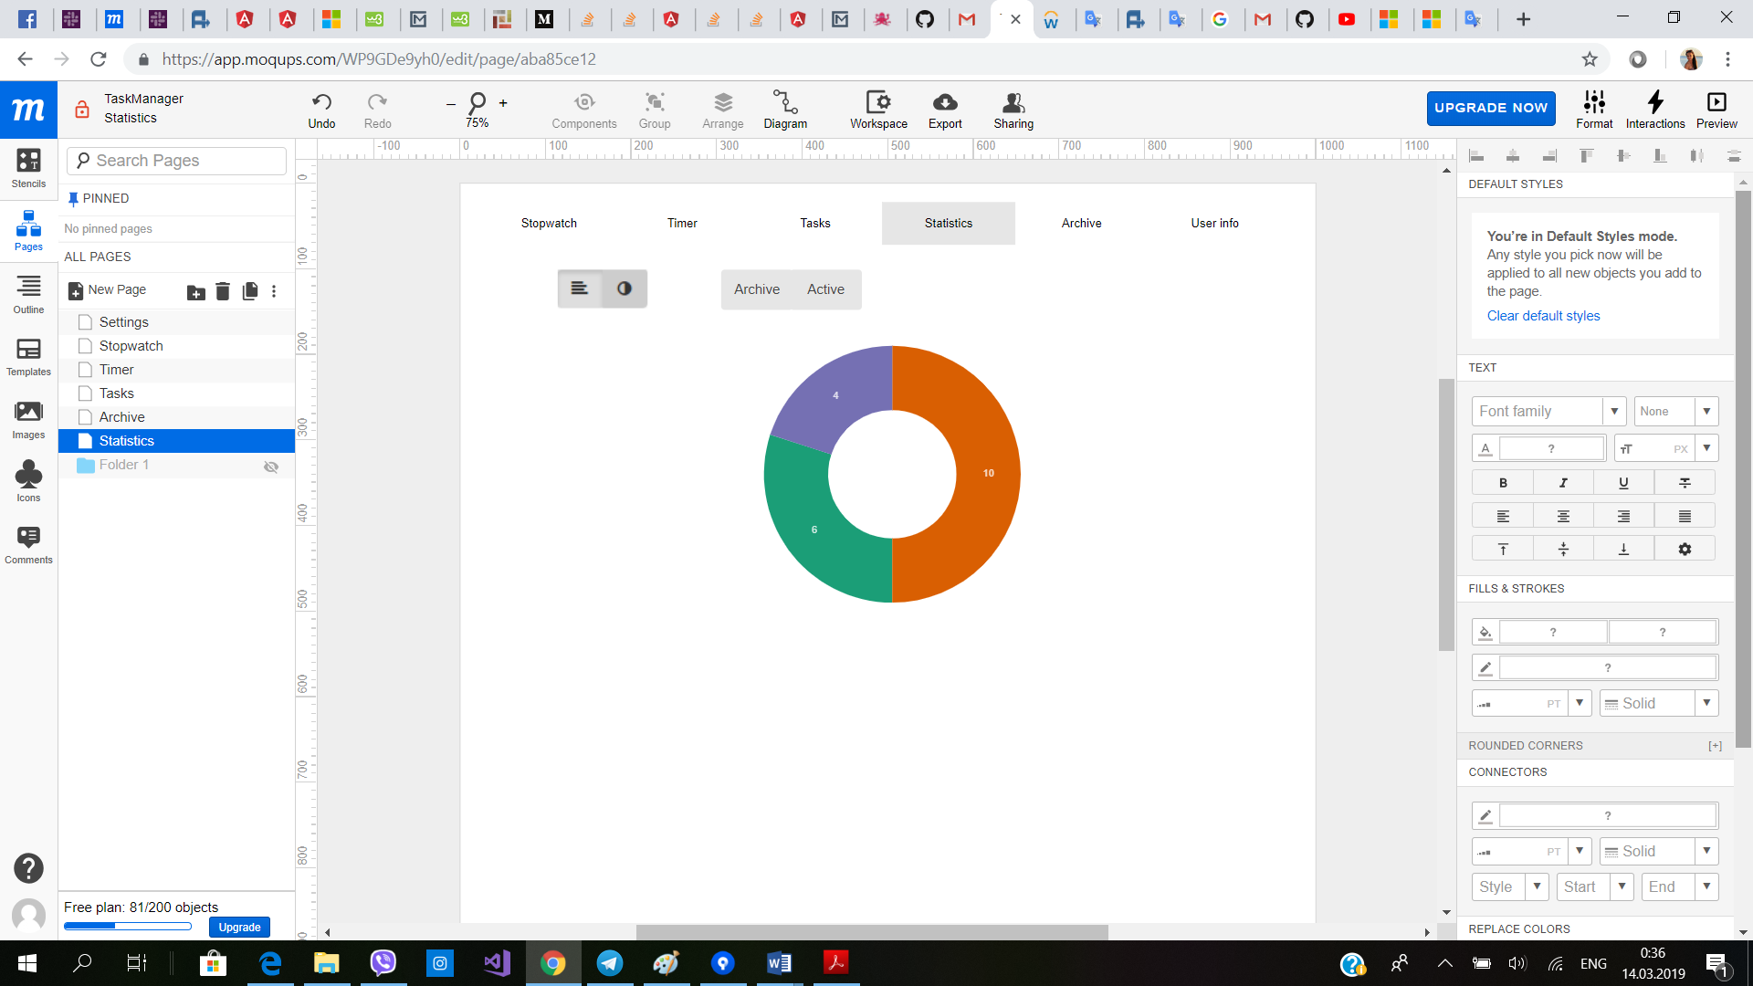

1. <https://app.moqups.com/WP9GDe9yh0/edit/page/a23afc5b0> - Settings page

