Ticket Booking System
System for booking tickets by date and points of departure and destination, information about available tickets and cab company.

Roles: guest, user and administrator.
Guest - has the opportunity to register his/her personal account or log in, if the one already exists. He/she can find tickets and read some information about different companies.Once the guest is registered, he/she has access to all actions allowed to user.

User- has the ability to find tickets, read some information about companies, and book or return tickets, log out of his/her personal account and edit personal information.

Administrator - fills in the system with content (information about available tickets and cab companies.) If the administrator notices user causing forbidden activity,administrator deactivates user's profile. Administrator also monitors serviceability of the system - reviews the list of errors, messages and exceptional situations that has occurred by users' and guests' interaction with the site. Can agree on tickets return and mailing.

Role | Action | Description | Function
Guest | Register | Create personal account | RegisterTest
Guest | Log In | Log into personal account | LoginTest
Guest | View companies data | Read information about companies | GetCompanyDataTest
Guest | Search Tickets | Find tickets by date range, departure and arrival point | GetTicketDataTest
User | Book ticket | Book ticket by selected date, departure and arrival point | BookTicketTest
User | Return ticket | Return earlier booked tickets | ReturnTicketTest
User | Edit personal information | Change name, surname, email etc. | IndexTest
User | Log out | Quit personal account | LogoutTest
Admin | Send newsletter | Send e-mail letters about user’s booking | Post
Admin | Ban user | Deactivate user’s account for prohibited behavior | BanTest
Admin | Monitor system | View the list of errors and warnings to prevent system malfunction | GetEntries  ByDateTest,  ViewTest
Admin | Create ticket | Add new ticket to database | AddTicket Test
Admin | Edit ticket | Change date and price for tickets | UpdateTicketTest
Admin | Delete ticket | Remove ticket from database | DeleteTicketTest
Admin | Create company | Add new actor to database | CreateCopanyTest
Admin | Edit company | Change information about company | EditCompanyTest

Existing methods

Role | Action | Description | Function
Guest | Register | Create personal account | Register
Guest | Log In | Log into personal account | Login
User | Change password | Change existing password | Change Password
User | Get tickets by destination and departure | Get ticket by selected departure and arrival point | GetTicketsByFronTo
User | Get tickets by date | Get ticket by selected date | GetTicketsByDate
User | Log off | Quit personal account | LogOff
User | Get tickets by type | Get tickets by selected type | GetTicketsByType
User | User get
User | Get all
User | Add ticket | Create a new ticket | AddTicket
Admin | Create ticket | Add new ticket to database | Create
Admin | Delete ticket | Remove ticket from database | Delete ticket
Admin | Update information | Update companies’ information | Update
Use Case Diagram
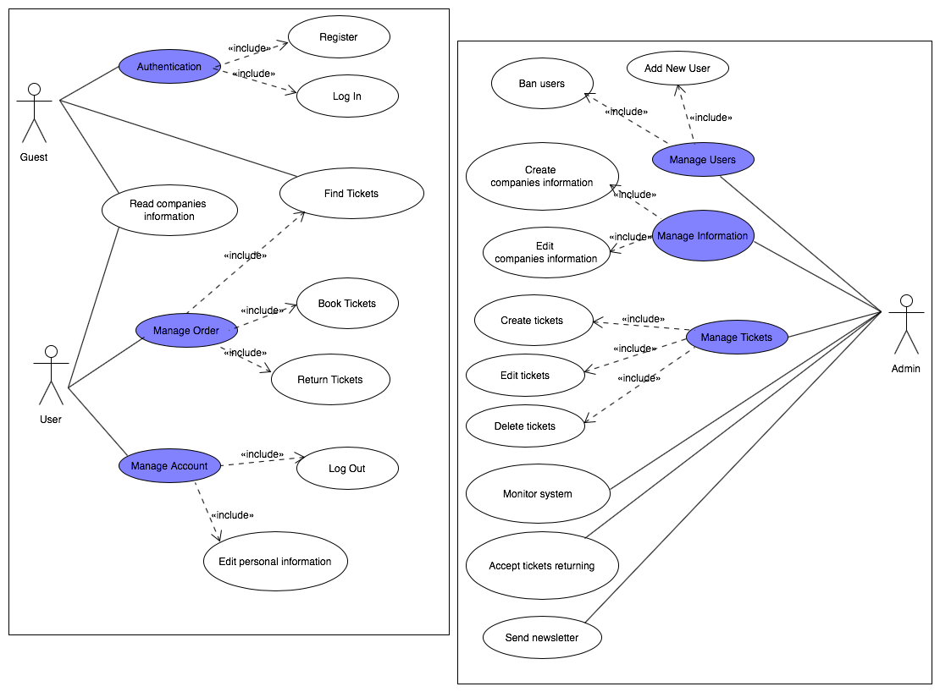

For guest:
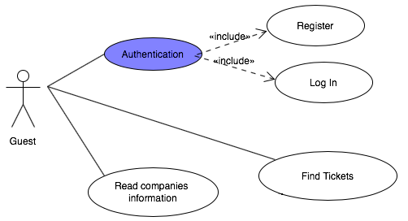

For user:
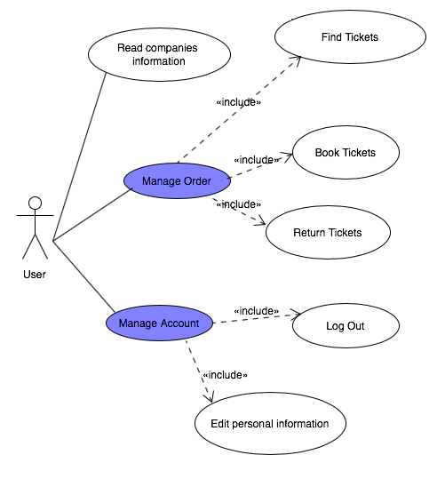
For admin:
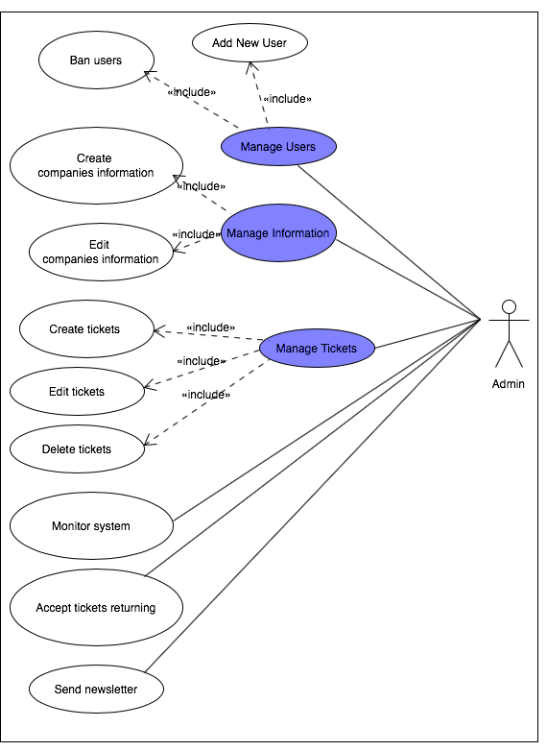

Class Diagram
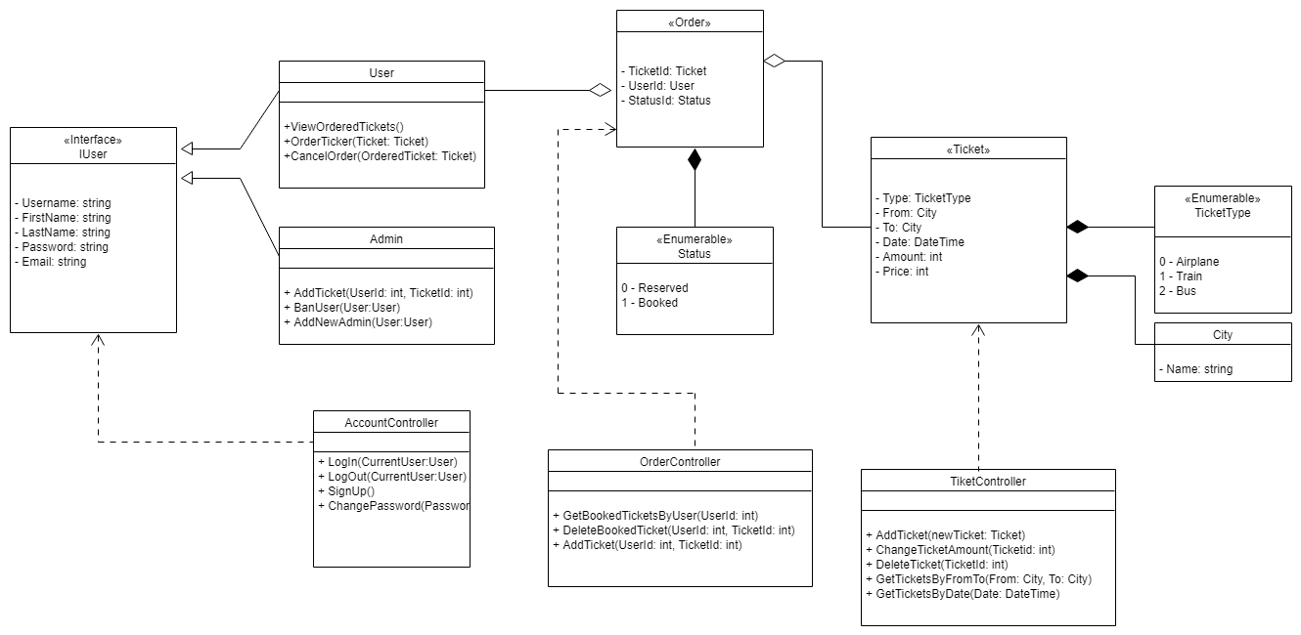
Sequence Diagram
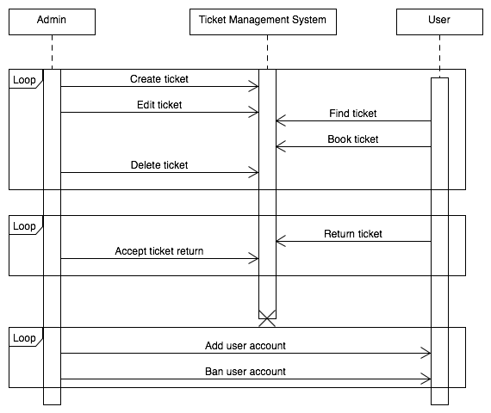

Basic layout

