**Project Assignment No: 02**

**Name: Omkar Amilkanthwar**

**Roll No: 41403**

**Problem Statement:**

Project problem statement feasibility assessment using NP-Hard, NP-Complete or satisfiability issues using modern algebra and/or relevant mathematical model.

**Learning Objective:**

* Understand the concept of NP-Hard, NP-Complete

**Learning Outcomes:**

* Formulate proper mathematical justification for NP-Completeness of problem
* Show NP-Completeness of the proposed system

**Theory:**

**Mathematical Model:**

1. **Negative Sampling**

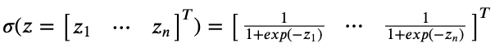

Negative Sampling uses vectorized sigmoid functions to model individual binary probabilities

1. **Loss Function:**

Loss function is actually the sum of mutual cross-entropies between the predicted output and each of the 2m target outputs which can be simplified to:

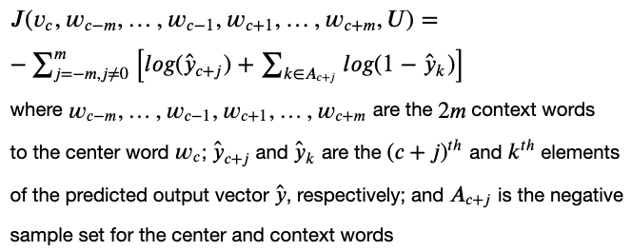

1. **Gradients**

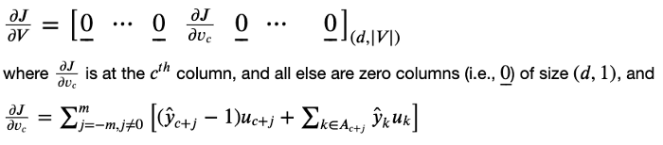

First Gradient w.r.t V (V is the matrix of all center word vectors.)

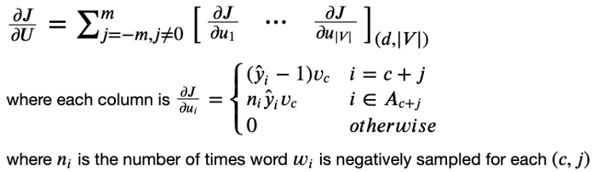

Second Gradient w.r.t U (U is the matrix of all context word vectors).

1. **Cosine Similarity:**

Cosine Similarity is a measurement that quantifies the similarity between two or more vectors.

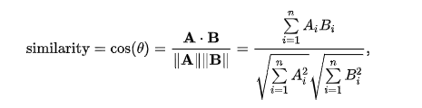

**Conclusion:**

Hence, we studied and implemented the Mathematical models