**ESP32 Presence Sensor with LD2410**

First Time Configuration

NOTE: Make sure you have ESPHome addon installed on you Home Assistant before starting

1. Connect the device to a power supply using the USBC connector
2. Go to your Home Assistant and you should have a message that a new device has been discovered, click on it!
   1. You can otehrwise go to Settings/Device and you will find it there

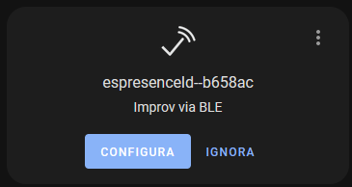

1. Click on the CONFIGUE button and you will be prompted to enter you WiFi credential (SSID and password) please do it
2. Click on CLOSE
3. Now go to your ESPHome addon web interface
4. You should have a new device ready to be “adopted”

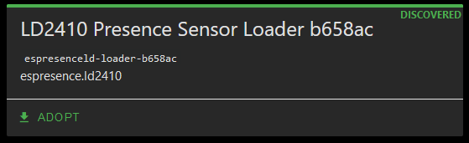

1. Click on ADOPT
2. Give to the device the name of your choice and click again ADOPT

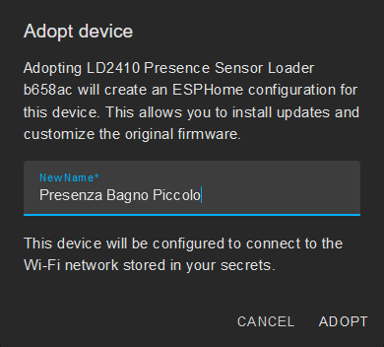

1. You will be prompted with this device encryption key, if you can please copy and save it, i twill be easier if in the future you need to recover this device in case of Home Assistance / ESPHome reinstallation
2. Press on INSTALL to begin download, compile and install the updated firmware for your device
3. Wait for process to be completed and if all is ok click on STOP to close the window
4. As last step go to Home Assistant “Settings/Devices” and you should see a new ESPHome device discovered with the name you just choose, click on its CONFIGURE button then click enter

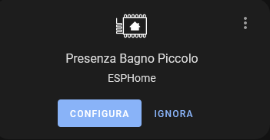

1. Congratulations, the setup is complete and you can start using your new Presence Device