外太空探索补充材料
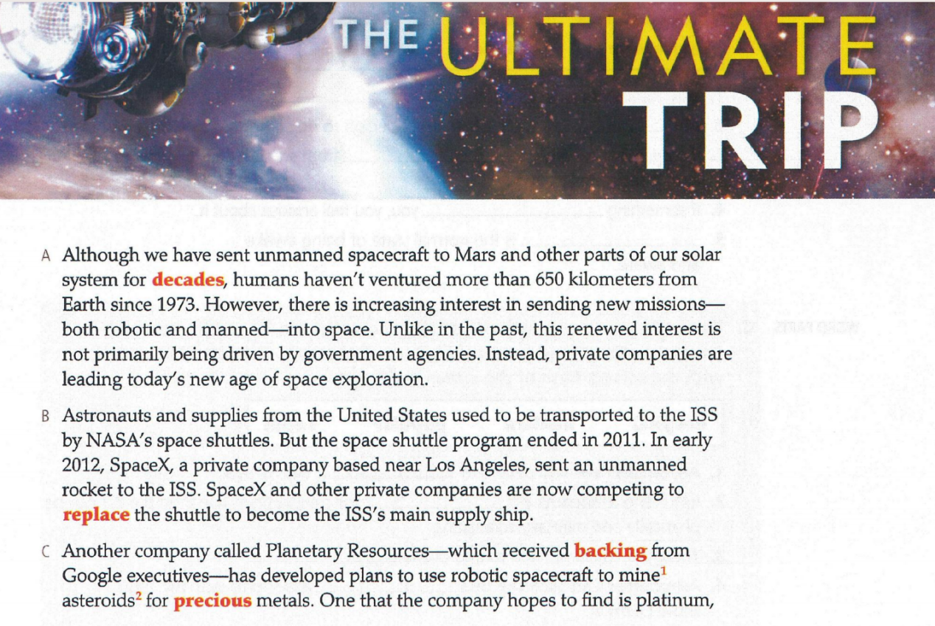
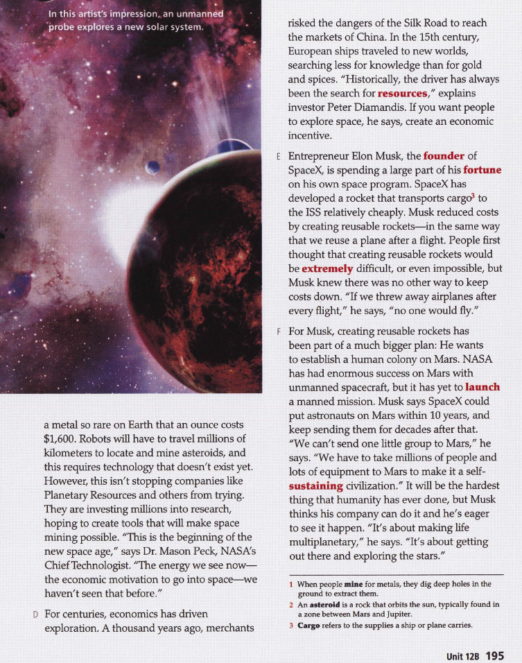
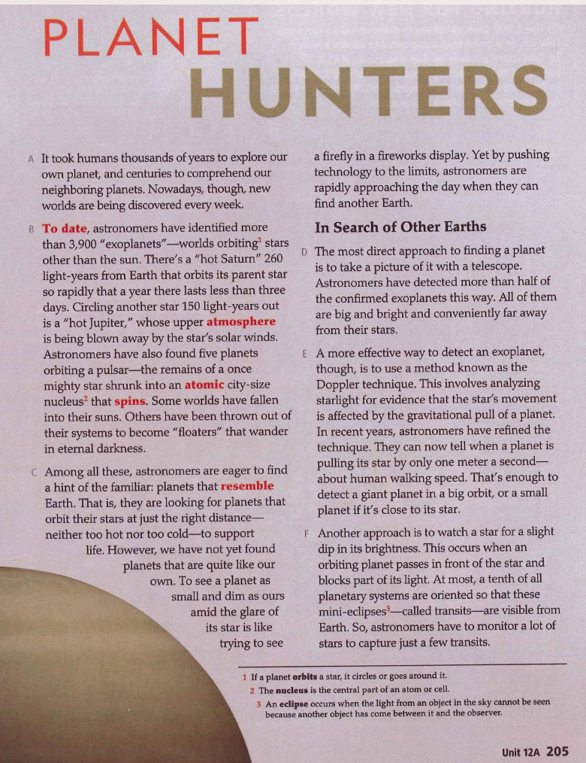
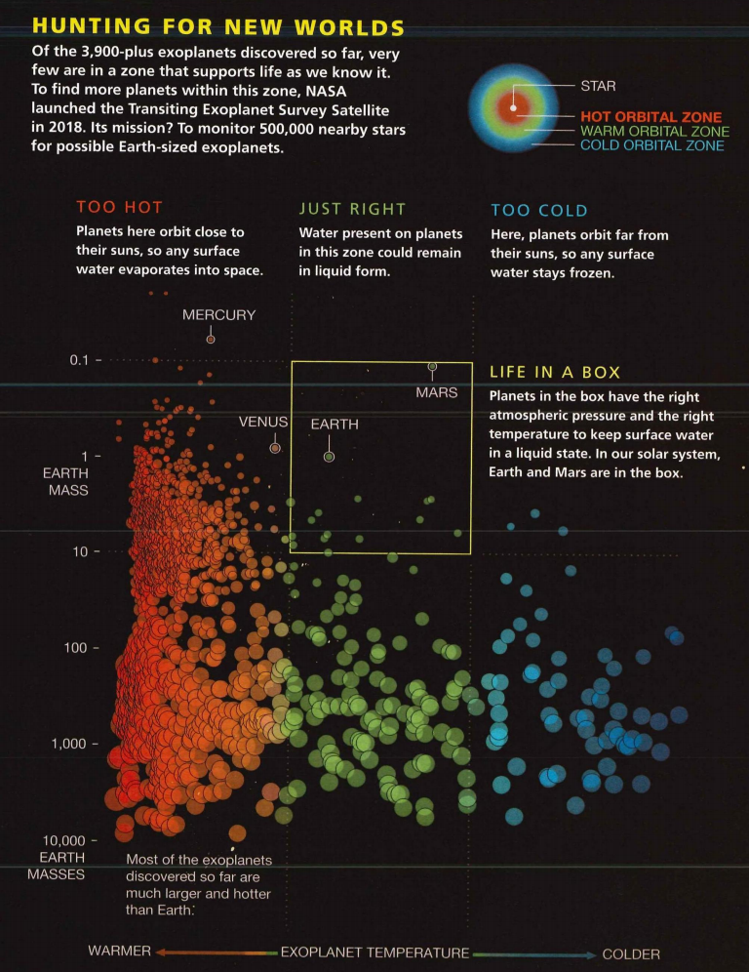

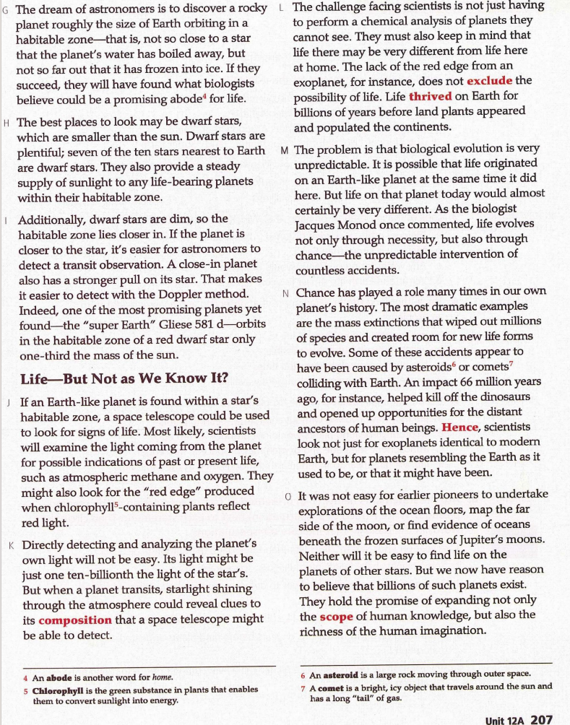

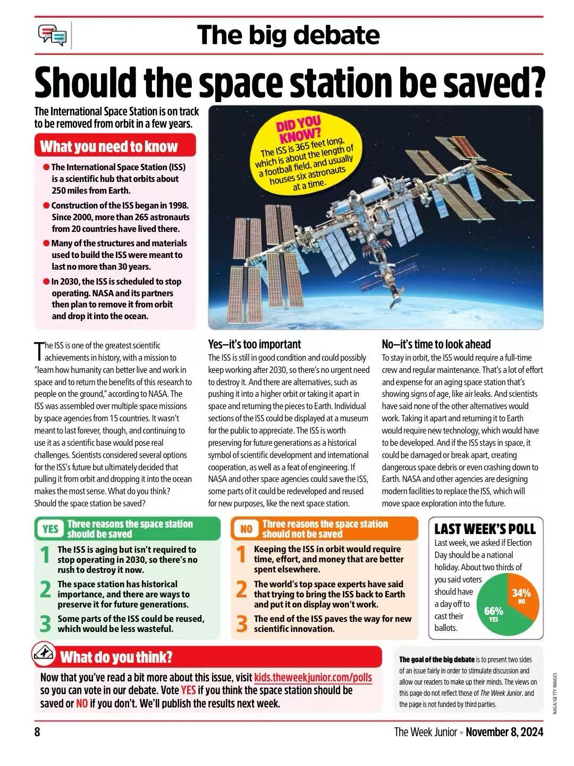

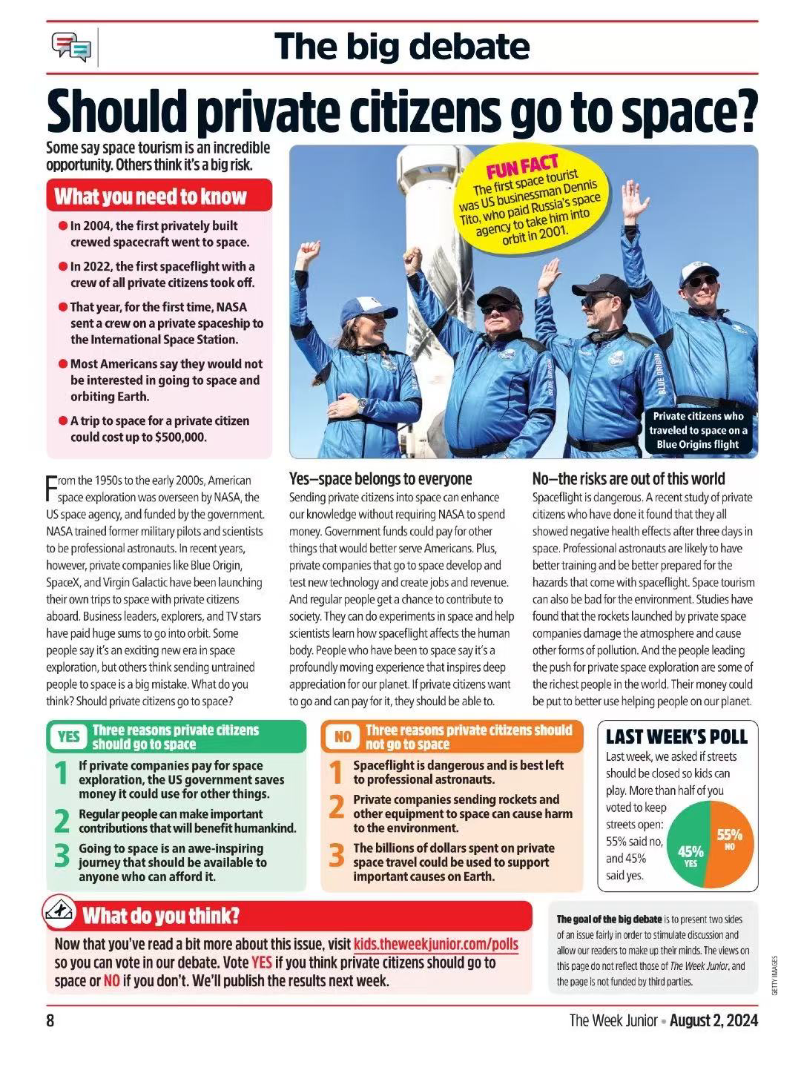

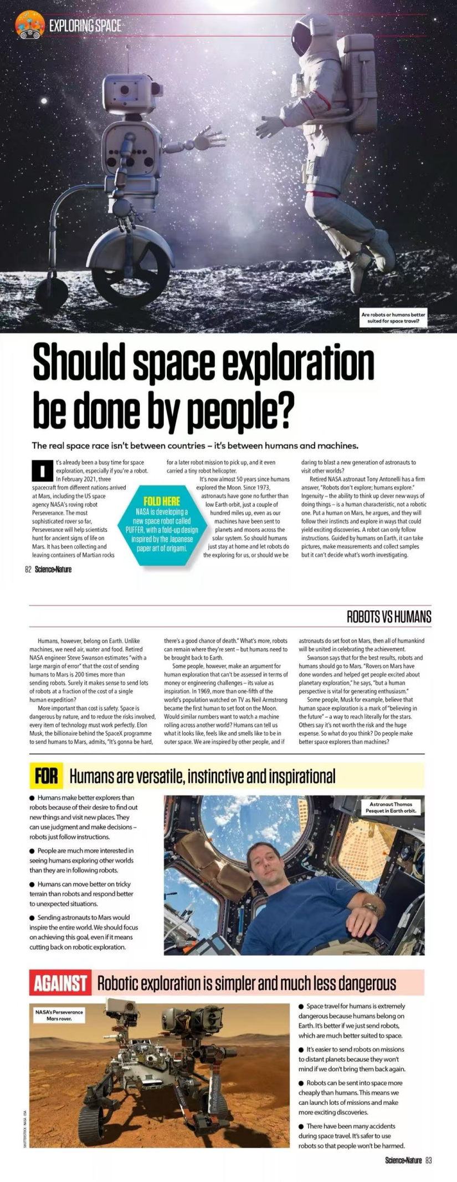

https://www.nationalgeographic.com/science/article/mars-rock-alien-life-microbes-chemistry This is the best evidence yet for ancient life on Mars

https://www.nationalgeographic.com/magazine/article/why-are-people-so-dang-obsessed-with-mars-feature Why are people so dang obsessed with Mars?

https://www.nationalgeographic.com/science/article/alien-planet-signs-life-biosignature-exoplanet Is there really alien life on this exoplanet? We asked 10 experts.

https://www.163.com/dy/article/KGG504VC0511A3AG.html

https://language.chinadaily.com.cn/news/2010-04/26/content_9775174.htm

