一、动态图：
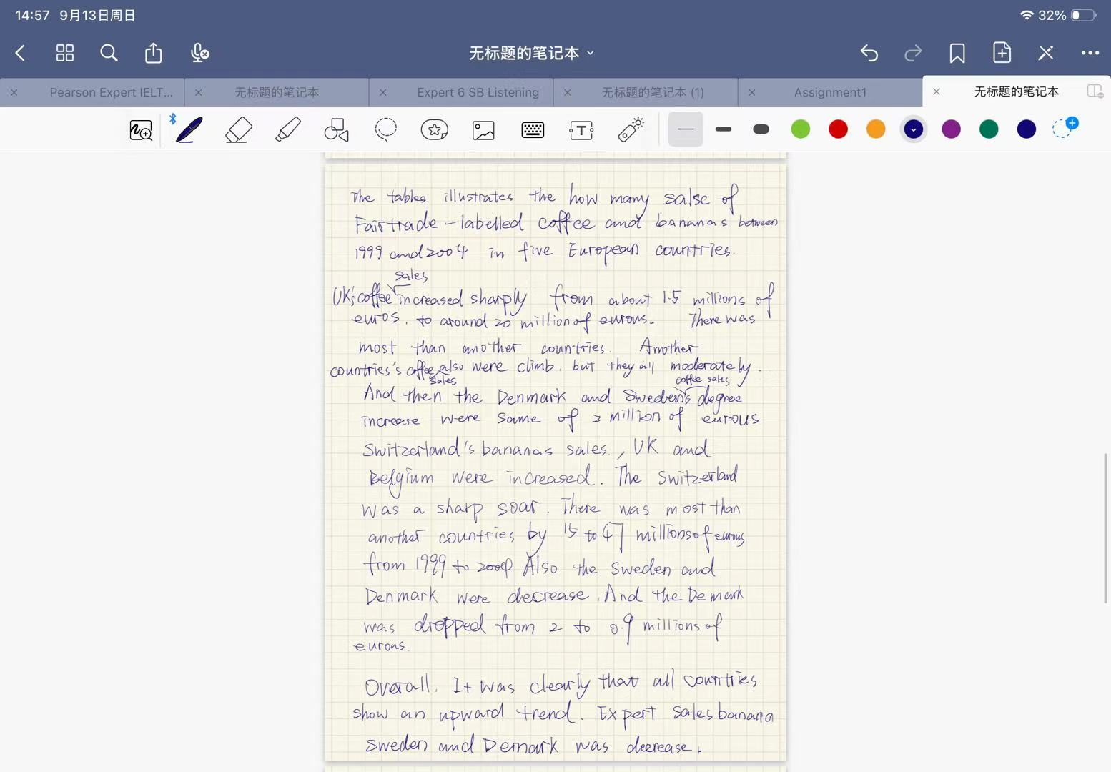
动态图表题侧重“随时间变化”的描述：需概括总体趋势、突出最大增幅与唯一下降，并用倍数/幅度进行对比。
【修改稿】（约 171 词）：
The tables show the sales of Fairtrade-labelled coffee and bananas in five European countries in 1999 and 2004. Overall, most of the countries saw a rise in the sales of both products, with the UK’s coffee market and Switzerland’s banana market recording the most dramatic growth.
With regard to coffee, sales in the UK increased from 1.5 million euros to 20 million euros, which was by far the sharpest rise of all. The other four countries also experienced growth, although it was fairly modest: sales in Switzerland doubled from 3 to 6 million euros, while Denmark, Belgium and Sweden rose by only 0.2, 0.7 and 0.2 million euros respectively.
As for bananas, Switzerland was the leading market, with sales soaring from 15 million to 47 million euros. The UK and Belgium also saw significant increases, rising from 1 to 5.5 million and from 0.6 to 4 million euros respectively. By contrast, banana sales in Sweden and Denmark fell, dropping from 1.8 to 1 million and from 2 to 0.9 million euros.
【修改要点】
- TA 任务完成度：原稿概述写“所有国家都呈上升趋势”，与香蕉数据矛盾（瑞典、丹麦实际下降）；修改稿改为“多数国家两类产品均增长，英国咖啡与瑞士香蕉增幅最大”，并补全比利时咖啡、香蕉等遗漏数据。
- CC 连贯与衔接：原稿以 And then/Also 硬连；修改稿用 With regard to/As for/By contrast/respectively 组织段内与段间逻辑。
- LR 词汇资源：原稿 sales 反复出现、a sharp soar 搭配不当；修改稿用 experienced growth/soared/leading market/dramatic growth 等多样表达。
- GRA 语法多样性：修正 the tables illustrates、were climb、degree increase were same 等语法错误；顺带将“丹麦、瑞典咖啡同样增幅”落实为各增 0.2 百万欧元；统一一般过去时。

二、静态图：
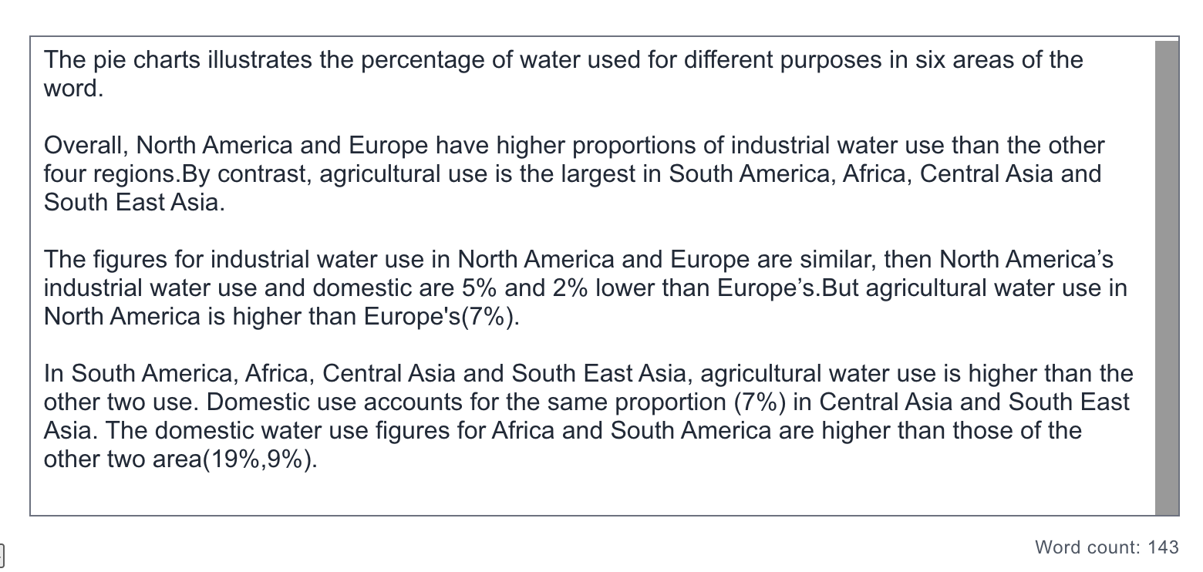
静态图题侧重“横向比较”：需按占比高低分组比较各地区，并点明最大/最小类别，数据必须与图完全一致。
【修改稿】（约 168 词）：
The pie charts show the percentage of water used for agricultural, industrial and domestic purposes in six areas of the world. Overall, industry accounted for a larger share of water use in North America and Europe than elsewhere, whereas agriculture dominated in the other four regions; domestic use was the smallest category in every area.
The figures for industrial water use in North America and Europe were broadly similar, at 48% and 53% respectively. North America’s industrial use was 5% lower than Europe’s, and its domestic use was also 2% lower (13%, compared with 15%). By contrast, agricultural water use in North America was 7% higher than in Europe (39% and 32%).
In South America, Africa, Central Asia and South East Asia, agriculture was by far the dominant use, accounting for 71%, 84%, 88% and 81% of the total respectively. Domestic use was consistently the smallest category in these regions, at 10% in South America, 7% in Africa and South East Asia, and only 5% in Central Asia.
【修改要点】
- TA 任务完成度：原稿末段数据错误——非洲与南美生活用水并非 19% 和 9%（那两个数字是工业用水占比）；修改稿更正为南美 10%、非洲 7%，并补上中亚 5%。
- CC 连贯与衔接：原稿 then/But 连接生硬；修改稿按“欧美工业主导 vs 其他四地区农业主导”分两段，用 whereas/By contrast/respectively 衔接。
- LR 词汇资源：原稿 use 一词过度重复；修改稿改用 accounted for/dominant/recorded/ranging from…to… 等。
- GRA 语法多样性：修正 illustrates→illustrate、word→world、the other two use→the other two categories 等错误，统一时态与单复数。

三、流程图：

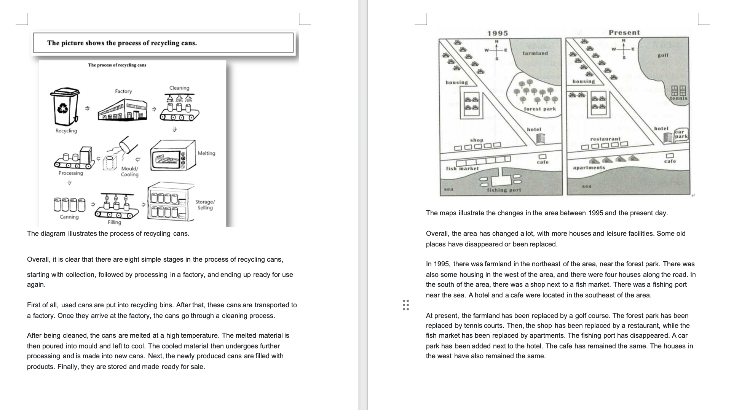
流程图题侧重“顺序描述”：需按环节先后完整复述，全程使用被动语态与顺序连接词，并给出整体概述。
【修改稿】（约 146 词）：
The diagram illustrates the process of recycling used cans. Overall, the process consists of a series of stages, beginning with the collection of old cans and ending with new cans being made ready for use again.
To begin with, used cans are put into recycling bins and are then transported to a factory. Once they arrive, the cans go through a cleaning process. After being cleaned, the cans are melted at a high temperature, and the resulting liquid metal is poured into moulds and left to cool. The cooled material then undergoes further processing before it is made into new cans.
In the next stage, the newly produced cans are filled with drinks or other products. Finally, they are stored until they are ready to be distributed and sold. In this way, the same metal can be recycled again and again rather than being thrown away.
【修改要点】
- TA 任务完成度：原稿已覆盖全部环节、结构完整。
- CC 连贯与衔接：保留原稿 First of all/After that/After being cleaned/Finally 的顺序链，并加入 In the next stage 使中段衔接更紧凑。
- LR 词汇资源：修正 poured into mould 缺冠词问题；使用 moulds/undergoes further processing/distributed 等流程词汇。
- GRA 语法多样性：修正单复数（mould→moulds），全程保持被动语态，句子长短有变化，符合流程图的语法要求。

四、地图：

地图题侧重“变化对比”：需分别描述过去与现在的布局，并明确指出被替换、新增、消失或保留的部分。
【修改稿】（约 167 词）：
The maps illustrate the changes that took place in the area between 1995 and the present day. Overall, the area changed considerably, with more housing and leisure facilities being provided, while several old features disappeared or were replaced by new ones.
In 1995, there was farmland in the north-east of the area, close to a forest park. Housing could be found in the west, with four houses standing along the road. In the south, a shop stood next to a fish market, and a fishing port was located near the sea. A hotel and a cafe occupied the south-east of the area.
At present, the farmland has been converted into a golf course, and the forest park has made way for tennis courts. The shop has been replaced by a restaurant, while the fish market has been replaced by apartments, and the fishing port has disappeared. A car park has been added beside the hotel, whereas the cafe and the houses in the west have remained unchanged.
【修改要点】
- TA 任务完成度：原稿内容完整，替换/新增/消失/保留四类变化均有覆盖。
- CC 连贯与衔接：原稿按“1995 vs 现在”两段组织已清晰；修改稿用 whereas/while 强化对比，并删去段首生硬的 Then。
- LR 词汇资源：用 converted into/made way for/replaced by/remained unchanged 等替换原稿反复出现的 has been replaced。
- GRA 语法多样性：保持现在完成时被动语态（has been + 过去分词）前后一致，句式有长短变化。

