Assignment on
Introduction to computer
Id no-06671610
3rd year 1st semester
2005-2006

Name: Tarek mahmud
2nd batch section: B
Dept. of management

Topics of assignment:

1.Q. What is computer?

2.Q. Types of computer?

3.Q. Components of computer ?
4.Q. Is a computer more advance than a human being?

5.Q. Definition of data?

6.Q. Difference between data and information?

7.Q. Explain the computer generation?

8.Q. Feature of a computer?

9.Q. use of computer?

10.Q. History of computer?
1.Q. What is computer?

Answer:

Computer:
A device that computes, especially a programmable electronic machine that performs high-speed mathematical or logical operations or that assembles, stores, correlates, or otherwise processes information.

KAVIN CLIVTON :“computer means electronic ,magnetic, optical or other high-speedster processing device or system which performs logical,arithmetic,and memory functions by manipulations of electronic, magnetic or optical impulses, and includes all input,output,processing,storage,computer software, or communication facilities which are connected or related to the computer in a computer system or computer network”.

According to encyclopedia of Britannica
Programmable machine that can store, retrieve, and process data. Today's computers have at least one CPU that performs most calculations and includes a main memory, a control unit, and an arithmetic logic unit. Increasingly, personal computers contain specialized graphic processors, with dedicated memory, for handling the computations needed to display complex graphics, such as for three-dimensional simulations and games. Auxiliary data storage is usually provided by an internal hard disk and may be supplemented by other media such as floppy disks or CD-ROMs. Peripheral equipment includes input devices (e.g., keyboard, mouse) and output devices (e.g., monitor, printer), as well as the circuitry and cabling that connect all the components. Generations of computers are characterized by their technology. First-generation digital computers, developed mostly in the U.S. after World War II, used vacuum tubes and were enormous. The second generation, introduced c. 1960, used transistors and were the first successful commercial computers. Third-generation computers (late 1960s and 1970s) were characterized by miniaturization of components and use of integrated circuits. The microprocessor chip, introduced in 1974, defines fourth-generation computers.

So we can say that, a computer is an electronic machine that stores, retrieves, and process data. It cannot think or reason, it can only carry out instruction given to it.
2.Q. Types of computer?

Answer:
Computers can be classified, or typed, many ways. Some common classifications are summarized below. For others see Category: Classes of computers.

Contents:
- 1 Microcomputers (Personal computers)
- 2 Minicomputers (Midrange computers)
- 3 Mainframe Computers
- 4 Classes by function
  - 4.1 Servers
  - 4.2 Workstation
  - 4.3 Embedded computers
- 5 Supercomputer
- 6 References

Microcomputers (Personal computers)
Microcomputers are the most common type of computers in existence today, whether at work in school or on the desk at home. The term "microcomputer" was introduced with the advent of single chip microprocessors. The term "microcomputer" itself, is now practically an anachronism.
These computers include:
- Desktop computers
- Laptop and notebook computers
- Tablet PC
- Palmtop computers
- Personal digital assistants (more commonly known as PDA's)
- Programmable calculator

Minicomputers (Midrange computers)
A minicomputer (colloquially, mini) is a class of multi-user computers that lies in the middle range of the computing spectrum, in between the largest multi-user systems (mainframe computers) and the smallest single-user systems (microcomputers or personal computers). The contemporary term for this class of system is midrange computer, such as the higher-end SPARC, POWER and Itanium -based systems from Sun Microsystems, IBM and Hewlett-Packard.

Mainframe Computers
The term mainframe computer was created to distinguish the traditional, large, institutional computer intended to service multiple users from the smaller, single user machines. These computers are capable of handling and processing very large amounts of data quickly. Mainframe computers are used in large institutions such as government, banks and large corporations. These institutions were early adopters of computer use, long before personal computers were available to individuals. "Mainframe" often refers to computers compatible with the computer architectures established in the 1960s. Thus, the origin of the architecture also affects the classification, not just processing power.
Mainframes are measured in integer operations per second or MIPS. An example of integer operation is moving data around in memory or I/O devices. A more useful industrial benchmark is transaction processing as defined by the Transaction Processing Performance Council. Mainframes are built to be reliable for transaction processing as it is commonly understood in the business world: a commercial exchange of goods, services, or money. A typical transaction, as defined by the Transaction Processing Performance Council, would include the updating to a database system for such things as inventory control (goods), airline reservations (services), or banking (money). A transaction could refer to a set of operations including disk read/writes, operating system calls, or some form of data transfer from one subsystem to another.

Classes by function

Servers
Server usually refer to a computer that is dedicated to providing a service. For example, a computer dedicated to a database may be called a "database server". "File servers" manage a large collection of computer files. "Web servers" process web pages and web applications. Many smaller servers are actually personal computers that have been dedicated to providing services for other computers.

Workstation
Workstations are computers that are intended to serve one user and may contain special hardware enhancements not found on a personal computer.

Embedded computers
Embedded computers are computers that are a part of a machine or device. Embedded computers generally execute a program that is stored in non-volatile memory and is only intended to operate a specific machine or device. Embedded computers are very common. Embedded computers are typically required to operate continuously without being reset or rebooted, and once employed in their task the software usually cannot be modified. An automobile may contain a number of embedded computers; however, a washing machine and a DVD player would contain only one. The central processing units (CPUs) used in embedded computers are often sufficient only for the computational requirements of the specific application and may be slower and less expensive than CPUs found in a personal computer.

Supercomputer
A supercomputer is focused on performing tasks involving intense numerical calculations such as weather forecasting, fluid dynamics, nuclear simulations, theoretical astrophysics, and complex scientific computations. A supercomputer is a computer that is at the frontline of current processing capacity, particularly speed of calculation. The term supercomputer itself is rather fluid, and today's supercomputer tends to become tomorrow's ordinary computer. Supercomputer processing speeds are measured in floating point operations per second or FLOPS. Example of floating point operation is the calculation of mathematical equations in real numbers. In terms of computational capability, memory size and speed, I/O technology, and topological issues such as bandwidth and latency, Supercomputers are the most powerful. Supercomputers are very expensive and not cost-effective just to perform batch or transaction processing. Transaction processing is handled by less powerful computer such as server computer or mainframe.

3.Q. Components of computer ?

Ans:

Computer Components:
Computers are made of the following basic components:
- Case with hardware inside:
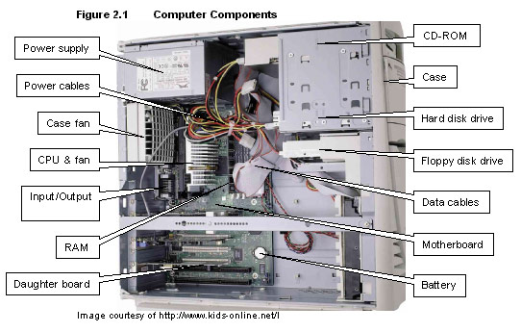
  - Power Supply - The power supply comes with the case, but this component is mentioned separately since there are various types of power supplies. The one you should get depends on the requirements of your system. This will be discussed in more detail later
  - Motherboard - This is where the core components of your computer reside which are listed below. Also the support cards for video, sound, networking and more are mounted into this board.

    - Microprocessor - This is the brain of your computer. It performs commands and instructions and controls the operation of the computer.
    - Memory - The RAM in your system is mounted on the motherboard. This is memory that must be powered on to retain its contents.
    - Drive controllers - The drive controllers control the interface of your system to your hard drives. The controllers let your hard drives work by controlling their operation. On most systems, they are included on the motherboard, however you may add additional controllers for faster or other types of drives.

  - Hard disk drive(s) - This is where your files are permanently stored on your computer. Also, normally, your operating system is installed here.
  - CD-ROM drive(s) - This is normally a read only drive where files are permanently stored. There are now read/write CD-ROM drives that use special software to allow users to read from and write to these drives.
  - Floppy drive(s) - A floppy is a small disk storage device that today typically has about 1.4 Megabytes of memory capacity.
  - Other possible file storage devices include DVD devices, Tape backup devices, and some others.
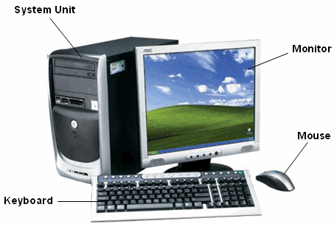
- Monitor - This device which operates like a TV set lets the user see how the computer is responding to their commands.
- Keyboard - This is where the user enters text commands into the computer.
- Mouse - A point and click interface for entering commands which works well in graphical environments.
4.Q. Is a computer more advance than a human being?

Ans:

Today’s world computer is a most powerful tools on the basis of data sharing. Our daily life is now dependent on various use of computer. And internet called the super power of the generation. By the computer daily work like as shopping , banking , any type of business, social networking and other work is being to make very simple. Its make the communication system is easy. It also buzzword the next world war is cyber war. So day by day computer will become powerful. But computer is controlled and managed by human. And it also up to date by human. Computer cannot continue by itself, it continue by the man. So we can say that computer is not more advance than a human being.

5.Q. Definition of data?

Ans:

• Factual information, especially information organized for analysis or used to reason or make decisions.
• Computer Science. Numerical or other information represented in a form suitable for processing by computer.
• Values derived from scientific experiments.
• Plural of datum

Q. Definition of information?

Ans:

Information is a data that is organized, has meaning and is useful. Examples are reports, news, letter etc.

6.Q. Difference between data and information?

Ans:

Here given the difference between data and information:

1.a. data is a collection of unorganized facts which can include words, number, image and sounds computer manipulate and process data to create information.
b. information is a data that is organized has meaning and useful.

2. a. Facts, statistics used for reference or analysis.
b. Knowledge derived from study, experience (by the senses), or instruction.

3. a. Data is a representation of information.
b. information is the exchangeable knowledge .

4. data is the primary facts.
b. information is the secondary facts.

5.a. Data must be interpreted, by a human or machine, to derive meaning
b. information is interpreted data"

7.Q. Explain the computer generation?
Ans:
Computer generation:

The history of computer development is often referred to in reference to the different generations of computing devices. A generation refers to the state of improvement in the product development process. This term is also used in the different advancements of new computer technology. With each new generation, the circuitry has gotten smaller and more advanced than the previous generation before it. As a result of the miniaturization, speed, power, and computer memory has proportionally increased. New discoveries are constantly being developed that affect the way we live, work and play.
Each generation of computers is characterized by major technological development that fundamentally changed the way computers operate, resulting in increasingly smaller, cheaper, more powerful and more efficient and reliable devices. Read about each generation and the developments that led to the current devices that we use today.

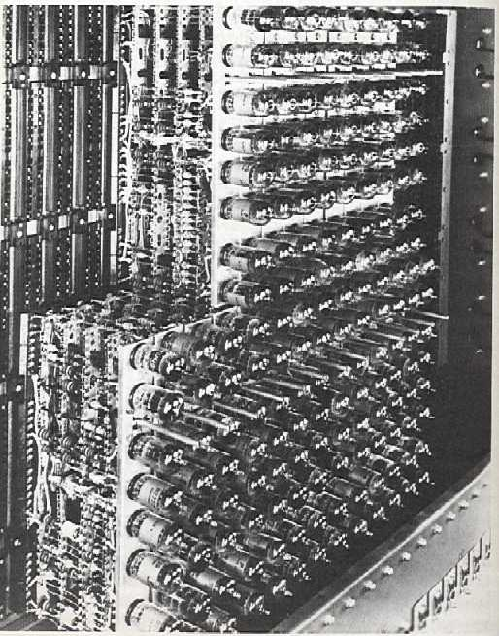
First Generation - 1940-1956: Vacuum Tubes
The first computers used vacuum tubes for circuitry and magnetic drums for memory, and were often enormous, taking up entire rooms. A magnetic drum,also referred to as drum, is a metal cylinder coated with magnetic iron-oxide material on which data and programs can be stored. Magnetic drums were once use das a primary storage device but have since been implemented as auxiliary storage devices.
The tracks on a magnetic drum are assigned to channels located around the circumference of the drum, forming adjacent circular bands that wind around the drum. A single drum can have up to 200 tracks. As the drum rotates at a speed of up to 3,000 rpm, the device's read/write heads deposit magnetized spots on the drum during the write operation and sense these spots during a read operation. This action is similar to that of a magnetic tape or disk drive.
They were very expensive to operate and in addition to using a great deal of electricity, generated a lot of heat, which was often the cause of malfunctions. First generation computers relied on machine language to perform operations, and they could only solve one problem at a time. Machine languages are the only languages understood by computers. While easily understood by computers, machine languages are almost impossible for humans to use because they consist entirely of numbers. Computer Programmers, therefore, use either high level programming languages or an assembly language programming. An assembly language contains the same instructions as a machine language, but the instructions and variables have names instead of being just numbers.
Programs written in high level programming languages retranslated into assembly language or machine language by a compiler. Assembly language program retranslated into machine language by a program called an assembler (assembly language compiler).
Every CPU has its own unique machine language. Programs must be rewritten or recompiled, therefore, to run on different types of computers. Input was based onpunch card and paper tapes, and output was displayed on printouts.
The UNIVAC and ENIAC computers are examples of first-generation computing devices. The UNIVAC was the first commercial computer delivered to a business client, the U.S. Census Bureau in 1951.
Acronym for Electronic Numerical Integrator And Computer, the world's first operational electronic digital computer, developed by Army Ordnance to compute World War II ballistic firing tables. The ENIAC, weighing 30 tons, using 200 kilowatts of electric power and consisting of 18,000 vacuum tubes,1,500 relays, and hundreds of thousands of resistors,capacitors, and inductors, was completed in 1945. In addition to ballistics, the ENIAC's field of application included weather prediction, atomic-energy calculations, cosmic-ray studies, thermal ignition,random-number studies, wind-tunnel design, and other scientific uses. The ENIAC soon became obsolete as the need arose for faster computing speeds.

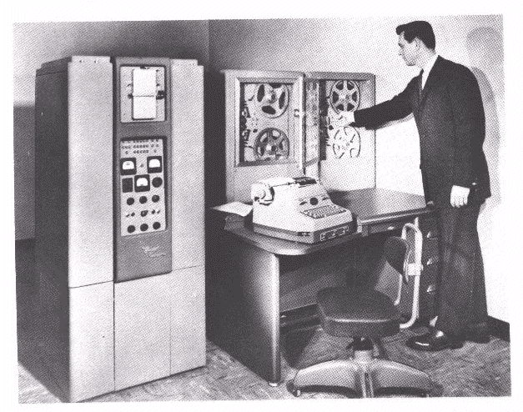
Second Generation - 1956-1963: Transistors
Transistors replaced vacuum tubes and ushered in the second generation computer. Transistor is a device composed of semiconductor material that amplifies a signal or opens or closes a circuit. Invented in 1947 at Bell Labs, transistors have become the key ingredient of all digital circuits, including computers. Today's latest microprocessor contains tens of millions of microscopic transistors.
Prior to the invention of transistors, digital circuits were composed of vacuum tubes, which had many disadvantages. They were much larger, required more energy, dissipated more heat, and were more prone to failures. It's safe to say that without the invention of transistors, computing as we know it today would not be possible.
The transistor was invented in 1947 but did not see widespread use in computers until the late 50s. The transistor was far superior to the vacuum tube, allowing computers to become smaller, faster, cheaper, more energy-efficient and more reliable than their first-generation predecessors. Though the transistor still generated a great deal of heat that subjected the computer to damage, it was a vast improvement over the vacuum tube. Second-generation computers still relied on punched cards for input and printouts for output.
Second-generation computers moved from cryptic binary machine language to symbolic, or assembly, languages, which allowed programmers to specify instructions in words. High-level programming languages were also being developed at this time, such as early versions of COBOL and FORTRAN. These were also the first computers that stored their instructions in their memory, which moved from a magnetic drum to magnetic core technology.
The first computers of this generation were developed for the atomic energy industry.

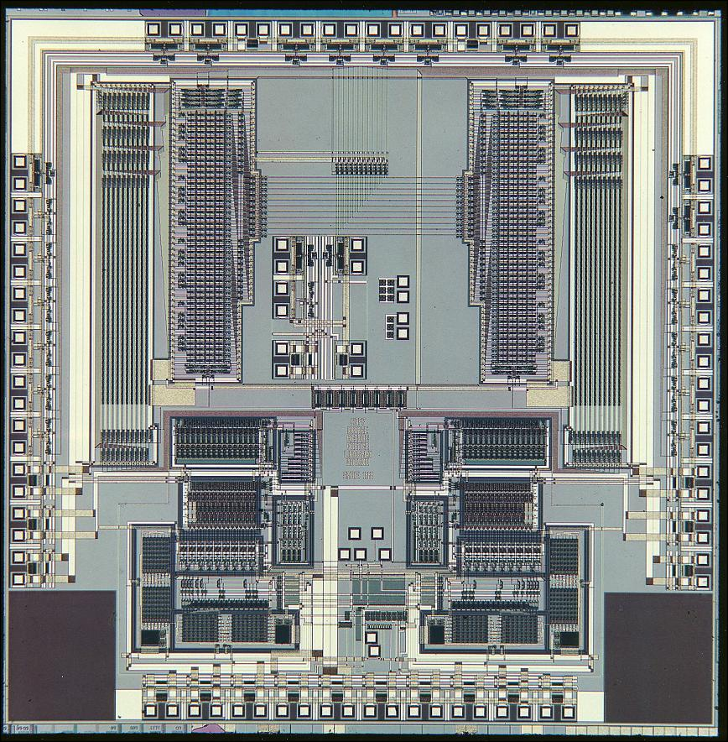
Third Generation - 1964-1971: Integrated Circuits
The development of the integrated circuit was the hallmark of the third generation of computers. Transistors were miniaturized and placed on silicon chips, called semiconductors, which drastically increased the speed and efficiency of computers.
A nonmetallic chemical element in the carbon family of elements. Silicon - atomic symbol "Si" - is the second most abundant element in the earth's crust, surpassed only by oxygen. Silicon does not occur uncombined in nature. Sand and almost all rocks contain silicon combined with oxygen, forming silica. When silicon combines with other elements, such as iron, aluminum or potassium, a silicate is formed. Compounds of silicon also occur in the atmosphere, natural waters, many plants and in the bodies of some animals.
Silicon is the basic material used to make computer chips, transistors, silicon diodes and other electronic circuits and switching devices because its atomic structure makes the element an ideal semiconductor. Silicon is commonly doped, or mixed, with other elements, such as boron, phosphorous and arsenic, to alter its conductive properties.
A chip is a small piece of semi conducting material(usually silicon) on which an integrated circuit is embedded. A typical chip is less than ¼-square inches and can contain millions of electronic components(transistors). Computers consist of many chips placed on electronic boards called printed circuit boards. There are different types of chips. For example, CPU chips (also called microprocessors) contain an entire processing unit, whereas memory chips contain blank memory.
Semiconductor is a material that is neither a good conductor of electricity (like copper) nor a good insulator (like rubber). The most common semiconductor materials are silicon and germanium. These materials are then doped to create an excess or lack of electrons.
Computer chips, both for CPU and memory, are composed of semiconductor materials. Semiconductors make it possible to miniaturize electronic components, such as transistors. Not only does miniaturization mean that the components take up less space, it also means that they are faster and require less energy.
Instead of punched cards and printouts, users interacted with third generation computers through keyboards and monitors and interfaced with an operating system, which allowed the device to run many different applications at one time with a central program that monitored the memory. Computers for the first time became accessible to a mass audience because they were smaller and cheaper than their predecessors.

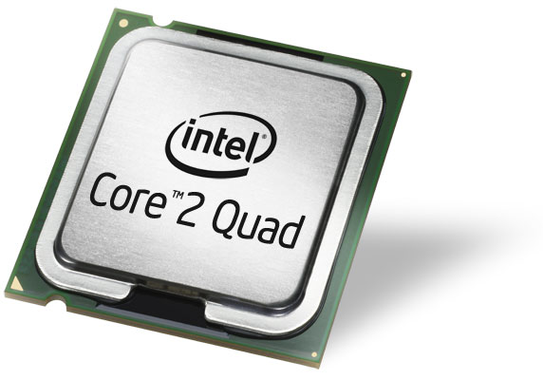
Fourth Generation - 1971-Present: Microprocessors
The microprocessor brought the fourth generation of computers, as thousands of integrated circuits we rebuilt onto a single silicon chip. A silicon chip that contains a CPU. In the world of personal computers, the terms microprocessor and CPU are used interchangeably. At the heart of all personal computers and most workstations sits a microprocessor. Microprocessors also control the logic of almost all digital devices, from clock radios to fuel-injection systems for automobiles.
Three basic characteristics differentiate microprocessors:
- Instruction Set: The set of instructions that the microprocessor can execute.

- Bandwidth: The number of bits processed in a single instruction.

- Clock Speed: Given in megahertz (MHz), the clock speed determines how many instructions per second the processor can execute.
In both cases, the higher the value, the more powerful the CPU. For example, a 32-bit microprocessor that runs at 50MHz is more powerful than a 16-bitmicroprocessor that runs at 25MHz.
What in the first generation filled an entire room could now fit in the palm of the hand. The Intel 4004chip, developed in 1971, located all the components of the computer - from the central processing unit and memory to input/output controls - on a single chip.
Abbreviation of central processing unit, and pronounced as separate letters. The CPU is the brains of the computer. Sometimes referred to simply as the processor or central processor, the CPU is where most calculations take place. In terms of computing power, the CPU is the most important element of a computer system.
On large machines, CPUs require one or more printed circuit boards. On personal computers and small workstations, the CPU is housed in a single chip called a microprocessor.
Two typical components of a CPU are:
- The arithmetic logic unit (ALU), which performs arithmetic and logical operations.

- The control unit, which extracts instructions from memory and decodes and executes them, calling on the ALU when necessary.
In 1981 IBM introduced its first computer for the home user, and in 1984 Apple introduced the Macintosh. Microprocessors also moved out of the realm of desktop computers and into many areas of life as more and more everyday products began to use microprocessors.
As these small computers became more powerful, they could be linked together to form networks, which eventually led to the development of the Internet. Fourth generation computers also saw the development of GUI's, the mouse and handheld devices

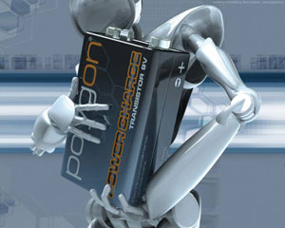
Fifth Generation - Present and Beyond: Artificial Intelligence
Fifth generation computing devices, based on artificial intelligence, are still in development, though there are some applications, such as voice recognition, that are being used today.
Artificial Intelligence is the branch of computer science concerned with making computers behave like humans. The term was coined in 1956 by John McCarthy at the Massachusetts Institute of Technology. Artificial intelligence includes:
- Games Playing: programming computers to play games such as chess and checkers

- Expert Systems: programming computers to make decisions in real-life situations (for example, some expert systems help doctors diagnose diseases based on symptoms)

- Natural Language: programming computers to understand natural human languages

- Neural Networks: Systems that simulate intelligence by attempting to reproduce the types of physical connections that occur in animal brains

- Robotics: programming computers to see and hear and react to other sensory stimuli
Currently, no computers exhibit full artificial intelligence (that is, are able to simulate human behavior). The greatest advances have occurred in the field of games playing. The best computer chess programs are now capable of beating humans. In May,1997, an IBM super-computer called Deep Blue defeated world chess champion Gary Kasparov in a chess match.
In the area of robotics, computers are now widely used in assembly plants, but they are capable only of very limited tasks. Robots have great difficulty identifying objects based on appearance or feel, and they still move and handle objects clumsily.
Natural-language processing offers the greatest potential rewards because it would allow people to interact with computers without needing any specialized knowledge. You could simply walk up to a computer and talk to it. Unfortunately, programming computers to understand natural languages has proved to be more difficult than originally thought. Some rudimentary translation systems that translate from one human language to another are in existence, but they are not nearly as good as human translators.
There are also voice recognition systems that can convert spoken sounds into written words, but they do not understand what they are writing; they simply take dictation. Even these systems are quite limited -- you must speak slowly and distinctly.
In the early 1980s, expert systems were believed to represent the future of artificial intelligence and of computers in general. To date, however, they have not lived up to expectations. Many expert systems help human experts in such fields as medicine and engineering, but they are very expensive to produce and are helpful only in special situations.
Today, the hottest area of artificial intelligence is neural networks, which are proving successful in an umber of disciplines such as voice recognition and natural-language processing.
There are several programming languages that are known as AI languages because they are used almost exclusively for AI applications. The two most common are LISP and Prolog.

8.Q. Feature of a computer?

Ans:
Now-a-days computer is playing a main role in everyday life it has become the need of people just like television, telephone or other electronic devices at home. It solves the human problems very quickly as well as accurately. The important characteristics of a computer are described below:
1. Speed
The computer is a very high speed electronic device. The operations on the data inside the computer are performed through electronic circuits according to the given instructions. The data and instructions flow along these circuits with high speed that is close to the speed of light. Computer can perform million of billion of operations on the data in one second. The computer generates signals during the operation process therefore the speed of computer is usually measure in mega hertz (MHz) or gega hertz (GHz). It means million cycles units of frequency is hertz per second. Different computers have different speed.
2. Arithmetical and Logical Operations
A computer can perform arithmetical and logical operations. In arithmetic operations, it performs the addition, subtraction, multiplication and division on the numeric data. In logical operation it compares the numerical data as well as alphabetical data.
3. Accuracy
In addition to being very fast, computer is also very accurate device. it gives accurate output result provided that the correct input data and set of instructions are given to the computer. It means that output is totally depended on the given instructions and input data. If input data is in-correct then the resulting output will be in-correct. In computer terminology it is known as garbage-in garbage-out.
4. Reliability
The electronic components in modern computer have very low failure rate. The modern computer can perform very complicated calculations without creating any problem and produces consistent (reliable) results. In general, computers are very reliable. Many personal computers have never needed a service call. Communications are also very reliable and generally available whenever needed.
5. Storage
A computer has internal storage (memory) as well as external or secondary storage. In secondary storage, a large amount of data and programs (set of instructions) can be stored for future use. The stored data and programs are available any time for processing. Similarly information downloaded from the internet can be saved on the storage media.
6. Retrieving data and programs
The data and program stored on the storage media can be retrieved very quickly for further processing. It is also very important feature of a computer.
ssss7. Automation
A computer can automatically perform operations without interfering the user during the operations. It controls automatically different devices attached with the computer. It executes automatically the program instructions one by one.
8. Versatility
Versatile means flexible. Modern computer can perform different kind of tasks one by one of simultaneously. It is the most important feature of computer. At one moment your are playing game on computer, the next moment you are composing and sending emails etc. In colleges and universities computers are use to deliver lectures to the students. The talent of computer is dependent on the software.
9. Communications
Today computer is mostly used to exchange messages or data through computer networks all over the world. For example the information can be received or send throug the internet with the help of computer. It is most important feature of the modern information technology.
10. Diligence
A computer can continually work for hours without creating any error. It does not get tired while working after hours of work it performs the operations with the same accuracy as well as speed as the first one.
11. No Feelings
Computer is an electronic machine. It has no feelings. It detects objects on the basis of instructions given to it. Based on our feelings, taste, knowledge and experience: we can make certain decisions and judgments in our daily life. On the other hand, computer can not make such judgments on their own. Their judgments are totally based on instructions given to them.
12. Consistency
People often have difficulty to repeat their instructions again and again. For example, a lecturer feels difficulty to repeat a same lecture in a class room again and again. Computer can repeat actions consistently (again and again) without loosing its concentration:
- To run a spell checker (built into a word processor) for checking spellings in a document.
- To play multimedia animations for training purposes.
- To deliver a lecture through computer in a class room etc.
A computer will carry out the activity with the same way every time. You can listen a lecture or perform any action again and again.
13. Precision
Computers are not only fast and consistent but they also perform operations very accurately and precisely. For example, in manual calculations and rounding fractional values (That is value with decimal point can change the actual result). In computer however, you can keep the accuracy and precision upto the level, you desire. The length calculations remain always accurate.

9.Q. use of computer?

Ans:

It consists of 2 parts-hardware and software . The computer processes input through input devices like mouse and keyboard. The computer displays output through output devices like color monitor and printer. The size of a computer varies considerably from very small to very big. The speed of computers also has a very large range. Computers have become indispensable in today’s world. Millions of people use computers all over the world.
There are several uses of computers: -
- Word Processing - Word Processing software automatically corrects spelling and grammar mistakes. If the content of a document repeats you don’t have to type it each time. You can use the copy and paste features. You can printout documents and make several copies. It is easier to read a word-processed document than a handwritten one. You can add images to your document.
- Internet - It is a network of almost all the computers in the world. You can browse through much more information than you could do in a library. That is because computers can store enormous amounts of information. You also have very fast and convenient access to information. Through E-Mail you can communicate with a person sitting thousands of miles away in seconds. There is chat software that enables one to chat with another person on a real-time basis. Video conferencing tools are becoming readily available to the common man.
- Digital video or audio composition – Audio or video composition and editing have been made much easier by computers. It no longer costs thousands of dollars of equipment to compose music or make a film. Graphics engineers can use computers to generate short or full-length films or even to create three-dimensional models. Anybody owning a computer can now enter the field of media production. Special effects in science fiction and action movies are created using computers.
- Desktop publishing - With desktop publishing, you can create page layouts for entire books on your personal computer.
- Computers in Medicine - You can diagnose diseases. You can learn the cures. Software is used in magnetic resonance imaging to examine the internal organs of the human body. Software is used for performing surgery. Computers are used to store patient data.
- Mathematical Calculations - Thanks to computers, which have computing speeds of over a million calculations per second we can perform the biggest of mathematical calculations.
- Banks - All financial transactions are done by computer software. They provide security, speed and convenience.
- Travel - One can book air tickets or railway tickets and make hotel reservations Telecommunications - Software is widely used here. Also all mobile phones have software embedded in them.
- Defense - There is software embedded in almost every weapon. Software is used for controlling the flight and targeting in ballistic missiles. Software is used to control access to atomic bombs.
- E-Learning – Instead of a book it is easier to learn from an E-learning software.
- Gambling-You can gamble online instead of going to a casino.
- Examinations-You can give online exams and get instant results. You can check your examination results online.
- Computers in Business - Shops and supermarkets use software, which calculate the bills. Taxes can be calculated and paid online. Accounting is done using computers. One can predict future trends of business using artificial intelligence software. Software is used in major stock markets. One can do trading online. There are fully automated factories running on software.
- Certificates - Different types of certificates can be generated. It is very easy to create and change layouts.
- ATM machines - The computer software authenticates the user and dispenses cash.
- Marriage - There are matrimonial sites through which one can search for a suitable groom or bride.
- News-There are many websites through which you can read the latest or old news.
- Classmates-There are many alumni websites through which you can regain contact with your classmates.
- Robotics - Robots are controlled by software.
- Washing Machines - They operate using software.
- Microwave Oven - They are operated by software.
- Planning and Scheduling - Software can be used to store contact information, generating plans, scheduling appointments and deadlines.
- Plagiarism - Software can examine content for plagiarism.
- Greeting Cards - You can send and receive greetings pertaining to different occasions.
- Sports – Software is used for making umpiring decisions. There are simulation software using which a sportsperson can practice his skills. Computers are also to identify flaws in techhnique.
- Aeroplanes – Pilots train on software, which simulates flying.
- Weather analysis – Supercomputers are used to analyze and predict weather.
Computers have leapfrogged the human society into another league. It is used in each and every aspect of human life. They will spearhead the human quest of eradicating social problems like illiteracy and poverty. It is difficult to imagine a world bereft of computers. This revolutionary technology is indeed a boon to the human race. May computers continue to shower their blessings to us.

10.Q. History of computer?

Ans:

The History of the Computer
Prehistoric man did not have the Internet, but it appears that he needed a way to count and make calculations. The limitations of the human body’s ten fingers and ten toes apparently caused early man to construct a tool to help with those calculations. Scientists now know that humankind invented an early form of computers. Their clue was a bone carved with presume numbers found in 8,500 BC.
The abacus was the next leap forward in computing between 1000 BC and 500 BD. This apparatus used a series of moveable beads or rocks. The positions changed to enter a number and again to perform mathematical operations. Leonardo DaVinci was credited with the invention of the world’s first mechanical calculator in 1500. In 1642, Blaise Pascal’s adding machine upstaged DaVinci’s marvel and moved computing forward again.
In 19th century England, Charles Babbage, a mathematician, proposed the construction of a machine that he called the Babbage Difference Engine. It would not only calculate numbers, it would also be capable of printing mathematical tables. The Computer History Museum in Mountain View, CA (near San Diego) built a working replica from the original drawings. Visitors can see in the device in operation there. Unable to construct the actual device, he earned quite a few detractors among England’s literate citizens. However, Babbage made a place for himself in history as the father of computing. Not satisfied with the machines limitations, he drafted plans for the Babbage Analytical Engine. He intended for this computing device to use punch cards as the control mechanism for calculations. This feature would make it possible for his computer to use previously performed calculations in new ones.
Babbage’s idea caught the attention of Ada Byron Lovelace who had an undying passion for math. She also saw possibilities that the Analytical Machine could produce graphics and music. She helped Babbage move his project from idea to reality by documenting how the device would calculate Bernoulli numbers. She later received recognition for writing the world’s first computer program. The United States Department of Defense named a computer language in her honor in 1979.
The computers that followed built on each previous success and improved it. In 1943, the first programmable computer Turing COLOSSUS appeared. It was pressed into service to decipher World War II coded messages from Germany. ENIAC, the brain, was the first electronic computer, in 1946. In 1951, the U.S. Census Bureau became the first government agency to buy a computer, UNIVAC .
The Apple expanded the use of computers to consumers in 1977. The IBM PC for consumers followed closely in 1981, although IBM mainframes were in use by government and corporations.
- 8,500 BC Bone carved with prime numbers found
- 1000 BC to 500 BC Abacus invented
- 1642 Blaise Pascal’s invented adding machine, France
- 1822 Charles Babbage drafted Babbage Difference Engine, England
- 1835 Babbage Analytical Engine proposed, England
- 1843 Ada Byron Lovelace computer program to calculate Bernoulli numbers, England
- 1943 Turing COLOSSUS the first programmable computer, England
- 1946 ENIAC first electronic computer, U.S.A.
- 1951 UNIVAC first computer used by U.S. government, U.S.A.
- 1969 ARPANET Department of Defense lays groundwork for Internet, U.S.A.
- 1968 Gordon Moore and Robert Noyce found in Intel, U.S.A.
- 1977 Apple computers for consumers sold, U.S.A.
- 1981 IBM personal computers sold, U.S.A.
- 1991 World Wide Web consumer Internet access, CERN, Tim Berners-Lee Switzerland/France
- 2000 Y 2K Bug programming errors discovered
- Current Technologies include word processing, games, email, maps, and streaming
The development of network technology and increases in processing capabilities for microcomputers made consumer Internet use possible by 1991. The computer evolution since then continues. New uses emerge every year.

