According to Miklos et al. (2001), Q is the quality factor of the resonance. If the modulation of the frequency is equal to one of the acoustical eignefunctions of the cavity, the energy from multiple modulation cycles will accumulate in a standing wave and the cavity will act as an acoustic amplifier (almost word-for-word from the reference, p. 1941). At the resonance frequency, the amplitude will be Q_{n} times larger than the amplitude far from the frequency.
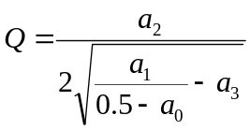
or the product of 2π and the energy accumulated over the energy lost in one period. This can also be written as
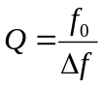
where Δf is half-width of the resonance profile. The half-width is measured where the amplitude is 1/√2 that at the resonant frequency (f₀).

