Can task-evoked brain activity separate adults with dyslexia from typical readers?
A nested cross-validated, feature-selection analysis of 7T motor-imagery fMRI
G. Cannavacciuolo · DESU DS · 3 October 2026 · Code: https://github.com/lo-g-os/DESU-DS-Project

Abstract
The main question addressed was whether the pattern of task-evoked activation across 97 atlas regions separates adults with developmental dyslexia (DYS) from typical readers (TYP) in two 7T motor-imagery tasks: imagined gait (N = 36; 16 DYS, 20 TYP) and imagined articulation (N = 32; 17 DYS, 15 TYP). Six model families were evaluated with nested cross-validation over 10 seeds, every fitted step refitted inside the training folds, and permutation tests of the whole pipeline. For articulation, linear models using all features reached balanced accuracies of 0.70–0.76 (AUC 0.73–0.81; p = .015–.035), but every 95% fold interval reached 0.50, so the pre-specified criterion was not met; gait was at chance. Feature selection never helped (pre-specified SFS test p = .19 and .17), and accuracy rose with the number of features, indicating a distributed signal. With shuffled labels the 97-feature model also fitted its training data perfectly while out-of-fold accuracy stayed near chance, so overfitting inflated training accuracy, whereas it did not affect the reported estimates. Selection outside the folds raised accuracy on pure noise to 0.66–0.90. Estimates refer to unseen participants of this sample (i.e., not validated on external cohorts) and fold intervals span approximately ±0.3.

1. Introduction
Developmental dyslexia is defined by reading difficulties, yet affected individuals often show subtle sensorimotor differences (Cannavacciuolo et al., 2026). Sensorimotor representations can be operationalised via motor imagery paradigms (Marchetti et al., 2022), relying on internal (i.e., forward) models of action without movement execution (i.e, isolating motor component and sensory prediction). In the companion univariate analyses of this dataset (GLM fitting on 7T task-based data), imagined gait and imagined articulation revealed region-level group differences across cortical, subcortical, and cerebellar regions. Univariate tests, however, examine one location at a time so that multivariate analyses can address whether the pattern of activation across the brain carry information about group membership (adults with or without dyslexia). Cross-validated accuracy therefore refers to participants of this sample held out from training (same population, scanner and protocol), not to external cohorts.
From a data-science perspective, the problem has three defining properties; firstly, a small sample (32–36 participants per task) described by 97 regional features, leading to a feature-to-sample ratio near 3:1, mildly imbalanced classes (16/20 and 17/15), and nuisance variables (age, head motion, usable runs) that could separate the groups on their own. Optimistic bias is to be identified as a central risk given that with this ratio, any leak of label information into a fitted step could produce high accuracy on noise so that even a correct pipeline gives very uncertain estimates. Hence nested cross-validation, small, fixed grids, permutation inference for every result, explicit confound control, and intervals on every estimate were performed. Similarly, dilution was an additional primary concern due to 97 features potentially hiding group differences concentrated in a few regions (vs the whole brain). We therefore tested whether feature selection, fitted strictly inside the training folds, improved held-out performance, and ran the same selection outside the folds, the most common circularity error in small-sample neuroimaging, as a labelled demonstration of the optimism it produces.

2. Materials and methods

2.1 Participants and data
Adults with developmental dyslexia and typical readers completed one 7T session (Siemens Terra) with two motor-imagery paradigms, namely imagined walking along a broad or narrow path (gait), and imagined articulation of simple or complex pseudo-syllable sequences (articulation). Each task forms its own dataset, so every participant with usable data for a task contributes to it, with final samples for gait N = 36 (16 DYS, 20 TYP) and articulation N = 32 (17 DYS, 15 TYP). Preprocessing (fMRIPrep 24.0.0) and the first-level GLM(SPM12; onsets aligned to scan start; canonical haemodynamic response; 24 motion, 6 aCompCor and spike regressors) produced one contrast image per participant and task. These steps are label-free and applied per participant, so they cannot leak group information across folds.

2.2 Feature construction
Features were regional means within a fixed anatomical atlas: 48 cortical and 15 subcortical regions (Harvard-Oxford) and 34 cerebellar lobules and nuclei (Diedrichsen atlas, after cerebellum-specific normalisation), giving 97 features per task. One contrast per task was used, chosen in advance to isolate imagery, including gait imagery vs baseline, and imagined articulation vs baseline. Atlas regions, unlike PCA, are fixed independently of the data and remain interpretable. Regional means were computed over voxels with data only, and each value's coverage was recorded. Values covering under 50% of their region were set to missing (3.8% of cells for gait, 3.6% for articulation, concentrated in inferior temporal cortex and posterior cerebellum) and imputed inside the pipeline with the training-fold median.

2.3 Pipeline and leakage control
All label-dependent or data-fitted steps form one scikit-learn Pipeline: median imputation, confound residualisation (optional), standardisation, feature selection (optional), and classifier (Figure 1). The whole Pipeline is refitted on every training fold and only applied to the corresponding test fold, so no step ever sees held-out participants. Confound residualisation regresses each feature on the confounds within the training fold and applies those coefficients to the test fold. Each analysis was run in a raw and a confound-controlled variant, reported side by side.
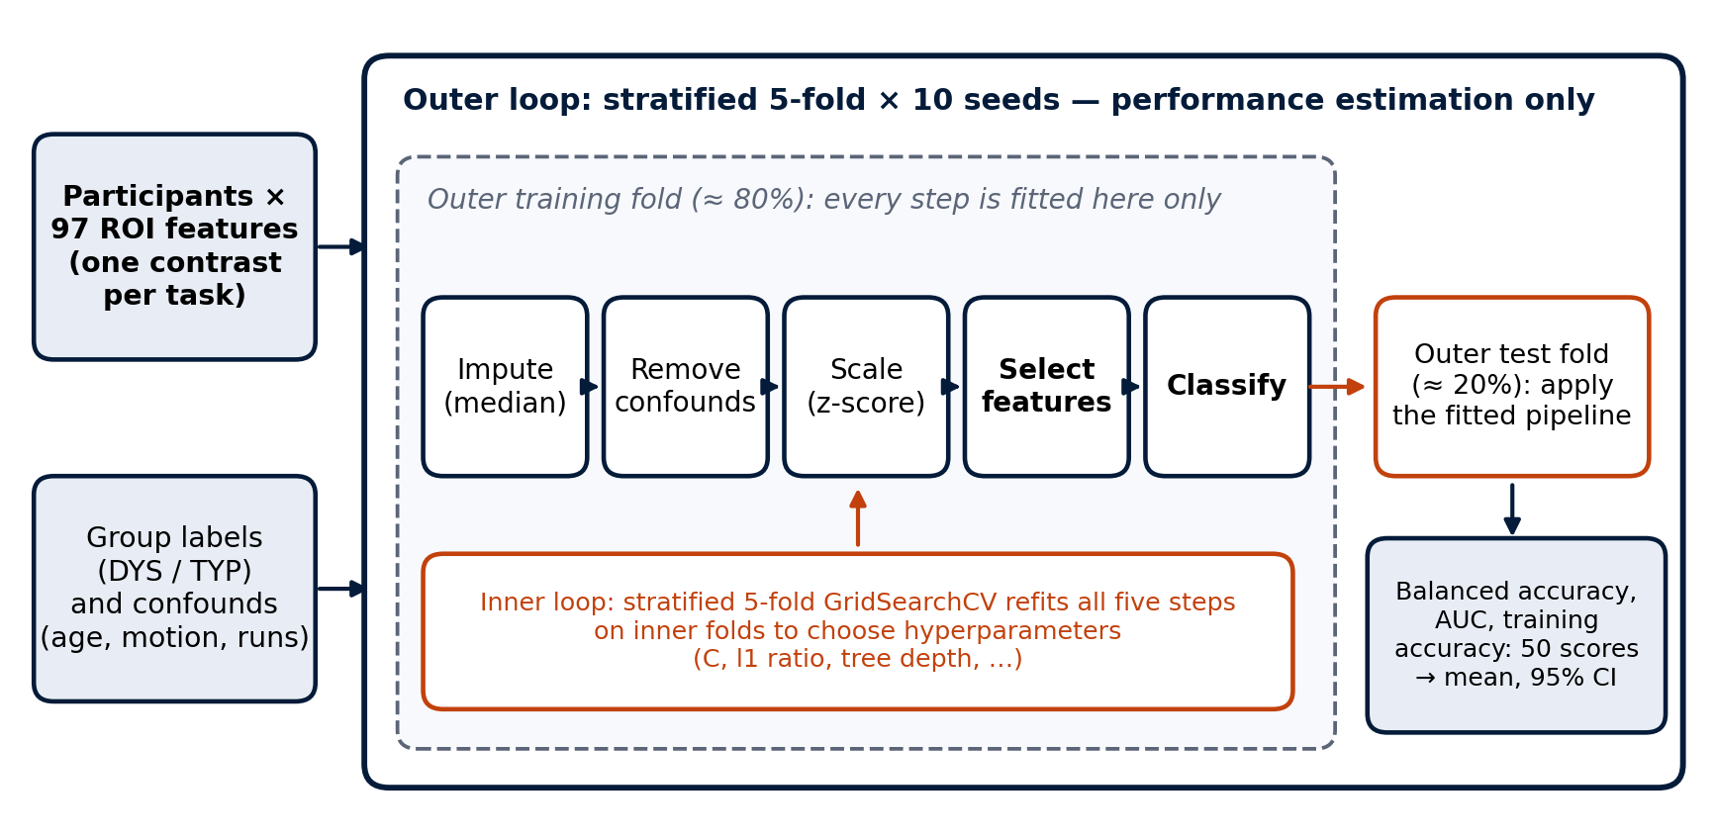
Figure 1. Nested cross-validation. Every fitted step (imputation, confound removal, scaling, feature selection and the classifier, with its hyperparameters chosen by an inner cross-validation) is estimated on the outer training fold only. The outer test fold is used once, for scoring. The procedure is repeated over 10 random fold assignments.

2.4 Feature selection
Three selection families were compared, each fitted inside the folds, including a filter (SelectKBest, ANOVA F), recursive feature elimination (RFE, ranking by L2 logistic coefficients, one feature removed per step), and forward sequential feature selection (SFS), which adds the feature that most improves balanced accuracy in its own internal 5-fold CV. SFS and the filter used k = 5 and 10, bracketing the common heuristic of about √N features (≈ 6 here), with the RFE curve likewise including k = 5 and 8. Data-driven reduction was the primary approach, with the pre-specified headline test being SFS with k = 10. The feature-count curve used RFE at k ∈ {1, 2, 3, 5, 8, 10, 15, 20, 30, 50, 97}, with C fixed at the modal value of the unselected model (a documented approximation). Under dilution, accuracy should peak at small k, whereas under a distributed or absent signal, it should stay flat or decline as k falls. Selection frequency of each region across the 50 outer folds measured stability.

2.5 Models and hyperparameters
Six model families spanning a range of capacity were compared (Table 1). Grids were deliberately coarse and fixed before any result was seen, because fine grids at this N tune to noise in the inner folds.
Table 1. Model families and hyperparameter grids. With SFS and RFE, the selector's internal model shares the classifier's C.
Model | Role | Grid (inner 5-fold CV)
L2 logistic regression | Primary | C ∈ {0.001, 0.01, 0.1, 1, 10}
Linear SVM | Primary | C ∈ {0.001, 0.01, 0.1, 1, 10}
Elastic-net logistic | Secondary (sparse) | C as above × l1 ratio ∈ {0.1, 0.5, 0.9}
Random forest (300 trees) | Exploratory | max depth ∈ {None, 5, 10}
Decision tree | Complexity ladder | max depth ∈ {2, 3, 5, None} × min leaf ∈ {1, 3, 5}
Gradient boosting | Complexity ladder | depth ∈ {2, 3} × learning rate ∈ {0.01, 0.1} × trees ∈ {50, 100}

2.6 Validation, metrics and inference
Performance was estimated with nested cross-validation: an outer stratified 5-fold split repeated over 10 seeds (50 outer test folds) and an inner stratified 5-fold grid search within each outer training fold. The primary metric was balanced accuracy, which is insensitive to class imbalance (chance = 0.5); ROC-AUC was reported alongside. Each estimate is the mean over the 50 outer folds with a 95% interval from their 2.5th–97.5th percentiles. Training-fold balanced accuracy was recorded for every fold, and the mean train–test gap was used as a descriptive index of overfitting. Significance was assessed by label permutation, with group labels shuffled and the complete nested pipeline, including selection and hyperparameter search, being refitted. This used 500 permutations for the two pre-specified headline configurations (SFS, L2 logistic, k = 10, confound-controlled, one per task) and 200 for the other configurations. A result counts as positive only if both the permutation p < .05 and the 95% interval excludes 0.5. With more features than training participants, a perfect training fit is guaranteed, so training accuracy carries no information about signal. Overfitting of the all-feature L2 model was therefore examined against shuffled labels (repeated stratified 5-fold, 10 repeats), training and validation balanced accuracy and log-loss across the L2 penalty, learning curves with C re-tuned at each training-set size, the inner-CV choice of C, and the correlation of coefficient vectors between training folds, each on real and on shuffled labels. Analogous curves for the 10 best features, gradient boosting and decision trees are in the notebook. None was used to choose a reported configuration.

2.7 Demonstration of selection leakage
Feature selection (filter, k = 5 and 10) was run inside the folds (arm A, correct) and once on all participants before cross-validation (arm B, a deliberate error), on the real features and on Gaussian noise of the same shape and missingness. Arm B was tested against a null that keeps the leaked selection fixed and one that repeats it on every permutation. Arm B is a demonstration only.

2.8 Confounds and software
Candidate confounds (age, sex, motion-outlier volumes in the task run, usable runs) were tested for a group difference and for classifying group on their own with the same nested procedure; age, motion and usable runs were residualised in the controlled variant. Software: Python 3.12.2, scikit-learn 1.7.2, NumPy 1.26.4, pandas 2.3.3, SciPy 1.11.4. Code, README and environment file: https://github.com/lo-g-os/DESU-DS-Project. No participant data are shared due to ethical reasons.

3. Results

3.1 Sample, features and confounds
The feature matrices are 36 × 97 (gait) and 32 × 97 (articulation), with 3.8% and 3.6% of values missing after the coverage rule. In the gait sample, DYS participants were younger than TYP (median 21 vs 24 years, p = .007), and age alone classified group above chance (balanced accuracy 0.69); this is why the confound-controlled variant matters for gait. In the articulation sample, no confound differed significantly between groups, although DYS participants had more motion-outlier volumes (median 33 vs 17, p = .08). No confound classified articulation group membership on its own (balanced accuracy 0.48–0.56; Table 2).
Table 2. Confound characterisation. p: Mann–Whitney (Fisher for sex). Alone (BA): balanced accuracy of a nested logistic classifier using only that variable (10 × 5-fold).
Confound | Gait: DYS / TYP | p | Alone (BA) | Articulation: DYS / TYP | p | Alone (BA)
Age (median, years) | 21 / 24 | .007 | 0.69 | 21 / 23 | .17 | 0.52
Motion-outlier volumes | 18 / 9 | .24 | 0.50 | 33 / 17 | .08 | 0.56
Usable runs | 2 / 2 | .02 | 0.60 | 2 / 2 | 1.0 | 0.50
Sex (% female) | 88 / 75 | .43 | 0.48 | 88 / 80 | .65 | 0.48

3.2 Reference model: all 97 features
The all-feature models are the reference against which data-driven selection was tested, not the primary analysis. For imagined articulation, the three linear models reached balanced accuracies of 0.75–0.76 in the raw variant (AUC 0.78–0.81) and 0.70–0.72 in the confound-controlled variant (Fig. 2). All six were permutation-significant (raw p = .015–.025, controlled p = .025–.035), but the 2.5th percentile of the fold scores was exactly 0.50 in the raw variant and 0.34–0.37 in the controlled variant, so by the pre-specified dual criterion no configuration counts as positive. For gait imagery, all configurations remained close to chance (0.47–0.61, every interval including 0.5; p = .13–.62). Tree-based models did not exceed the linear models in either task (articulation 0.49–0.62).
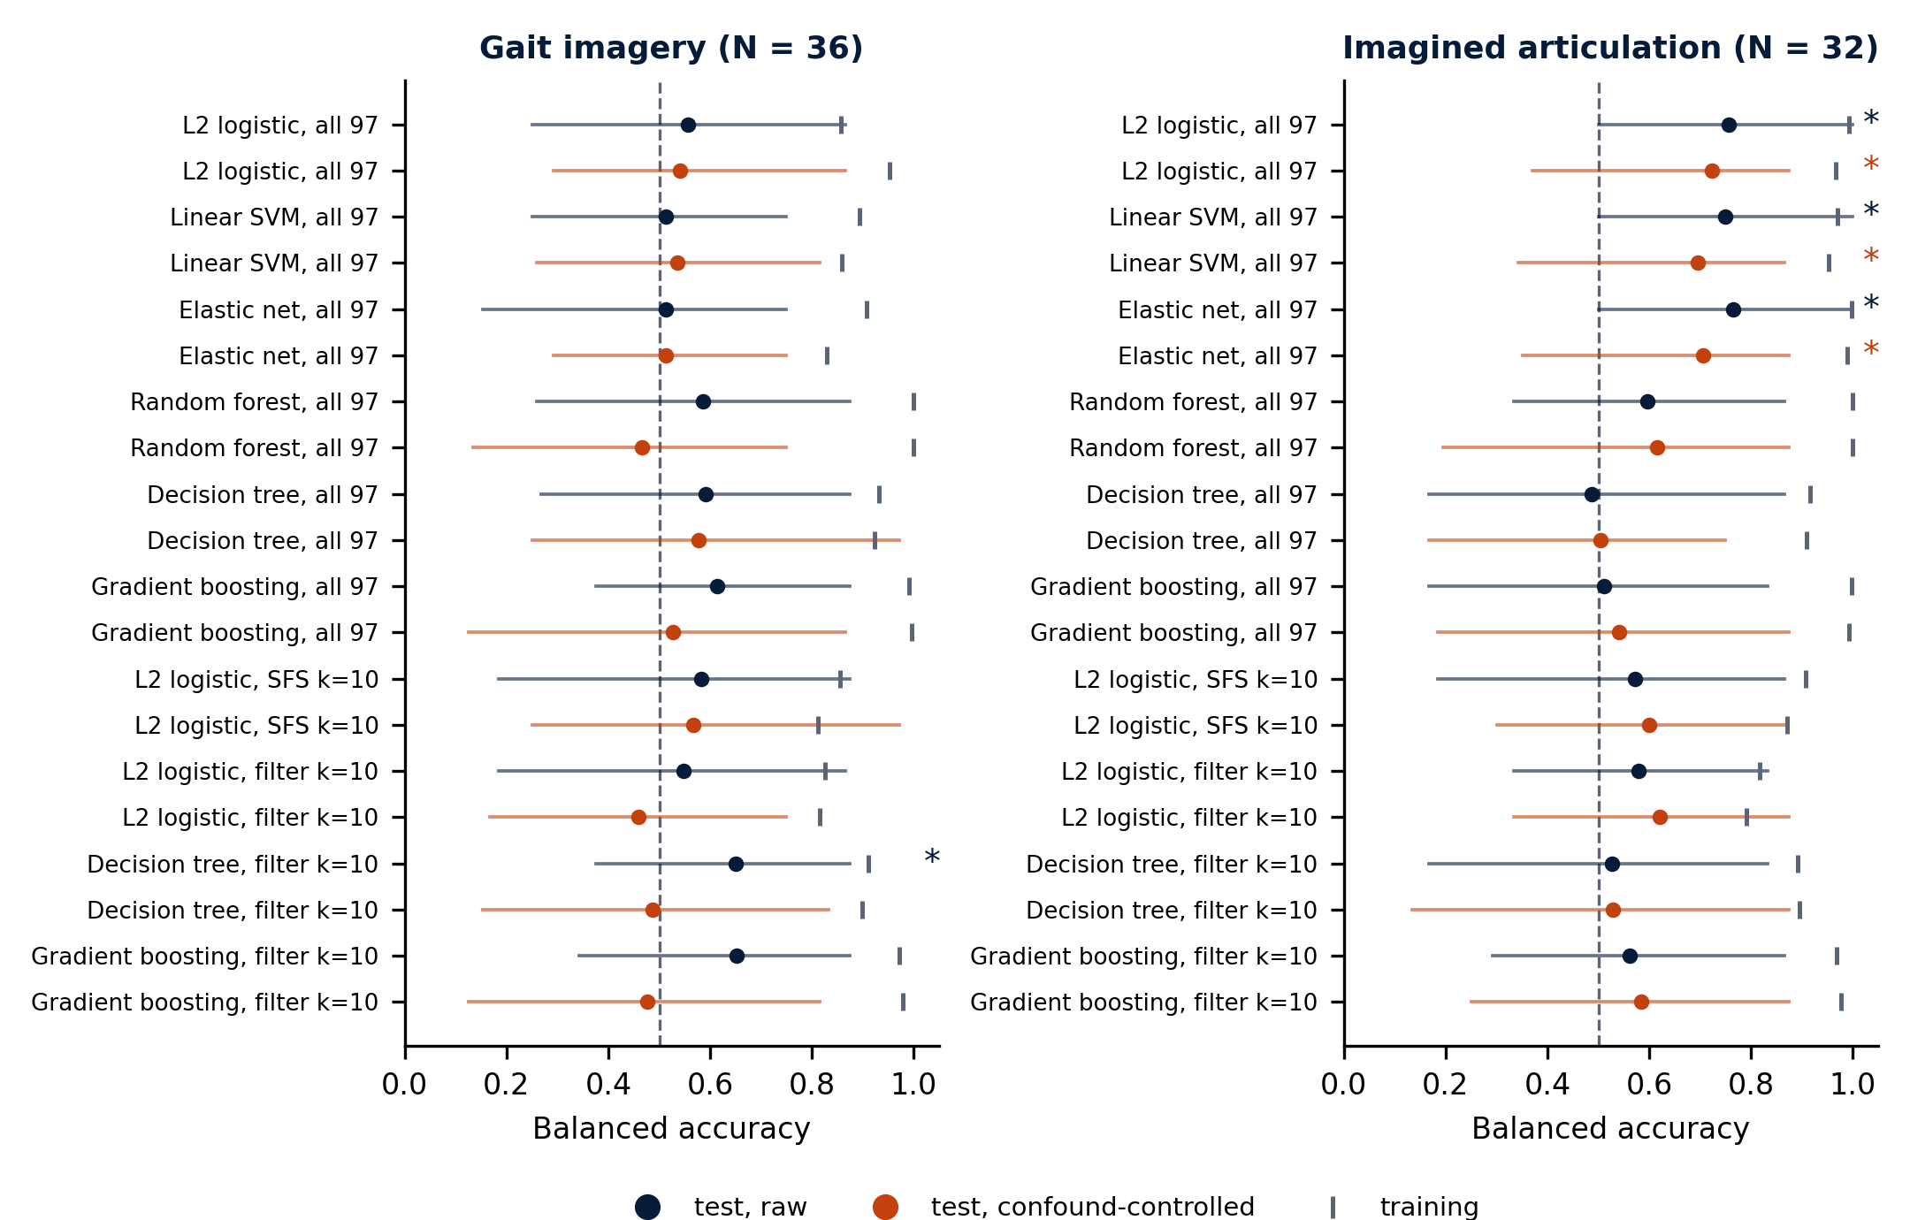
Figure 2. Held-out balanced accuracy (dots, mean of 50 outer folds; lines, 95% interval) and training balanced accuracy (ticks); navy, raw; orange, confound-controlled. All-feature models and k = 10 selection configurations (k = 5 in the notebook). Dashed line: chance. Asterisk: permutation p < .05.

3.3 Underfitting and overfitting
The train–test gap was 0.22–0.41 for the regularised linear models, 0.38–0.53 for random forest and gradient boosting, and 0.34–0.43 for single trees (Fig. 2). With 25–29 training participants and 97 features, the training data are linearly separable for almost any labelling, so near-perfect training accuracy is expected with or without signal. The diagnostics were therefore repeated with shuffled labels (Fig. 3). With shuffled labels, training accuracy reached 1.00 from C ≈ 0.3 in both tasks, while validation accuracy stayed near chance (0.46–0.55) at every C: the model memorises any labelling, but this does not leak into out-of-fold estimates. With real articulation labels, validation accuracy rose from 0.56 under strong regularisation (underfitting: both losses at the chance value of 0.69) to 0.76–0.78 for C ≥ 0.1, while validation log-loss was lowest (0.52) at C ≈ 0.3 and rose to 0.95 at C = 100. Weak regularisation thus overfits the predicted probabilities (overconfidence) but not the ranking of participants. The inner CV chose C = 0.1–1 in 37 of 50 outer folds. The learning curve rose from 0.52 with 8 training participants to 0.76 with 26 without a plateau, whereas the shuffled-label curve stayed at chance: the estimate is limited by variance, not bias. Coefficient vectors of training folds correlated at r = 0.82 (shuffled labels 0.70, from shared participants alone). Gait showed none of these signatures (validation accuracy 0.56 vs 0.51 shuffled; weight r 0.75 vs 0.77). On the 10 best features (notebook), validation loss was higher than with all 97 (articulation 0.64 vs 0.50), gradient boosting overfitted after 2–5 iterations, and trees gained nothing beyond depth 5. The all-feature model overfits its training data, as it must, but the out-of-fold estimates and the equally flexible permutation null absorb this.
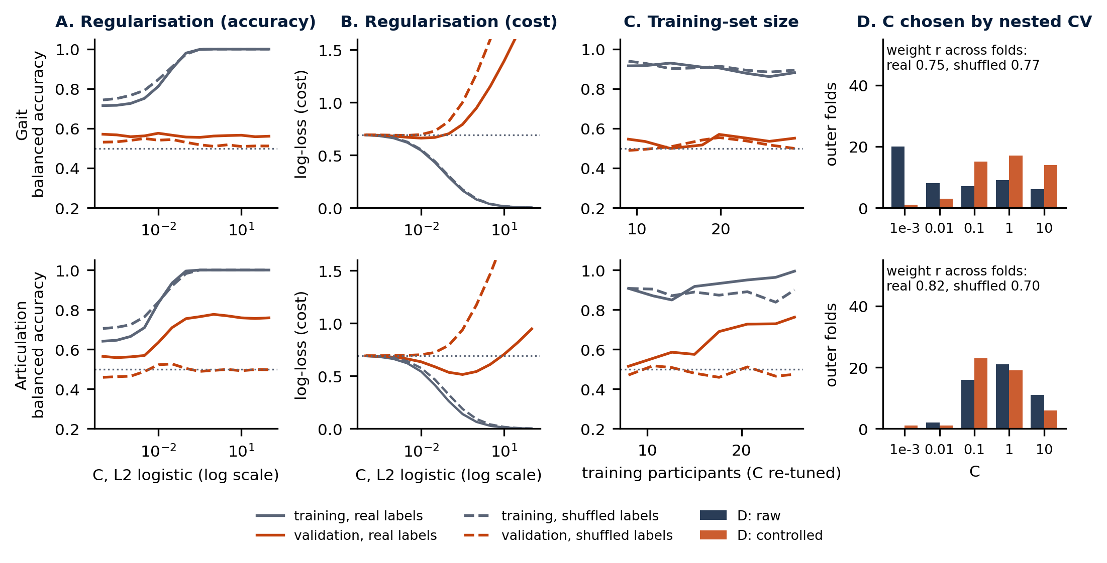
Figure 3. Diagnostics for the all-97-feature L2 logistic model (raw; repeated stratified 5-fold, 10 repeats). Solid: real labels; dashed: shuffled labels (new permutation per repeat). Grey: training; orange: validation. Dotted: chance (balanced accuracy 0.5, log-loss 0.69). Means over 50 splits; single folds spread by about ±0.3. (D) C chosen by the inner CV in each outer fold; inset, mean correlation of coefficient vectors between training folds of a repeat.

3.4 Does feature selection help?
At the size suggested by the √N heuristic (k = 5–8), no tested configuration reached p < .05: RFE 0.61–0.69 (p = .055–.16), filter 0.57–0.63 (p ≥ .095), SFS 0.58–0.60 (not permutation-tested). Forward SFS did not improve performance. In articulation it lowered balanced accuracy relative to using all features (0.57–0.62 at k = 5 or 10, against 0.70–0.76), and in gait it remained at chance (0.54–0.58). The pre-specified headline test (SFS, L2 logistic, k = 10, controlled, 500 permutations) was null in both tasks: gait 0.57 (p = .19), articulation 0.60 (p = .17). The filter did no better (articulation 0.57–0.63, p = .095–.22; gait 0.46–0.57, p ≥ .26). In articulation, the RFE curve (Fig. 4) rose with the number of retained features, from 0.52–0.53 at k = 1 to 0.73–0.78 at k = 50–97, and reached p < .05 only from k = 15 (raw) or k = 30 (controlled): the pattern predicted for a distributed signal, not for dilution. In gait, the controlled curve was flat at chance (0.49–0.54); in the raw variant only k = 1 reached 0.72 (p = .025), a single region (anterior middle temporal gyrus, selected in 94% of folds) that fell to 0.50 after confound control, consistent with the age difference between the gait groups. Taken together, the dilution hypothesis is not supported: the articulation signal is spread across many regions, and every selection method weakened it.
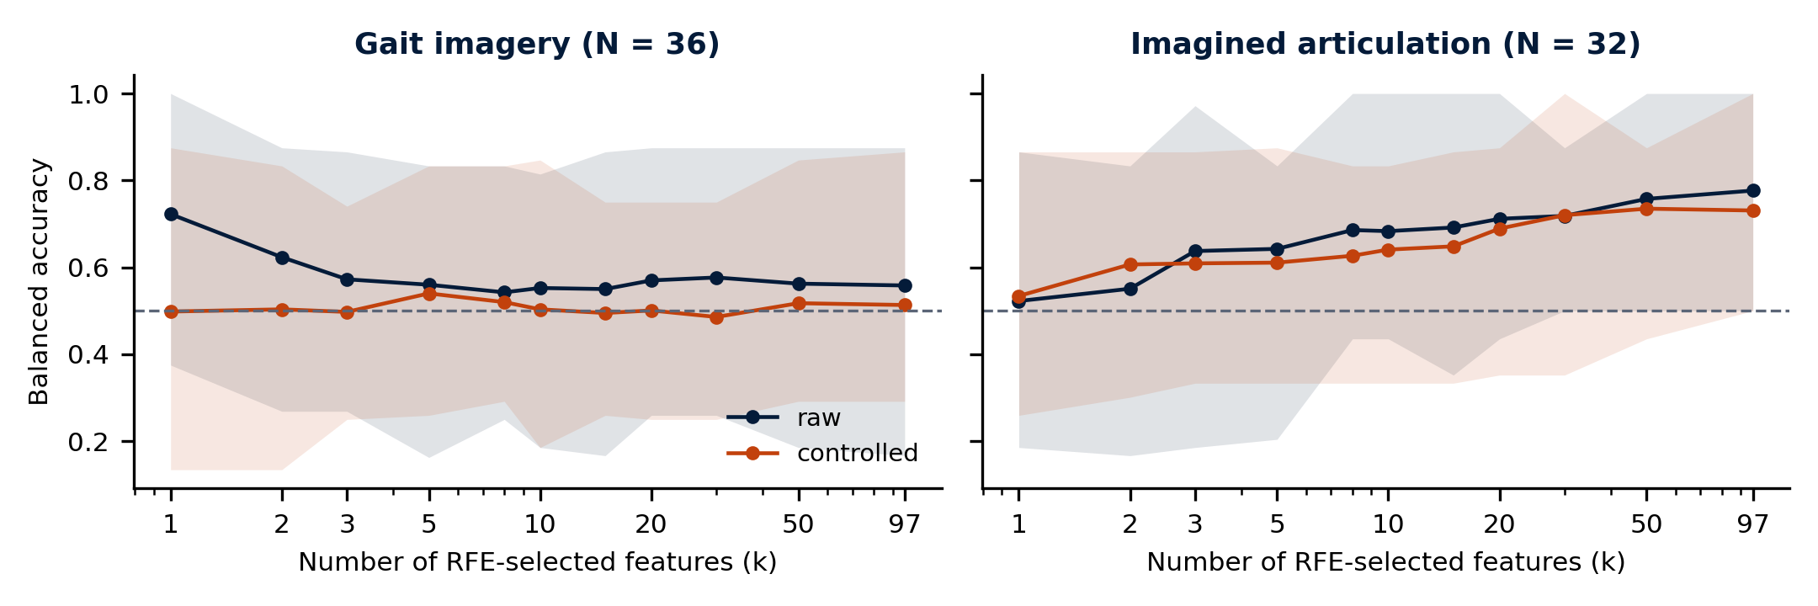
Figure 4. Balanced accuracy as a function of the number of features retained by RFE, refitted inside every training fold. Shaded band: 95% interval over 50 outer folds. Dashed line: chance.

3.5 Selection stability
Forward SFS was unstable: across the 50 outer folds it selected 69–96 of the 97 regions at least once, and only one region (gait, anterior middle temporal gyrus) was chosen in more than 62% of folds. The filter and RFE were more stable (at k = 10, 39–66 regions used, 2–9 chosen in at least half of the folds), but the methods agreed poorly: of the ten most frequently selected regions, SFS shared 1–5 with the filter or RFE. Regional identities are therefore not interpreted.

3.6 Demonstration: selection outside the folds
Selecting features once on all participants (arm B) raised balanced accuracy on the real features from 0.59–0.63 (arm A) to 0.71–0.85, and on pure noise from 0.51–0.57 to 0.66–0.90. Against the careless null that keeps the leaked selection fixed, every arm-B result on real data appeared significant (p = .005–.020); against the null that repeats the selection on every permutation, none did (p = .10–.63). Leakage therefore produces high and apparently significant accuracy even from noise, and only a null that reproduces the whole pipeline exposes it.

3.7 Error analysis
Out-of-fold predictions of the four all-feature linear configurations were recomputed with the same seeds. In articulation, the mean misclassification rate was 0.27 (8 of 32 participants never misclassified, 5 in at least 75% of seeds), and error rates were consistent across models and confound variants (Spearman ρ = 0.75–0.93). In gait, it was 0.45 (ρ = 0.45–0.88). Neither group was misclassified more often (articulation p = .62; gait p = .07), and error rate was not related to age, motion, motor competence (MABC-2) or reading fluency (|ρ| ≤ 0.35, all p ≥ .06).
Number of tests. Each task involved 53 permutation tests: 12 all-feature configurations, the SFS headline test, 4 filter, 8 model-ladder and 22 RFE configurations, and 6 for the leakage demonstration. A Bonferroni-equivalent threshold (p < .00047) lies below the smallest p attainable with 200 permutations (≈ .005), so no result would survive formal correction.

4. Discussion
Imagined articulation carries group information in its whole-brain activation pattern, but the evidence is modest: the all-feature linear models were above chance in three model families and both confound variants, permutation-significant, and supported by the learning-curve and weight-stability diagnostics, yet no configuration met the pre-specified dual criterion and none would survive correction. Gait imagery carried no detectable group information. Feature selection never helped, because the articulation signal is distributed, and selection outside the folds readily turned noise into apparent accuracy. Having more features than participants let every all-feature model fit its training data perfectly, but the permutation null has the same capacity, so the price was wide intervals rather than optimistic estimates. With 6–7 test participants per fold, fold-percentile intervals can include 0.5 even at a mean accuracy of 0.75, so the dual criterion was conservative by design. The same participants were misclassified by all linear models, unrelated to age, motion or behaviour, which points to heterogeneity within groups rather than a nuisance variable. This pattern fits the companion univariate analyses, which found articulation group differences spread over cortical, thalamic and cerebellar regions, but only few, focal effects for gait. Because all estimates refer to held-out participants of this sample, a distributed group difference in oromotor imagery is a hypothesis for an independent cohort.

5. Methodological perspectives
Uncertainty and model comparison. Fold percentiles describe the spread of fold scores, not the uncertainty of the mean; corrected resampled t-tests (Nadeau & Bengio, 2003) or a posterior of balanced accuracy (Brodersen et al., 2010) would give calibrated intervals and formal comparisons between configurations.
Stable selection and interpretable patterns. Stability selection (Meinshausen & Bühlmann, 2010) would retain only consistently chosen regions, and linear weights should be converted into activation patterns, with bootstrap intervals, before any anatomical reading (Haufe et al., 2014).
Both tasks and continuous targets. Nested stacking of the task-specific models would test whether the tasks carry complementary information; nested regression on motor or reading scores, or normative modelling of deviations from typical readers (Marquand et al., 2016), would address the heterogeneity that a binary split averages away.
Sample size and external validation. Pooling cohorts requires harmonisation fitted within the training folds (e.g. ComBat; Fortin et al., 2017); a pre-registered pipeline tested once on an untouched external sample is the strongest test.

References
Ambroise, C., & McLachlan, G. J. (2002). Selection bias in gene extraction on the basis of microarray gene-expression data. PNAS, 99, 6562–6566.
Brodersen, K. H., Ong, C. S., Stephan, K. E., & Buhmann, J. M. (2010). The balanced accuracy and its posterior distribution. Proc. ICPR, 3121–3124.
Cannavacciuolo, G., Marchetti, R., Vaugoyeau, M., Colé, P., Pinto, S., & Assaiante, C. (2026). Cross-domain spontaneous tempo differences in adults with developmental dyslexia: Evidence from speech and gait. Research in Developmental Disabilities, 175, 105319.
Cawley, G. C., & Talbot, N. L. C. (2010). On over-fitting in model selection and subsequent selection bias in performance evaluation. JMLR, 11, 2079–2107.
Diedrichsen, J., et al. (2009). A probabilistic MR atlas of the human cerebellum. NeuroImage, 46, 39–46.
Fortin, J.-P., et al. (2017). Harmonization of multi-site diffusion tensor imaging data. NeuroImage, 161, 149–170.
Guyon, I., Weston, J., Barnhill, S., & Vapnik, V. (2002). Gene selection for cancer classification using support vector machines. Machine Learning, 46, 389–422.
Haufe, S., et al. (2014). On the interpretation of weight vectors of linear models in multivariate neuroimaging. NeuroImage, 87, 96–110.
Kriegeskorte, N., Simmons, W. K., Bellgowan, P. S. F., & Baker, C. I. (2009). Circular analysis in systems neuroscience. Nature Neuroscience, 12, 535–540.
Marchetti, R., Vaugoyeau, M., Colé, P., & Assaiante, C. (2022). A sensorimotor representation impairment in dyslexic adults: A specific profile of comorbidity. Neuropsychologia, 165, 108134.
Marquand, A. F., Rezek, I., Buitelaar, J., & Beckmann, C. F. (2016). Understanding heterogeneity in clinical cohorts using normative models. Biological Psychiatry, 80, 552–561.
Meinshausen, N., & Bühlmann, P. (2010). Stability selection. JRSS B, 72, 417–473.
Nadeau, C., & Bengio, Y. (2003). Inference for the generalization error. Machine Learning, 52, 239–281.
Ojala, M., & Garriga, G. C. (2010). Permutation tests for studying classifier performance. JMLR, 11, 1833–1863.
Pedregosa, F., et al. (2011). Scikit-learn: Machine learning in Python. JMLR, 12, 2825–2830.
Varoquaux, G. (2018). Cross-validation failure: small sample sizes lead to large error bars. NeuroImage, 180, 68–77.

