Multivariate sensitivity analysis of task-fMRI activation in developmental dyslexia
Data Science / Machine Learning Diploma Project -- Written Report
[Author name] -- [Course/Programme] -- [Date]
Abstract
Does the pattern of task-evoked activation across the brain distinguish dyslexic (DYS) from typically-developing (TYP) adult readers, beyond single-region univariate contrasts? We tested this using ROI-averaged activation from two motor-imagery fMRI tasks (gait, articulation) in 30–45 participants (task-dependent usable N), with nested cross-validated classification (four linear/nonlinear model families, permutation testing, confound control for age and motion). Across 24 pre-specified configurations, no classifier separated groups above chance (balanced accuracy 0.44–0.60, all permutation p>.12). Two further pre-specified extensions — continuous motor-competence (MABC-2) regression and cross-task generalisation — were also null, as was a post-hoc, fully disclosed wider hyperparameter search (0/8 configurations) and a cerebellum-restricted feature-set follow-up (24 configurations), whose closest signal — articulation-only cerebellar activation — was resolved null by a full permutation test (p=.067). Per-subject error analysis found no classifier-beating signal but did find that misclassification is consistent across independent model families. The main limitation is sample size: 95% confidence intervals of roughly ±15–20 percentage points mean this analysis cannot distinguish a true null from a real but small, undetectable effect.
Introduction
Developmental dyslexia is frequently accompanied by subtle sensorimotor differences, and a companion univariate analysis in this project found narrow, mostly cerebellar group differences in task-evoked activation during locomotor (gait) and oromotor (articulation) motor-imagery tasks, plus a within-group relationship between motor competence and activation in dyslexic participants specifically. Univariate contrasts test one region at a time and can miss information that is only visible in the joint pattern across many regions simultaneously. This project's machine-learning strand asks the complementary question directly: is there a distributed, multivariate pattern across activation maps that separates dyslexic from typically-developing readers, or that tracks motor competence continuously, beyond what a region-by-region test can show?
This is framed throughout as a multivariate sensitivity analysis, not a diagnostic classifier, and that distinction matters for how any result should be read. A sensitivity analysis asks whether group-discriminative information exists in the data at all, under the most favourable set of standard analytic choices; it does not attempt, and would not be validated to attempt, individual-level diagnosis.
The data-science problem this creates is worth stating plainly. Between 30 and 45 participants are available, split into two unequally-sized groups (mild class imbalance); each subject is a vector of roughly 100–300 features — averaged activation within anatomically-defined ROIs — from one or two task contrasts. This is the canonical small-n, high-dimensional regime: a poorly controlled analysis can produce impressively high cross-validated accuracy from noise alone, and even a correctly controlled one has power only for a large effect. Every design choice below — nested cross-validation, a small fixed model list, coarse grids, mandatory permutation testing, explicit confound checks — follows from taking that regime seriously, not treating it as a smaller large-sample problem.
The remainder of this report proceeds in the order the analysis was actually run: a fixed analysis plan and feasibility check, primary classification, two pre-specified extensions (a continuous motor-competence target and cross-task generalisation), a disclosed post-hoc exploratory arm, a cerebellum-restricted follow-up, and a per-subject error analysis — followed by a discussion that engages directly with what, if anything, a null result at this scale can and cannot support.
Materials and methods
Data and sample
Participants were adult readers who completed a single 7T session comprising two task-fMRI paradigms: a locomotor (gait motor-imagery) task and an oromotor (articulation) task, alongside demographic and motor-competence measures, including the Movement Assessment Battery for Children, 2nd edition (MABC-2, a continuous percentile score). Standard fMRIPrep preprocessing and first-level GLM modelling (SPM12) produced per-subject contrast (beta) maps; full preprocessing detail is reported in the companion univariate manuscript and is not repeated here, consistent with this report's own conciseness requirement.
The nominal cohort is 45 participants (21 dyslexic, 24 typically-developing), but the usable sample for any given analysis is smaller once first-level GLM completeness and behavioural-record availability are both required — checked explicitly before any modelling, not assumed (Table 1). The exact usable N for every analysis is reported alongside its result below, never omitted or implied to be the nominal 45; the both-tasks-required definition (N=30) was fixed in advance as the primary analysis, since it matches the requirement that every subject contribute to both tasks and keeps the cross-task generalisation analysis (Results) available. A data-quality pass preceded modelling: subject-ID correspondence, GLM completeness, and duplicate records were checked programmatically rather than assumed; none were found.
Table 1. Usable sample size by analysis definition.
Analysis definition | Usable N
Gait only, whole-brain | 38
Gait only, whole-brain + cerebellar | 36
Articulation only, whole-brain | 34
Articulation only, whole-brain + cerebellar | 32
Both tasks required, whole-brain | 32
Both tasks required, whole-brain + cerebellar (primary) | 30

Feature construction
Voxelwise features at the acquisition's native 1.6 mm resolution would yield roughly 10⁵–10⁶ features per subject — usable only with heavy regularisation and effectively uninterpretable at this N. The primary feature representation is instead ROI-averaged activation: each subject's contrast map is averaged within 97 anatomically-defined regions (48 cortical + 15 subcortical, Harvard-Oxford atlas; 34 cerebellar, Diedrichsen atlas — chosen for adequate cerebellar and supplementary-motor coverage given the study's hypotheses). This is an anatomically principled reduction, not a data-driven one, which matters specifically because a data-driven reduction (e.g., PCA) fit before cross-validation would leak structure between folds. ROIs were fixed in advance and were not chosen because they appeared in the univariate group-contrast results, which would have made any subsequent classification circular.
One contrast per task was used, chosen in advance to isolate the same cognitive process (motor imagery, not overt execution) so the two tasks are conceptually matched for the cross-task analysis described below: gait-imagery-vs-baseline (97 features) and two articulation contrasts, imagined-simple-vs-baseline and imagined-complex-vs-baseline, entered as separate 97-feature blocks. The primary (both-tasks) dataset therefore has 291 features per subject. Contrast (beta) maps, not t-maps, were used as features, since t-maps embed each subject's own residual variance — itself a function of motion and scan length — introducing a nuisance dimension unrelated to the activation pattern of interest. Missing per-ROI values, concentrated in subjects with a known cerebellar-normalisation failure rather than missing at random, are handled by listwise deletion, not imputation — fabricating brain values for exactly the subjects whose anatomy failed registration would manufacture signal, not recover it (N reported per analysis, Table 1).
Cerebellar-restricted feature set
A later, disclosed post-hoc arm (Results) restricted the feature set to the 34 cerebellar (Diedrichsen) regions only, applied to the same three datasets as the primary analysis (both-tasks N=30, gait-only N=36, articulation-only N=32) with the identical model families, hyperparameter grids, and nested-CV/confound-control pipeline described above — a feature-set restriction only, not a new modelling decision. This was not an arbitrary post-hoc pick: the cerebellar atlas was already part of the primary feature set on a priori grounds (above), and restricting to it independently improves the feature-to-sample ratio (34–68 features vs. 97–291 at the same N). The one configuration whose 100-permutation sanity check approached the pre-specified threshold (articulation-only, elastic-net and random forest) was carried forward to the full ≥1000-permutation test under a separate authorisation, exactly as in the primary analysis.
Pipeline and leakage control
Every classification and regression result is computed with a pipeline of at most two label-dependent steps — an optional confound-residualisation step (below) and feature standardisation — followed by the classifier or regressor. Both steps, along with hyperparameter selection, are refit from scratch inside every cross-validation fold using only that fold's training data; nothing that uses group labels is ever fit once on the full sample and reused. Confound residualisation, where used, regresses each feature on the confound variables (linear regression fit on the training fold only) and carries the training-fold-estimated coefficients forward to residualise the held-out test fold — a held-out subject's adjustment never uses that subject's own data. Unsupervised, per-subject preprocessing steps (spatial smoothing, normalisation) occur upstream of this pipeline and are not label-dependent, so they carry no leakage risk of this kind. Standardisation is applied uniformly across model families, including random forest, for pipeline simplicity, though scale-invariant for tree splits. No outlier-clipping is applied to ROI values themselves: at this N, trimming subject-level values risks discarding genuine variance, so motion-outlier-volume count is instead treated as a candidate confound (below), not a filter.
Model families and hyperparameters
A small, closed list of model families was fixed in advance and never extended after seeing results (Table 1). Two are treated as primary — L2-regularised logistic regression and linear SVM, both linear and well-behaved once regularised at this feature-to-sample ratio. Elastic-net logistic regression is secondary, included for sparser, more interpretable solutions at the cost of an extra hyperparameter. Random forest is explicitly exploratory: included to confirm nonlinearity was tested, not because it was expected to outperform the linear models — at roughly 24 training subjects per fold and 291 features, a forest has far more capacity than the data can constrain — and is reported on equal footing, not favoured if it scores higher on a given split. Deep learning was not attempted: it cannot be validated at this sample size, and omitting it is a methodological choice, not an oversight. Hyperparameter grids were deliberately coarse and fixed before any performance number was seen — a finer grid at this N tunes to noise in the inner-fold splits rather than finding a genuinely better model. A substantially wider, fully disclosed grid was run only after the primary result was seen, as a separate, clearly labelled post-hoc arm (Results).
Table 2. Model families and hyperparameter grids, fixed in advance.
Model | Role | Hyperparameters searched (inner loop)
L2-regularised logistic regression | Primary | C ∈ {0.001, 0.01, 0.1, 1, 10}
Linear SVM | Primary | C ∈ {0.001, 0.01, 0.1, 1, 10}
Elastic-net logistic regression | Secondary | C ∈ {0.001, 0.01, 0.1, 1, 10} × l1_ratio ∈ {0.1, 0.5, 0.9}
Random forest | Exploratory | max depth ∈ {None, 5, 10} (300 trees fixed)

Validation
Performance was estimated with nested cross-validation: an outer stratified 5-fold split (performance estimation only) repeated across 20 random seeds (100 outer-fold scores per configuration), with an inner stratified 5-fold split (hyperparameter selection only) nested inside every outer training fold. Leave-one-out was avoided for the outer loop, since single-subject test folds give high-variance estimates at this N. Balanced accuracy and ROC-AUC are reported as mean and 95% CI (2.5th/97.5th percentile) across all 100 outer-fold scores; regressions report R² and mean absolute error the same way. A result counts as positive only if it meets two criteria fixed in advance: permutation p<.05, and a 95% CI excluding chance.
Permutation testing
Every reported model was tested against a label-permutation null: group labels were shuffled and the entire nested pipeline re-fit from scratch, repeated ≥1000 times per configuration, yielding an empirical p-value. This is computationally the most expensive part of the analysis and was run only after explicit authorisation, given its cost.
Confound checks
Four candidate confounds were checked for (a) a between-group difference and (b) the ability to predict group membership on their own, using the same nested procedure used for the neural features: age, sex (this pipeline's only categorical variable, binary-coded), head motion (mean framewise displacement and outlier-volume count, each task), and gait-imagery duration (self-paced, so a group difference could carry non-neural information). Any confound found to predict group above chance is regressed out of the neural features in a parallel "confound-controlled" variant of every analysis, reported alongside — never in place of — the uncontrolled ("raw") variant.
Software and reproducibility
Python 3.12, scikit-learn 1.7, numpy, pandas, and scipy; code, README, and environment specification at the project repository (link in the accompanying submission).
Results
In total, 44 significance tests were run across the whole-brain analysis: 24 primary classification configurations (3 datasets × 4 model families × 2 confound variants), 4 regression configurations (MABC-2, 2 model families × 2 variants), 8 cross-task-generalisation configurations (2 directions × 2 model families × 2 variants — an exception is the elastic-net/random-forest secondary-dataset permutation tests, not run given the already-null primary result and finite compute budget, and reported here as such), and 8 post-hoc exploratory configurations. A further 24 cerebellum-restricted configurations are reported below (Cerebellar-restricted follow-up), bringing the total across the whole analysis to 68. Every configuration actually run is reported below; none were selected out after the fact.
Sample and feature matrix
Usable N varies by analysis definition, as established in Methods (Table 1). The primary, both-tasks-required dataset has N=30 (291 features: 97 gait + 97×2 articulation ROIs); the higher-N single-task secondary datasets have N=36 (gait-only, 97 features) and N=32 (articulation-only, 194 features). Two subjects otherwise eligible were excluded from the primary dataset specifically for lacking cerebellar-space coverage, a stricter requirement than the whole-brain feature set alone. Class balance is mild throughout (roughly 45–55% dyslexic per dataset), consistent with the decision to use balanced accuracy and AUC rather than raw accuracy as primary metrics.
Confound characterisation
Of four candidates checked, three predicted group membership above chance on their own using the same nested classification procedure as the neural analysis: age (balanced accuracy 0.64, 95% CI excludes chance), the articulation task's motion-outlier-volume count (0.62), and the number of usable runs per subject (0.65, driven largely by a structural exclusion pattern rather than motion itself). Sex and gait-imagery duration did not. All three confirmed confounds are regressed out of the neural features in every "controlled" analysis below, reported alongside — never instead of — the "raw" (uncontrolled) result.
Primary classification
No classifier configuration met the pre-specified positive-result criterion (permutation p<.05 and a 95% CI excluding chance) in any of the three datasets tested: the primary both-tasks-required analysis (N=30) or the two higher-N single-effector secondary analyses (gait-only N=36; articulation-only N=32). Figure 1 shows all 24 configurations. Balanced accuracy ranges from 0.44 to 0.60 across every model, dataset, and confound variant; every 95% CI includes chance performance (0.5); permutation p-values range from approximately 0.13 to 0.74, far from the required threshold.
One pattern recurs across the null result without altering its conclusion: confound-controlled variants show consistently lower permutation p-values than raw across every model and dataset — evidence that age, motion, and run-count added noise rather than masked a true signal confound removal revealed. Articulation-only's numerically closer performance to significance, visible already at the whole-brain level here, motivated the dedicated cerebellum-restricted follow-up reported below.
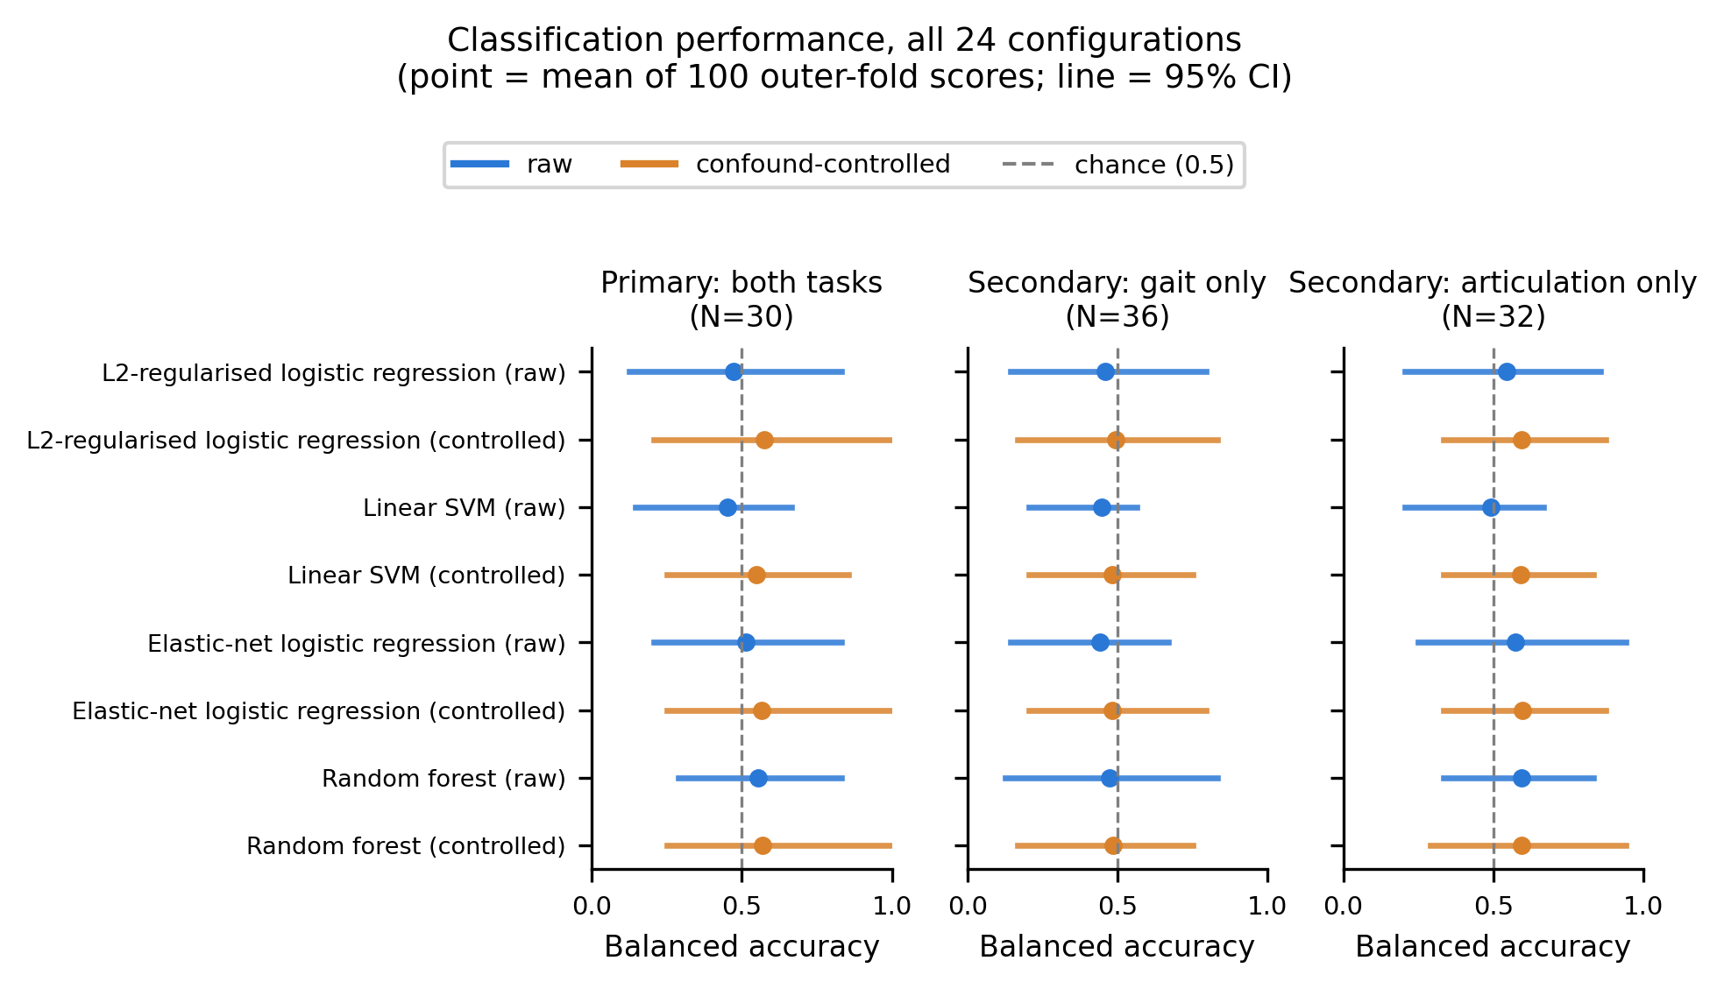
Figure 1. Classification performance across all 24 configurations. Point = mean of 100 outer-fold balanced-accuracy scores; line = 95% CI. Dashed line = chance (0.5).
Pre-specified extensions
Two further analyses were specified in advance and run regardless of the primary result. Predicting continuous MABC-2 score from the same 291 features, across all participants with a recorded score (N=29, both groups), produced negative R² for every model and confound variant (Table 2) — worse than predicting the sample mean for every participant — with permutation p between .72 and .82. This is a genuinely informative contrast with the companion univariate analysis, which finds several large, mostly corrected within-group associations between MABC-2 and activation: the two results are not contradictory, since a spatially localised, single-region effect can be real and still invisible to a linear model that must average within broad ROIs and regularise across the whole feature vector jointly, but the gap is worth stating plainly rather than reconciling away.
Table 3. MABC-2 regression, N=29.
Model | Variant | R² (95% CI) | Permutation p
Ridge (primary) | raw | −1.55 ([−6.58, 0.04]) | .790
Ridge (primary) | controlled | −1.82 ([−9.25, −0.06]) | .821
ElasticNet (secondary) | raw | −0.84 ([−4.41, 0.00]) | .718
ElasticNet (secondary) | controlled | −0.90 ([−5.54, 0.00]) | .765

Cross-task generalisation — training on one task's activation pattern and testing on the other, for the same held-out subjects, in both directions — was likewise null: balanced accuracy 0.50–0.61 across both directions and both primary model families, permutation p between .12 and .45. No evidence that a linear model's discriminative pattern (such as it is) transfers between the locomotor and oromotor systems.
Post-hoc exploratory hyperparameter search
After the primary result returned a clean null, a substantially widened hyperparameter search (9 regularisation values with class-weighting for the linear models; wider elastic-net and random-forest grids — 8 configurations, no new model families) was run on the primary dataset only, disclosed here because the decision to run it was made after seeing a null result. Zero of eight configurations cross even the uncorrected *p*<.05 line — fewer than the ~0.4 expected by chance across 8 tests under a true null — against a Bonferroni-adjusted threshold of p<.00114 (0.05/44 tests total) that would in any case apply. Widening the search did not recover a signal the coarse grid missed.
Cerebellar-restricted follow-up
Restricting the 97-ROI feature set to the 34 cerebellar regions only did not rescue the classification question for the both-tasks dataset (N=30; balanced accuracy 0.51–0.57, sanity-check p 0.21–0.36 across 8 configurations) or for gait-only (N=36; balanced accuracy 0.42–0.58, sanity-check p 0.22–0.84). Articulation-only cerebellar features (N=32) produced the closest pattern to significance seen anywhere in this project: all 8 configurations scored above chance (balanced accuracy 0.58–0.64), with a 100-permutation sanity-check p as low as 0.079 (elastic-net, confound-controlled) — directionally consistent with the companion univariate analysis's finding that oromotor group differences are numerically richer than locomotor ones, though every 95% CI still included chance and the pre-specified criterion was not met by the sanity check alone.
This pattern was resolved with the full ≥1000-permutation test, run for the two closest model families under a separate authorisation (Methods). Neither crossed the required threshold: elastic-net, confound-controlled, balanced accuracy=0.638, empirical p=.067; random forest, confound-controlled, balanced accuracy=0.624, p=.115 (raw variants: 0.602/p=.125 and 0.617/p=.140, respectively). The pre-specified positive-result criterion is not met by any configuration — the closest pattern to significance anywhere in this project does not survive the confirmatory test, and this cerebellar-restricted arm is reported in full as a second, independent null.
Learning curve
To distinguish a true null from an artefact of too little data, a learning curve was computed for both primary model families (nested hyperparameter selection preserved at every point) across training-set sizes from 9 to 24 subjects on the primary dataset (Figure 3). The raw (uncontrolled) curves for both models are flat at chance across the entire range, with no appreciable improvement from roughly a third to the full training set, arguing against underpowering as the explanation for the null result above, at least within this range. The confound-controlled curves fluctuate more (balanced accuracy 0.55-0.62 throughout) with a modest uptick at the largest training size for both models, but every point's 95% CI overlaps every other point's, so this reads as noise around a flat trend rather than a rising one. Neither curve shows the smooth upward trajectory that would indicate a model starved of data rather than a genuine absence of exploitable signal.
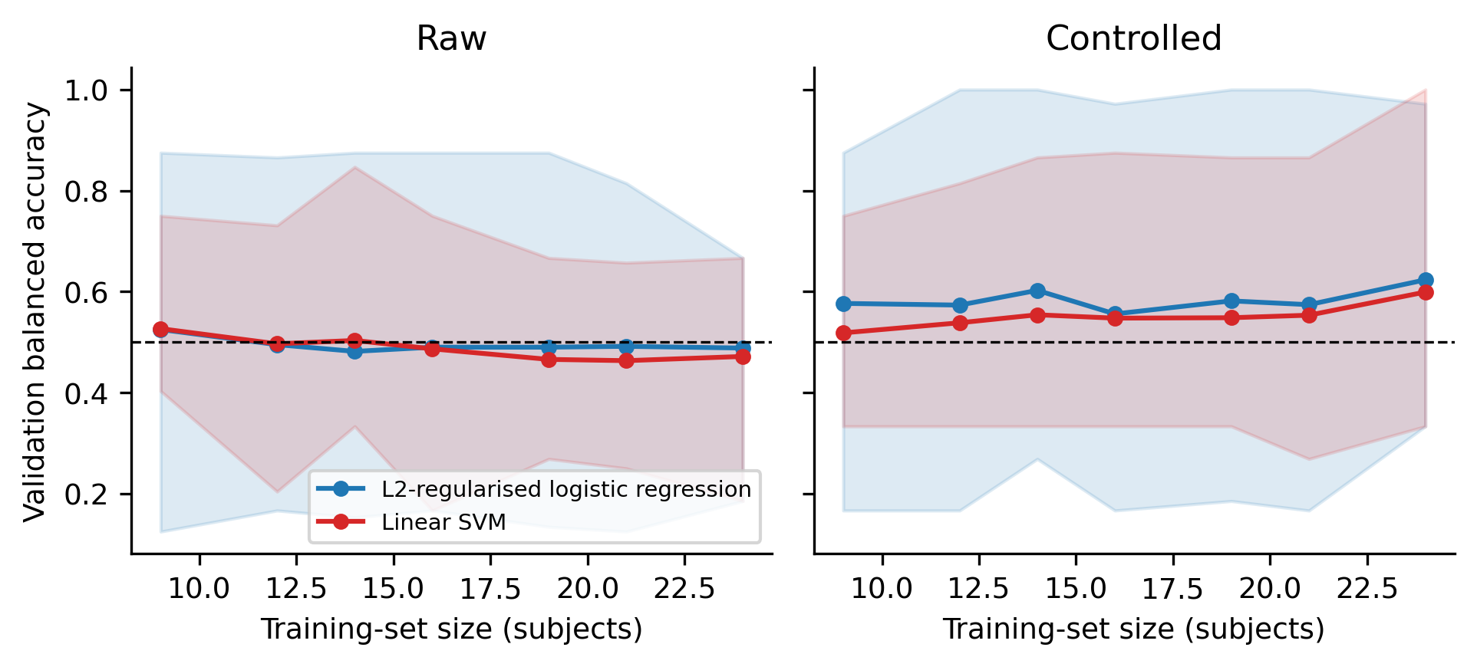
Figure 3. Learning curve for both primary model families (raw and confound-controlled), primary dataset (N=30). Point = mean validation balanced accuracy across 5-fold CV repeated 10 times, with hyperparameters re-selected via nested grid search at every point; shaded band = 95% CI. Dashed line = chance (0.5).
Error analysis
No model classifies above chance overall, but per-subject out-of-fold predictions (logged across all seeds for the two primary model families, raw and confound-controlled — 4 configurations) show that misclassification is not spread uniformly across individuals. One of 30 subjects is never misclassified across any configuration; 7 of 30 are misclassified in at least 75% of folds (Figure 2A). Misclassification rate does not correlate significantly with age, sex, or either task's motion-outlier count (all Spearman/Mann-Whitney p>.18); the correlation with MABC-2 is the largest of the four (ρ=.37, p=.052) and is named here as a trend, not a finding.
More informative is that this pattern is consistent across independent model families rather than idiosyncratic per model: every pairwise correlation between the four primary-family configurations' per-subject misclassification rates is positive, and five of six are individually significant (e.g., L2-logistic vs. linear SVM, raw: ρ=.64, p=.0001; Figure 2B). The same subjects tend to be difficult regardless of which linear model or confound-handling variant is used. This does not overturn the null result above — a model that cannot beat its own permutation baseline is still, by definition, not extracting group-discriminative information in aggregate — but it does suggest that whatever separates the two groups in this feature space, if anything does, is not uniformly present across individuals.
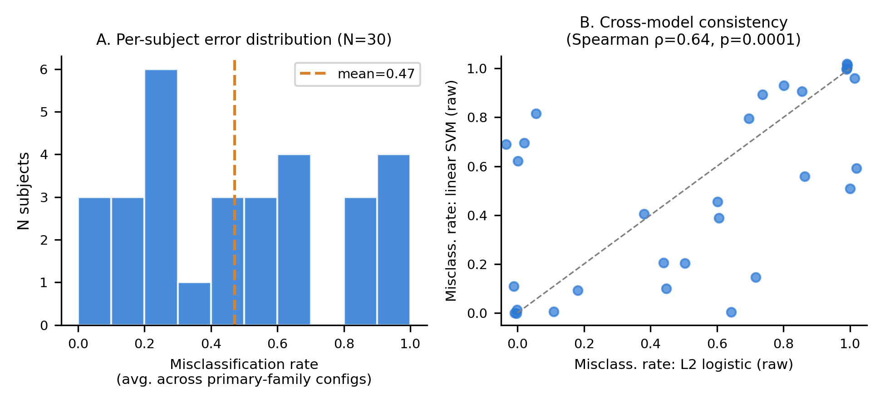
Figure 2. Error analysis. (A) Distribution of per-subject misclassification rate, averaged across the two primary model families, raw and confound-controlled (N=30). (B) Per-subject misclassification rate is correlated between independent model configurations (L2-logistic vs. linear SVM, both raw), indicating consistent rather than idiosyncratic error structure.
Discussion
No multivariate signal — classifying group membership, predicting continuous motor competence, or generalising across effectors — was detected in ROI-averaged task-fMRI activation at this sample size, across 24 primary configurations, 8 disclosed exploratory configurations, 2 further pre-specified extensions, and a further 24-configuration cerebellum-restricted follow-up (Results). The null held across every framing tried (classification, regression, cross-task transfer, and a cerebellum-restricted feature set), speaking against an artefact of one modelling choice rather than proving true absence: a 95% CI spanning roughly 30 points around a balanced-accuracy estimate cannot distinguish a true null from a real but small, underpowered-to-detect effect. Per the project's own analysis plan, no weight or pattern-stability map is reported — with no model reaching significance, there is no stable pattern to interpret, and an uninterpretable weight map from a non-significant model would manufacture the visual impression of a finding the numbers do not support.
Critical evaluation. The single most consequential limitation is sample size, and it is worth being specific about what was and was not already done about it. A continuous target (MABC-2), cross-task generalisation, and a cerebellum-restricted feature representation were all already tried — the latter on non-circular, a priori grounds (Methods) — and none changed the conclusion; these are not “future work” but analyses this project actually ran and reports null, including the closest-to-significance pattern seen anywhere in the project (articulation-only cerebellar features), which did not survive the full permutation test. A narrower, single-region reduction beyond the cerebellar restriction remains rejected: selecting regions on any basis connected to this study's own univariate results would be circular, and no independent justification currently exists for a cut narrower than the cerebellar arm's atlas-based one. Whether N≈30–45 can answer this question at all deserves to be asked directly: this analysis cannot rule a real effect in or out with any useful precision, and a well-powered replication — not a cleverer pipeline on the same 30–45 participants — is the honest next step. One further concrete direction comes from the error analysis: since misclassification is consistent across independent model families rather than idiosyncratic noise, a study powered to model individual variability directly (e.g., continuous per-subject measures against continuous outcomes, rather than a fixed binary split) may better match whatever structure is actually present here.
What this adds to the univariate analyses. A multivariate null across three independent framings is complementary, not redundant, evidence alongside the companion univariate group-contrast results: it specifically rules out a distributed whole-brain pattern that a mass-univariate, region-by-region test could in principle miss by design. Read alongside the univariate analysis's own finding of substantial individual heterogeneity in activation topography, and the structure identified in the error analysis above, the most defensible reading is that any true group difference here is narrow and individually heterogeneous — not well captured by a single-region univariate test averaged over a fixed group model, nor by a linear multivariate pattern averaged over broad anatomical regions — not that no difference of any kind exists.
References
1. Cawley, G. C., & Talbot, N. L. C. (2010). On over-fitting in model selection and subsequent selection bias in performance evaluation. Journal of Machine Learning Research, 11, 2079–2107.
2. Varoquaux, G., Raamana, P. R., Engemann, D. A., Hoyos-Idrobo, A., Schwartz, Y., & Thirion, B. (2017). Assessing and tuning brain decoders: Cross-validation, caveats, and guidelines. NeuroImage, 145, 166–179.
3. Nichols, T. E., & Holmes, A. P. (2002). Nonparametric permutation tests for functional neuroimaging: A primer with examples. Human Brain Mapping, 15(1), 1–25.
4. Combrisson, E., & Jerbi, K. (2015). Exceeding chance level by chance: The caveat of theoretical chance levels in brain signal classification and statistical assessment of decoding accuracy. Journal of Neuroscience Methods, 250, 126–136.
5. Haufe, S., Meinecke, F., Görgen, K., Dähne, S., Haynes, J.-D., Blankertz, B., & Bießmann, F. (2014). On the interpretation of weight vectors of linear models in multivariate neuroimaging. NeuroImage, 87, 96–110.
6. Pedregosa, F., Varoquaux, G., Gramfort, A., et al. (2011). Scikit-learn: Machine learning in Python. Journal of Machine Learning Research, 12, 2825–2830.
7. Breiman, L. (2001). Random forests. Machine Learning, 45(1), 5–32.
8. Zou, H., & Hastie, T. (2005). Regularization and variable selection via the elastic net. Journal of the Royal Statistical Society: Series B, 67(2), 301–320.
9. Cortes, C., & Vapnik, V. (1995). Support-vector networks. Machine Learning, 20(3), 273–297.
10. Diedrichsen, J., Balsters, J. H., Flavell, J., Cussans, E., & Ramnani, N. (2009). A probabilistic MR atlas of the human cerebellum. NeuroImage, 46(1), 39–46.
11. Henderson, S. E., Sugden, D. A., & Barnett, A. L. (2007). Movement Assessment Battery for Children – Second Edition (MABC-2). Pearson.
12. Brodersen, K. H., Ong, C. S., Stephan, K. E., & Buhmann, J. M. (2010). The balanced accuracy and its posterior distribution. In Proceedings of the 20th International Conference on Pattern Recognition, 3121–3124.

