**3701ICT/7421ICT Mobile Application Development**

**MAD**

**Lab 2**  **JS functions and Simple Layout**

1. Exercise 1 (50 pts, 10pt each question)

Please retrieve the lab exercise from our GitHub repository at:

<https://github.com/LarryAtGU/mad_ex_week2>. Ensure you install it and address all 5 questions provided. Each question is valued at 10 points. Achieving a full pass on all test cases for a question will result in full credit. Should you pass only some of the test cases, you will be awarded 50% of the points for that question.

1. Exercise 2 (16 pts, 2pt each question)

Q1. What's one of the main roles of the built-in <View> component?

* 1. Directly output text.
  2. Structure/ Group other child components.
  3. Handle touch events.

Q2. Can you use HTML elements (e.g. <div>, <p>, <input>) in React Native apps?

1. Yes, React Native is able to handle HTML components, but native components are preferred.
2. No, React Native doesn’t provide any built-in components, you need to build all components from scratch.
3. No, React Native doesn’t recognize these components – it doesn’t know how to compile them to native views.

Q3, What’s the relation between React Native component styling and CSS (Cascading Style Sheets) for the Web?

1. React Native styling is inspired by CSS (comparable/ similar property names and values)
2. React Native uses the exact same syntax but only supports a limited set of features.
3. There is no connection.

Q4, Which of the following example style rules does NOT work in React Native?

1. borderColor: ‘black’
2. padding: 10
3. ‘background-color’: ‘#ccc’

Q5, Why would you use const styles = StyleSheet.create({}) instead of a regular JavaScript object (const styles = {})?

1. There is no reason to use StyleSheet.
2. Using a StyleSheet adds validation and potential performance improvements.
3. Using a StyleSheet unlocks extra styling properties.

Q6, What is “Flexbox”?

1. A styling property that allows you to order items in a grid.
2. A component built into React Native which you can use to structure content.
3. A concept/ set of styling properties that allows you to structure content (i.e. create layouts).

Q7, What's the default styling/ layout behavior of a <View> component?

1. It organizes child components in a grid.
2. It doesn’t allow any ordering or structuring of child components.
3. It uses Flexbox to organize its child components.

Q8, If a <View> has flexDirection: 'column' (which is the default) - what does alignItems: 'flex-end' do in that case?

1. It positions all child elements at the end of the column – on the horizontal axis.
2. It positions all child elements at the end of the column – on the vertical axis.
3. It has no effect.
4. Exercise 3 （34pts）

Create a simple React Native application that displays a Tic Tac Toe board as shown in Figure 1. You are welcome to use a different colour scheme and display various player positions.

Please include a screenshot of your application and another screenshot of your entire `App.js` file.

You must utilize Flexbox and the attributes discussed in the second-week lecture.

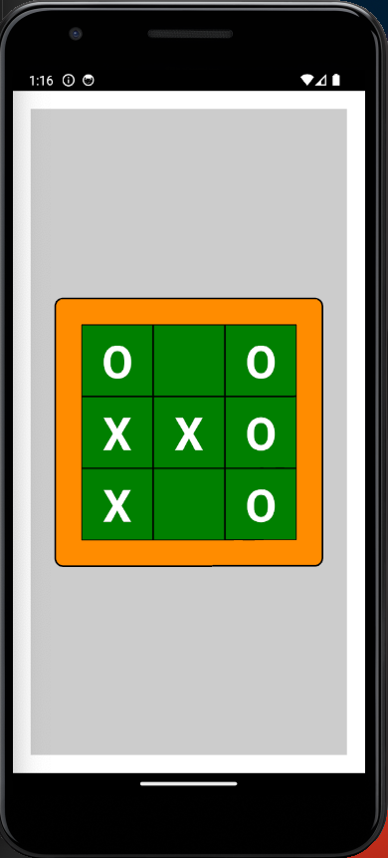

Figure 1 A tic tac toe board.