**3701ICT/7421ICT Mobile Application Development**

**MAD**

**Lab 1**  **JavaScript Foundation and Hello World App**

Prior to our initial lab session, please take a moment to review and acquaint yourself with the Lab Rules (<https://lms.griffith.edu.au/courses/21765/pages/lab-rules>).

1. Exercise 1 (80pts)

Please retrieve the lab exercise from our GitHub repository at: <https://github.com/LarryAtGU/mad_ex_week1>. Ensure you install it and address all 10 questions provided. Each question is valued at 8 points. Achieving a full pass on all test cases for a question will result in full credit. Should you pass only some of the test cases, you will be awarded 50% of the points for that question.

Comprehensive instructions on how to download, install, and execute the tests are available at the link mentioned above. Should you encounter any difficulties, do not hesitate to seek assistance from your lab tutor. It is important to avoid hardcoding as a means to pass the test cases. Upon successfully passing all test cases, you will observe a specific output in your terminal, as depicted in the image provided below:

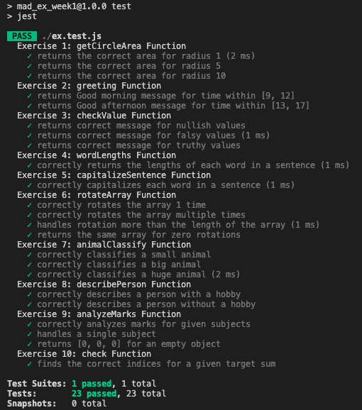

1. Exercise 2 (20pts)

Develop a basic React Native application that renders the text “Hello World” along with your group number on the screen. The display should align with the layout provided in the diagram below, and the application should be compatible with both Android and iPhone emulators.

Ensure that the text elements are clearly visible and properly styled to match the example layout. This exercise will acquaint you with the fundamental structure of a React Native application and the process of running it in an emulator environment.

Upon completion, please demonstrate the functioning application to your lab tutor for verification and assessment.

