Name: G S A M E W L B Egodawele

Reg. No: 524654478

**Python Workshop Series**

**Department of Computer Science – OUSL**

**Activity 01**

The activity given is following.

---------------------------------------------------------------------------------------------------------------------

*Activity 01*

*Get user inputs for the red colour words. Display the following sentences*

*Question 1*

*That's amazing! You're age years young!  
eg: That's amazing! You're 23 years young!*

*Question 2*

*It's cool that your favorite color is color and you love hobby  
eg : It's cool that your favorite color is blue and you love reading books*

---------------------------------------------------------------------------------------------------------------------

We need to get inputs for **Age, Color** and **Hobby** from the user.

Question 1

#6/1/2025

#This is the python code for user input 'age'

#The input from the user

AgeInput = input("I would love to know your age: ")

#Print out the input

print("That is fantastic! Congratulations for being", AgeInput, "years old!")

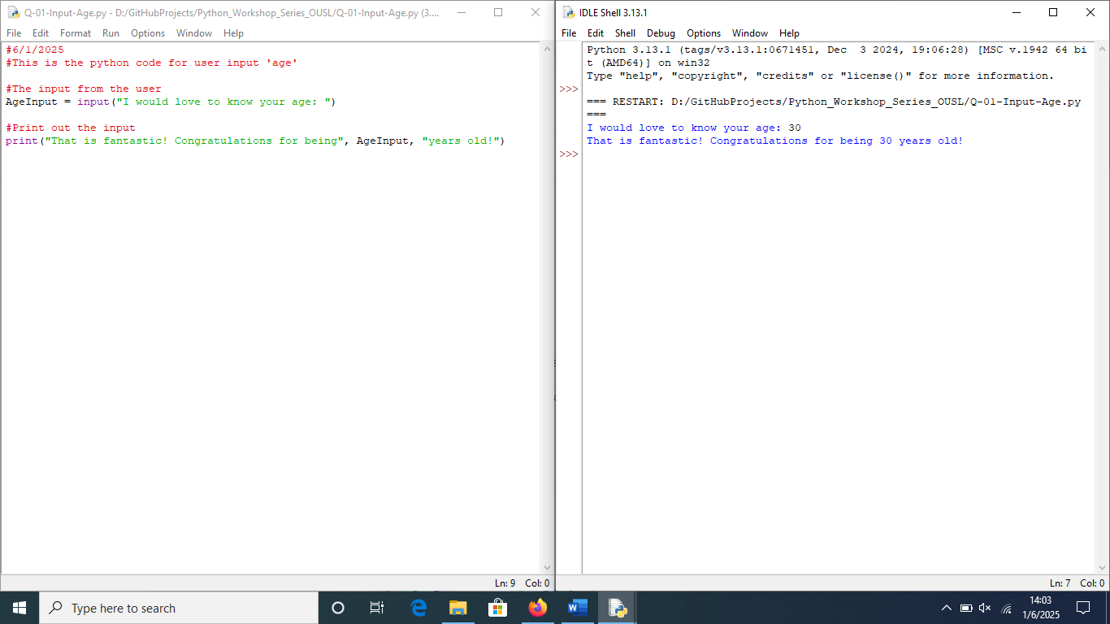

Question 2

#6/1/2025

#This is the python code for user input 'Color' and 'Hobby'

#The input from the user

ColorInput = input("So what is your favorite color: ")

HobbyInput = input("What is your favorite hobby may I ask: ")

#Print out the input

print("Fabulous!! You like",ColorInput,"color and your hobby is",

HobbyInput,"which is cool!")

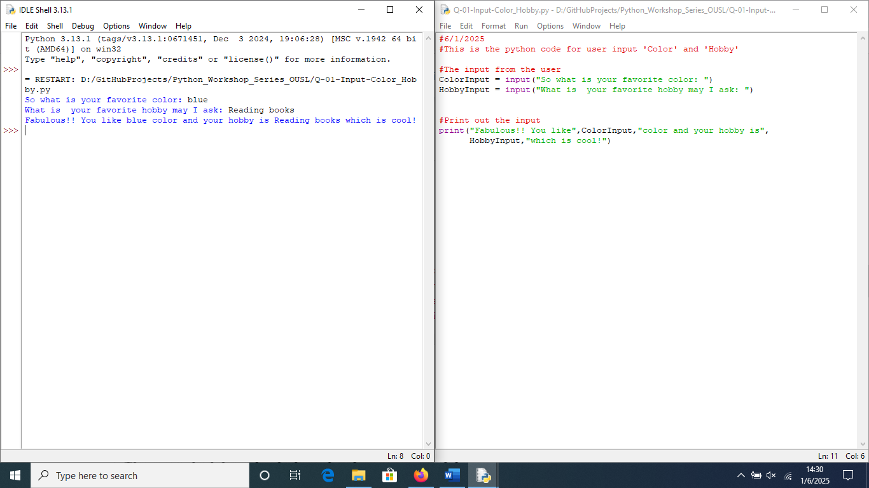

**For more information, please visit repositories:**

<https://github.com/loachana/Python_Workshop_Series_OUSL.git>