Name: G S A M E W L B Egodawele

Reg. No: 524654478

**Python Workshop Series**

**Department of Computer Science – OUSL**

**Activity 02**

The activity given is following.

---------------------------------------------------------------------------------------------------------------------

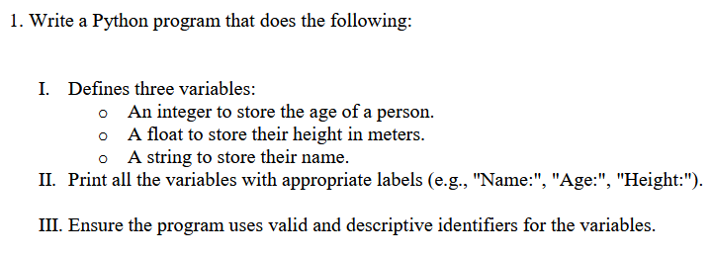

------------------------------------------------------------------------------------------------------------------

*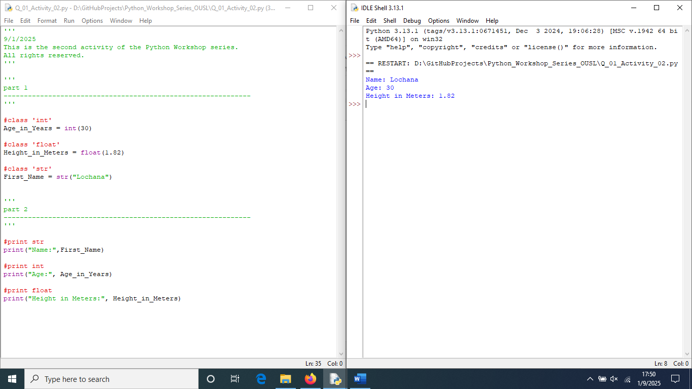The source code follows*

**Dear sir/madam, Please visit repositories for more information :**

'''

9/1/2025

This is the second activity of the Python Workshop series.

All rights reserved.

'''

'''

part 1

-------------------------------------------------------------

'''

#class 'int'

Age_in_Years = int(30)

#class 'float'

Height_in_Meters = float(1.82)

#class 'str'

First_Name = str("Lochana")

'''

part 2

-------------------------------------------------------------

'''

#print str

print("Name:",First_Name)

#print int

print("Age:", Age_in_Years)

#print float

print("Height in Meters:", Height_in_Meters)

<https://github.com/loachana/Python_Workshop_Series_OUSL.git>