s Name: G S A M E W L B Egodawele

Reg. No: 524654478

**Python Workshop Series**

**Department of Computer Science – OUSL**

**Activity 03**

The activity given is following.

---------------------------------------------------------------------------------------------------------------------

1. **Check if either a = 4 or b = 10 is smaller than 5.**
2. **Apply the bitwise OR operation to 7 and 12. Convert both numbers to binary, carry out the OR operation, and determine the resulting decimal value.**
3. **Apply the bitwise XOR operation to 5 and 3. Convert both numbers to binary, perform the XOR operation, and determine the resulting decimal value.**
4. **Perform a right shift operation on the number 20 by 3 positions. Provide both the binary and decimal results.**

---------------------------------------------------------------------------------------------------------------------

1.

#11/1/2025

#This is answer for the first question in activity 3

#All rights reserved

#First a and b are defined

a = 4

b = 10

#Print a and b values for the interface

print("Assume a:", a)

print("Assume b:", b)

#Need to check if a or b is smaller than 5

if a < 5 or b < 5:

print("a or b is smaller than 5")

else:

print("a and b is not smaller than 5")

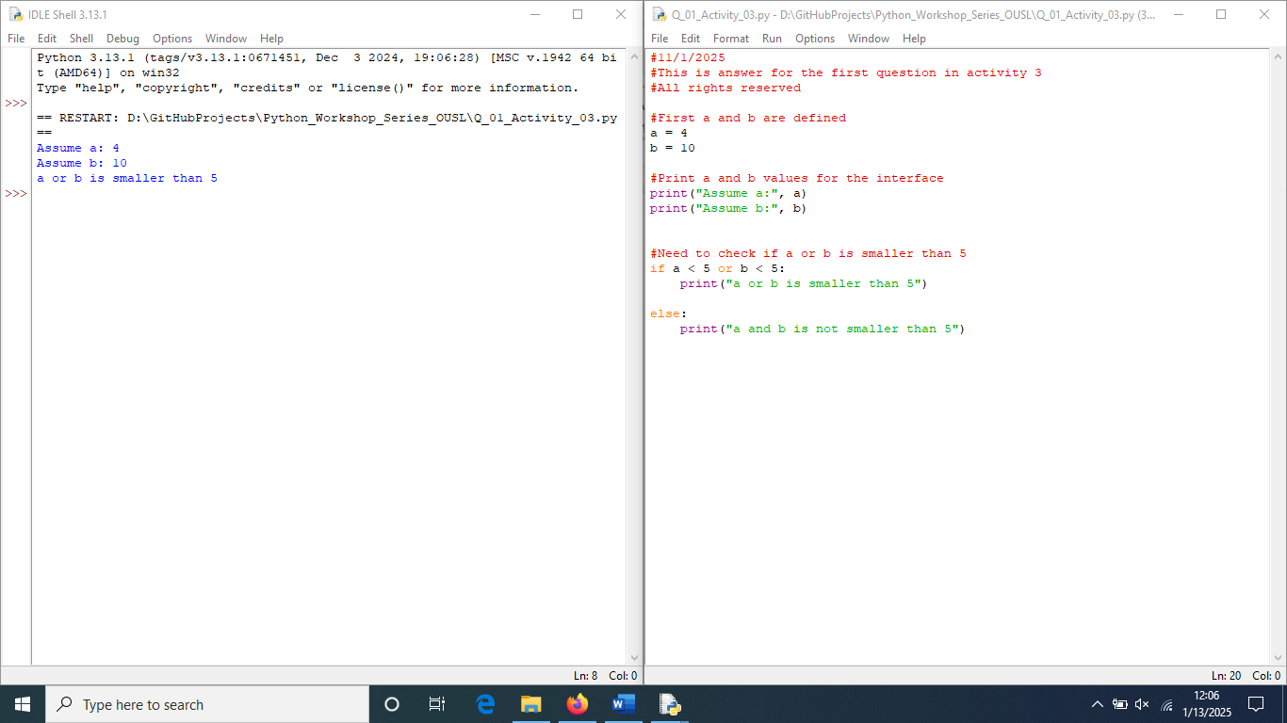

**2.**

#13/1/2025

#Question 2 is about applying bitwise OR operation and varification

#All right reserved

#define variables

a = 7

b = 12

#bitwise(|) operation

print("Bitwise OR opearion of 7 and 12 is",a|b)

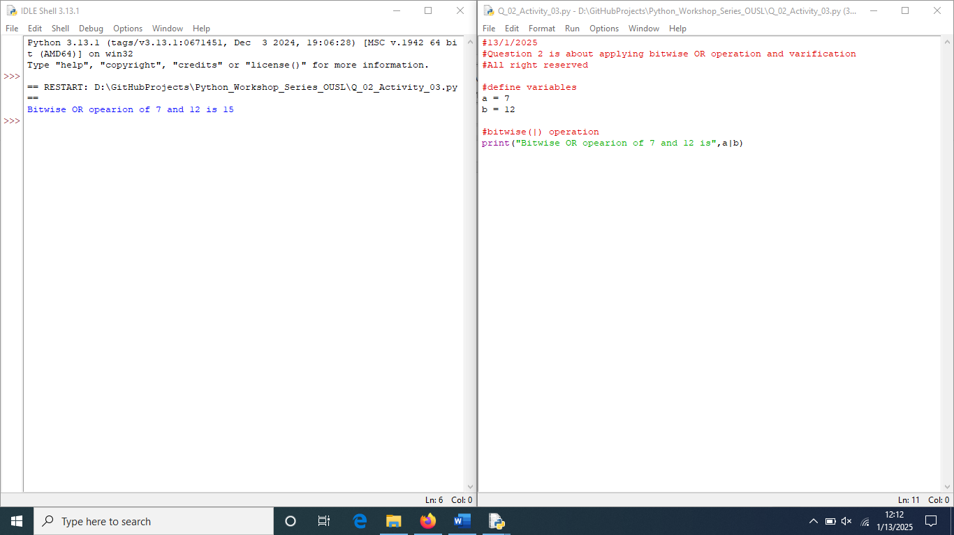

**3.**

#13/1/2025

#Question 3 is about applying bitwise XOR operation and verification

#All right reserved

#define variables

a = 5

b = 3

#bitwise(|) operation

print("Bitwise XOR operation of 5 and 3 is",a^b)

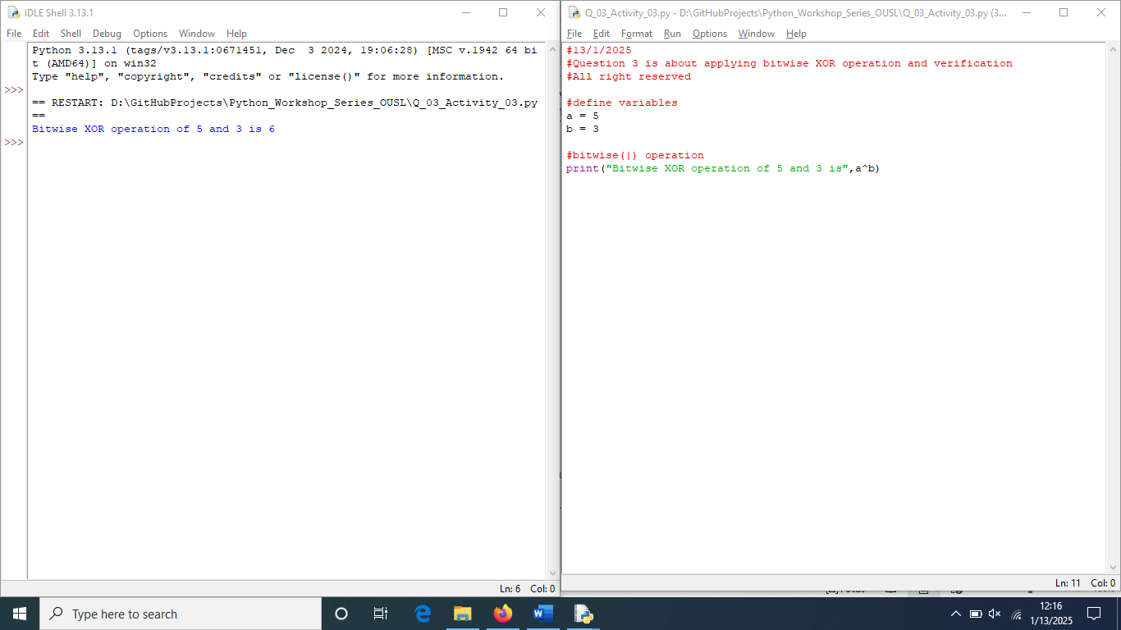**4.**

#13/1/2025

#Question 4 is about performing right shift operation and verification

#All rights reserved

#define variables

number = 20

digits_to_right = 3

#bitwise(|) operation

print("Bitwise Right shift(>>) operation on number 20 by 3 positions is:", number>>digits_to_right)

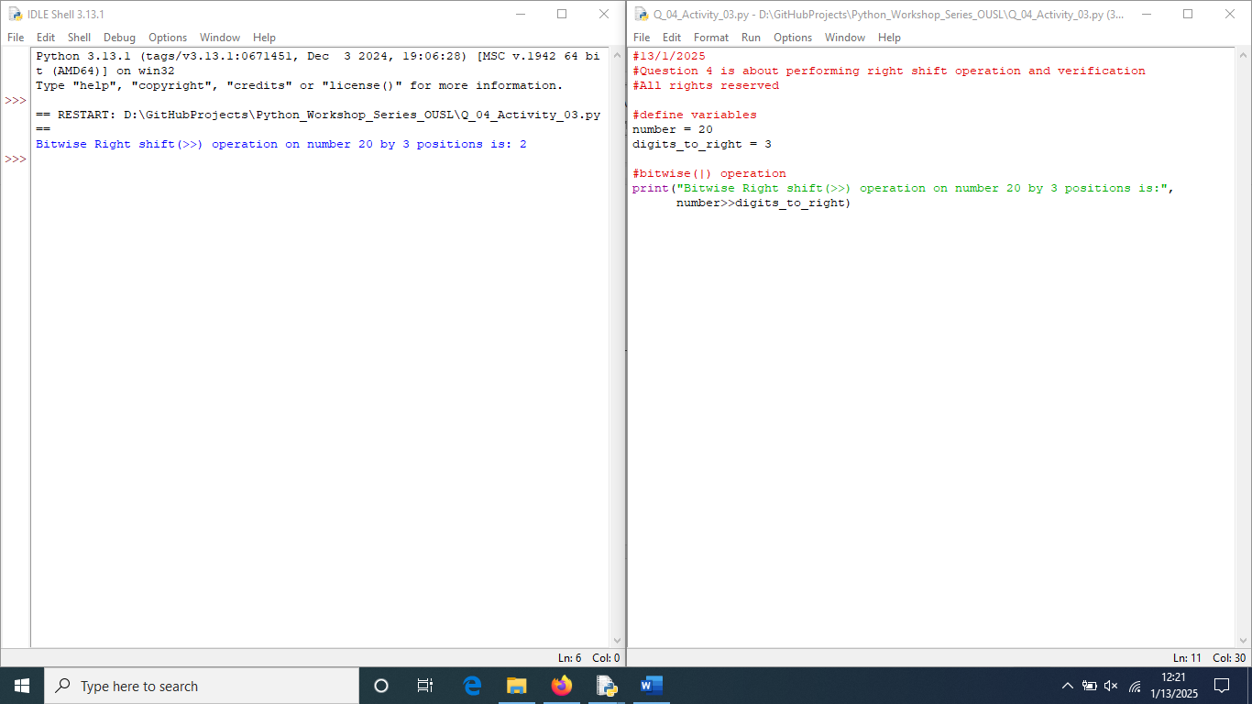

**Dear sir/madam, please visit repositories for more information:**

<https://github.com/loachana/Python_Workshop_Series_OUSL.git>