Name: G S A M E W L B Egodawele

Reg. No: 524654478

**Python Workshop Series**

**Department of Computer Science – OUSL**

**Activity 04**

The activity given is as follows.

---------------------------------------------------------------------------------------------------------------------

1. **Write a Python program that asks the user to enter a number and prints whether the number is even or odd. If the user input 0, print (“Invalid Input”)**
2. **Write a Python program that asks the user to enter an integer and prints whether the number is divisible by 3, divisible by 5, divisible by both, or divisible by neither. The program should keep asking for a number until the user enters 0 to stop.**

---------------------------------------------------------------------------------------------------------------------

*This block is intentionally left blank.*

**1.**

#15/1/2025

#This is the code for Q1 in activity 4 of python workshop @ OUSL

#All rights reserved

#>> We use while toop to keep asking integers from the user.

#>> We also use Try-Except block to prevent the user to enter invalid input.

#>> Inside the loop, We use If statement to classify the integer given by the user.

#The head

print("THE EVEN-ODD IDENTIFIER\nInput q to quit\n-----------------------")

#While loop to keep asking

while True:

try:

x = input("Give me the number: ")

if x == "q":

quit() #'q' terminates the program

elif x == "":

print("Looks like empty input!") #identify empty input

elif x == " ":

print("That was space, not a number!") #identify space

elif int(x) == 0:

print("Invalid Input!") #identify 0

elif int(x)%2 == 0:

print("That was an even number pal!") #identify even numbers

elif int(x)%2 == 1:

print("That was an odd number pal!") #identify odd numbers

except:

print("I don't know what that was!") #for other unknown inputs

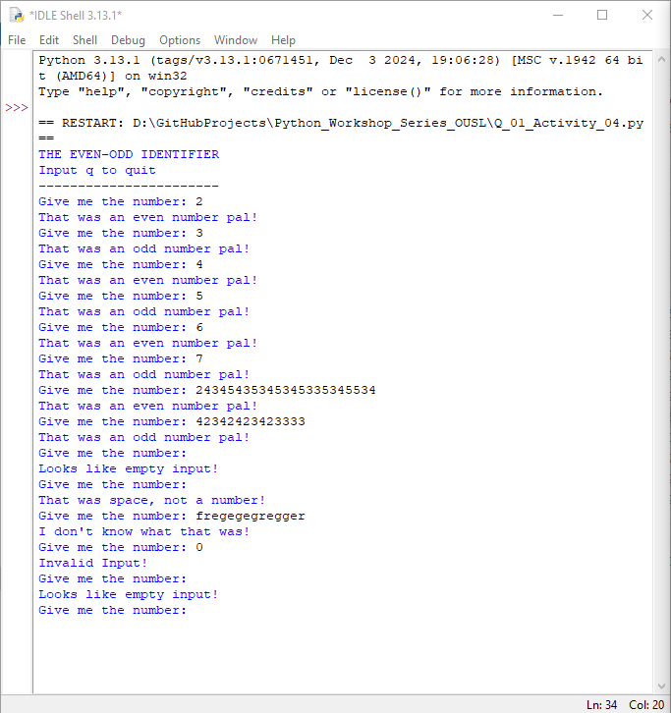

**2.**

#16/1/2025

#This is the code for Q2 in activity 4 of python workshop @ OUSL

#All rights reserved

#>> We use while toop to keep asking integers from the user.

#>> We also use Try-Except block to prevent the user to enter invalid input.

#>> Inside the loop, We use If statement to classify the integer given by the user.

#The head

print("THE THREE FIVE FACTOR IDENTIFIER\nInput 0 to stop\n--------------------------------")

#While loop to keep asking

while True:

try:

x = input("Give me the number: ")

if x == "":

print("Looks like empty input!") #identify empty input

elif x == " ":

print("That was space, not a number!") #identify space

elif int(x) == 0:

break #0 breaks the program

elif int(x)%3 == 0 and int(x)%5 == 0:

print(x,"is devisible by both 3 and 5") #identify numbers by 3,5

elif int(x)%3 == 0:

print(x, "is devisible by 3") #identify numbers by 3

elif int(x)%5 == 0:

print(x, "is devisible by 5") #identify numbers by 5

else:

print(x,"is devisible by neither both 3 and 5") #Numbers neither 3,5

except:

print("I don't know what that was!") #for other unknown inputs

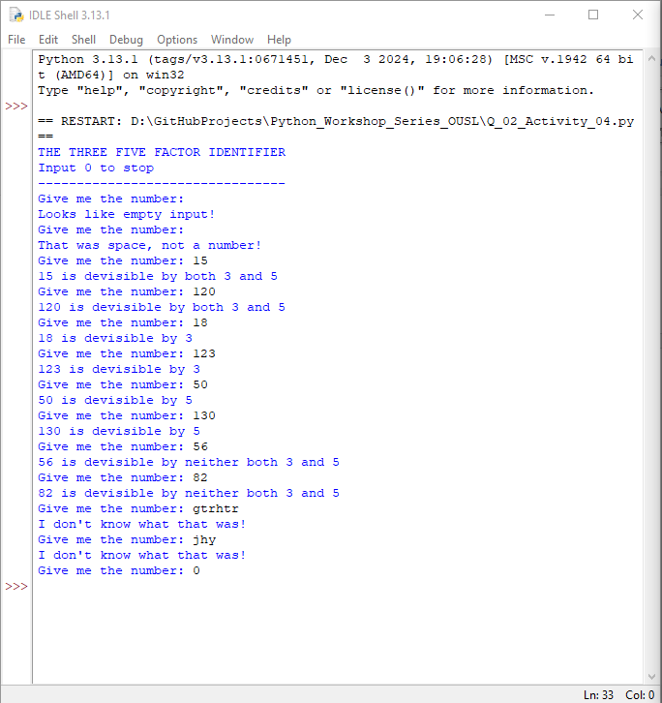

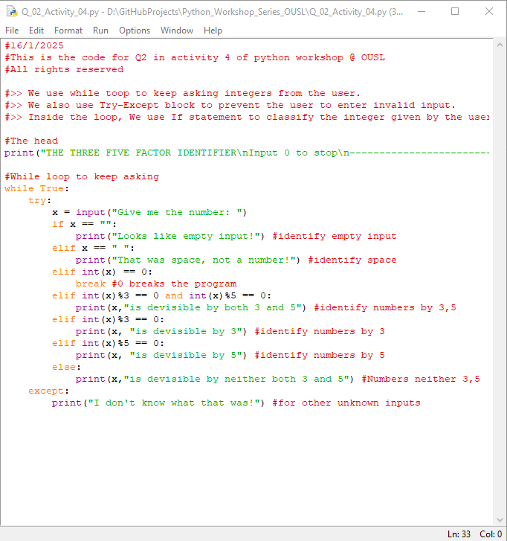

**Dear sir/madam, please visit repositories for more information:**

<https://github.com/loachana/Python_Workshop_Series_OUSL.git>