Name: G S A M E W L B Egodawele

Reg. No: 524654478

**Python Workshop Series**

**Department of Computer Science – OUSL**

**Activity 05**

The activity given is as follows.

---------------------------------------------------------------------------------------------------------------------

Write a Python program that creates a multiplication table for a given number and stores the results in an array. The program should:

1. Ask the user to input a number for which the multiplication table will be created.
2. Use an array to store the results of the multiplication table from 1 to 10.
3. Display the array and print each multiplication result in a readable format.

---------------------------------------------------------------------------------------------------------------------

1. Entire code runs inside a *while loop*
2. The number to input must be taken. Code goes follow.

**input_number = input("the number: ")**

1. A way to stop the program must be set up.

**if input_number == 'q'or input_number =='Q':**

**break**

1. One to ten consecutive numbers are created and stored in an array.

**elif input_number.isdigit():**

**one_to_ten_array = [i for i in range(1,11)]**

1. The input number is stored in an array ten times.

**input_number_array = [int(input_number) for j in range(1,11)]**

1. Multiplication is performed using above two arrays and is assigned into another array.

**multiplication = [one_to_ten_array[k]*input_number_array[k] for k in range(0,10)]**

1. The readable format is done using the following code.

**for p in range(0,10):**

**if p == 0:**

**print("The Readable Math Table\n---------------------------------------------")**

**print(f"{one_to_ten_array[p]} x {input_number_array[p]} = {multiplication[p]}\n")**

*This block is intentionally left blank*

**Final Code:**

#18/1/2025

#This is the code for activity 5 of python workshop @ OUSL

#All rights reserved

while True:

print("----------------\nTHE MATH TABLE\npress q to quit\n----------------")

input_number = input("the number: ")

if input_number == 'q'or input_number =='Q':

break

elif input_number.isdigit():

one_to_ten_array = [i for i in range(1,11)]

#print(one_to_ten_array)

input_number_array = [int(input_number) for j in range(1,11)]

#print(input_number_array)

multiplication = [one_to_ten_array[k]*input_number_array[k] for k in range(0,10)]

print(f"\nThe Array of Multiplication Table\n---------------------------------------------\n{multiplication}\n")

for p in range(0,10):

if p == 0:

print("The Readable Math Table\n---------------------------------------------")

print(f"{one_to_ten_array[p]} x {input_number_array[p]} = {multiplication[p]}\n")

else:

print("Invalid input! Please try again.")

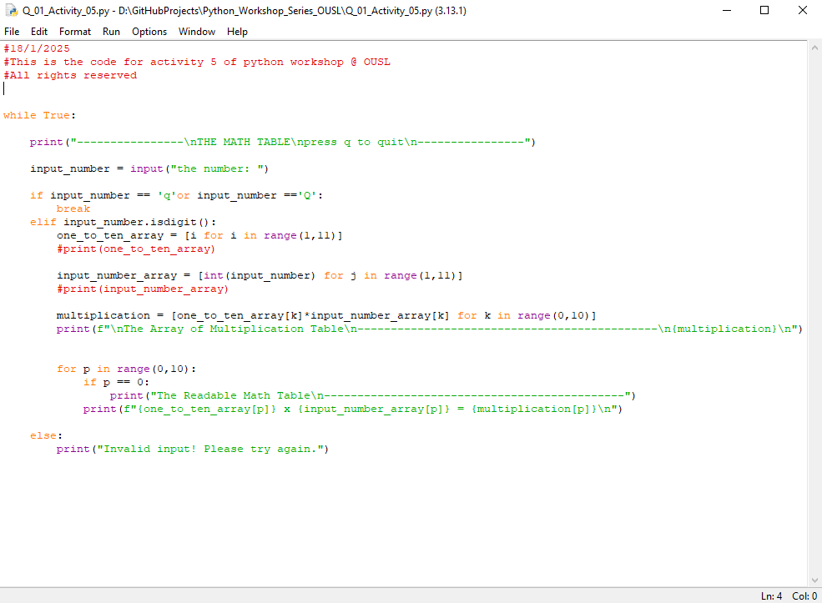

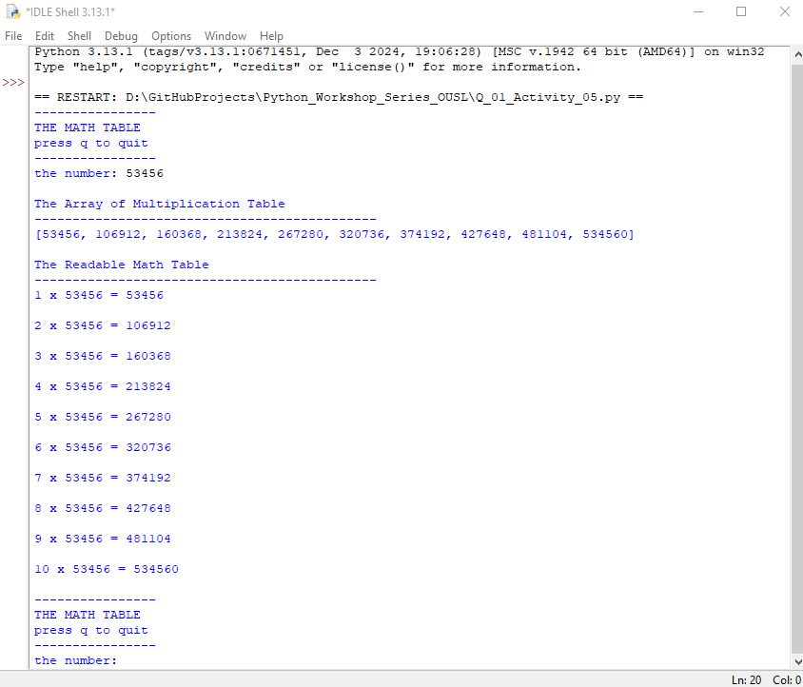

**Dear sir/madam, please visit repositories for more information:**

<https://github.com/loachana/Python_Workshop_Series_OUSL.git>