Name: G S A M E W L B Egodawele

Reg. No: 524654478

**Python Workshop Series**

**Department of Computer Science – OUSL**

**Activity 06**

The activity given is as follows.

---------------------------------------------------------------------------------------------------------------------

1. Write a Python function that takes two numbers as arguments and returns their sum.
2. Write a function that checks if a number is even or odd.

---------------------------------------------------------------------------------------------------------------------

#21/1/2025

#This is in response to the Q1 of activity 6.

#All rights reserved

#The function is defined

def summing_machine(num1, num2): #Take two arguments as num1, num2

The_output = num1 + num2 #Summing process

return The_output #returns the sum

#Testing

print(f"The sum of 42352525 and 23524334 are: {summing_machine(42352525,23524334)}\n")

#Further improvements

input1 = int(input("First number: "))

input2 = int(input("Second number: "))

print(f"The sum of {input1} and {input2} are {summing_machine(input1,input2)}")

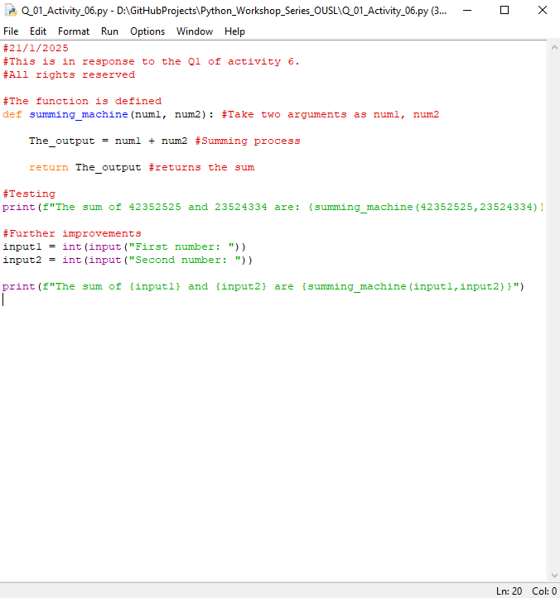



#21/1/2025

#This is in response to the Q2 of activity 6.

#All rights reserved.

#The function is defined

def even_odd_inspector(num_guy):

if num_guy%2 == 0:

return "even"

elif num_guy%2 == 1:

return "odd"

#Recurring process

while True:

try:

input_number = input("Enter the number: ")

input_number_int = int(input_number)

result = even_odd_inspector(input_number_int)

print(result)

except:

if input_number == "q" or input_number == "Q":

break

print("Enter valid number!")

**Dear sir/madam, please visit repositories for more information:**

<https://github.com/loachana/Python_Workshop_Series_OUSL.git>