Name: G S A M E W L B Egodawele

Reg. No: 524654478

**Python Workshop Series**

**Department of Computer Science - OUSL**

**Activity 08**

The activity given is as follows.

---------------------------------------------------------------------------------------------------------------------

1. Look at the following code snippet and identify the errors:

**numbers = [1, 2, 3]**

**print(numbers[3])**

1. What type of exception will this raise?
2. How can it be handled using Try-Except. Give codebase?

---------------------------------------------------------------------------------------------------------------------

**numbers = [1, 2, 3]**

This code line assigns a list which consists of 1, 2, 3 to the variable *numbers.*

The indexes of 1 , 2 , 3 are as follows

1 🡪 index 0

2 🡪 index 1

3 🡪 index 2

To call each element, the code goes

numbers[0] gives 1

numbers[1] gives 2

numbers[2] gives 3

But when numbers[3] is called python returns an *Index Error* because the calling is out of range.

Error is ***IndexError: list index out of range***

Above error can be fixed using try-exception method in python

numbers = [1,2,3]

try:

print(numbers[3])

except:

print("numbers[3] is out of range")

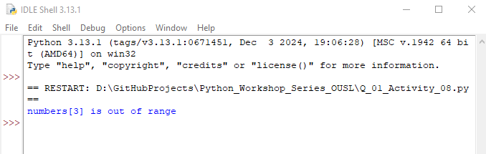

**Dear sir/madam, please visit repositories for more information:**

<https://github.com/loachana/Python_Workshop_Series_OUSL.git>