Name: G S A M E W L B Egodawele

Reg. No: 524654478

**Python Workshop Series**

**Department of Computer Science - OUSL**

**Activity 09**

The activity given is as follows.

---------------------------------------------------------------------------------------------------------------------

1. Create a file called my_notes.txt and write the following text into it

Welcome to Python Beginners course

Python is a powerful programming language.

2. Append a new line to my_notes.txt

I am learning how to handle files!

3. Read and print the content of my_notes.txt

---------------------------------------------------------------------------------------------------------------------

#2/2/2025

#This is the answer for anctivity 9

#All rights reserved

the_file = open("my_notes.txt", "w")

the_file.write("Welcome to Python Beginners course.\nPython is a powerful programming language.")

the_file.close()

2.

#2/2/2025

#This is the answer for anctivity 9

#All rights reserved

the_file = open("my_notes.txt", "a")

the_file.write("\n"+"I am learning how to handle files!")

the_file.close()

3.

#2/2/2025

#This is the answer for anctivity 9

#All rights reserved

the_file = open("my_notes.txt", "r")

text = the_file.read()

print(text)

the_file.close()

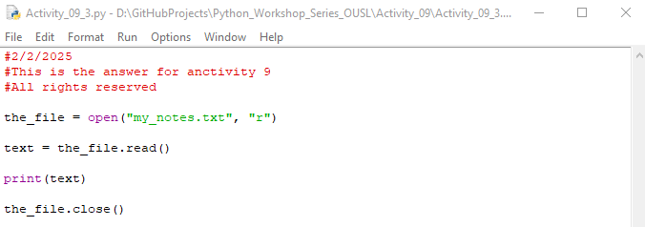

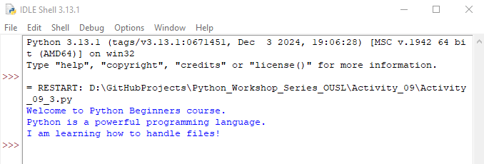

Project folder:

**Dear sir/madam, please visit repositories for more information:**



<https://github.com/loachana/Python_Workshop_Series_OUSL.git>