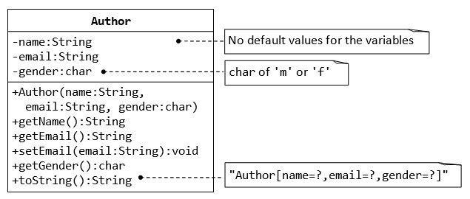

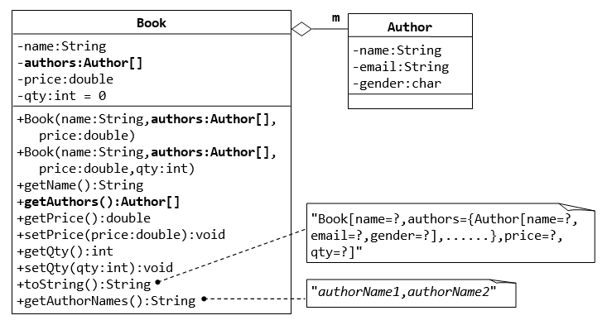

A class called **Author** is designed to model a book's author. It contains:

* Three **private** instance variables: *name* (String), *email* (String), and *gender* (char of either 'm' or 'f');
* One constructor to initialize the name, email and gender with the given values;
  + (There is no default constructor for Author, as there are no defaults for name, email and gender.)
* public getters/setters: getName(), getEmail(), setEmail(), and getGender();
* Printing Author object should print :
  + "Author[name=?,email=?,gender=?]", e.g., "Author[name=Tan Ah Teck,email=ahTeck@somewhere.com,gender=m]".

A class called Book is designed to model a book written by *several* authors. It contains:

* Four private instance variables: name (String), authors (of the class  Author you have just created), price (double), and qty (int);
* Two constructors:
* public Book (String name, Author[] authors, double price) { ...... }
* public Book (String name, Author[] authors, double price, int qty) { ...... }
* public methods getName(), getAuthors(), getPrice(), setPrice(), getQty(), setQty().
* Printing Book object should print:
  + "Book[name=?,authors={Author[name=?,email=?,gender=?],..},price=?,qty=?"]
* Introduce new methods called getAuthorName(author), getAuthorEmail(author), getAuthorGender(author) in the Book class to return the name, email and gender of the author of the book.
* Write a method to print comma separated String of Author names , for instance “‘authorName1, authorName2…authorNameN”.
* **Write a test driver called TestBook to test all the public methods in the class Book.**

1. Declare and Allocate and array of Authors.
2. Declare and Allocate a book instance.
3. Print the Book instance.
4. Print the name and email of all the authors from a Book instance.