Angular_Testing

Overview
Unit Testing
This is sometimes also called Isolated testing. It’s the practice of testing small isolated pieces of code. If your test uses some external resource, like the network or a database, it’s not a unit test.
Functional Testing
This is defined as the testing of the complete functionality of an application. In practice with web apps, this means interacting with your application as it’s running in a browser just like a user would interact with it in real life, i.e. via clicks on a page.
This is also called End To End or E2E testing.

Important
In this section we are only going to cover how to perform unit testing with Angular.

You will learn:
- How to write and run tests in Angular using Jasmine & Karma.
- How to write tests for classes, components, directives and pipes.
- How to use the Angular Test Bed to help test behaviors that depend on the Angular framework.
- How to write tests using mocks and spys.
- How to write tests that depend on change detection.
- How to write tests that involve an asynchronous action.
- How to write tests that require the dependency injection framework.
- How to write tests that involve the Http service.
- How to write tests that involve model driven forms (template driven forms require E2E testing).
- How to write tests to test the Router.

Jasmine & Karma
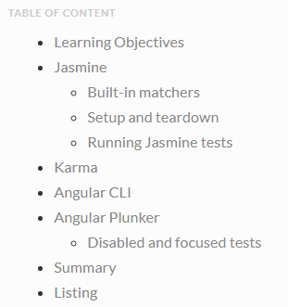

We can test our Angular applications from scratch by writing and executing pure java script functions. Creating instances of the relevant classes, calling functions and checking the actual versus expected result.
But since testing is such a common activity with java script there are a number of testing libraries and frameworks we can use which reduce the amount of time it takes to write tests.
Two such tools and frameworks that are used when testing Angular is Jasmine and Karma and a discussion of those is the topic of this lecture.

Learning Objectives
- What is the Jasmine test framework?
- How to write tests in Jasmine?
- What is the Karma test runner?
- How to create and run tests using the Angular CLI?
- How to create and run tests in Plunker?

Jasmine
Jasmine is a javascript testing framework that supports a software development practice called Behaviour Driven Development, or BDD for short. It’s a specific flavour of Test Driven Development (TDD).
Jasmine, and BDD in general, attempts to describe tests in a human readable format so that non-technical people can understand what is being tested. However even if you are technical reading tests in BDD format makes it a lot easier to understand what’s going on.
For example if we wanted to test this function:

function helloWorld() {
return 'Hello world!';
}

We would write a jasmine test spec like so:
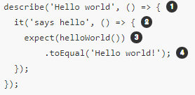

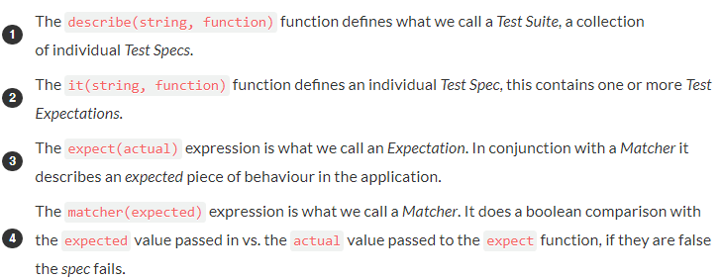

expect(array).toContain(member);
expect(fn).toThrow(string);
expect(fn).toThrowError(string);
expect(instance).toBe(instance);
expect(mixed).toBeDefined();
expect(mixed).toBeFalsy();
expect(mixed).toBeNull();
expect(mixed).toBeTruthy();
expect(mixed).toBeUndefined();
expect(mixed).toEqual(mixed);
expect(mixed).toMatch(pattern);
expect(number).toBeCloseTo(number, decimalPlaces);
expect(number).toBeGreaterThan(number);
expect(number).toBeLessThan(number);
expect(number).toBeNaN();
expect(spy).toHaveBeenCalled();
expect(spy).toHaveBeenCalledTimes(number);
expect(spy).toHaveBeenCalledWith(...arguments);

Setup and teardown
Sometimes in order to test a feature we need to perform some setup, perhaps it’s creating some test objects. Also we may need to perform some cleanup activities after we have finished testing, perhaps we need to delete some files from the hard drive.
These activities are called setup and teardown (for cleaning up) and Jasmine has a few functions we can use to make this easier:
beforeAll
This function is called once, before all the specs in describe test suite are run.
afterAll
This function is called once after all the specs in a test suite are finished.
beforeEach
This function is called before each test specification, it function, has been run.
afterEach
This function is called after each test specification has been run.

describe('Hello world', () => {

let expected = "";

beforeEach(() => {
expected = "Hello World";
});

afterEach(() => {
expected = "";
});

it('says hello', () => {
expect(helloWorld())
.toEqual(expected);
});
});

Running Jasmine tests
To manually run Jasmine tests we would create a HTML file and include the required jasmine javascript and css files like so:
<link rel="stylesheet" href="jasmine.css">
<script src="jasmine.js"></script>
<script src="jasmine-html.js"></script>
<script src="boot.js"></script>

We then load in the parts of our application code that we want to test, for example if our hello world function was in main.js:

<link rel="stylesheet" href="jasmine.css">
<script src="jasmine.js"></script>
<script src="jasmine-html.js"></script>
<script src="boot.js"></script>

<script src="main.js"></script>

Important
The order of script tags is important.
We then would load each individual test suite file, for example if we placed our test suite code above in a file called test.js we would load it in like so:

<link rel="stylesheet" href="jasmine.css">
<script src="jasmine.js"></script>
<script src="jasmine-html.js"></script>
<script src="boot.js"></script>

<script src="main.js"></script>

<script src="test.js"></script>
To run the tests we simply open up the HTML file in a browser.
Once all the files requested via script and link are loaded by a browser the function window.onload is called, this is when Jasmine actually runs the tests.

Karma
Manually running Jasmine tests by refreshing a browser tab repeatedly in different browsers every-time we edit some code can become tiresome.
Karma is a tool which lets us spawn browsers and run jasmine tests inside of them all from the command line. The results of the tests are also displayed on the command line.
Karma can also watch your development files for changes and re-run the tests automatically.
Karma lets us run jasmine tests as part of a development tool chain which requires tests to be runnable and results inspectable via the command line.
It’s not necessary to know the internals of how Karma works. When using the Angular CLI it handles the configuration for us and for the rest of this section we are going to run the tests using only Jasmine.

