Overview
Loamen Proxy Hero is a professional proxy software to test, use and manange proxy list.You can use Loamen Proxy Hero to protect your Internet privacy or access the blocked sites by hiding your real IP using a proxy. Loamen Proxy Hero (LPH) is a professional proxy checker and proxy switcher for your browsers. It can test the details (speed, anonymity, country, city, distance, smtp, ssl) of the proxy and automatically change the proxy settings of your browsers. Moreover, LPH is the client program of Loamen proxy list service. You can easily and quickly get daily fresh proxy list from LPH by just one click.

Features
- Proxy Checker: professionally test the details of the proxies.
- Proxy Switcher: quickly change the proxy settings of the browsers.
- Proxy Downloader: get daily fresh proxy lists by just one click.
- Proxy Manager: easily maintain your personal proxy list.

Source Code
https://github.com/loamen/ProxyHero

License
GNU Lesser General Public License v3.0

Language Setting

Step 1
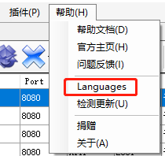

Step 2 Select language file “English.xml”

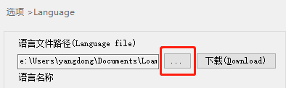

Step 3 Restart Application

