RF-GBT Stacking Ensemble for Forecasting:
Implementation and Evaluation on Two Real-World Datasets
Nhóm: ........................................ | Lớp: ........................................ | Môn học: ........................................
Abstract—This report implements two predictive analytics models identified in the HW1 paper: Random Forest and Gradient Boosted Tree. The two models are evaluated on two real-world forecasting datasets: Bike Sharing for next-hour rental-count prediction and Air Quality for next-hour CO concentration prediction. A combined RF-GBT Stacking model is then developed by using Random Forest and Gradient Boosted Tree as base learners and Ridge Regression as the meta-model. The study also reports an additional extension in which feature engineering and hyperparameter tuning were tested. However, this extension did not outperform the best original baseline models; therefore, the final conclusions are based on the original Random Forest, Gradient Boosted Tree, and RF-GBT Stacking results. Models are evaluated using MAE, RMSE, R², and fitting time.
Keywords—predictive analytics, forecasting, Random Forest, Gradient Boosted Tree, stacking ensemble, regression, hyperparameter tuning

I. INTRODUCTION
Business analytics is commonly discussed as a progression from descriptive analytics to predictive analytics and then prescriptive analytics. Descriptive analytics explains what happened, predictive analytics estimates what will happen, and prescriptive analytics recommends what should be done. The HW1 paper emphasizes that prescriptive analytics often depends on the output of predictive models. Therefore, a reliable forecasting component is an important foundation for later decision support or decision automation.
This assignment focuses on the predictive layer. The objective is not to build a full prescriptive optimization system, but to implement two forecasting models discussed in the HW1 paper and to evaluate whether a combined ensemble can improve prediction accuracy. The selected models are Random Forest and Gradient Boosted Tree, both of which belong to the Machine Learning/Data Mining group of predictive analytics methods. They are appropriate for tabular forecasting tasks because they can model non-linear relationships without requiring strict distributional assumptions.
The proposed development is RF-GBT Stacking. In this approach, Random Forest and Gradient Boosted Tree are used as base learners, and Ridge Regression is used as a meta-model. This design is motivated by the fact that Random Forest and Gradient Boosted Tree learn in different ways. Random Forest reduces variance through averaging many independently trained trees, while Gradient Boosted Tree sequentially corrects prediction errors. Their different learning mechanisms may provide complementary predictions.
In addition to the main implementation, an extension with feature engineering and hyperparameter tuning was tested. This extension included cyclic time features, weekend or rush-hour indicators, interaction features, and validation-based tuning of model parameters. The extension is reported transparently because it is a meaningful development attempt, but the results did not improve upon the best original models. This observation is also useful: it shows that model improvements must be validated empirically rather than assumed.
II. RELATED BACKGROUND
A. Predictive and Prescriptive Analytics
The HW1 paper classifies analytics into three broad stages. Descriptive analytics answers questions about the past and present, predictive analytics estimates future outcomes, and prescriptive analytics recommends actions based on predicted future states and decision constraints. In this work, the forecasting output can be interpreted as the input that a later prescriptive model could use. For example, predicted bike demand could support bike rebalancing decisions, while predicted CO concentration could support pollution warning or mitigation strategies.
B. Tree-Based Ensemble Learning
A decision tree recursively partitions data based on feature conditions. Although a single tree can capture non-linear patterns, it can overfit the training data. Ensemble tree methods improve robustness by combining multiple trees. Random Forest follows the bagging principle: many trees are trained on different bootstrap samples and their predictions are averaged. Gradient Boosted Tree follows the boosting principle: trees are added sequentially to reduce remaining prediction errors.
These two ensemble strategies are useful baselines for supervised regression. Bagging tends to reduce variance and stabilize predictions, while boosting can reduce bias and improve accuracy if the hyperparameters are well chosen. Because the two algorithms have different error behavior, stacking them is a reasonable model development direction.
III. DATASETS AND FORECASTING FORMULATION
Two real-world datasets are used. The Bike Sharing dataset contains hourly rental records with calendar and weather variables. The target variable is cnt(t+1), meaning the number of rentals in the next hour. The Air Quality dataset contains hourly gas-sensor and environmental measurements. The target variable is CO(GT)(t+1), meaning the next-hour CO concentration. Both tasks are formulated as one-step-ahead supervised regression problems.
Dataset summary: Bike Sharing uses cnt(t+1) as the next-hour rental-count target after preprocessing 17,354 rows. Air Quality uses CO(GT)(t+1) as the next-hour CO concentration target after preprocessing 7,649 rows. Bike features include calendar, weather, and lag/rolling demand variables. Air features include sensor, pollutant, environmental, and lag/rolling CO variables.
The datasets are time-dependent; therefore, random shuffling is avoided. Instead, observations are sorted chronologically and split into training, validation, and test portions. This prevents future information from leaking into model training and makes the evaluation closer to a real forecasting scenario. The validation set is used for the stacking meta-model and for additional tuning experiments, while the test set is reserved for final evaluation only.
For both datasets, lag features and rolling features are created. Lag features such as lag_1 and lag_24 represent previous values of the target and allow the model to learn short-term inertia and daily repetition. Rolling mean features summarize recent trends. The construction is done carefully so that only current and past values are used for prediction. In Bike Sharing, the variables casual and registered are removed because their sum equals cnt; keeping them would introduce target leakage.
IV. METHODOLOGY
A. Random Forest Regressor
Random Forest trains multiple decision trees on bootstrap samples of the training data. At each split, a subset of features may be considered, which increases diversity among the trees. For regression, the final output is the average of all tree predictions. This averaging mechanism makes Random Forest robust to noise and suitable for tabular forecasting datasets with non-linear interactions between time, weather, and lag features.
B. Gradient Boosted Tree Regressor
Gradient Boosted Tree builds an additive ensemble of shallow trees. Each new tree is trained to reduce the remaining errors of the current ensemble. The update can be written intuitively as F_m(x) = F_{m-1}(x) + learning_rate × h_m(x), where h_m(x) is the new tree. The learning rate controls how strongly each new tree affects the final model. Gradient boosting can achieve high accuracy, but it is more sensitive to hyperparameters than Random Forest.
C. RF-GBT Stacking
Stacking introduces a second learning layer. First, Random Forest and Gradient Boosted Tree are fitted on the training data. Their validation-set predictions are then used as input features for a Ridge Regression meta-model. Finally, test-set predictions from the two base learners are combined using the trained Ridge model. The goal is to let the meta-model learn whether one learner should receive more weight and whether the two predictions contain complementary information.
D. Additional Feature Engineering and Tuning
A further extension was tested after the main experiment. The feature engineering part added cyclic time encodings, weekend and rush-hour indicators, and interaction features such as temperature-humidity interactions. The hyperparameter tuning part used a manual grid search on the validation set. For Random Forest, the tested parameters included the number of trees, maximum depth, minimum samples per leaf, and maximum features. For Gradient Boosted Tree, the tested parameters included the number of estimators, learning rate, maximum depth, and subsampling ratio.
The purpose of this extension was to check whether more explicit temporal and interaction features, together with tuned parameters, could reduce forecasting error. However, the tuned experiment did not outperform the best original models on the test set. Therefore, it is discussed as an additional experiment and future development direction rather than being treated as the final selected model.
Extension summary: The additional experiment tested cyclic time encodings, weekend and rush-hour indicators, interaction features, and validation-based grid search for RF/GBT parameters. The best tuned configurations did not outperform the best original test RMSE, so the extension is reported as an attempted improvement and future-work direction rather than as the final selected model.
V. EXPERIMENTAL SETUP
The same experimental pipeline is applied to both datasets. First, the data are loaded and sorted by time. Second, the next-step target variable is created. Third, lag and rolling features are generated. Fourth, the dataset is split into train, validation, and test sets in chronological order. Finally, Random Forest, Gradient Boosted Tree, and RF-GBT Stacking are trained and evaluated.
The evaluation metrics are MAE, RMSE, and R². MAE measures the average absolute error and is easy to interpret because it uses the same unit as the target. RMSE is the square root of the mean squared error and penalizes large errors more strongly; it is the main metric used for model comparison. R² measures how much of the target variance is explained by the model. Lower MAE/RMSE and higher R² indicate better predictive performance.
For reproducibility, the notebook uses fixed random states and exports result summaries. The main table in this report is taken from the executed notebook output. The figures are also taken from the notebook-generated plots, ensuring consistency between the code and the report.
VI. RESULTS
TABLE I. TEST RESULTS (RF = RANDOM FOREST, GBT = GRADIENT BOOSTED TREE)
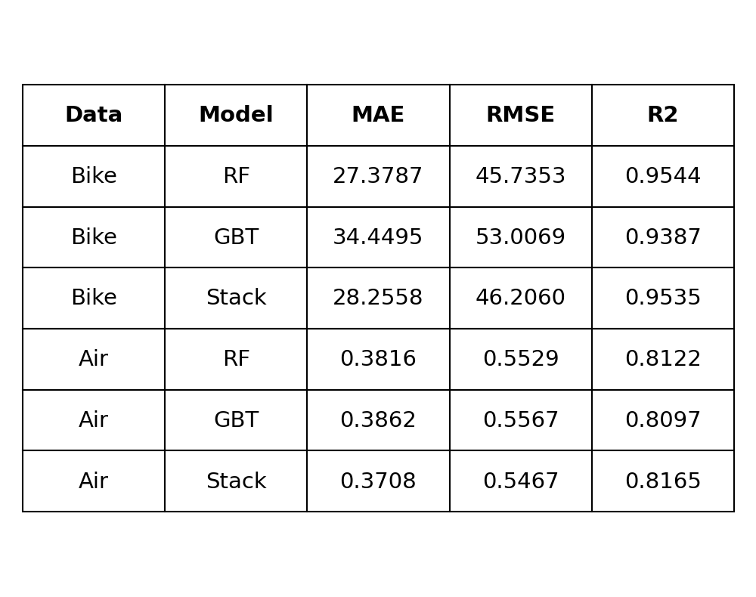
Table I shows the final test results. On Bike Sharing, Random Forest obtains the lowest RMSE and the highest R². RF-GBT Stacking is close to Random Forest, but it does not surpass the best single model. The improvement calculation confirms this: stacking is approximately 1.03% worse than the best Bike Sharing baseline in terms of RMSE. Therefore, the selected model for Bike Sharing is Random Forest.
On Air Quality, RF-GBT Stacking obtains the lowest MAE and RMSE and the highest R² among the three original models. The improvement over the best single baseline is approximately 1.14% in RMSE. Although this gain is modest, it supports the idea that stacking can help when base learners provide complementary signals. Therefore, the selected model for Air Quality is RF-GBT Stacking.
Fig. 1. RMSE comparison from the executed notebook for Bike Sharing and Air Quality. Lower is better.
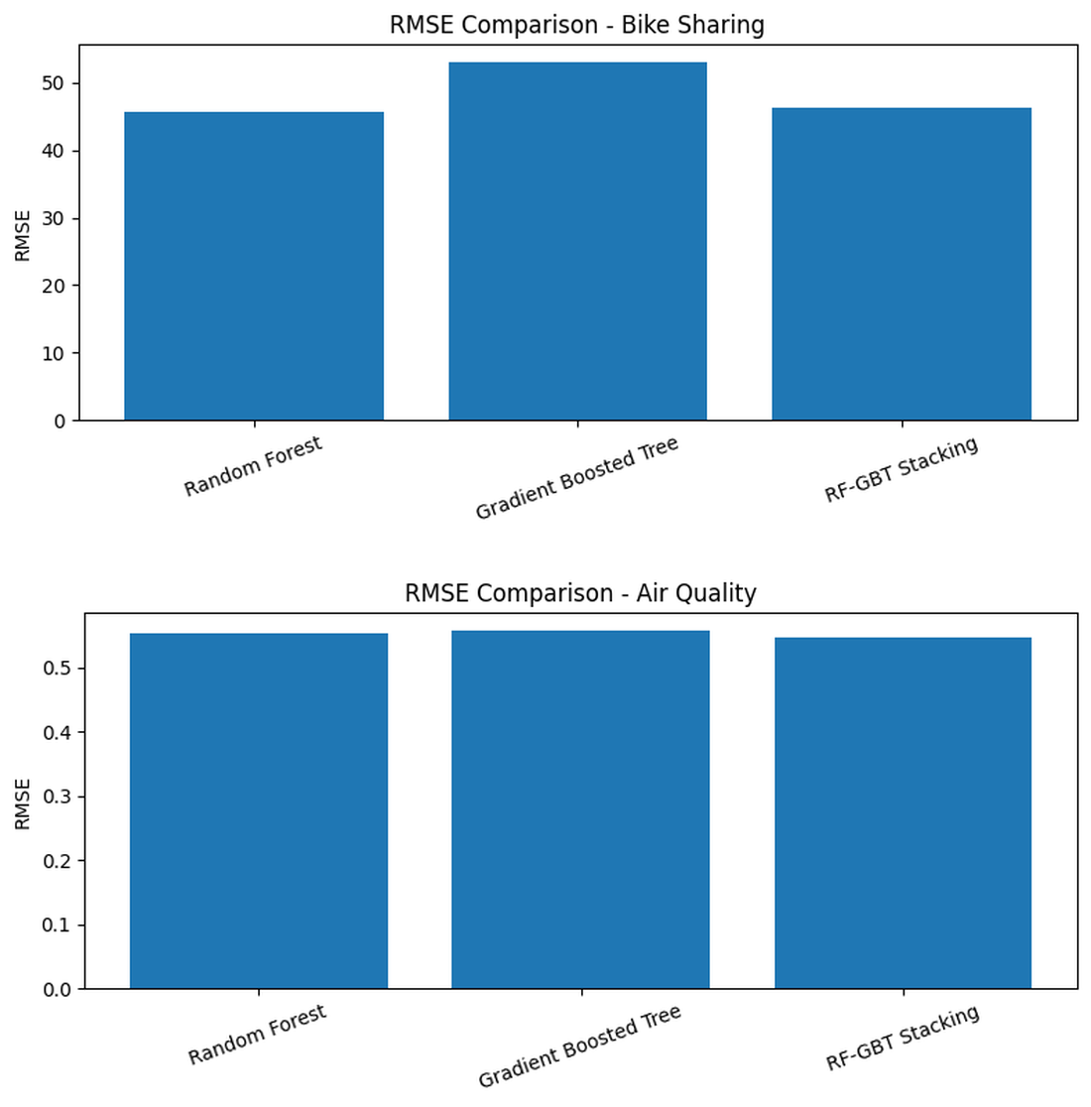
The actual-vs-predicted plots provide additional qualitative insight. For Bike Sharing, Random Forest follows the main demand cycles and captures many peaks, although some extreme values remain smoothed. For Air Quality, RF-GBT Stacking follows the general trend of CO concentration and reduces some deviations compared with individual models. These plots support the quantitative interpretation from the RMSE and R² metrics.
Fig. 2. Actual vs. predicted plots for the final selected models: Random Forest on Bike Sharing and RF-GBT Stacking on Air Quality.
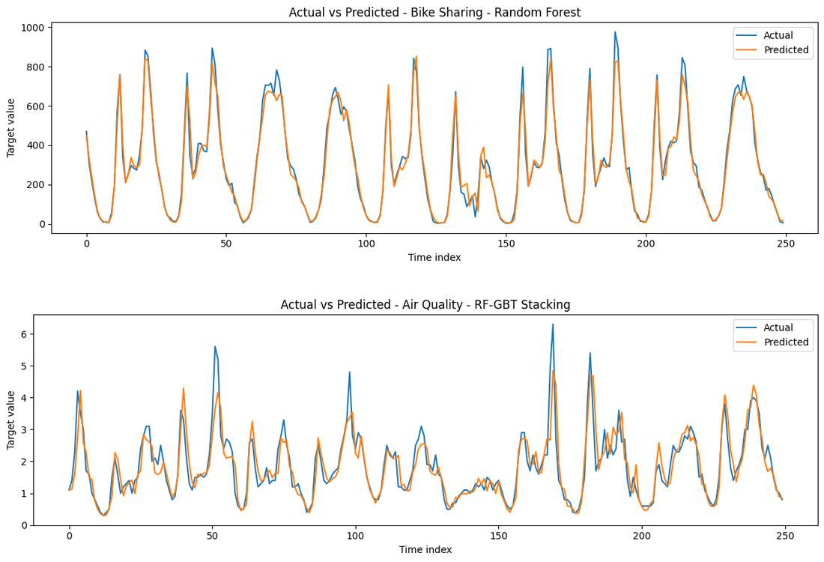
VII. DISCUSSION
A. Interpretation of Bike Sharing Results
The Bike Sharing result indicates that Random Forest is a strong model for this tabular time-dependent dataset. The combination of calendar features, weather variables, and lag features gives Random Forest enough information to model hourly demand patterns. Its averaging mechanism also helps reduce variance and avoid unstable predictions. Stacking does not improve this dataset because the second base learner does not add enough complementary information to overcome the strong Random Forest baseline.
B. Interpretation of Air Quality Results
The Air Quality result is different. RF-GBT Stacking slightly outperforms both individual models. This suggests that the two tree-based learners capture partly different aspects of the sensor data. Random Forest provides stable predictions, while Gradient Boosted Tree may capture residual patterns through sequential error correction. Ridge Regression then combines these two prediction sources. The improvement is small, so it should be interpreted carefully, but it is consistent with the motivation for using stacking.
C. Why the Additional Tuning Did Not Improve
The added feature engineering and hyperparameter tuning did not improve the test results. One reason is that the original lag and rolling features already captured important temporal patterns. Another reason is that additional features can introduce noise if they do not contribute meaningful information. In time-series data, a configuration that performs best on the validation interval may not necessarily generalize to the test interval if the distribution changes over time. This result demonstrates that tuning is a useful experimental step, but it does not guarantee improvement.
A practical lesson is that model selection should be based on final test performance, not on model complexity. In this work, the simpler Random Forest remains the best choice for Bike Sharing, while the original RF-GBT Stacking remains the best choice for Air Quality. The tuned extension is still valuable because it provides evidence about what does not improve the current setting. This is important in an experimental assignment because a proposed improvement should be supported by metrics instead of being accepted only because it is more complicated.
From an implementation perspective, the additional experiment also helped verify the correctness of the validation protocol. Parameters were selected using validation-set RMSE rather than test-set RMSE. Therefore, even though the tuned configuration did not improve the test result, the comparison remains fair and avoids overfitting the conclusion to the test set.
VIII. THREATS TO VALIDITY
This experiment has several limitations. First, the evaluation uses a single chronological train/validation/test split. A rolling-window validation strategy could provide a more stable estimate across multiple time periods. Second, the hyperparameter grid is limited to keep runtime manageable. A broader or randomized search may discover better parameter settings. Third, the study focuses on tree-based models and does not compare against specialized time-series models or deep learning methods. Finally, the datasets represent two domains only, so the conclusions should not be generalized without additional experiments.
IX. FUTURE DEVELOPMENT
Future work can extend this study in four directions. First, the tuning process can be improved using Randomized Search or Bayesian Optimization instead of a small manual grid. These methods can explore a wider parameter space while controlling runtime. Second, the feature set can be refined with more domain-specific variables, such as weekly lag features for bike demand or short-window pollution trends for air quality. Feature selection can also be used to remove noisy added features.
Third, additional base learners can be added to the stacking framework. XGBoost, LightGBM, CatBoost, Support Vector Regression, or neural networks may provide more diverse predictions. A more diverse stacking ensemble may improve performance if the base learners make different types of errors. Fourth, the forecasting outputs can be connected to a prescriptive optimization layer. For Bike Sharing, predicted demand could guide bike redistribution among stations. For Air Quality, predicted CO concentration could support early warning systems or pollution-control recommendations. This would connect the predictive layer implemented in this report with the prescriptive analytics direction emphasized in the HW1 paper.
Another future direction is to separate the effects of feature engineering and tuning. Instead of changing both at the same time, future experiments should test original features with tuned parameters, additional features with default parameters, and additional features with tuned parameters. This ablation study would make it clearer whether performance changes come from the feature set, the parameters, or their interaction.
X. REPRODUCIBILITY AND GITHUB STRUCTURE
The notebook, datasets or data-download instructions, result CSV files, and report should be uploaded to GitHub. A recommended repository structure includes a notebooks folder for the implementation, a data folder or data README, a results folder for metric summaries, and a report folder for the IEEE paper. The README should explain how to install dependencies, download the datasets, and run the notebook from start to finish. This is important because the assignment requires both code and data to be submitted through GitHub. In addition, the repository should include the metric summary CSV file so that the reported values can be checked without rerunning all models. If the raw datasets are not uploaded due to size or licensing concerns, the README should contain direct download instructions and expected file names such as hour.csv and AirQualityUCI.csv.
XI. PRACTICAL IMPLICATIONS
The experimental results have practical meaning beyond the numerical comparison. In the Bike Sharing case, a stable Random Forest model is attractive because it provides strong accuracy without requiring a second learning layer. This means a bike-sharing operator could use a comparatively simple model to forecast next-hour demand and prepare redistribution decisions. In the Air Quality case, the stacking result suggests that combining model outputs can be useful when the underlying sensor relationships are more complex.
The results also show that model development should be evidence-based. A more complex pipeline, such as additional feature engineering or hyperparameter tuning, should not automatically replace a simpler baseline. Instead, the final deployment choice should be made according to test RMSE, interpretability, runtime, and reproducibility. In real applications, the selected model should also be monitored over time because traffic behavior, weather patterns, and pollution dynamics may change.
XII. CONCLUSION
This report implemented two predictive analytics models from the HW1 paper, Random Forest and Gradient Boosted Tree, and evaluated them on two real-world forecasting datasets. It also developed RF-GBT Stacking as a combined model using Ridge Regression as the meta-model. The results show that Random Forest is the best model on Bike Sharing, while RF-GBT Stacking is the best model on Air Quality. An additional feature engineering and hyperparameter tuning experiment was conducted, but it did not improve over the best original models. Therefore, the final model selection is based on the original baseline and stacking results. The study shows that model combination can be beneficial, but only when the base models provide complementary predictive information.
REFERENCES
[1] K. Lepenioti, A. Bousdekis, D. Apostolou, and G. Mentzas, “Prescriptive analytics: Literature review and research challenges,” International Journal of Information Management, vol. 50, pp. 57-70, 2020.
[2] A. Liaw and M. Wiener, “Classification and regression by randomForest,” R News, vol. 2, no. 3, pp. 18-22, 2002.
[3] J. H. Friedman, “Greedy function approximation: A gradient boosting machine,” Annals of Statistics, vol. 29, no. 5, pp. 1189-1232, 2001.
[4] A. E. Hoerl and R. W. Kennard, “Ridge regression: Biased estimation for nonorthogonal problems,” Technometrics, vol. 12, no. 1, pp. 55-67, 1970.
[5] UCI Machine Learning Repository, Bike Sharing and Air Quality datasets. Accessed in the experiment notebook.

