Configure SSL for ContosoServices8585 Web site

The following are the steps for configuring ContosoServices8585 Web site in IIS to use the temporary certificate created in the ContosoSetup batch script for Secure Sockets Layer (SSL) communication. This will enable SSL for the transport communication.

## SSL setup steps for IIS version 7

1. Click **Start** and then click **Run**.
2. In the Run dialog box, type **inetmgr** and then click OK.
3. In the Internet Information Services (IIS) Manager dialog box, expand the (local computer) node, and then expand the **Sites** node.
4. Click **ContosoServices8585** and then click **Bindings...** in the **Actions** pane.  This brings up the bindings editor that lets you create, edit, and delete bindings for your website.

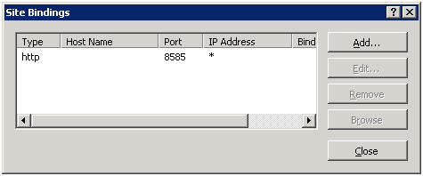

1. Click the **Add...** button to add your new SSL binding to the site. New bindings default to http on port 80.

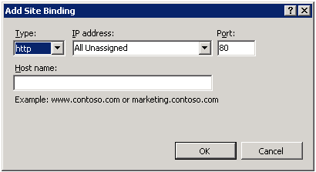

1. Select **https** in the **Type** drop-down. New bindings default to https on port **443**

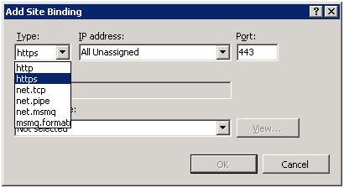

1. Change Port from 443 to **8686**. And select the certificate which has **your computer name** (that is automatic created by ContosoSetup.bat) from the **SSL Certificate** drop-down and click **OK**. Make sure to select the certificate that is issued by **ContosoRootCATest**.
   * 1. 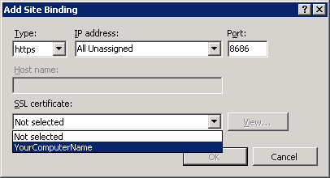
2. Click **Close.** Now you have a new SSL binding on your site and all that remains is to verify that works.

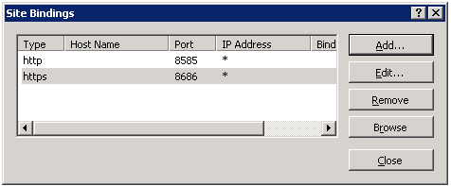

1. Restart IIS

## SSL setup steps for IIS version 6

1. Click **Start** and then click **Run**.
2. In the Run dialog box, type **inetmgr** and then click OK.
3. In the Internet Information Services (IIS) Manager dialog box,expand the (local computer) node, and then expand the **Web Sites** node.
4. Right-click **ContosoServices8585** Web Site and then click **Properties**.
5. In the ContosoServices8585 Web Site Properties dialog box, click the D**irectory Security** tab, and then in the **Secure Communications** section, click **Server Certificate**…
6. On the Web Server Certificate Wizard welcome screen, click **Next** to continue.
7. On the Server Certificate screen, select the **Assign an existing certificate** radio button option, and then click **Next**.
8. On the Available Certificates screen, select the certificate which has your computer name (that is automatic created by ContosoSetup.bat), and then click Next. Make sure to select the certificate that is issued by **ContosoRootCATest**.
9. Change the port number from **443** to **8686**. Click **Next**.
10. Verify the information on the certificate summary screen, and then click **Next**.
11. Click **Finish** to complete the certificate installation.
12. In the ContosoServices8585 Web Site Properties dialog box, click OK.
13. Restart IIS.