7-laborotoriya

Mavzu:CSS orqali matn va bloklarni bezash:
Fan.Web texnologiyalar.
Ishdan maqsad. CSS yordamida veb-sahifadagi matn va blok elementlarni zamonaviy, estetik va funksional ko‘rinishga keltirish usullarini o‘rganish va amaliyotda qo‘llash orqali foydalanuvchi interfeysini yaxshilash.
Nazariy qisim.CSS (Cascading Style Sheets) — bu HTML hujjatlarining tashqi ko‘rinishini boshqarish uchun ishlatiladigan uslublar jadvali tilidir. HTML veb-sahifadagi elementlarning tarkibini belgilasa, CSS esa ularning ko‘rinishi, joylashuvi, o‘lchami, rangi va boshqa estetik xususiyatlarini belgilaydi. Veb-dizaynning asosiy qismi sahifadagi matn va blok elementlarni to‘g‘ri bezashdan iborat bo‘lib, bu foydalanuvchiga qulay, tushunarli va jozibador interfeys yaratishda muhim o‘rin tutadi.

1. Matnni bezashda CSS ning o‘rni
Matn (typografiya) veb-sahifaning eng ko‘p foydalaniladigan elementi hisoblanadi. Matnning noto‘g‘ri tanlangan o‘lchami, rangi yoki masofasi o‘qishni qiyinlashtiradi. CSS yordamida matn quyidagi xususiyatlar orqali boshqariladi:

font-family — shrift oila turi (Arial, Times New Roman, Roboto va boshqalar)
font-size — matn kattaligini belgilaydi
font-weight — shriftning qalinligini belgilaydi (normal, bold)
color — matn rangini belgilaydi
text-align — matnning joylashuvini belgilaydi (chap, o‘ng, markazda)
line-height — matn satrlari orasidagi balandlik
letter-spacing — harflar orasidagi masofa
text-transform — matnni katta/kichik harfga o‘tkazish
text-shadow — matn soyasi To‘g‘ri tanlangan font va masofalar matnning o‘qilish qulayligini oshiradi. Shu sababli responsiv dizaynda shrift o‘lchamlarini % yoki rem birliklarida belgilash tavsiya etiladi.

2. Blok elementlarni bezash
Veb-sahifa tuzilmasi blok elementlardan iborat bo‘ladi (div, section, header, footer va boshqalar). Blok dizayni foydalanuvchi e’tiborini kerakli joyga yo‘naltirish va navigatsiyani soddalashtirishga xizmat qiladi. CSS bloklar uchun quyidagi xususiyatlarni ta’minlaydi:
width va height — blok o‘lchamlari
margin — blok atrofidagi tashqi masofa
padding — blok ichidagi bo‘shliq
border — blok chekka chizig‘i
border-radius — burchaklarni yumaloqlash
background-color / background-image — fon rang yoki rasm
box-shadow — blok soyasi
Bloklarni joylash uchun zamonaviy metodlar:
Flexbox — elementlarni gorizontal yoki vertikal yo‘nalishda tartiblaydi
CSS Grid — murakkab sahifa maketlarini yaratishga imkon beradi. Bu usullar eski float texnikasiga nisbatan tezroq va moslashuvchan.

3. Rangi va kontrastning ahamiyati
Dizaynda to‘g‘ri ranglar uyg‘unligi muhim. Matn va fon rangi o‘zaro kontrastli bo‘lishi shart. Masalan, oq fon ustida qora yoki to‘q matn o‘qish uchun eng qulay.
Ijobiy dizayn amaliyoti:
Juda yorqin yoki juda xira ranglardan qochish
Katta muhim bo‘limlar uchun ta’kid (highlight) ranglardan foydalanish
Brend konsepsiyasiga mos rang sxemasini tanlash

4. Responsiv (moslashuvchan) dizayn
Turli ekran o‘lchamlarida sahifaning to‘g‘ri ko‘rinishi uchun CSS’da media queries ishlatiladi:

@media (max-width: 600px) {
body {
font-size: 14px;
}
}
Bu CSS media query deb ataladi. Media query — sahifaning ekranga mos tarzda ko‘rinishini ta'minlaydigan CSS qoidasi. Ya'ni responsiv dizayn qilish uchun ishlatiladi. (max-width: 600px) shuni anglatadi:
Agar ekran kengligi 600 piksel yoki undan kichik bo‘lsa, ichidagi CSS qoidalari ishga tushadi. Bu odatda telefonlar va kichik ekranli qurilmalar uchun qo‘llanadi. Bu mobil qurilmalarda matn va bloklarning mos o‘lchamlarda ko‘rinishini ta’minlaydi.

Amaliy qismi:
Kod qismi: <!doctype html>
<html lang="uz">
<head>
<meta charset="utf-8">
<meta name="viewport" content="width=device-width,initial-scale=1">
<title>Pasport ma'lumotlari — Form</title>
<style>
:root{
--bg:#c114d1;
--card:#6de00f;
--accent:#0b4edd;
--muted:#43ce20;
--danger:#e40f0f;
--radius:12px;
--shadow: 0 6px 20px rgba(16,24,40,0.08);
--max-width:920px;
font-family: Inter, ui-sans-serif, system-ui, -apple-system, "Segoe UI", Roboto, "Helvetica Neue", Arial;
color-scheme: light;
}

*{box-sizing:border-box}
html,body{height:100%}
body{
margin:0;
background:linear-gradient(180deg,var(--bg),#eef2ff 100%);
display:flex;
align-items:center;
justify-content:center;
padding:32px;
-webkit-font-smoothing:antialiased;
-moz-osx-font-smoothing:grayscale;
}

.container{
width:100%;
max-width:var(--max-width);
background:var(--card);
border-radius:var(--radius);
box-shadow:var(--shadow);
padding:28px;
overflow:hidden;
}

header{
display:flex;
align-items:center;
gap:16px;
margin-bottom:18px;
}

.logo{
width:56px;height:56px;border-radius:10px;
background:linear-gradient(135deg,var(--accent),#7c3aed);
display:flex;align-items:center;justify-content:center;color:#fff;font-weight:700;font-size:20px;
box-shadow:0 6px 18px rgba(37,99,235,0.18);
}

h1{font-size:20px;margin:0}
p.lead{margin:0;color:var(--muted);font-size:14px}

form{margin-top:12px}

.card-grid{
display:grid;
grid-template-columns:1fr;
gap:18px;
}

@media(min-width:840px){
.card-grid{grid-template-columns:1fr 380px;align-items:start}
}

.panel{
background:linear-gradient(180deg,#fff,#fbfdff);
border-radius:10px;padding:18px;border:1px solid rgba(15,23,42,0.03);
}

.field{display:flex;flex-direction:column;margin-bottom:12px}
label{font-size:13px;color:#111827;margin-bottom:6px}
.hint{font-size:12px;color:var(--muted);margin-top:6px}

input[type=text], input[type=email], input[type=date], input[type=number], input[type=password], select, textarea{
width:100%;
padding:10px 12px;
border-radius:8px;
border:1px solid #e6e9ef;
outline:0;font-size:14px;
transition:box-shadow .15s, border-color .15s;
}
input:focus, select:focus, textarea:focus{
border-color:rgba(37,99,235,0.9);
box-shadow:0 6px 18px rgba(37,99,235,0.08);
}

textarea{min-height:90px;resize:vertical}

.two-col{display:grid;grid-template-columns:1fr 1fr;gap:12px}
@media(max-width:420px){.two-col{grid-template-columns:1fr}}

.file-input{display:flex;align-items:center;gap:12px}
.file-btn{padding:8px 10px;border-radius:8px;border:1px dashed #dbeafe;background:#f8fbff;cursor:pointer}
.photo-preview{width:100%;height:220px;border-radius:8px;border:1px solid #e5e7eb;display:flex;align-items:center;justify-content:center;overflow:hidden;background:#fafafa}
.photo-preview img{width:100%;height:100%;object-fit:cover}

.actions{display:flex;gap:10px;align-items:center;margin-top:12px}
button.primary{
background:var(--accent);color:#fff;padding:10px 14px;border-radius:10px;border:0;cursor:pointer;font-weight:600;
box-shadow:0 8px 30px rgba(37,99,235,0.16);
}
button.ghost{background:transparent;border:1px solid #e6e9ef;padding:10px 12px;border-radius:10px;cursor:pointer}

.error{color:var(--danger);font-size:13px;margin-top:6px}

footer.note{font-size:13px;color:var(--muted);margin-top:14px}

/* Small helper styles for info list */
.info-list{display:flex;flex-direction:column;gap:10px}
.info-item{display:flex;justify-content:space-between;align-items:center;padding:10px;border-radius:8px;border:1px dashed #eef2ff;background:linear-gradient(180deg,#fff,#fbfdff)}
.info-item strong{font-size:13px}

</style>
</head>
<body>
<main class="container" role="main">
<header>
<div class="logo">P</div>
<div>
<h1>Pasport ma'lumotlari</h1>
<p class="lead">CSS bilan bezatilgan foydalanuvchi forma. Kerakli maydonlarni to'ldirib, saqlang.</p>
</div>
</header>

<form id="passportForm" class="" action="#" method="post" enctype="multipart/form-data" novalidate>
<div class="card-grid">
<!-- LEFT: Form fields -->
<section class="panel" aria-labelledby="form-heading">
<h2 id="form-heading" style="font-size:16px;margin:0 0 8px 0">Asosiy ma'lumotlar</h2>

<div class="two-col">
<div class="field">
<label for="surname">Familiya</label>
<input id="surname" name="surname" type="text" placeholder="Familiyangiz" required>
<div class="error" data-for="surname"></div>
</div>

<div class="field">
<label for="givenName">Ism</label>
<input id="givenName" name="givenName" type="text" placeholder="Ismingiz" required>
<div class="error" data-for="givenName"></div>
</div>
</div>

<div class="two-col">
<div class="field">
<label for="patronymic">Otasining ismi (agar mavjud)</label>
<input id="patronymic" name="patronymic" type="text" placeholder="Otasining ismi">
</div>

<div class="field">
<label for="passportNumber">Pasport raqami</label>
<input id="passportNumber" name="passportNumber" type="text" placeholder="AA1234567" pattern="[A-Za-z0-9]{5,20}" required>
<div class="hint">Harflar va raqamlar, 5–20 belgi</div>
<div class="error" data-for="passportNumber"></div>
</div>
</div>

<div class="two-col">
<div class="field">
<label for="nationality">Fuqarolik (Millat)</label>
<input id="nationality" name="nationality" type="text" placeholder="O'zbekiston" required>
<div class="error" data-for="nationality"></div>
</div>

<div class="field">
<label for="gender">Jinsi</label>
<select id="gender" name="gender" required>
<option value="">— Tanlang —</option>
<option value="male">Erkak</option>
<option value="female">Ayol</option>
<option value="other">Boshqa</option>
</select>
<div class="error" data-for="gender"></div>
</div>
</div>

<div class="two-col">
<div class="field">
<label for="birthDate">Tug'ilgan sana</label>
<input id="birthDate" name="birthDate" type="date" required>
<div class="error" data-for="birthDate"></div>
</div>

<div class="field">
<label for="birthPlace">Tug'ilgan joy</label>

</div>

</aside>

</div>
</html>
Natija: Pasport ma’lumotlari saytimizning tayyor qismi yani biroz bo’rttirilgan holda stil berganman.
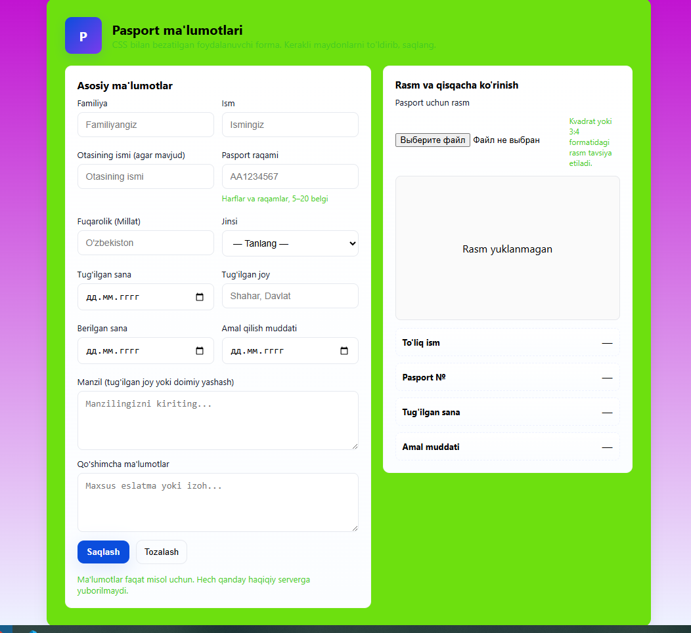

Rasim qo’yish uchun yangi oyna chiqargan qismim.
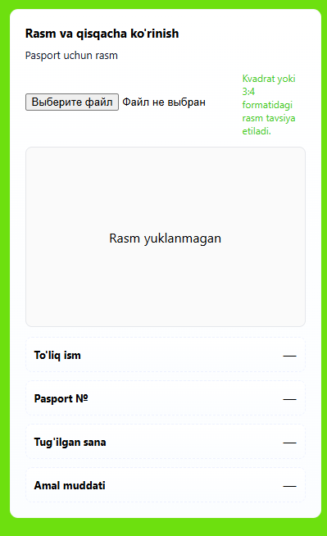
Xulosa:CSS orqali matn va bloklarni bezash — veb-dizaynning eng muhim bosqichlaridan biridir. Ushbu mavzuni o‘rganish davomida matnning shrift turi, o‘lchami, rangi, joylashuvi va o‘qilish qulayligini ta’minlovchi asosiy xususiyatlar bilan tanishildi. Shuningdek, HTML sahifasidagi blok elementlarga ramka, bo‘shliq, fon, soya va burchaklarni yumaloqlash kabi bezak berish usullari amalda ko‘rib chiqildi. ko‘rsatib o‘tildi.

