- Lobarotoriya
Mavzu:JavaScript eventlar bilan ishlash (click, submit, change)
Fan nomi:Web tyexnologiya
Ishdan maqsad:Ushbu amaliy ishning asosiy maqsadi — JavaScript dasturlash tili yordamida veb-sahifadagi foydalanuvchi harakatlarini kuzatish, ularni qayta ishlash va dinamik interaktiv interfeyslar yaratish ko‘nikmalarini shakllantirishdir.

Nazariy ma’lumot:

Hodisalarni boshqarish mexanizmini o‘rganish

Veb-elementlarga addEventListener metodi orqali hodisa tinglovchilarini biriktirish va foydalanuvchi harakat qilganda ma'lum bir funksiyani ishga tushirish (callback functions) tamoyillarini o'zlashtirish.

2. Click (Bosish) hodisasi bilan ishlash
Foydalanuvchi tugmalarni yoki boshqa elementlarni bosganda sahifadagi ma'lumotlarni o'zgartirish, menyularni ochish/yopish yoki yangi elementlar qo'shish kabi interaktiv amallarni bajarishni o'rganish.

3. Submit (Yuborish) hodisasi va shakllar nazorati
Foydalanuvchi tomonidan to'ldirilgan ma'lumotlarni (form) serverga yuborishdan oldin tutib qolish (preventDefault), ma'lumotlar to'g'riligini tekshirish (validation) va xatoliklarni real vaqtda ko'rsatish ko'nikmasini hosil qilish.

4. Change (O'zgarish) hodisasi orqali dinamikani ta'minlash
Input, select yoki checkbox kabi elementlardagi qiymatlar o'zgarganda sahifa tarkibini darhol yangilash (masalan, filtrlar bilan ishlash yoki narxlarni hisoblash) usullarini amalda qo'llash.

5. DOM bilan aloqani mustahkamlash
Hodisalar sodir bo'lganda Document Object Model (DOM) bilan manipulyatsiya qilish, ya'ni HTML elementlarini dasturiy ravishda o'zgartirish orqali "tirik" veb-ilovalar yaratish tajribasiga ega bo'lish.

Kutilayotgan natija:
Ish yakunida siz foydalanuvchining har bir harakatiga (tugma bosilishi, ma'lumot kiritilishi) mantiqiy javob qaytaruvchi, ma'lumotlarni xatosiz qayta ishlaydigan va interaktivlik darajasi yuqori bo'lgan funksional veb-sahifa yarata olasiz.

Kod qsmi:
<!DOCTYPE html>
<html lang="uz">
<head>
<meta charset="utf-8">
<meta name="viewport" content="width=device-width, initial-scale=1.0">
<title>Elektron Pasport Ma'lumotlari</title>
<link rel="stylesheet" href="passport.css">
<script src="passport.js" defer></script>
</head>
<body>

<div class="passport-card">
<div class="watermark">UZB</div>

<h2>O'zbekiston Respublikasi</h2>

<!-- Controls: edit / save / reset -->
<div style="display:flex; gap:8px; justify-content:center; margin-bottom:12px;">
<button id="btn-edit" class="btn-verify" style="width:auto; padding:8px 12px;">Tahrirlash</button>
<button id="btn-save" class="btn-verify" style="width:auto; padding:8px 12px; display:none;">Saqlash</button>
<button id="btn-reset" class="btn-verify" style="width:auto; padding:8px 12px; background:rgba(200,30,30,0.9);">Qayta tiklash</button>
</div>

<!-- Add custom field (key, label, value) - wrapped in a form to demonstrate submit event -->
<form id="add-field-form" style="display:flex; gap:8px; justify-content:center; margin-bottom:12px;" autocomplete="off">
<input id="new-key" name="key" placeholder="kalit (mas: company)" style="padding:8px; border-radius:6px; border:none; min-width:100px;">
<input id="new-label" name="label" placeholder="label (mas: Manzil)" style="padding:8px; border-radius:6px; border:none; min-width:140px;">
<input id="new-value" name="value" placeholder="qiymat" style="padding:8px; border-radius:6px; border:none; min-width:140px;">
<button id="btn-add" type="submit" class="btn-verify" style="width:auto; padding:8px 12px;">Qo'shish</button>
</form>

<div class="info-group">
<span class="label">Familiyasi / Surname:</span>
<span class="value" data-field="surname">Ro'zimova</span>
</div>

<div class="info-group">
<span class="label">Ismi / Given Names:</span>
<span class="value" data-field="given">lobar</span>
</div>

<div class="info-group">
<span class="label">Millati / Nationality:</span>
<span class="value" data-field="nationality">O'ZBEK</span>
</div>

<div class="info-group">
<span class="label">Tug'ilgan sanasi / Date of birth:</span>
<span class="value" data-field="dob">15.05.2004</span>
</div>

<div class="info-group">
<span class="label">Jinsi / Sex:</span>
<span class="value" data-field="sex">ERKAK / MALE</span>
</div>

<div class="info-group">
<span class="label">Pasport seriyasi va raqami:</span>
<span class="value serial-number" data-field="serial">AA 1234567</span>
</div>

<div class="info-group">
<span class="label">Amal qilish muddati:</span>
<span class="value" data-field="expiry" style="color: #e74c3c;">25.05.2030</span>
</div>

<!-- custom fields will be rendered here -->
<div id="custom-fields"></div>

<button class="btn-verify">Ma'lumotlarni tasdiqlash</button>

<a class="back-link" href="index.html">← Ortga (Bosh sahifaga)</a>
</div>

</body>
</html>

Amaliyqism:
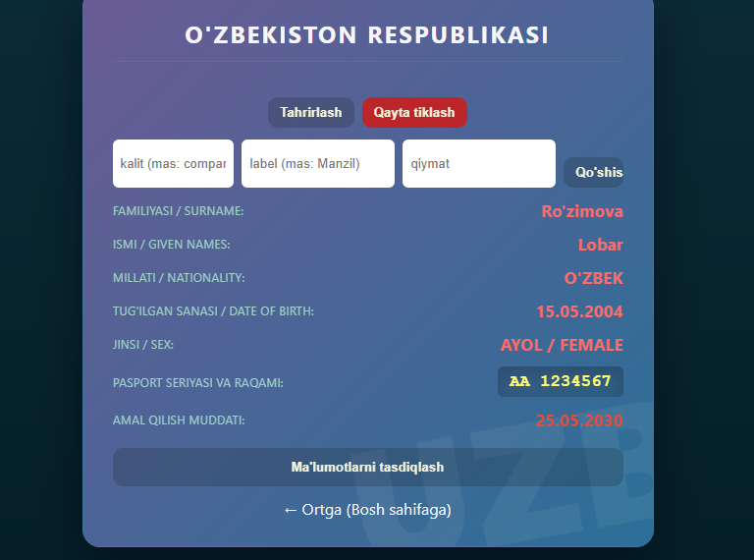
Xulosa:
Umumiy xulosa qilib aytganda, JavaScript hodisalari bilan ishlash mahorati frontend dasturchisi uchun eng muhim ko‘nikmalardan biri bo‘lib, u zamonaviy, tezkor va foydalanuvchi uchun qulay interfeyslar yaratishning poydevori hisoblanadi.

