LABORATORIYA ISHI № 1
Mavzu: jQuery va PHP yordamida AJAX so‘rovlari yuborish va javobni qayta ishlash
1. Ishning maqsadi
Ushbu laboratoriya ishining maqsadi talabalarga jQuery va PHP texnologiyalari yordamida AJAX so‘rovlarini yuborish, server tomondan kelgan javoblarni qabul qilish hamda ularni veb sahifada sahifani yangilamasdan dinamik tarzda aks ettirish ko‘nikmalarini hosil qilishdan iborat.
2. Nazariy ma’lumotlar
2.1. AJAX tushunchasi
AJAX (Asynchronous JavaScript and XML) — bu veb sahifani to‘liq qayta yuklamasdan turib server bilan ma’lumot almashish texnologiyasidir. AJAX yordamida foydalanuvchi interfeysi tezkor va qulay bo‘ladi.
AJAX asosan quyidagi texnologiyalar asosida ishlaydi:
- HTML / CSS
- JavaScript
- jQuery
- PHP
- JSON yoki oddiy matn formatlari
2.2. jQuery AJAX metodlari
jQuery AJAX bilan ishlashni soddalashtiradi. Eng ko‘p ishlatiladigan metodlar:
- $.ajax()
- $.get()
- $.post()
Ularning afzalligi:
- Kam kod yoziladi
- Xatoliklarni oson boshqarish mumkin
- Brauzerlararo moslik mavjud
2.3. PHP server tomoni
PHP — server tomonda ishlovchi dasturlash tili bo‘lib, foydalanuvchidan kelgan AJAX so‘rovlarini qabul qiladi va qayta ishlaydi. PHP orqali:
- Ma’lumot qabul qilish
- Tekshirish
- JSON yoki matn ko‘rinishida javob qaytarish mumkin
3. Kerakli dasturiy vositalar
- Web-brauzer (Google Chrome, Mozilla Firefox)
- Matn muharriri (VS Code, Sublime Text)
- Lokal server (XAMPP, OpenServer yoki Denwer)
- PHP 7.x yoki undan yuqori
4. Laboratoriya ishining bajarilish tartibi
4.1. Loyiha tuzilmasini yaratish
ajax_lab/
│
├── index.php
├── script.js
└── server.php
5. Amaliy qism
5.1. Foydalanuvchi interfeysini yaratish (index.php)
<!DOCTYPE html>
<html lang="uz">
<head>
<meta charset="UTF-8">
<title>AJAX jQuery + PHP</title>

<script src="https://code.jquery.com/jquery-3.6.0.min.js"></script>
<script src="script.js"></script>
</head>
<body>

<h2>AJAX orqali ma’lumot yuborish</h2>

<label>Ism:</label><br>
<input type="text" id="name"><br><br>

<label>Yosh:</label><br>
<input type="number" id="age"><br><br>

<button id="sendBtn">Yuborish</button>

<h3>Natija:</h3>
<div id="result"></div>

</body>
</html>
5.2. jQuery AJAX kodi (script.js)
$(document).ready(function () {

$("#sendBtn").click(function () {

let name = $("#name").val();
let age = $("#age").val();

$.ajax({
url: "server.php",
type: "POST",
data: {
name: name,
age: age
},
success: function (response) {
$("#result").html(response);
},
error: function () {
$("#result").html("Xatolik yuz berdi!");
}
});

});

});
5.3. Server tomoni (server.php)
<?php

if(isset($_POST['name']) && isset($_POST['age'])) {

$name = htmlspecialchars($_POST['name']);
$age = intval($_POST['age']);

if($name == "" || $age <= 0){
echo "Iltimos, barcha maydonlarni to‘ldiring!";
} else {
echo "Ism: <b>$name</b><br>";
echo "Yosh: <b>$age</b>";
}

} else {
echo "Ma’lumot kelmadi!";
}

?>
6. Ish natijasi
Laboratoriya ishi bajarilgandan so‘ng talaba:
- jQuery yordamida AJAX so‘rovi yubora oladi
- PHP orqali POST ma’lumotlarni qabul qiladi
- Serverdan qaytgan javobni sahifani yangilamasdan ko‘rsatadi
- Xatoliklarni boshqarishni o‘rganadi
7. Nazorat savollari
- AJAX nima va u nima uchun ishlatiladi?
- jQuery AJAX ning afzalliklari nimada?
- $.ajax() metodining asosiy parametrlari qaysilar?
- PHP da POST ma’lumotlar qanday olinadi?
- AJAX yordamida sahifa nega qayta yuklanmaydi?
8. Mustaqil topshiriqlar
18-topshiriq. Texnik yordam
Texnik yordam so‘rovi formasini yarating.
Talablar:
Forma maydonlari: support_login, support_email, support_muammo, support_daraja, support_sana
Muammo darajasi tanlov orqali bo‘lsin
Javob rangli chiqsin.
Amaliy qismi:
Kod qismi: <!DOCTYPE html>
<html lang="uz">
<head>
<meta charset="UTF-8">
<title>Texnik Yordam So‘rovi</title>

<!-- Google Font -->
<link href="https://fonts.googleapis.com/css2?family=Poppins:wght@300;500;700&display=swap" rel="stylesheet">

<style>
body {
margin: 0;
height: 100vh;
font-family: 'Poppins', sans-serif;
background: linear-gradient(135deg, #667eea, #764ba2);
display: flex;
justify-content: center;
align-items: center;
animation: bgMove 8s infinite alternate;
}

@keyframes bgMove {
from { filter: hue-rotate(0deg); }
to { filter: hue-rotate(40deg); }
}

.container {
background: white;
padding: 30px 40px;
width: 400px;
border-radius: 20px;
box-shadow: 0 20px 40px rgba(0,0,0,0.2);
animation: fadeIn 1.2s ease;
}

@keyframes fadeIn {
from { opacity: 0; transform: translateY(40px); }
to { opacity: 1; transform: translateY(0); }
}

h2 {
text-align: center;
color: #5a3fc0;
margin-bottom: 20px;
}

label {
font-size: 14px;
color: #444;
}

input, textarea, select {
width: 100%;
padding: 10px;
margin: 8px 0 15px;
border-radius: 10px;
border: 1px solid #ccc;
transition: 0.3s;
}

input:focus, textarea:focus, select:focus {
border-color: #764ba2;
box-shadow: 0 0 8px #764ba2;
outline: none;
}

button {
width: 100%;
padding: 12px;
background: linear-gradient(135deg, #667eea, #764ba2);
color: white;
border: none;
border-radius: 12px;
font-size: 16px;
cursor: pointer;
transition: 0.4s;
}

button:hover {
transform: scale(1.05);
box-shadow: 0 10px 20px rgba(0,0,0,0.3);
}

.result {
margin-top: 20px;
padding: 15px;
border-radius: 12px;
display: none;
animation: slideUp 0.6s ease;
}

@keyframes slideUp {
from { opacity: 0; transform: translateY(20px); }
to { opacity: 1; transform: translateY(0); }
}

.low { background: #d4edda; color: #155724; }
.medium { background: #fff3cd; color: #856404; }
.high { background: #f8d7da; color: #721c24; }
</style>
</head>
<body>

<div class="container">
<h2>🛠 Texnik Yordam</h2>

<form id="supportForm">
<label>Login</label>
<input type="text" id="support_login" required>

<label>Email</label>
<input type="email" id="support_email" required>

<label>Muammo tavsifi</label>
<textarea id="support_muammo" rows="3" required></textarea>

<label>Muammo darajasi</label>
<select id="support_daraja" required>
<option value="">Tanlang</option>
<option value="low">Past</option>
<option value="medium">O‘rtacha</option>
<option value="high">Yuqori</option>
</select>

<label>Sana</label>
<input type="date" id="support_sana" required>

<button type="submit">Yuborish 🚀</button>
</form>

<div id="result" class="result"></div>
</div>

<script>
document.getElementById("supportForm").addEventListener("submit", function(e){
e.preventDefault();

let daraja = document.getElementById("support_daraja").value;
let result = document.getElementById("result");

result.className = "result " + daraja;
result.style.display = "block";

result.innerHTML = `
<strong>✅ So‘rov yuborildi!</strong><br>
Muammo darajasi: <b>${daraja.toUpperCase()}</b><br>
Tez orada siz bilan bog‘lanamiz.
`;
});
</script>

</body>
</html>
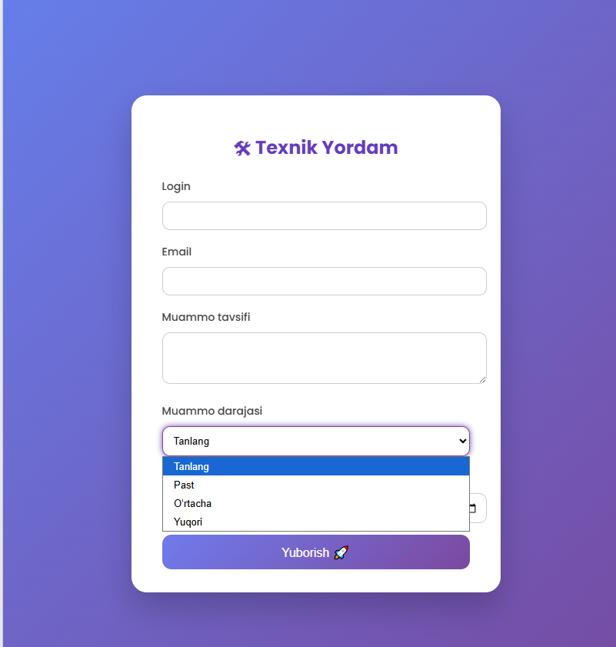

Savollarga javob:
1.AJAX (Asynchronous JavaScript and XML) — bu veb-texnologiya bo‘lib, u brauzer va server o‘rtasida ma’lumot almashishni sahifani to‘liq qayta yuklamasdan amalga oshirish imkonini beradi. AJAX JavaScript yordamida ishlaydi va foydalanuvchi biror amal bajargan paytda serverga so‘rovni fon rejimida yuboradi. Natijada sahifa yangilanmaydi, faqat kerakli ma’lumotlar olinadi yoki yuboriladi.
2.jQuery AJAX — bu AJAX texnologiyasi bilan ishlashni yanada oson va qulay qiladigan jQuery kutubxonasining maxsus funksiyalari to‘plamidir. U brauzer bilan server o‘rtasida ma’lumot almashishni sahifani qayta yuklamasdan amalga oshirish imkonini beradi va murakkab JavaScript kodlarini yozishga bo‘lgan ehtiyojni kamaytiradi.
3.$.ajax() — bu jQuery kutubxonasidagi eng kuchli va moslashuvchan AJAX metodi bo‘lib, u brauzer bilan server o‘rtasida ma’lumot almashishni sahifani qayta yuklamasdan amalga oshirish imkonini beradi. Ushbu metod yordamida GET yoki POST orqali serverga so‘rov yuborish, turli formatdagi ma’lumotlarni qabul qilish va ularni sahifada dinamik tarzda chiqarish mumkin.
4.PHP’da POST orqali yuborilgan ma’lumotlar $_POST superglobal massivi orqali olinadi. $_POST — bu PHP tilida oldindan yaratilgan maxsus massiv bo‘lib, HTML forma yoki AJAX so‘rovlari orqali POST metodi yordamida yuborilgan ma’lumotlarni qabul qilish uchun ishlatiladi. Superglobal massiv bo‘lgani sababli, u PHP skriptining istalgan joyida qo‘shimcha e’lon qilinmasdan to‘g‘ridan-to‘g‘ri ishlatilishi mumkin.
5.AJAX yordamida sahifa qayta yuklanmasligining asosiy sababi uning asinxron ishlashidadir. AJAX (Asynchronous JavaScript and XML) texnologiyasi brauzer bilan server o‘rtasida ma’lumot almashishni fon rejimida amalga oshiradi. Ya’ni foydalanuvchi biror amal bajarganda, masalan forma yuborganda yoki tugmani bosganda, sahifa to‘liq yangilanmaydi, balki faqat kerakli ma’lumotlar serverga yuboriladi va javob olinadi.

