- Lobarotoriya
Mavzu: JSON formatda ma’lumotlarni olish va ulash
Fan nomi:Web texnologiya
Ishdan maqsad: Ushbu amaliy ishning asosiy maqsadi — zamonaviy veb-texnologiyalarda ma’lumot almashishning standart formati bo‘lgan JSON (JavaScript Object Notation) bilan ishlash, tashqi manbalardan ma’lumotlarni qabul qilish va ularni veb-sahifada dinamik aks ettirish ko‘nikmalarini shakllantirishdir.
Nazariy ma’lumot:JSON (JavaScript Object Notation) — bu ma’lumotlarni almashish uchun foydalaniladigan yengil, matnga asoslangan formatdir. U kompyuterlar uchun o‘qishga oson, insonlar uchun esa tushunarli qilib yaratilgan.

1. JSON Strukturasi
JSON ma'lumotlari ikkita asosiy tuzilmadan iborat:
1.Obyektlar: Jingalak qavslar {} ichida yoziladi va "kalit: qiymat" juftliklaridan tashkil topadi.
2.Massivlar: To‘rtburchak qavslar [] ichida yoziladi va qiymatlar ro‘yxatini saqlaydi.
Muhim qoida: JSONda kalitlar (keys) har doim qo‘shtirnoq ichida bo‘lishi shart.
JSON
{
"ism": "Ali",
"yosh": 25,
"ko'nikmalar": ["JavaScript", "HTML", "CSS"]
}

2. JavaScript va JSON bilan ishlash
JavaScript’da JSON bilan ishlash uchun ikkita asosiy metod mavjud:
JSON.parse(): JSON formatidagi matnni JavaScript obyektiga aylantiradi (Serverdan ma'lumot kelganda ishlatiladi).
JSON.stringify(): JavaScript obyektini JSON matniga aylantiradi (Serverga ma'lumot yuborilayotganda ishlatiladi).

3. Fetch API: Ma’lumotlarni olish
Fetch API — bu brauzer orqali tarmoq so‘rovlarini (HTTP requests) amalga oshirish uchun zamonaviy interfeysdir. U asinxron ishlaydi, ya'ni ma'lumot kelayotgan vaqtda sahifa boshqa ishlarni bajarishda davom etishi mumkin.

4. Asinxronlik tushunchasi (Async/Await)
Veb-so‘rovlar vaqt talab qiladi (internet tezligiga qarab). Shuning uchun JavaScript asinxronlikdan foydalanadi:
Promise: Bu hali yakunlanmagan, lekin kelajakda natija beradigan amalning va’dasi.
Await: Bu kalit so‘z asinxron funksiya ichida ishlatilib, "va’da" (Promise) bajarilguncha kutishni buyuradi.
Kod qismi:
/* passport.css - animations and transitions for passport page */
/* ANIM: sections below are labeled with ANIM comments to help you find and tweak animations quickly. */
:root{
/* HIGH-CONTRAST palette to make changes immediately visible */
--bg: #06121a; /* very dark navy background */
--card-start: #2a2dc9; /* warm gold start */
--card-end: #bafc7d; /* orange end */
--accent: #0be5a8; /* bright teal accent for values */
--label: #794b4b; /* near-white labels */
--muted: rgba(255,255,255,0.85);
}
html,body{height:100%;}
body{
font-family: 'Segoe UI', Tahoma, Geneva, Verdana, sans-serif;
background: linear-gradient(180deg,var(--bg) 0%, #042026 100%);
display:flex;
align-items:center;
justify-content:center;
margin:0;
padding:20px;
}

.passport-card{
/* ANIM: card entrance - transform + opacity transition (see .passport-card.card--show) */
width:520px;
max-width:95%;
background: linear-gradient(135deg, var(--card-start) 0%, var(--card-end) 100%);
border-radius:18px;
padding:28px 30px;
color: #f3f7f8;
position:relative;
overflow:hidden;
border:1px solid rgba(255,255,255,0.06);
box-shadow: 0 20px 50px rgba(2,6,23,0.6);
transform: translateY(30px) scale(.98);
opacity:0;
transition: transform 560ms cubic-bezier(.2,.9,.2,1), opacity 420ms ease;
}
.passport-card.card--show{
transform: translateY(0) scale(1);
opacity:1;
}

.watermark{
/* ANIM: watermark rotation / subtle motion (keyframes: watermark-rotate) */
position:absolute;
right:-40px;
bottom:-40px;
opacity:0.06;
font-size:170px;
font-weight:800;
color:#fff;
pointer-events:none;
transform: rotate(-12deg);
animation: watermark-rotate 16s linear infinite;
}
@keyframes watermark-rotate{
from{transform: rotate(-12deg) scale(.98)}
50%{transform: rotate(-8deg) scale(1.02)}
to{transform: rotate(-12deg) scale(.98)}
}

h2{
text-align:center;
text-transform:uppercase;
letter-spacing:2px;
margin:0 0 18px 0;
color: rgba(255,255,255,0.95);
border-bottom:1px solid rgba(255,255,255,0.06);
padding-bottom:12px;
}

/* ANIM: staggered info reveal - elements get class 'show' via JS and use the slideUp keyframes */
.info-group{
display:flex;
justify-content:space-between;
align-items:center;
margin-bottom:12px;
opacity:0;
transform: translateY(8px);
}
.info-group.show{
animation: slideUp 420ms cubic-bezier(.15,.9,.25,1) forwards;
animation-delay: var(--delay, 0ms);
}
@keyframes slideUp{
from{opacity:0; transform: translateY(8px)}
to{opacity:1; transform: translateY(0)}
}

.label{
font-size:0.78rem;
color:var(--label);
text-transform:uppercase;
}
.value{
font-size:1.05rem;
font-weight:700;
color:var(--accent);
letter-spacing:0.3px;
}

.serial-number{
/* ANIM: serial number glow - keyframes: serial-glow */
font-family: 'Courier New', Courier, monospace;
background: rgba(0,0,0,0.12);
padding:6px 12px;
border-radius:6px;
color:#f6d55c;
box-shadow: 0 6px 18px rgba(0,0,0,0.18) inset;
position:relative;
overflow:hidden;
animation: serial-glow 2.6s ease-in-out infinite;
}
@keyframes serial-glow{
0%,100%{filter:brightness(1)}
50%{filter:brightness(1.25)}
}

.btn-verify{
/* ANIM: button ripple + temporary 'verified' visual. Ripple element inserted by JS as a child .ripple */
display:block;
width:100%;
padding:12px;
margin-top:18px;
background: rgba(10,15,10,0.18);
color: #f7f7de;
border:none;
border-radius:10px;
cursor:pointer;
font-weight:700;
position:relative;
overflow:hidden;
transition: background 260ms ease, transform 160ms ease;
}
.btn-verify:hover{ transform: translateY(-3px); background: rgba(10,15,10,0.26); }

/* ripple element created by JS */
.btn-verify .ripple{
position:absolute;
border-radius:50%;
transform: scale(0);
background: rgba(255,255,255,0.24);
animation: ripple 650ms ease-out;
pointer-events:none;
}
@keyframes ripple{
to{ transform: scale(6); opacity:0; }
}

/* small verified state */
.btn-verify.verified{
background: linear-gradient(90deg,#38b000,#2ecc71);
color:#04200f;
}

/* controls / add-field inputs */
#add-field-row input{
background: rgba(255,255,255,0.06);
color: #fff;
outline: none;
}

.info-group .remove-btn{
margin-left:12px;
background: rgba(200,30,30,0.9);
border: none;
color: #fff;
padding:4px 8px;
border-radius:6px;
cursor:pointer;
font-size:0.85rem;
display:none; /* shown only in edit mode */
}
.info-group.editing .remove-btn{ display:inline-block; }

/* Validation styles */
.invalid{
outline: 2px solid rgba(255,107,107,0.9);
background: rgba(255,107,107,0.03);
border-radius: 4px;
}
.error-message{
display:block;
color: #ffb3b3;
font-size: 0.78rem;
margin-top:6px;
}

.back-link{
display:block;
margin-top:12px;
text-align:center;
color: rgba(255,255,255,0.92);
text-decoration:none;
}
.back-link:hover{ text-decoration:underline }

/* responsive */
@media (max-width:540px){
.passport-card{ padding:18px; }
.watermark{ font-size:120px; right:-24px; bottom:-24px }
}

Amaliy qismi:
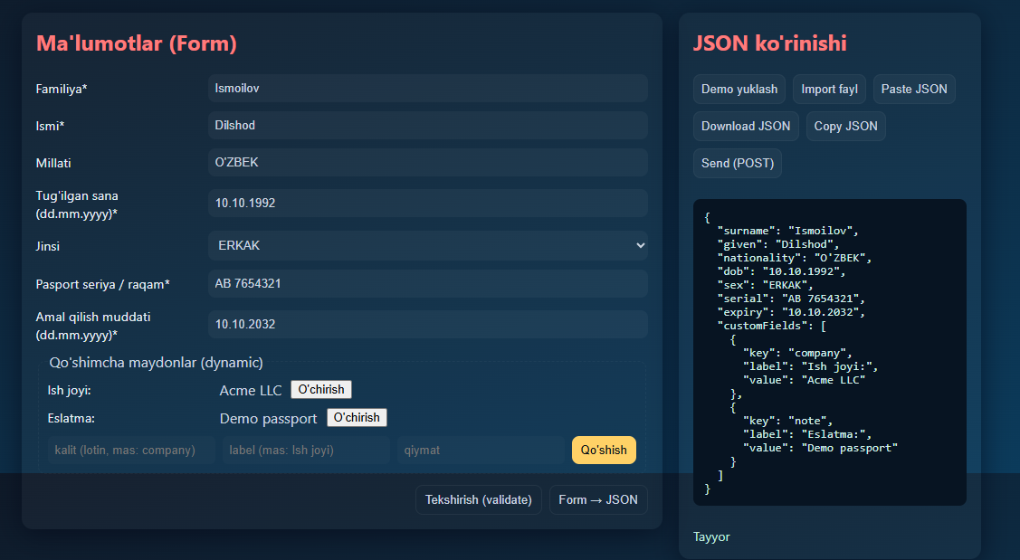
1-rasim:
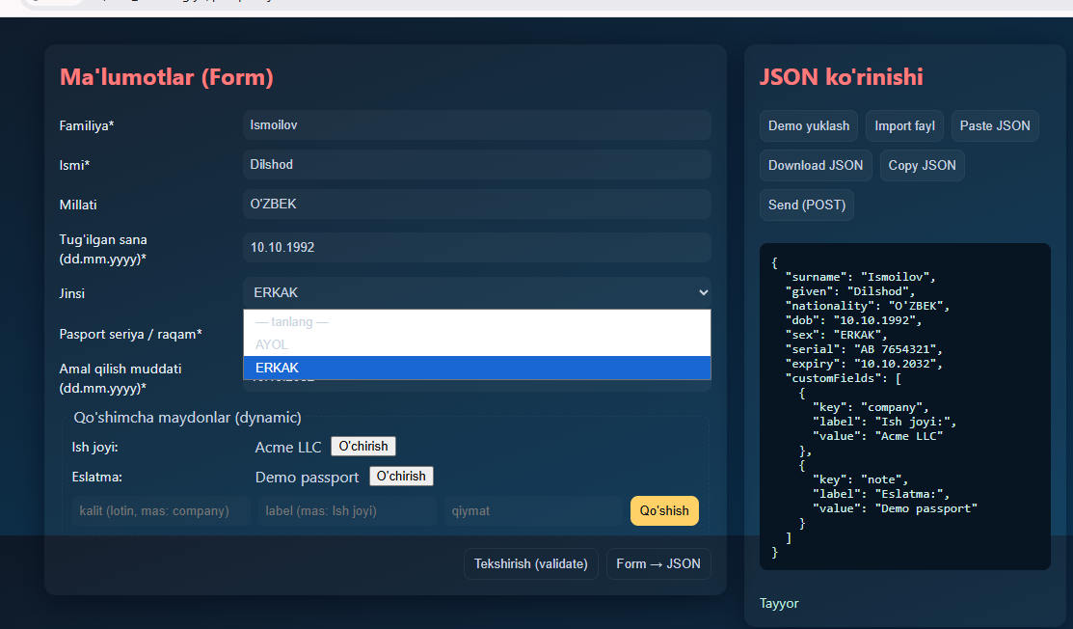
- rasim:
Xulosa:
Ushbu ishni amalga oshirish jarayonida shunga amin bo‘ldimki, zamonaviy frontend dasturchisi uchun ma’lumotlarni olish va ulash qobiliyati eng muhim ustunliklardan biridir. JSON — ma’lumotlarning tili, Fetch API — ularni tashuvchi ko‘prik, Asinxron dasturlash esa — saytimizning tez va silliq ishlashini ta’minlovchi mexanizmdir.

