Office round-trip fixture

LH-OFFICE-V1-DOC-H1
This body paragraph keeps bold, italic, and underlined runs after export.
Pasted body paragraph — T-328-PASTE
中文保真检查 ✅ — edited

Checklist
- Import the source
- Edit content and formatting
- Save and reopen
- Export the DOCX
- No content loss
- No layout drift
Item | Owner | Status
Draft | Ari | Ready
Export | Bo | Ready
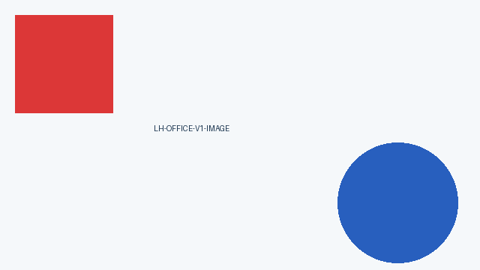
Figure 1 — Synthetic fidelity image
Source: LobeHub repository (target preserved).

Appendix
LH-OFFICE-V1-DOC-END
Reopen/export invariant: BODY + HIERARCHY + TABLE + IMAGE + LINK.

