Instructions

1. To start setting up the program, you need to launch it and click on the settings button - Figure 1.

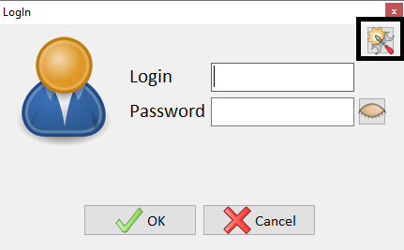

Figure 1 – Program settings button

The settings form will open - Figure 2.

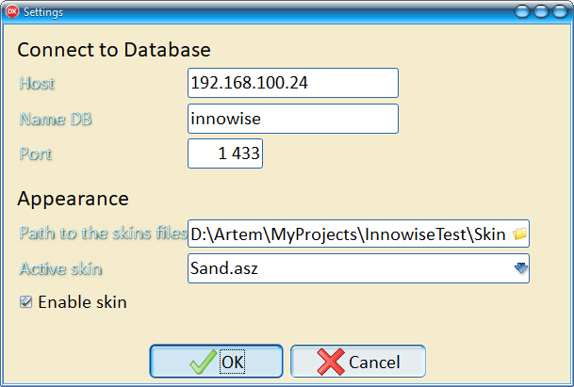

Figure 2 – Completed program settings.

A folder with skins is included with the program.

Next, you need to enter your login and password to log in to the database. After successful authorization, the main form of the program will be displayed on the screen - Figure 3.

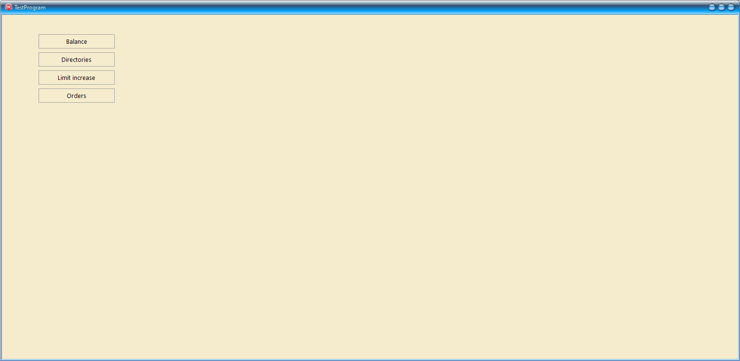

Figure 3 – Main form of the program

The Administration menu item allows you to configure the access rights of user groups to system menu items (for the root user - all rights are granted by default).

First you need to select the Directories menu item and fill out the directories (Services, Clients, Currencies) – Figure 4.

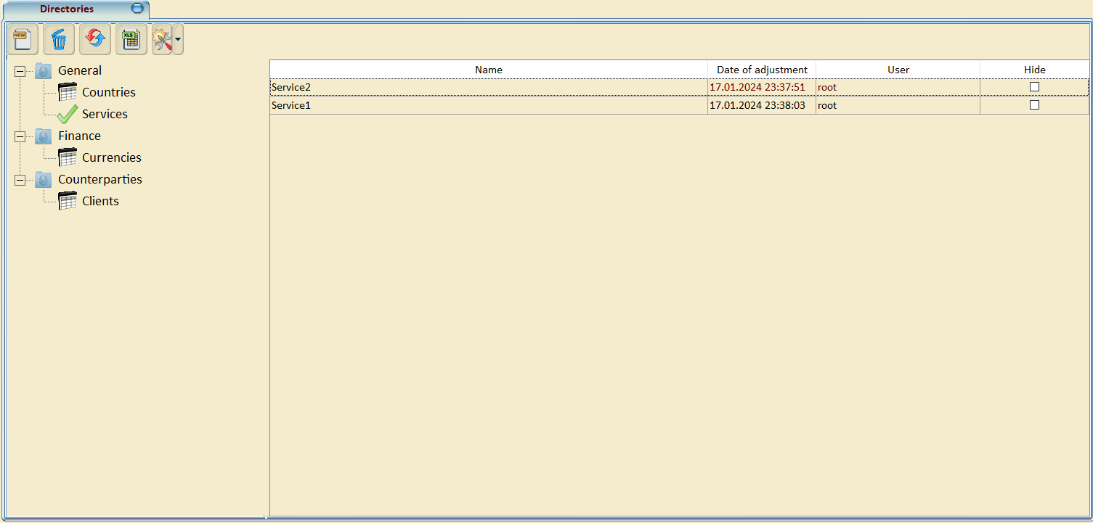

Figure 4 – Necessary reference books for testing

To add a new record to the table, you need to click on the button , and in the line that appears, fill in the fields with data, after filling in the editable fields, press the Enter button - Figure 5

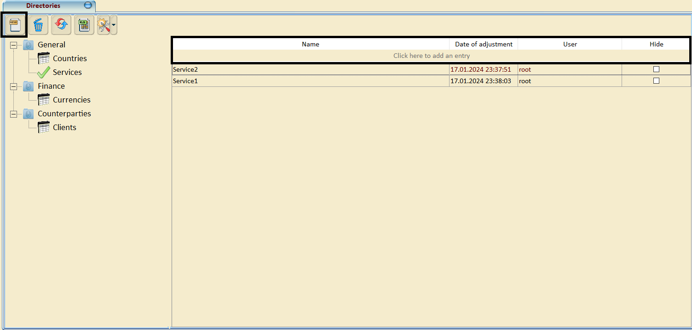

Figure 5 - adding an entry to the directory

Thus, fill out all the above reference books.

To top up a client’s account, you must select a menu item Limit increase, press the button  and fill in the data in the line that appears (Customer, Currency, Value, Date of adjustment) - Figure 6.

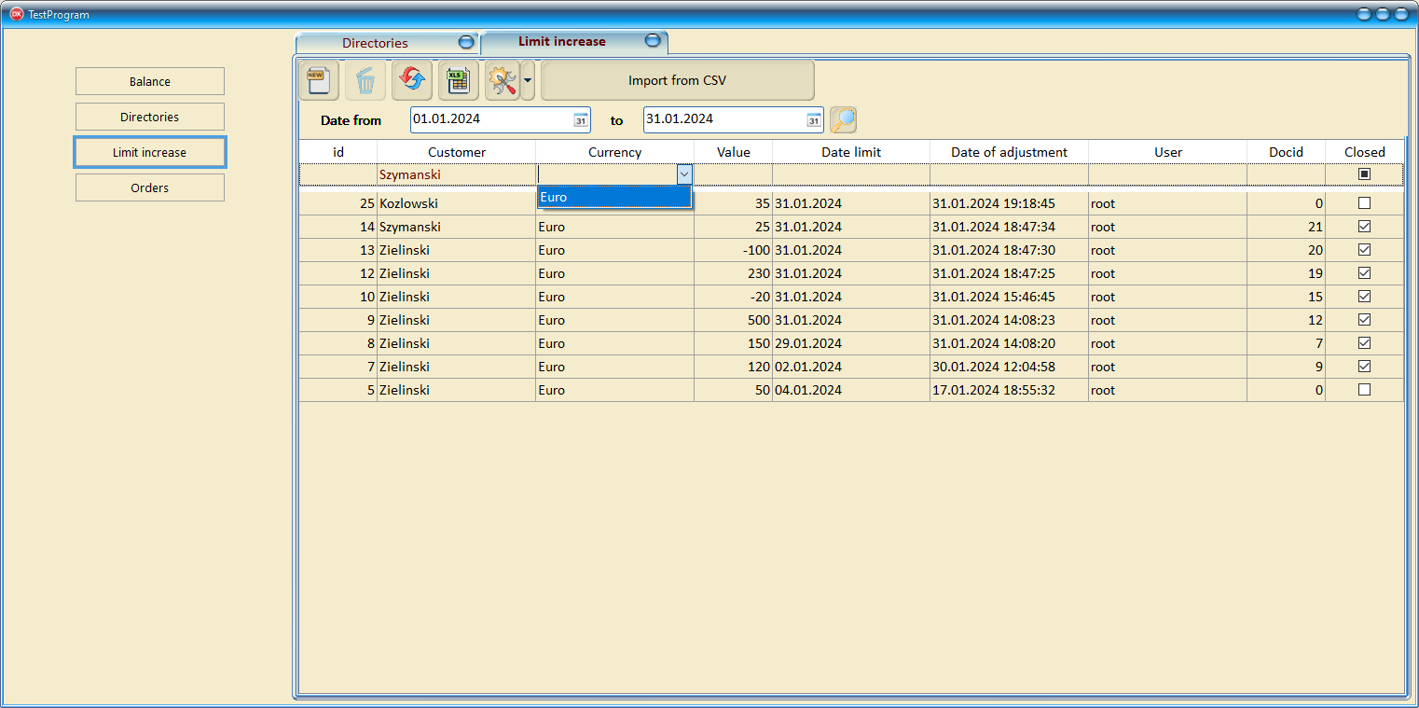

Figure 6 – Filling out the client account replenishment register

To complete the account replenishment, you must check the Closed box and confirm your choice - Figure 7.

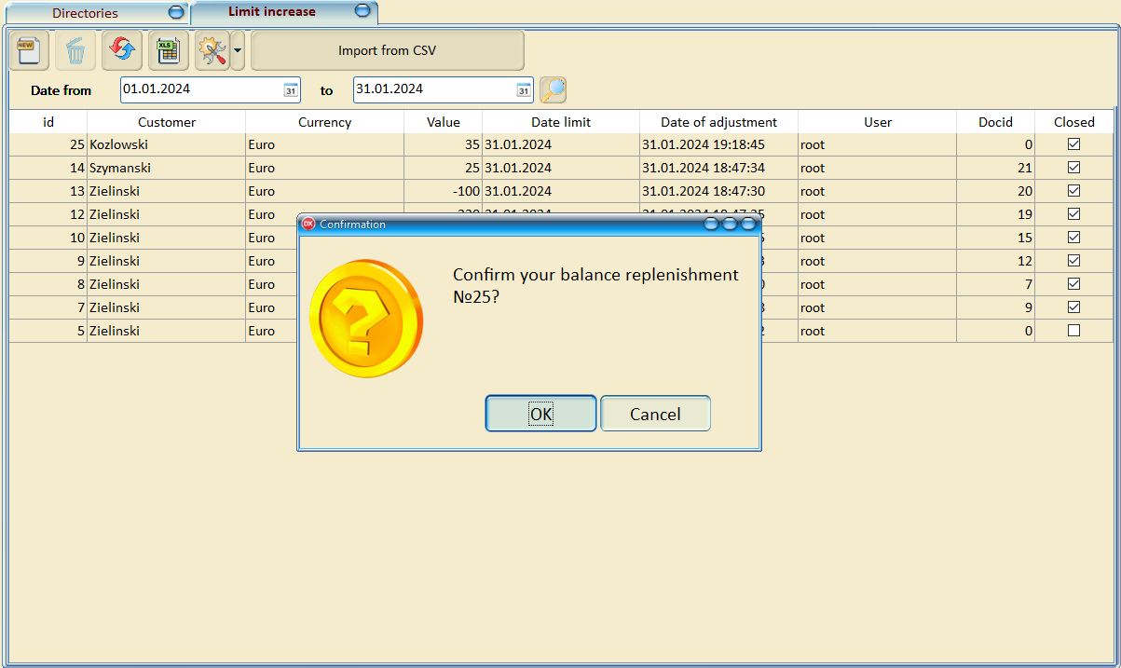

Figure 7 – Confirmation of replenishment of the client’s account

To load data from a CSV file, click on the "Import from CSV" button and select the file. Files for verification are attached.

To check the client’s limit, you need to select the Balance menu item, select the desired date range and see the balance - Figure 8.

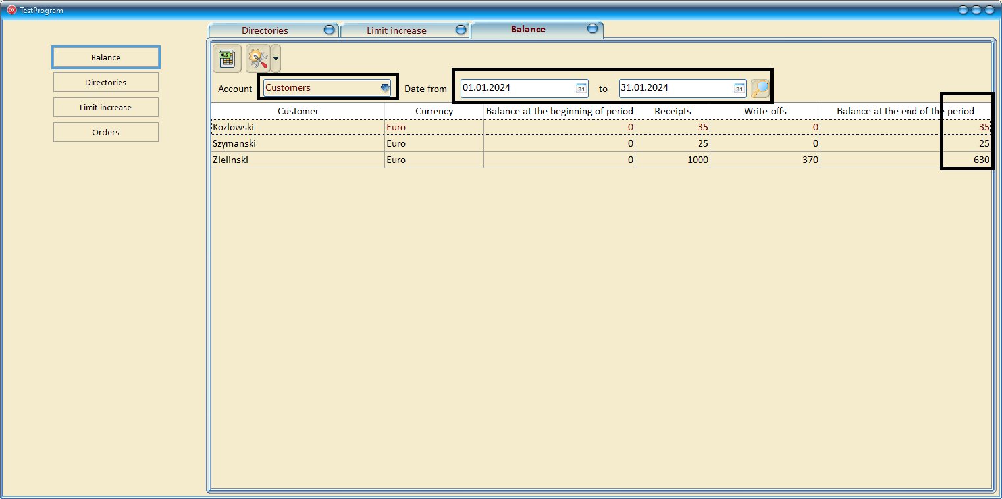

Figure 8 – Checking client balances for the period

To place an order for a client, you must select the Orders menu item. Add an entry to the table - Figure 9.

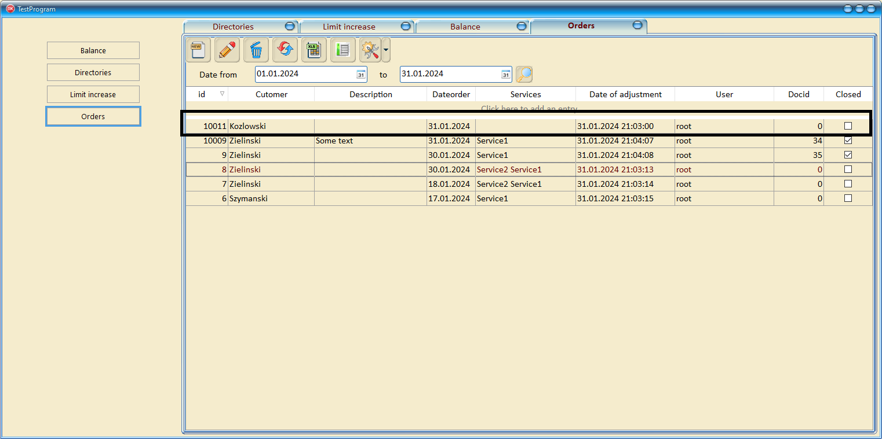

Figure 9 – Creating an order

To fill out an order, you need to click on the button , after which the order filling form will open - Figure 10.

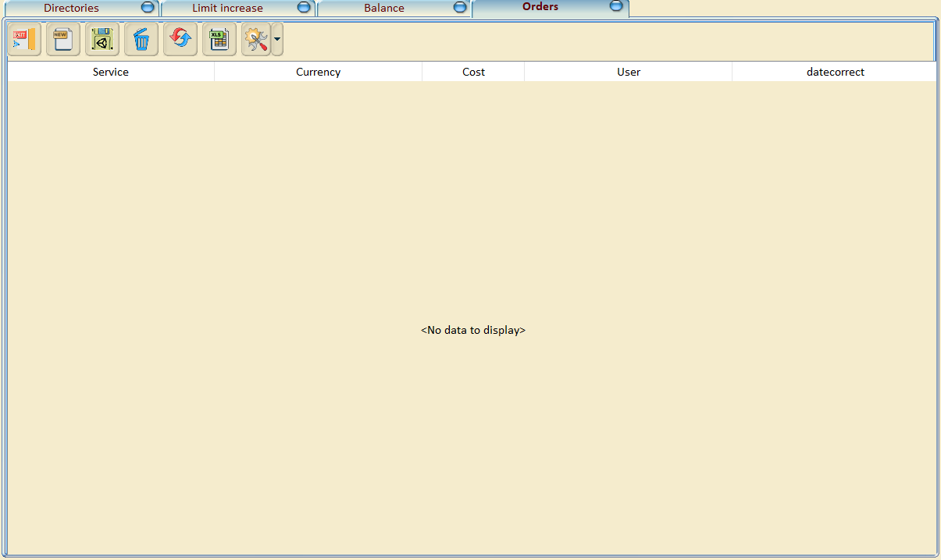

Figure 10 – Fill out the order with services

After filling in the services, you must save by clicking on the button  and confirm the action - Figure 11.

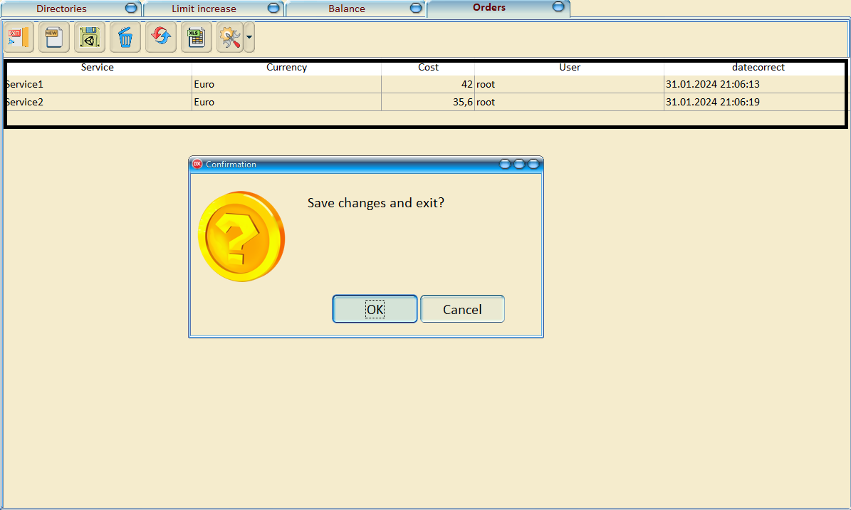

Figure 11 – Saving order data

To confirm the sale of the order, the client must check the box - Figure 12.

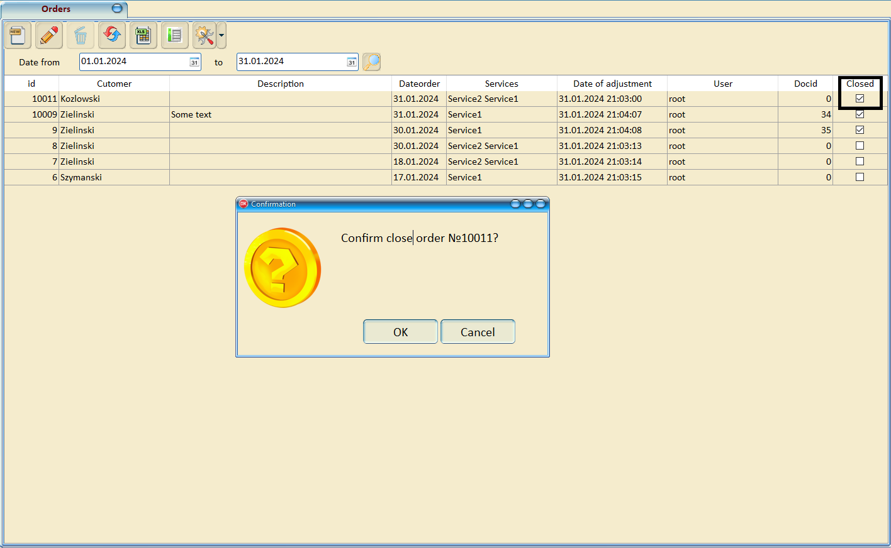

Figure 12 – Confirmation of the sale of an order to a client

Now you can check the client’s balance as of the current date - Figure 13.

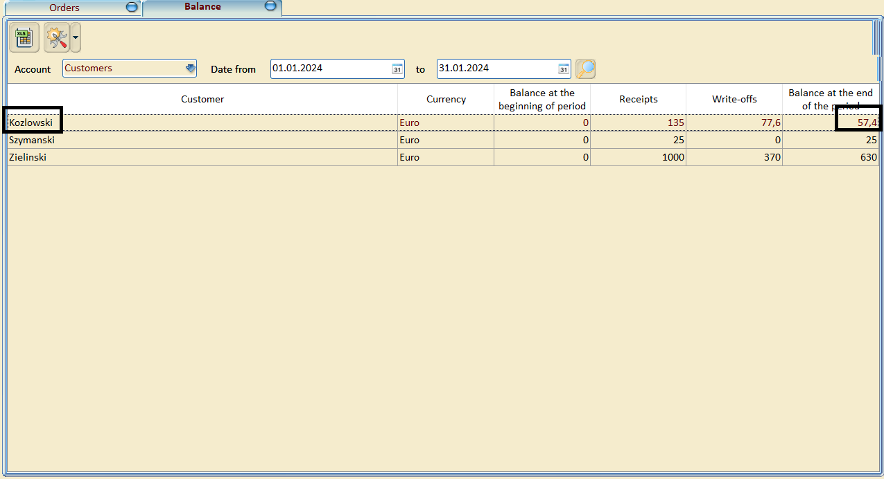

Figure 13 – client balance

You can also view the balance by orders; to do this, you need to select the order account and update the table - Figure 14.

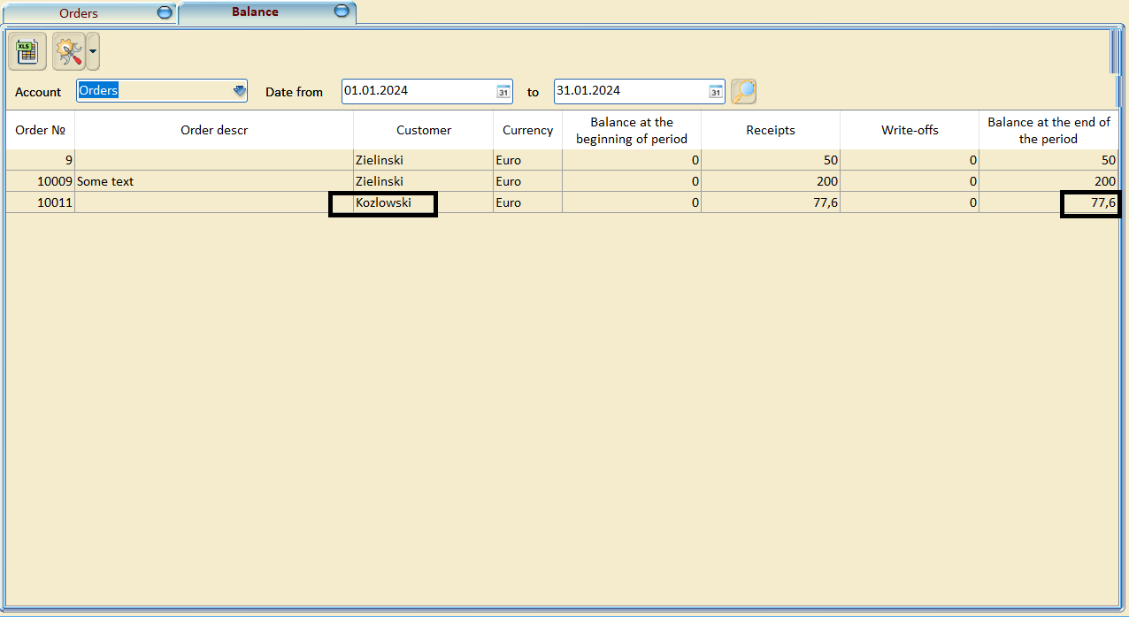

Figure 14 – Balance by orders

If we try to open a client’s balance replenishment and there is not enough money in the current balance, the program will display a message - Figure 15.

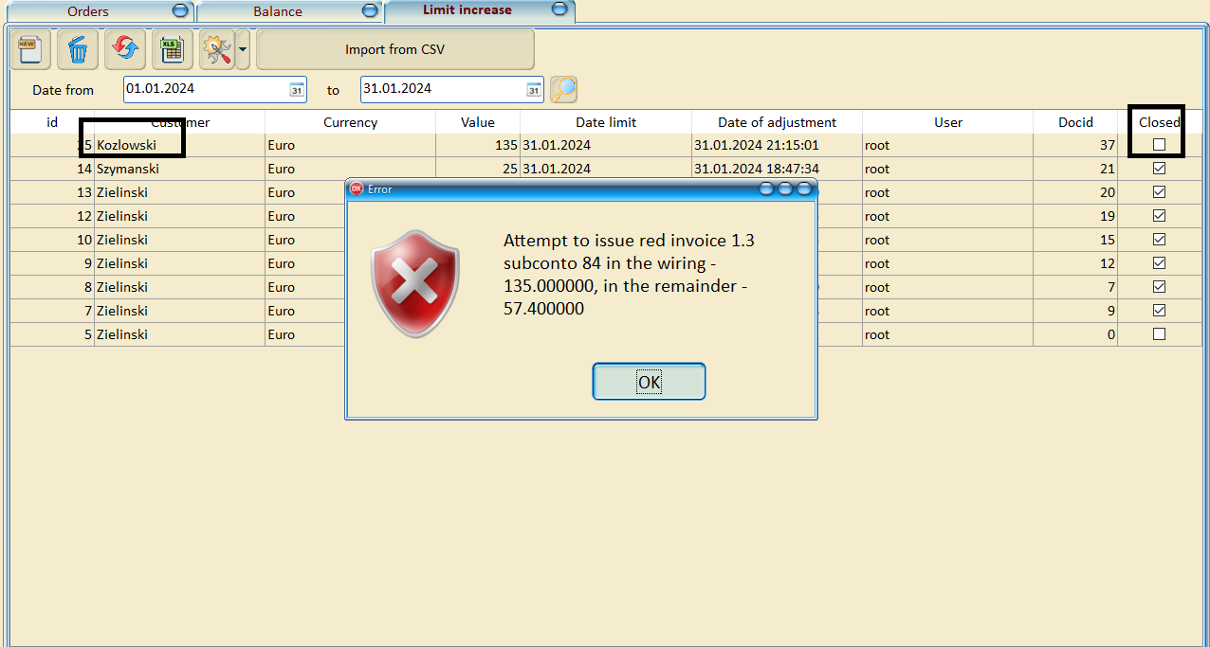

Figure 15 – Error exceeding the permissible limit

And the document will not be opened.

Additional features

1. You can search for any information in any table:
2. 1. Search for text throughout the table
3. 2. Search for values ??by any set of fields
4. 3. Multiple filters for each field
5. 4. Hiding unnecessary columns and remembering this choice
6. 5. Grouping by any set of fields
7. 6. Export a table to Excel

All additional features are contained in the table settings - Figure 16.

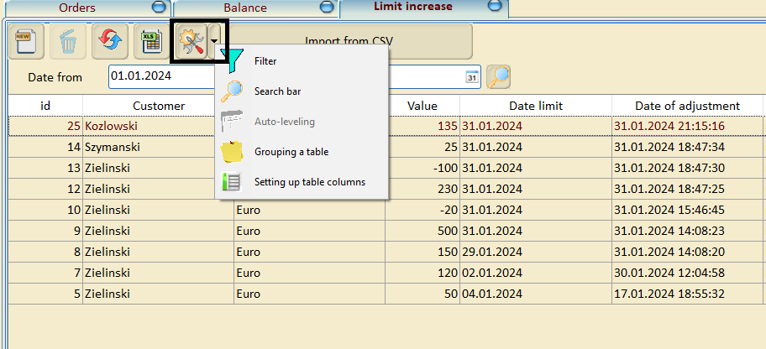

Figure 16 – additional features

If you enable all the features, it will look like Figure 17.

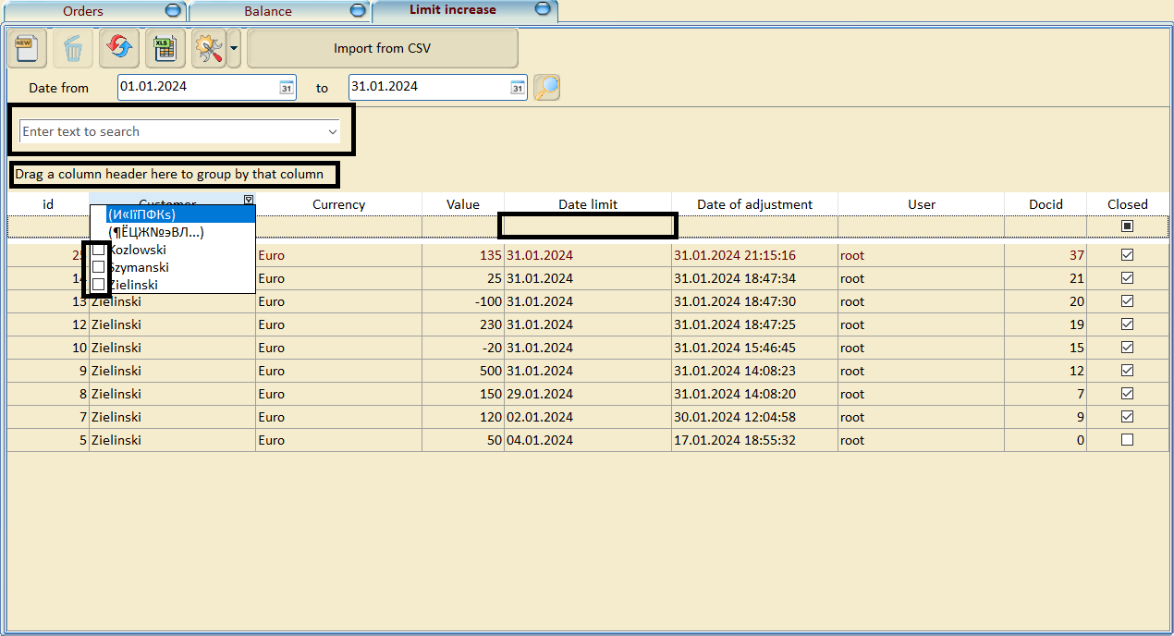

Figure 17 – All search and grouping options

To generate a report on orders, you need to select a period and click on the button Figure 18.

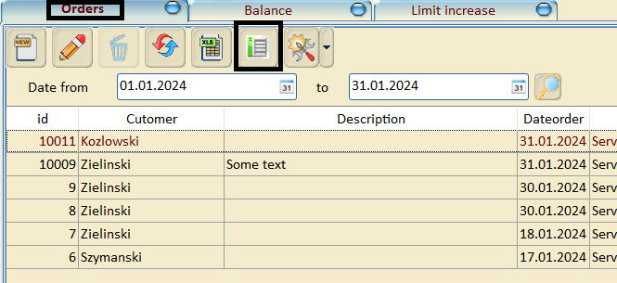

Figure 18 – Generate report

The result of generating the report - Figure 19

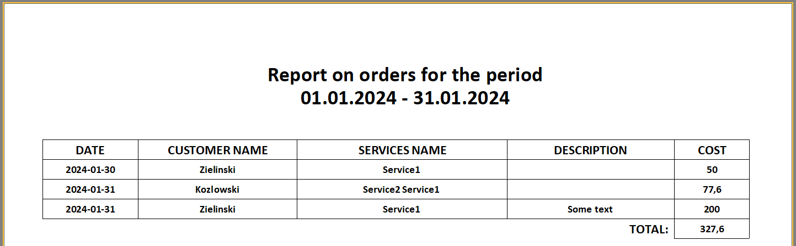

Figure 18 – Result generate report