MediScan Application Sitemap & Navigation Flow Architecture
Ecosystem Navigation Mapping and Role-Based User Interfaces (Splash Gateway, Patient, Pharmacist, Driver, and Admin)
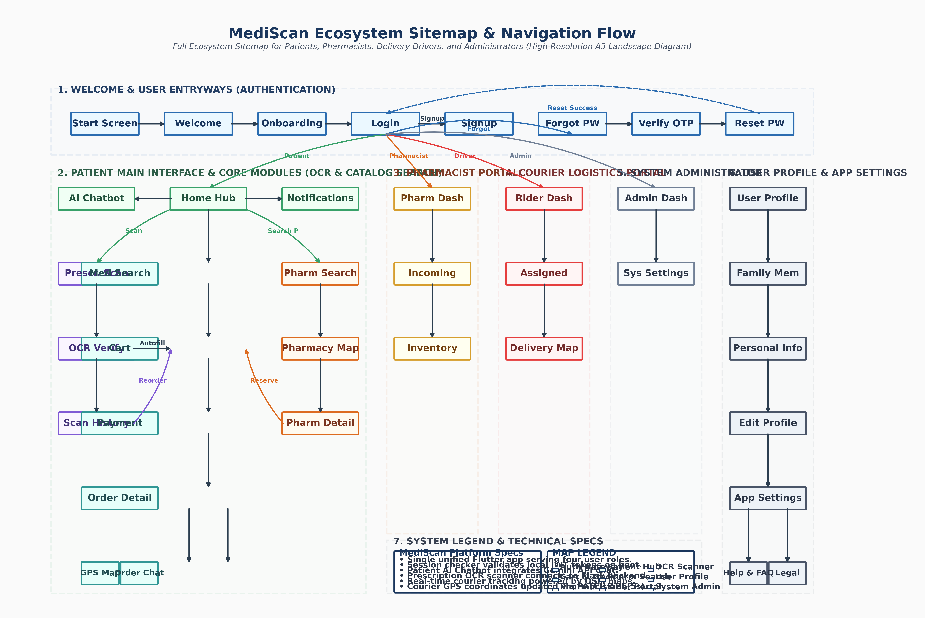

Ecosystem Modules & Screen Specifications
The MediScan application consists of 43 distinct views structured into 5 core logical modules. Authentication state checks validate and forward user profiles dynamically to their corresponding dashboards on launch. The table below documents each module, its screen allocation, role permissions, and key technological components:
Module & Area | Primary Screen Views | Role Access | Core Tech & Interactions
1. Auth & Entry Gateway | • Start Screen (Splash)  • Welcome Screen  • Onboarding Screen  • Login / Signup  • Forgot / Reset Password  • Verify OTP Screen | All Users  (Patients, Pharmacists,  Drivers, Admins) | • Shared preferences JWT caching  • JWT payload role parsing  • Navigation AuthGuard interceptors  • Email/SMS verification codes
2. Patient Dashboard | • Home Screen (Main Hub)  • Chatbot Screen  • Notifications Screen  • Profile & Settings  • Family Members  • Help / Legal pages | Patient / Customer | • Provider state notification alerts  • Gemini AI health assistant chat  • System notifications polling API  • Theme toggles (Light/Dark)  • Arabic/French localization
3. Prescription OCR & Checkout | • Prescription Scan  • OCR Verification Screen  • Prescription History  • Medicine Search  • Cart & Payment Screen  • Order Details & Tracking | Patient / Customer | • EasyOCR local + Gemini Vision  • Background verification image autofill  • Debounced catalog searches  • OpenStreetMap client tracking  • Location updates interpolating Tween
4. Pharmacist Management | • Pharmacy Dashboard  • Incoming Reservations  • Inventory Screen | Pharmacist / Owner | • Real-time stock update triggers  • Reservation status overrides  • Stock logs management
5. Courier Logistics & Admin | • Delivery Dashboard  • Assigned Orders  • Order Delivery Map  • Admin Dashboard  • System Settings | Delivery Riders /  System Admin | • Geolocator GPS tracking coords  • HTTP PATCH driver coords (5s timer)  • Administrative registration controls  • Database log analysis tools
Note: This Website Map documents the complete screen layout referenced in the MediScan Frontend and Backend Manuals. The landscape layout ensures the complex interactions and role flows are easily read when printing the project report.

