Project Screenshots

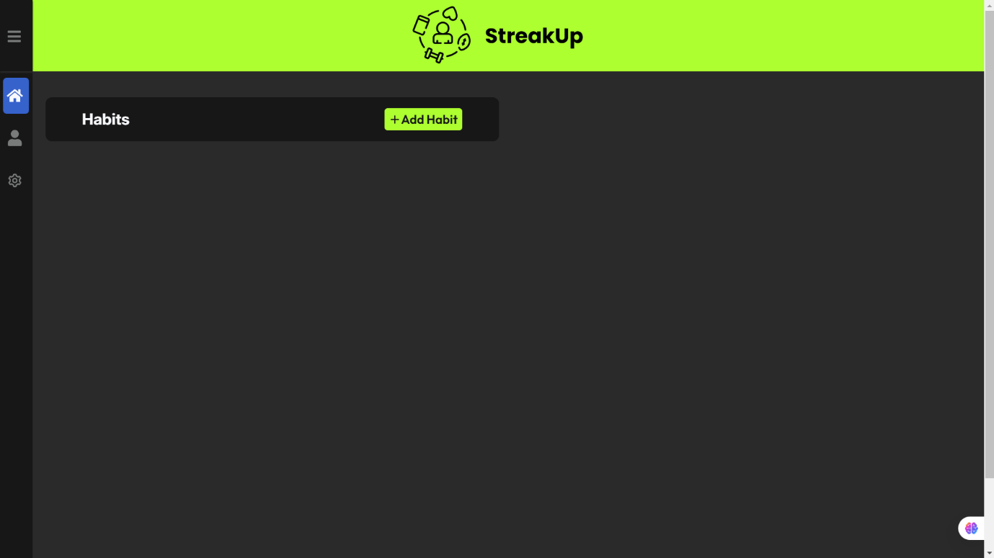

This is the homepage

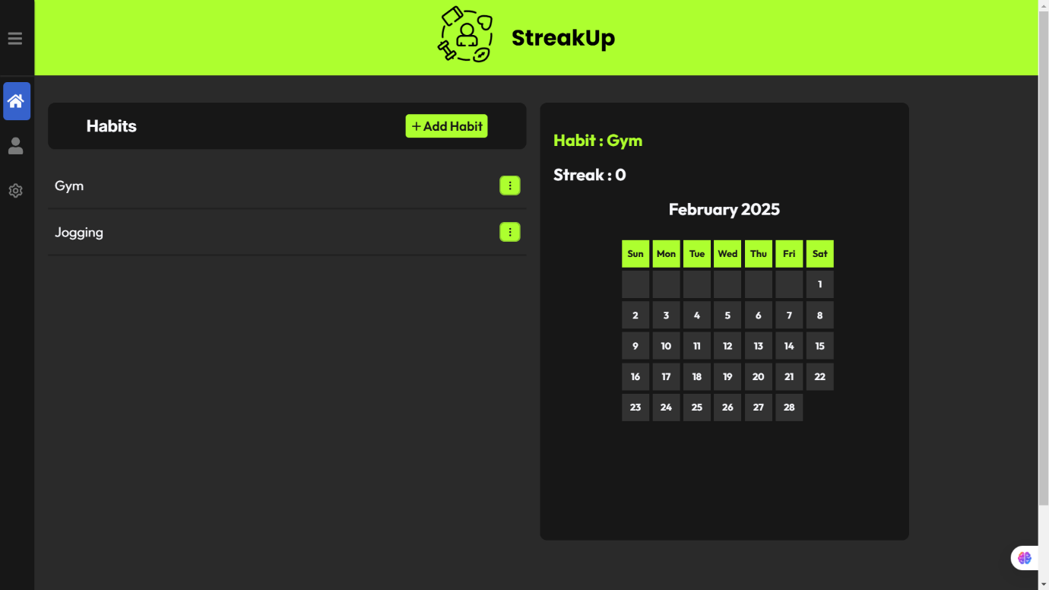

View button is pressed

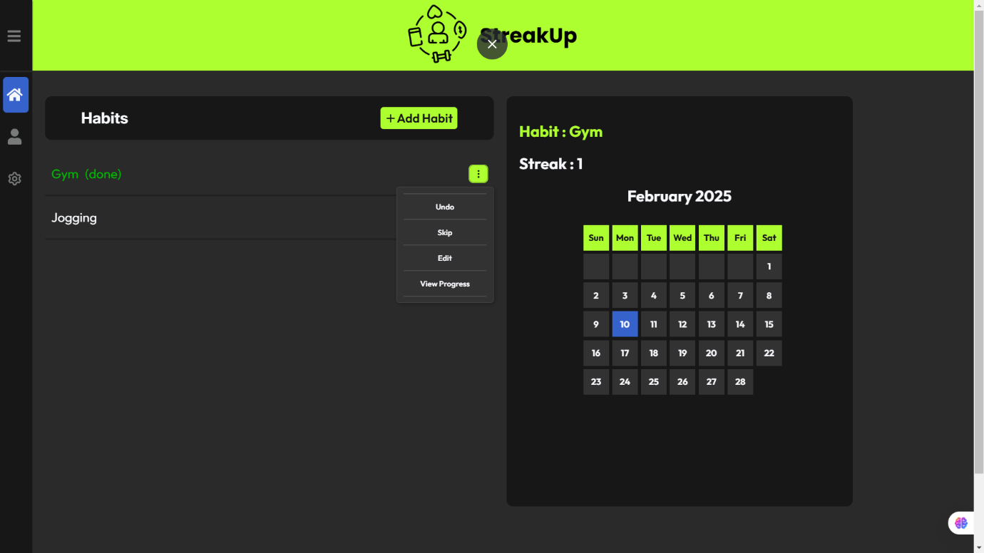

Gym is done and the date is marked in calendar next day Done will be reset to false. Strict mode is off so user can skip the task and streak will not reset

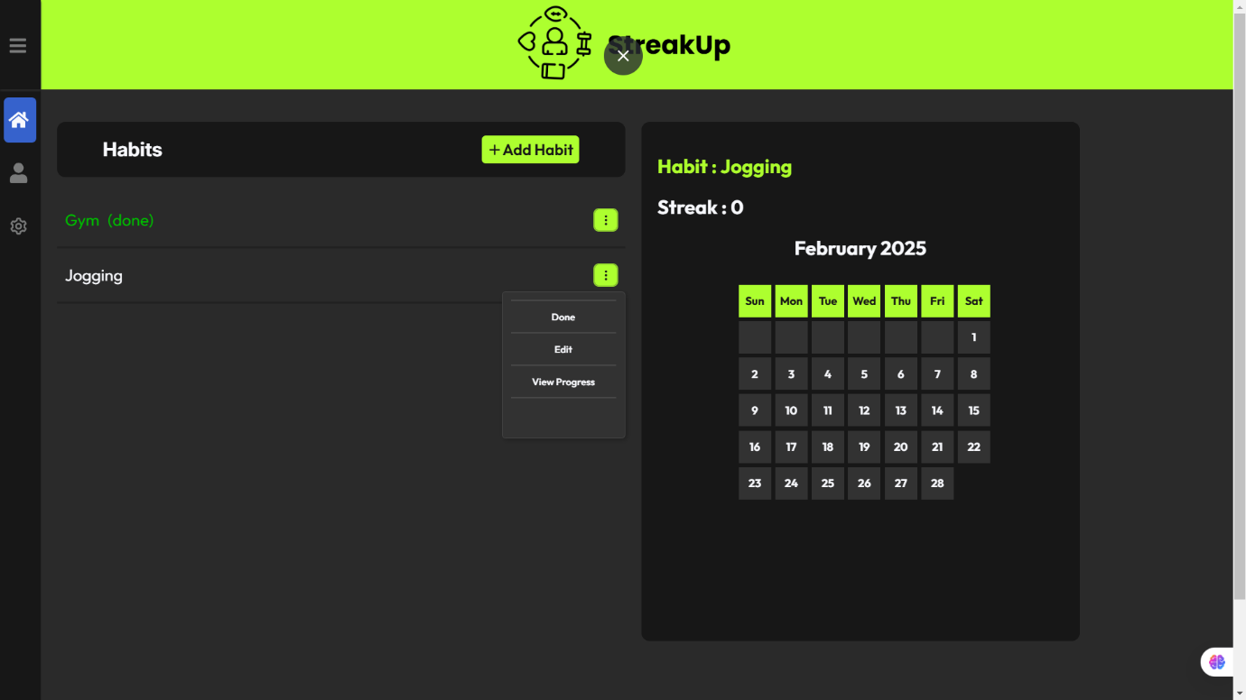

Jogging is on strict mode so user can not skip and streak will be reset to 0 if missed.