Updated by Joanne Hall (9/18/2020)

############################################################################

The following instructions describe the steps to create the DoB product and associated Active Fire layers. These instructions were created when the updated 2016 - 2019 DoB product was created in 2020. All python codes are based on ArcPy. There is 1 IDL code.

############################################################################

**Version 1:** 2001 - 2015. Used MCD14ML Collection 6 Version 1

**Version 2:** 2016 - 2019. Used MCD14ML Collection 6 Version 3. The lat/lon values are not truncated, there is a Day/Night flag, and the type mask has been improved.

**1.0: Burn Scar PreProcessing**

|  |  |  |
| --- | --- | --- |
| **Step** | **Task** | **Information** |
| Step 1 | Download AK and CA scars and split into yearly layers  Merge AK and CA scars together, add UID_Fire(unique identifier), reproject to CAEA projection | For the update this was all done in ArcGIS.  I created a clean copy which contained the UID_Fire (unique identifier per year), and kept the DiscDate and REP_DATE (the report date for each scar) |
| Step 2 | Created buffered scars (1000m) | This can be changed to 500m. This buffer just extracts all the fires within 1000m of the scar edge. |
| Step 3 | Create a CSV file of the UID_Fire, Month and Date from the fire database | This assigns the Fire Database date to the scar if there were no AFs. I manually copied the clean scar attributes into Excel and then created a cleaned CSV file per year in the correct format. It turns out some of the dates were on a different column so I had to go back and copy all attributes to fill in as many null dates as possible. Add 0 and 0 under Month and Day for scars with no dates (this was a 2016 problem only) |

**2.0: Active Fire PreProcessing**

|  |  |  |
| --- | --- | --- |
| **Step** | **Code** | **Information** |
| Step 1 |  | Download the Active Fire data (fuoco.umd.edu) |
| Step 2 | *Reproject_CAEC.py* | Reproject to CAEA projection |
| Step 3 | *clip_AK_CA.py* | Clip global reprojected AFs to Alaska and Canada shapefile |
| Step 4 | *select_af_scars.py* | Spatial join the AFs within the buffered scar boundaries. This code extracts out the AF within the scar boundary and joins the UID_Fire to each AF point |
| Step 5 |  | Merge all the monthly AFs into yearly layers (I did this manually in ArcGIS) |
| Step 6 |  | Clean up Yearly AFs (remove non-zeros type fires to keep with initial analysis)  **These Active Fires will be your starting Active Fires (“original” - see Section 5.0)**  You will want to keep a copy that has not been filtered so you have a record of the original AFs going into the analysis. |
| Step 7 | *consecutive_filtering_part1.py* | Extract out attribute table for each year to be read into IDL code in next step |
| Step 8 | *fpm_consecutive_days.pro* | Extract out the UID and the longest gap (over 20 days) between AF observations per scar to help identify which scars to clean up. Manual checking and cleaning of AFs within each scar |
| **Manual Filtering of Active Fires**   * Each scar with a temporal gap in AF observations must be checked * See End of Document for Examples of Stage 1 Filtering | | |

**3.0: Main Codes**

|  |  |  |
| --- | --- | --- |
| **Step** | **Code** | **Information** |
| Step 1 | *step1_split_af_scars_by_attributes.py* | Splitting the scars and AFs by attributes |
| Step 2 | *step2_remove_af_duplicates_per_scar.py* | Create a copy and remove any duplicates, add Julian Day decimal time |
| Step 3 | *IDW.py* |  |
| **Stage 2 Manual Filtering - see end of the document for examples**   * Look at each IDW output and see if additional AFs have to be removed | | |
| Step 4 | *step4_AF_split_Round2.py* | Resplit the new AFs into the new folder |
| Step 5 | *step5_remove_af_duplicates_per_scar_Round2.py* | The same as step 2 code but the paths are now reading data from different folders (You can just use step 2) |
| Step 6 | *step6_IDW_Round2.py* | Rerun IDW but some of the paths are different |
| Step 7 | *step7_IDW_PostProcessing.py* | We have to add the UID_Fire and other attributes to each individual scar IDW output otherwise when we merge them we are unable to identify which is which |
| Step 8 | *step8_IDW_error_copy.py* | Copying the scars that had no AF points or 1 AF point for addition processing |
| **Within the IDW output there is an error folder. For these scars, you need to manually open up the layers and likely redo the IDW in ArcGIS. I believe the majority do not contain any fires that are close enough for the IDW to work (they are out in the buffered zone only).**  **\*\*\*I had to open each IDW polygon error and check they did not have AFs and had a FD.**  **I then ran them through the *clip_error_manual_FD.py* and copied them into the FD merging folder**  **Find any scars that are split along the border and extract them out, dissolve them, and rerun the IDW. Then that IDW output can be applied back to the original scar boundary. For these I just run it in ArcGIS** | | |
| Step 9 | *step9_No_AF.py* | Adding the FD dates to the scars with no AFs |
| Step 10 | *step10_AF_Other.py* | Dealing with scars with 1 AF |
| Step 11 | *step11_no_FD_date_error_copy.py* | Copying the scars with no Fire DataBase Date and No Active Fire |
| Step 12 | *step12_no_FD_attributes.py* | Adding NA to scars with no Fire DataBase Date and No Active Fire - you can probably combine the last 2 codes |
| Step 13 | *step13_initial_merging.py* | Merging each individual category of outputs. I uncomment out each one and run the merge |

**4.0: PostProcessing DoB**

|  |  |  |
| --- | --- | --- |
| **Step** | **Code** | **Information** |
| Step 1 | *add_date.py* | Add the Map Date YYYY-MM-DD |
| Step 2 | *DOB_rename.py* | Rename the file |

**5.0: Active Fire PostProcessing**

The codes have been fixed so that this step works correctly. Certain steps were run manually so if you are following the outputs they will not quite match. Specifically, the TARGET_FID was removed by mistake during the Section 3 codes and therefore, I manually created a TARGET_FID column on the primary_residual AF layer by spatially joining a specially created layer. All codes have been fixed so no need to run anything manually except for at the end.

|  |  |  |
| --- | --- | --- |
| **Step** | **Code** | **Information** |
| Step 1 | *step1_rename_cleanup.py* | Create an “original” active fire layer and do some initial cleaning (you will want to open the layer and check if there are any other columns you might want to clean) |
| Step 2 | *step2_primary_residual.py* | Assigning “primary” to fires that were in the IDW and moving the residuals for further processing |
| Step 3 | *step3_primary_residual_part2.py* | Assigning residual to the fires removed in the IDW code |
| Step 4 | *step4_merge_clean.py* | Merge primary and residual fires together and some more cleaning |
| Step 5 | *step5_join_with_orig.py* | Join with the original fire layer from step 1 - this was when I realized I needed the TARGET_FID column during the IDW stages. I went back and manually created it but the codes have been fixed now to not remove that column |
| Step 6 | *step6_add_removed_status*.py | Add removed to the fires that were manually removed |
| Step 7 | *step7_clean_table*.py | Cleaning up table and renaming - although the renaming is pointless due to next step |
| **Manually join FD and REF_ID in ArcGIS and manual cleaning to get to DAAC ready version**   * Here I need to join using the UID_FIRE on the Actvie Fire attribute table and the csv files that contain the FD_Agency and REF_ID * Removed some of the excess join columns. | | |

**Next page shows the filtering examples**

**Stage 1 Filtering**

* List of each scar with 20+ day gap in consecutive observations
* Each scar will be unique so we cannot simply remove all fire points with more than 20+ day gap
* Look at the locations of the fires relative to the surrounding fires (by date)

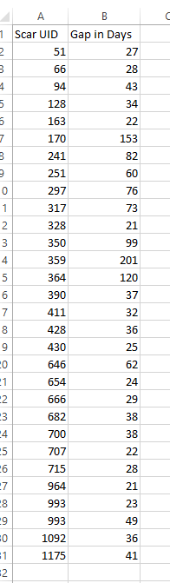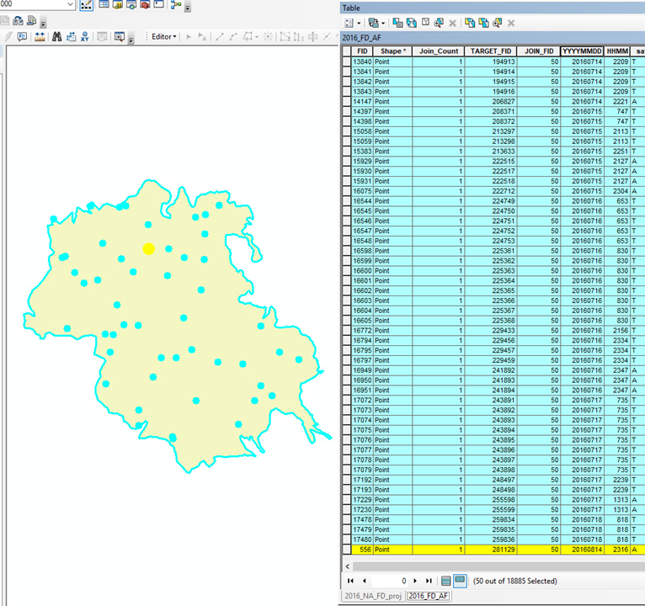

The figure above shows an example of a scar that has 1 AF point that occurs 27 days after the previous fire. In this instance, it can be removed. Each scar is different so you have to make sure that it makes sense to remove anomalous fires. The second filtering stage will go into a lot more detail with cleaning. This stage is really just removing the very obvious fires that are not within a reasonable timeframe of the majority of the fires.

**Stage 2 Filtering**

* This occurs after the first IDW output stage
* Further removal of fires based on any extreme “bulls-eye” effects.
* This is also a judgment call.

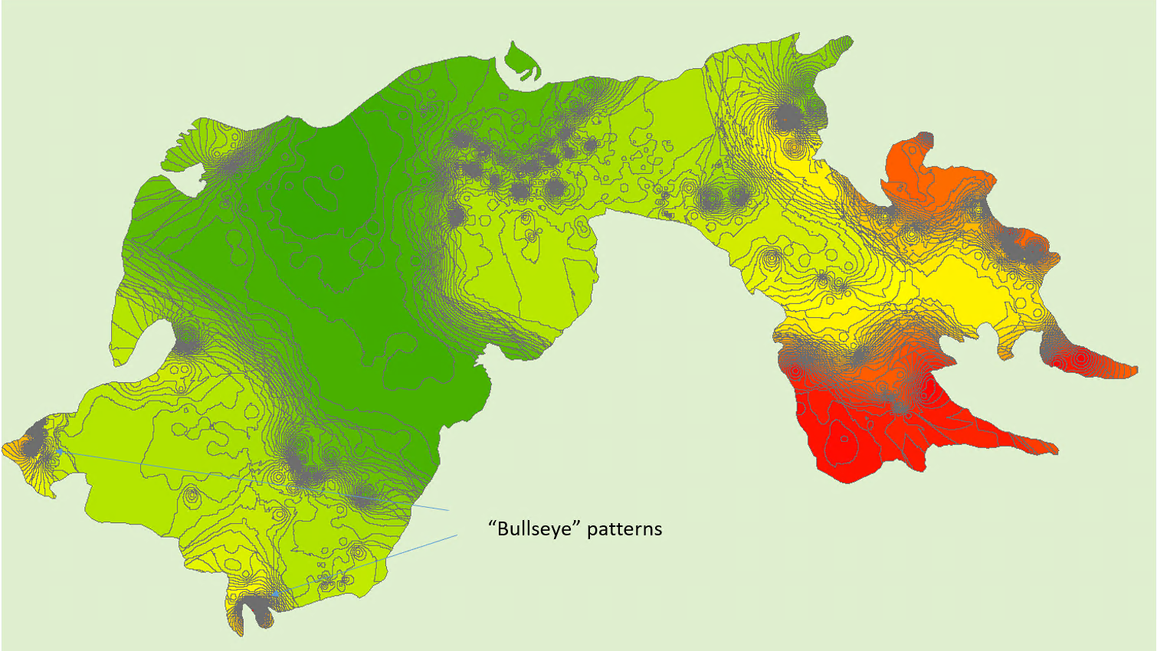

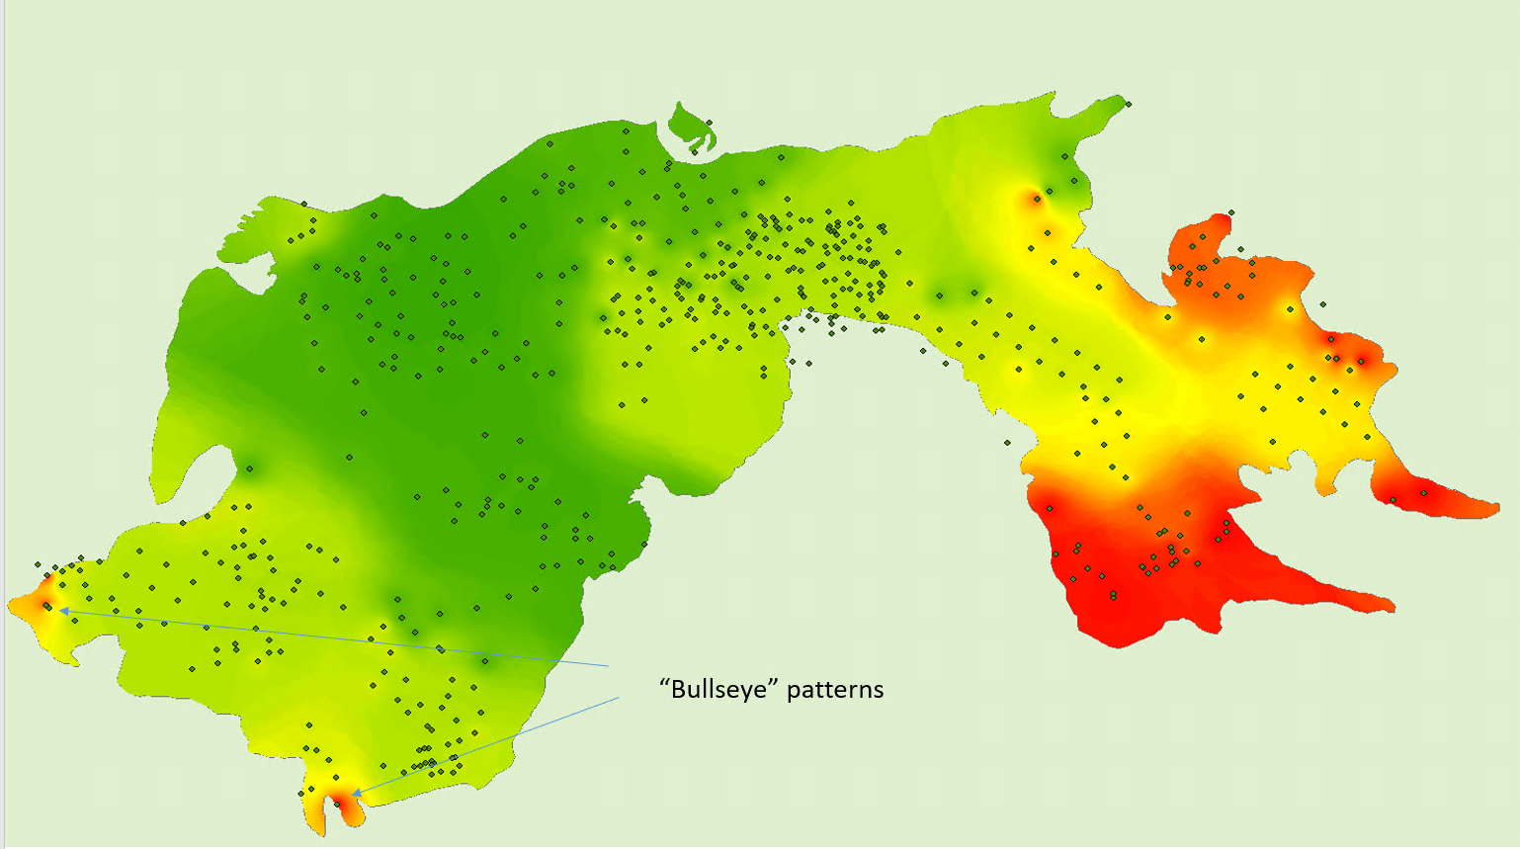

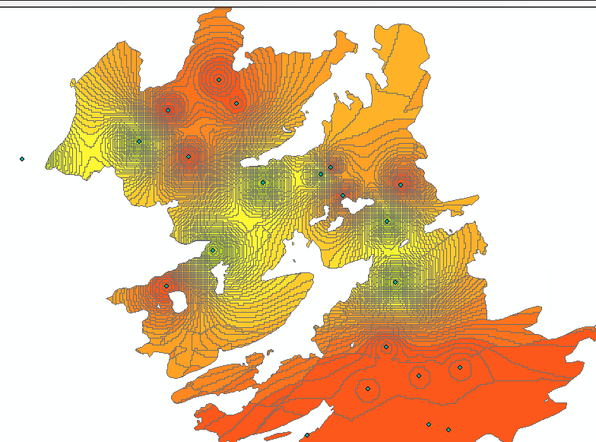

Here is an example of why you need to clean some scars. We have a fire that lasted a long time but it was clearly smouldering or another fire front came through much later and so there were fires in June and August in the same place.

**Issues to be aware of**

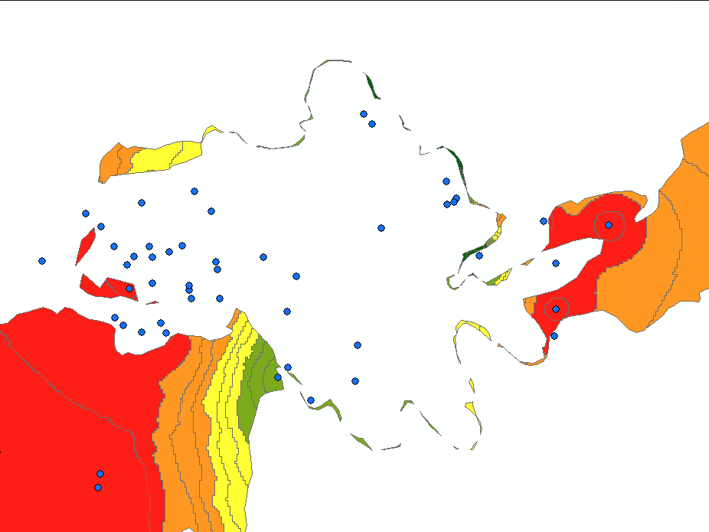

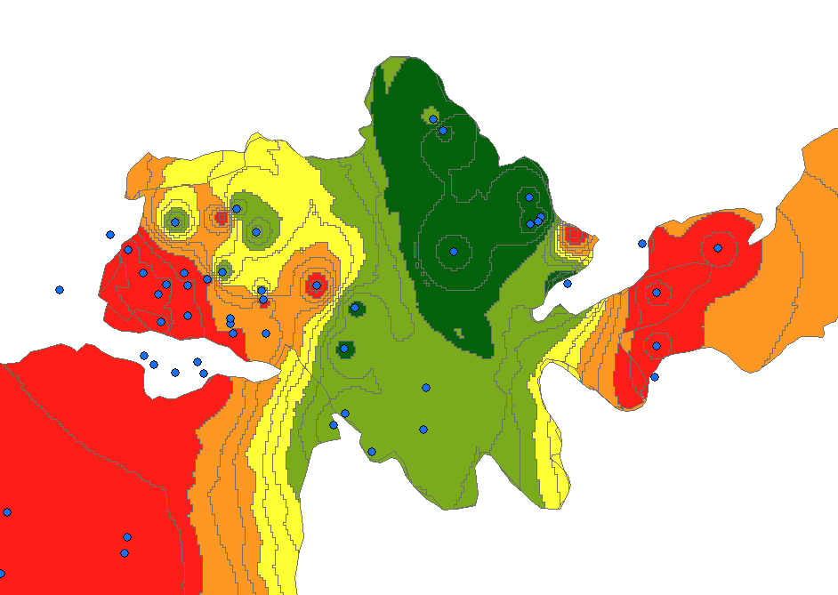

The FD database has some scars that are cut outs of the original larger scar.

**Potential Improvements**

1. Redo with the updated MCD14ML product (or at least test out to see how much it changes)
2. Clean up the FD database before starting the project. Dissolve scars and run the IDW so it is 1 smooth surface and then clip out the original scars. This is what I did for the border scars (2001 - 2015).