Escape Work Post-Mortem
Last year I happened to play an anomaly hunt entry, and unfortunately that time I didn't really know about the genre and I got very confused playing it. Since then I've seen a bit about them on the tube and finally played the superb Ten Bells which made me really want to try and do a version myself for this years' jam.
The genre you repeatedly play the same level, some days everything is normal and you leave through the good exit or something is abnormal and you leave through the bad exit.
The things I identified as confusing for me with last years anomaly hunt was that was located in a typical looking dungeon was that I wasn't sure what the anomalies were and there wasn't enough to orient me so I could understand were the exits were.
My thinking by placing it in an office was that it'd be easier to learn the layout, easier to differentiate between the two exits (main exit and fire escape) and also since most of us have more experience with offices than dungeons and that offices follow stricter rules for what is normal, that it'd be easier to communicate that something is abnormal.

Building the level
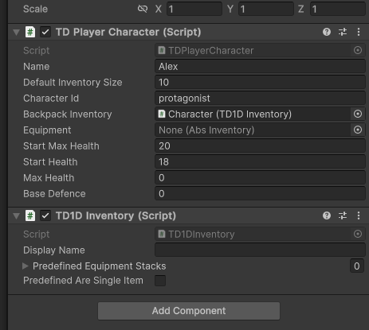
Not having to implement camera, transitions, rebindable things and saving/loading is absolutely fantastic. That said, the base code isn't plugin structured and assumes you want to make a much more complicated crawler than I wanted here, especially with regards to floors being able to move around so there were loads of configuration like for example characters with inventory that is utterly useless to the current game. Still I think it did save me a lot of time, but it probably costs quite a bit in performance. And my game seems to be requiring quite a bit.

Tiled to Unity pipeline worked very smoothly with the iterating on small details of the level in Tiled and then just pressing a button to have it appear in Unity but if you have played the game you know
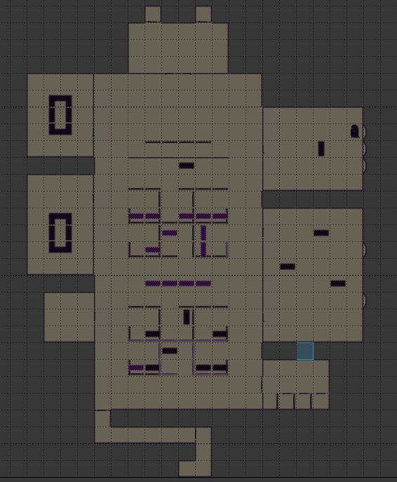
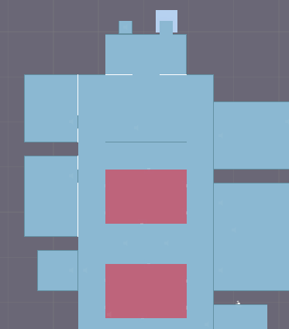

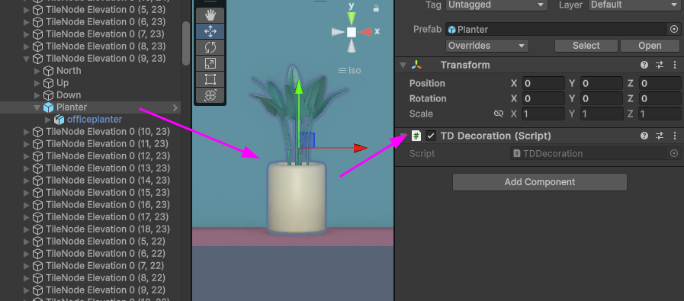
there's a whole lot of decorations which have to be injected and positioned with precision into the generated geometry. My solution here which I had not really tested before was a little script that tells the generator to safe keep everything below it in the hierarchy when the generator code clears the level and regenerates a new one. And then it returns it to the same node coordinates with the same position and rotation. This proved golden for not only decorating things but placing anomalies and adding scripts to them. But one thing that for sure wasn't great were the times I had decorated an area and forgotten to place the script, which caused the work to disappear as soon as I regenerated the level with some new tiled information.
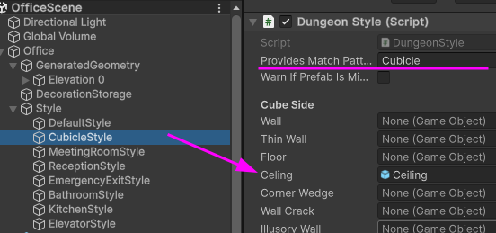
Using the object layer in Tiled to mark regions for style / asset variations and then have the generator match these up was something I had pre-constructed but that I had no real reason to test much before but that worked out of the box. In this example making the area above the cubicles having a different ceiling.
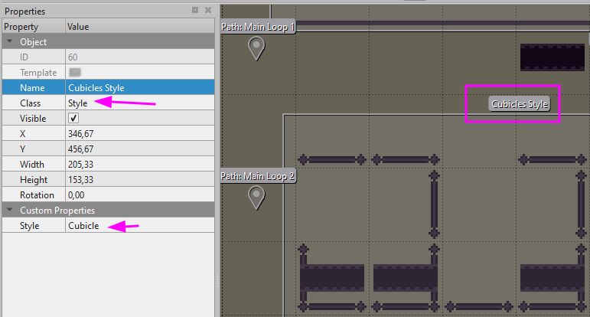
So far these parts of the tooling had been quite tested in previous and ongoing projects though not always stretched to their full potential.

Untested tools
So lets switch to what I hadn't really tried out that much before, which were the level transitions and the saving and loading. And this almost cost me the jam entry completely. The

