Pp

Ecommerce Website-Book Store

Sai vara prathyush parepally

**Website Architecture**

**ASP.NET shopping cart software designed for developers & marketers.**

When making an ecommerce platform comparison, Multifront’s innovative ASP.NET ecommerce architecture is a favorite among ASP.NET developers and marketing teams alike because it allows for full customization of business rules, admin interfaces, and the entire e-commerce site experience.

The ecommerce architecture also makes Multifront quick to deploy and incredibly easy to manage. Ecommerce store management is so easy, in fact, that after development you can turn over management of your web stores to your marketing department—which lightens up IT’s workload and your company’s ecommerce website maintenance budget.

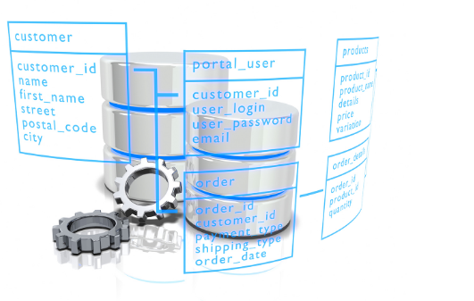

## Multifront is the most flexible .NET ecommerce software in the industry.

**100% Customizable Layout and Design**

Multifront‘s adaptable .NET framework includes a robust, flexible product catalog that allows you to showcase virtually any type of product or service imaginable. With standard MVC 5 and CSS style sheets, any conceivable design and layout can be achieved with Multifront. In addition, an extensive set of well-structured user controls allow you to make very granular modifications to the User Admin Interface.

With access to the entire source code, Multifront gives .NET developers complete freedom to fully customize the look, feel, and function of your multi-store ecommerce website. All of your ecommerce business rules and requirements can be met without constraint, regardless of their complexity.

**Implement Advanced Business Rules**

Multifront is a powerful .NET ecommerce platform that gives developers the ultimate control over virtually every aspect of the business process logic and data access. For example, you can modify the Shipping library to implement your own custom shipping process and even integrate it with third party shipping tracking systems.

**Build and Deploy Hundreds of Stores Using One Database**

Multifront's customizable .NET ecommerce software provides you with a single platform to launch hundreds of ecommerce stores that share the same database. You can customize each store to have its own unique design and layout. Custom code and integrations can be shared between stores hence significantly accelerating your project.

**Integrate Seamlessly Using Our Robust API**

Multifront comes with an advanced web service API that enables 3rd party applications to download and upload data to the storefront in real-time. You can extend these web services to integrate Multifront with virtually any back office system, including ERP, Accounting, and Content Management Systems.

**N-Tier Architecture for Ultimate Flexibility**

The n-tier design of Multifront's .NET architecture follows Microsoft Prescribed Patterns & Practices. The user interface, business logic, data access and integration layers exist in separate libraries so changes can be made quickly and independently without reworking the entire application.

Features of the Website

**Navigation**

* Manage your main navigations including header, side and footer
* Add drop down to main navigation
* Manage SEO elements on links such as link title
* Set links to open in same or new window

**Auto Email Messages**

* Manage main email template design
* Set messaging for order status emails
* Set messaging for thank you email on product reviews and blog comment submissions

**Order Tracking**

* Customer can track their order after successfully shipped the item.
* Set messaging for order status emails

**Orders**

* Search and sort to easily find orders by specific variables
* Manage and updated order status
* View order number and all customer information
* View order information and purchase details (products, tax, shipping, addresses, etc.)
* Add private notes to the order
* View shipping and billing address maps
* Create and manage custom order statuses
* Receive email when order is placed
* Export orders to Excel

Screenshots of website

Customer Login

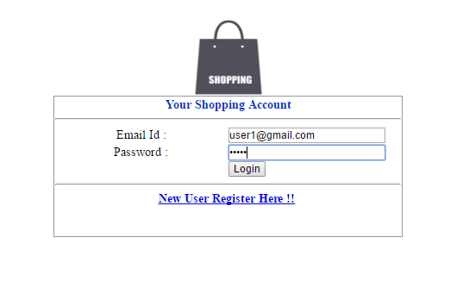

Customer Registration

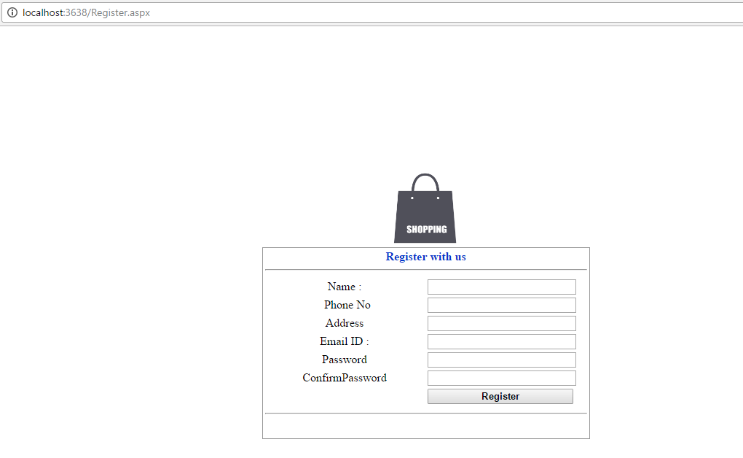

Catelog

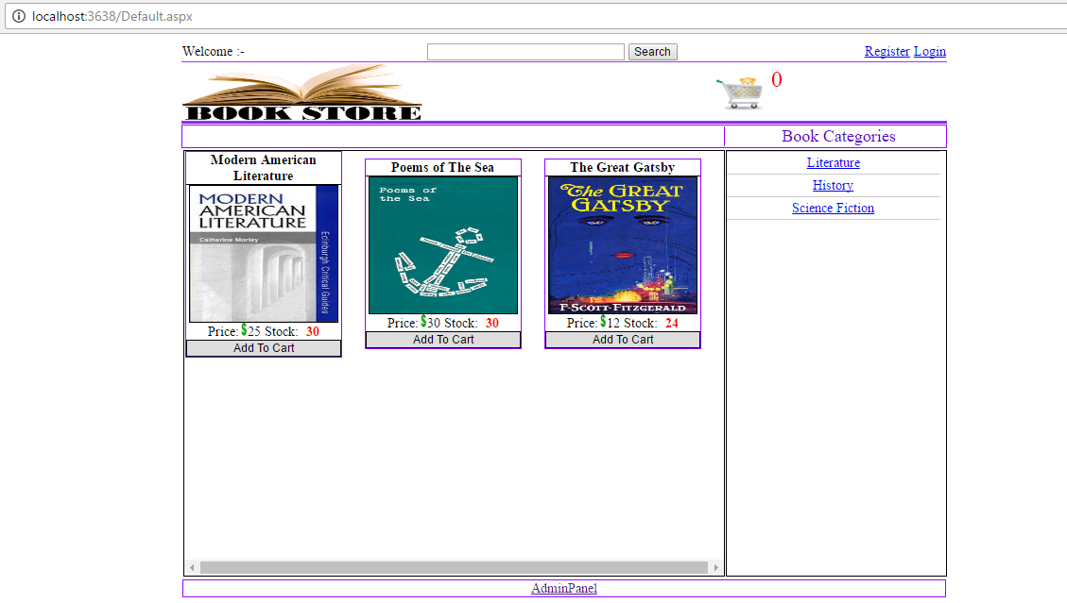

My profile

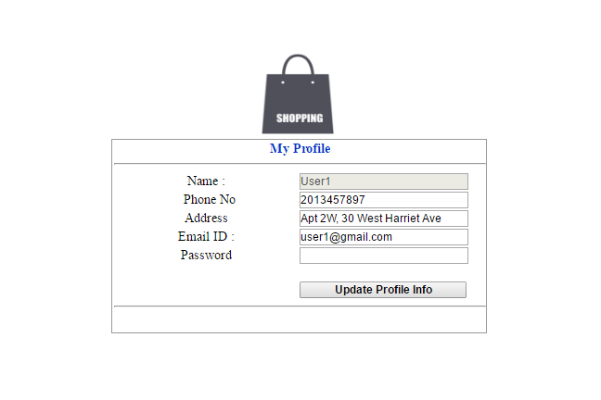

Shopping details

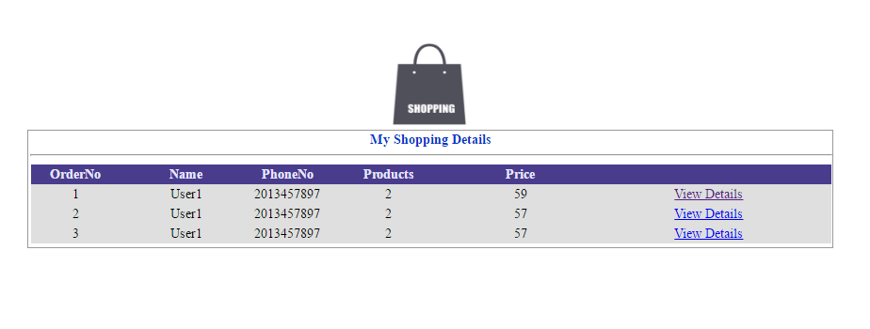

Order details

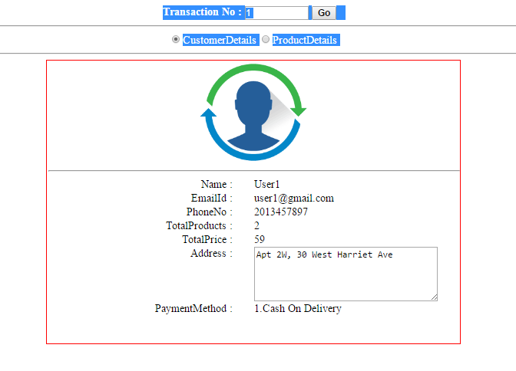

Product order details



Successful order placement

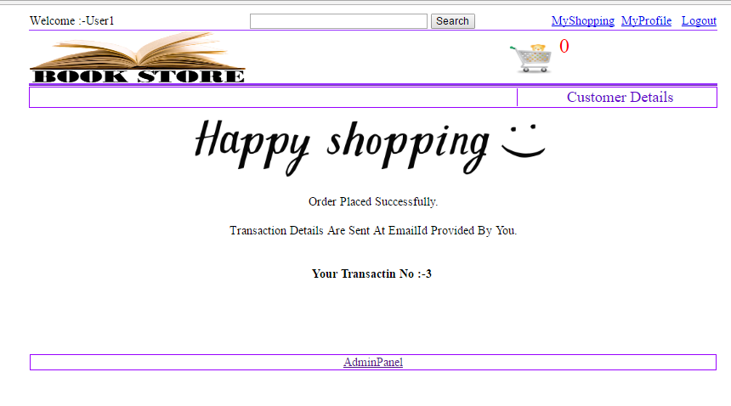

Search Products

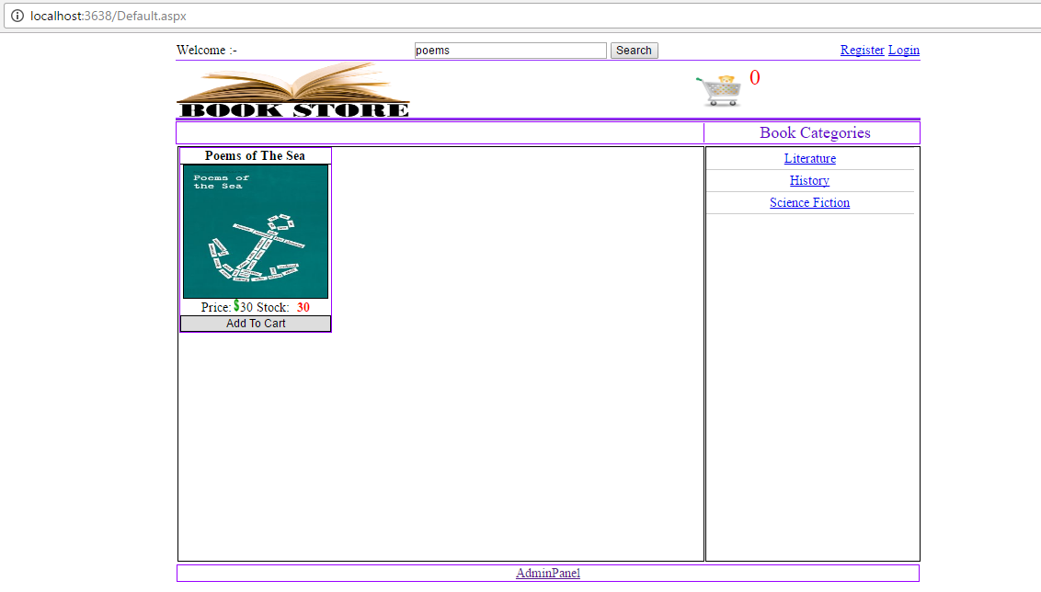

Shopping cart page

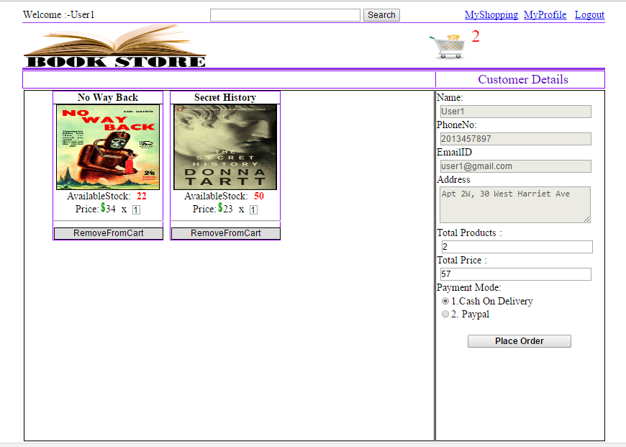

Admin Panel

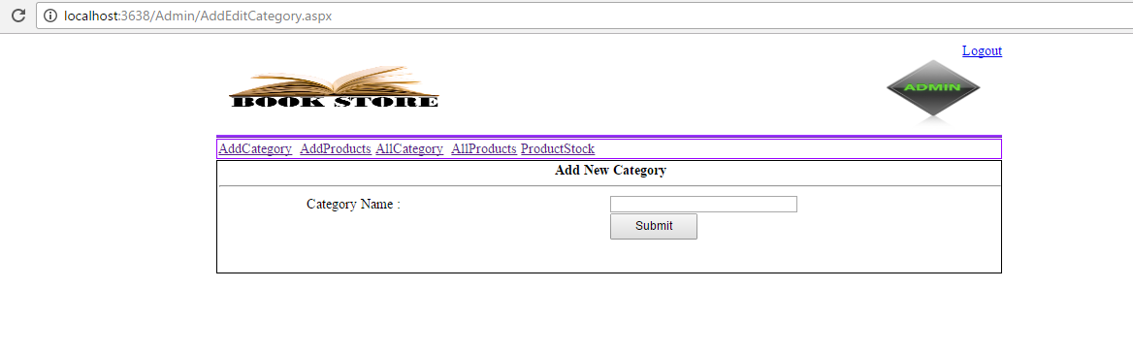

Adding new Product

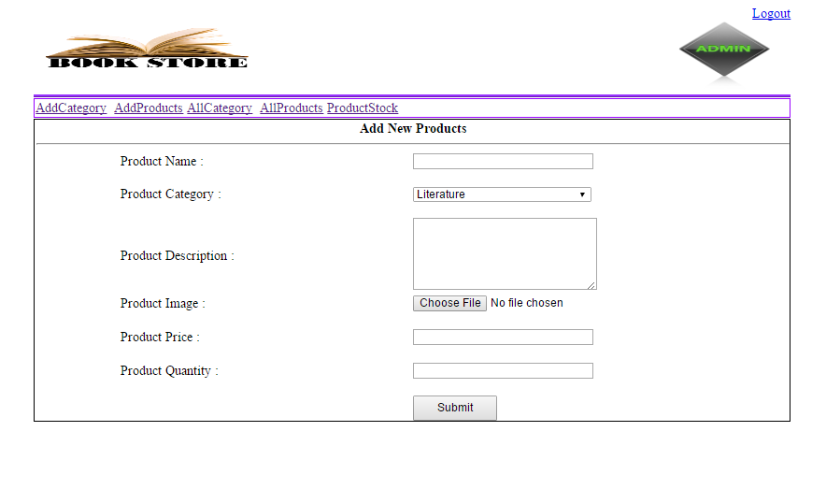

Admin Login

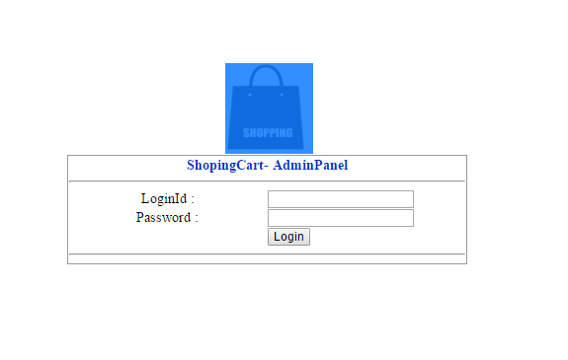

All Category

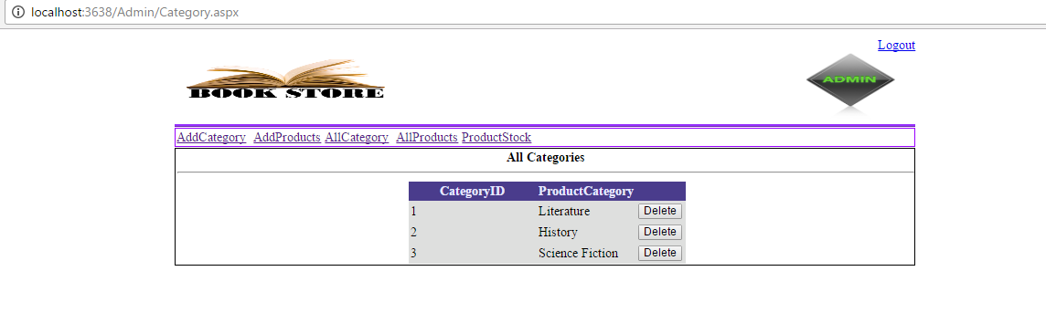

All Products

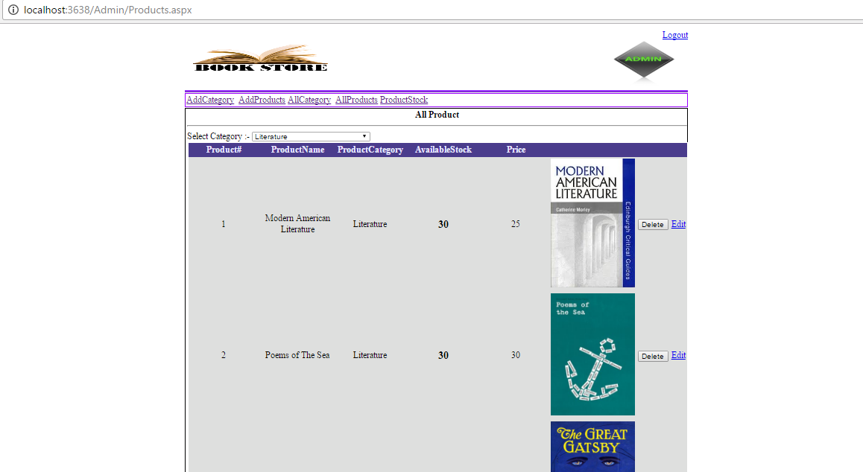

All Product editing

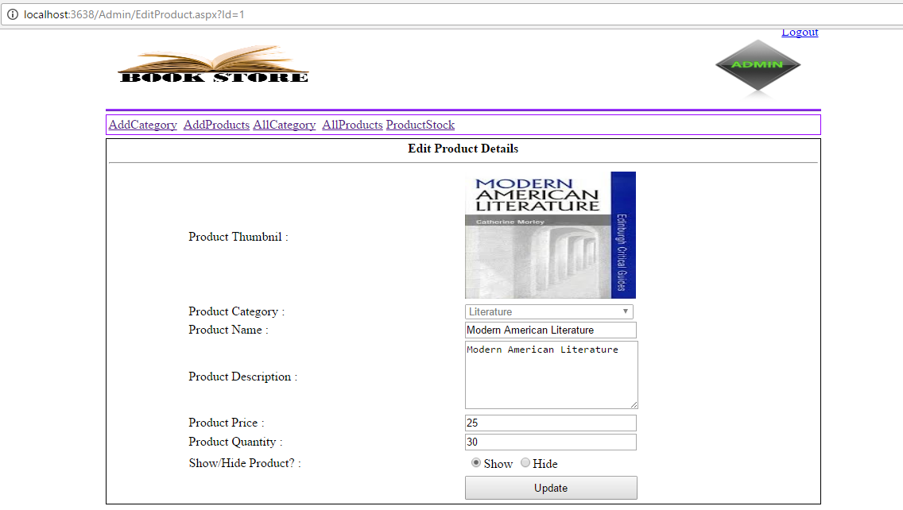

Product stock

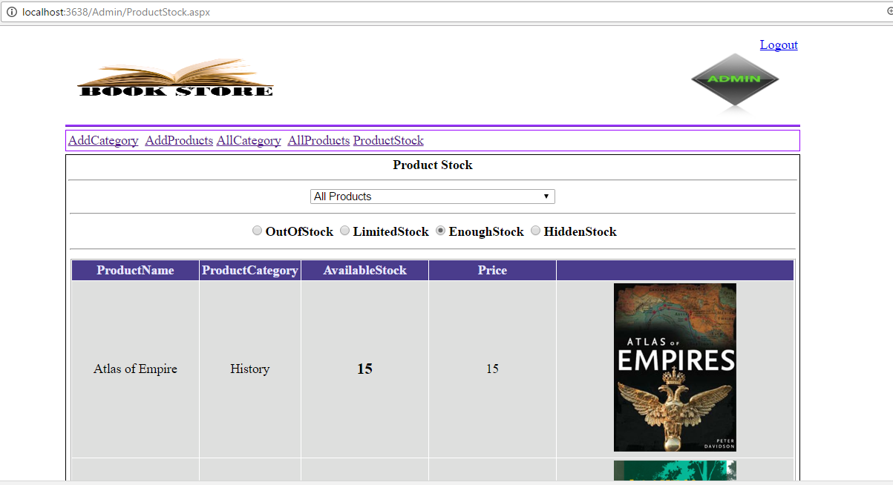

Source Code

Source Code is available in the zip folder provided since there are more than 20 files we did a zip file for src code.

Zip file name : Book store