Capri Science Fair 26-27: Science in Life
Thursday November 19, 2026

There is science everywhere in your life! You just need to choose something you really enjoy and ask an interesting question about it. Then answer the question with an exciting science fair project that you can really make your own!!

Who: Capri students from all grades are highly encouraged!

Topic: Science in Life

What do you enjoy most? Is it sports, food, nature, music, games, Lego, Disneyland, or anything else that interests you? Find the science in it!!

Please note the topic is not exclusive, students may submit any science projects within the attached regulations and project categories.

Key dates:
Now: Start thinking and exploring your world! Get a notebook and make it your
science fair notebook. Start it with your initial interests and ideas.

Thursday Oct 22 First Approval of your Science Fair Project
Complete the online form: https://localhostusr.github.io/capri-science-fair-2026-27/

Thursday Nov 12 Final Entry and Approval of your Science Fair Project

Thursday Nov 19 3:00-5:00pm - Capri 2026-27 Science Fair set up in the MPR
5:00-7:00pm - Capri 2026-27 Science Fair
7:00-7:30pm – Take Projests Home
Questions? Contact Science Fair coordinator Kris Thomson krisdthomson@gmail.com
In School: Ms. Holmes in the STEM room.

Capri Science Fair 26-27: Science in Life

Part 1: How to decide what to do? What question do you want to ask and answer?
- What is 1 of your favorite things? Pick a food, sport, activity, game, music, beach, park, water, dance, Lego, squishy, stuffy, or anything else that interests you!
- What type of science fair project do you want to do? There are 5 main types. The traditional model, the design/engineer model, the product comparison model, the demonstration model, and the scientific/infographic model. Ask you teacher for the differences between these to help find your style.
- Ask the question: What are 5 fun and interesting science fair projects of the type you like, about your favorite thing, for a person in your grade? Ask your parents, ask your teacher, ask your friends, and if you have permission, ask google for some ideas.
- Brainstorm a BUNCH of ideas for projects, not just one. Write notes about them in your notebook whether that is music, sports, machines, stars, gardening, people, pollution, art, math, or animals. The more questions the better so keep asking until you find a project that you think you will enjoy.
- You can work alone or in groups up to 3 students.
- Think about which of your questions might best be answered using scientific inquiry. Those questions might look like: "Does this cause that?" "If I change this, will it make that change too?" "Why does that happen when I change this?" "Is it true that this happens when you do that?" You can also tackle practical problems such as, "How can I measure that when it is too hard to measure directly?" "Can I use this scientific principle to solve that practical problem?" Lots of possibilities.
- With your topic, question and project decided, you’re ready to start!!

Registration
Use this QR code or this link to register:
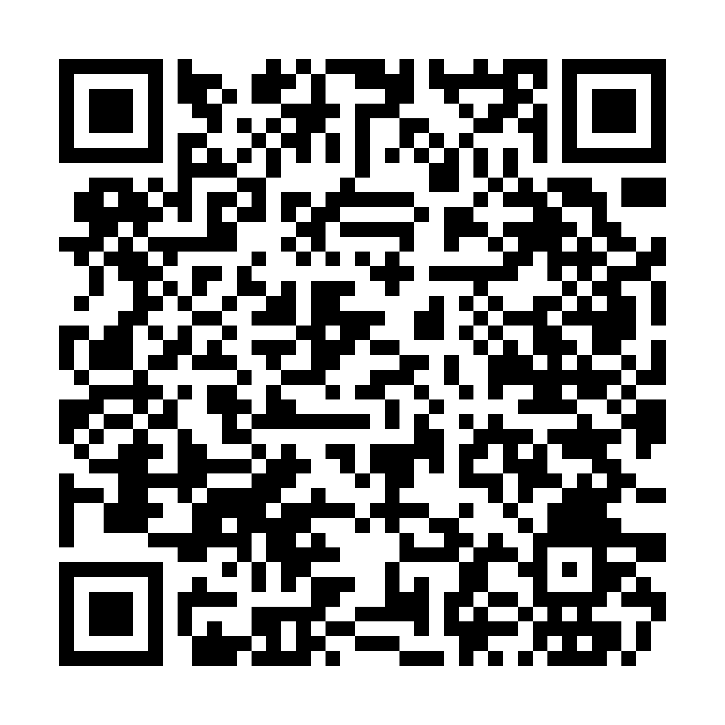
https://localhostusr.github.io/capri-science-fair-2026-27/

Capri Science Fair 26-27: Science in Life

Part 2: Planning, research and development:

- Get information from your teacher on the basics of a science fair project.
- Start with research and preparation. The more you do early the easier it is to complete.
- Get a new science fair booklet for recording your ideas
- Choose what type of science project fits your idea:

Template Type | Core Focus | Best Grade Level | Best For... | Key Sections
1. The Traditional Scientific Method | Testing a variable with a controlled experiment | 2rd – 6th Grade | Experiments (e.g., "Which soap grows the least mold?") | Question, Hypothesis, Variables, Materials, Procedure, Data, Conclusion
2. The Engineering Design Process | Solving a specific problem by building a prototype | 3rd – 6th Grade | Inventions and builds (e.g., Egg Drop challenge, Solar Oven) | Problem, Brainstorm, Design, Build, Test & Redesign, Final Product
3. The Product Comparison | Testing consumer products against everyday standards | K – 3rd Grade | Simple tests (e.g., "Which brand of popcorn pops the best?") | Question, Brands Tested, Tests Performed, Cost vs. Performance, Winner
4. The Demonstration / Model | Recreating a known scientific phenomenon visually | K – 3nd Grade | Visual learners (e.g., Volcano, Model of the Solar System) | Topic, How It Works, Real-World Example, Key Vocabulary
5. The Science Infographic / Poster | Researching a specific topic and synthesizing facts | K – 6th Grade | Research projects (e.g., "How does climate change affect glaciers?") | Main Topic, 5+ Important Facts, Visual Diagrams, Sources

Capri Science Fair 26-27: Science in Life

Part 2: Planning, research and development: Continued

- Do you like your project? If not, now is the time to change it a bit to be more interesting to you.
- Ask everyone you can, internet included, what are the things that you should think about when doing this type of project? What are the supplies that you will need? What are mistakes you should be careful to avoid? How many steps will be required? What is the right order?
- Now create your project plan. It is step by step guide to completing your project. You can follow the examples below. Your teacher should be able to give you a template to follow also.
- Your plan is a brief summary (fewer than 300 words) of the purpose of your project, your experimental/design procedure, key findings or data, and significant conclusions that can be drawn from the evidence you will collect. Your plan will be the the template for your final abstract.

Project Plan Outline
A. Objective or Goal
State the goal or purpose of the project.
State the objective or investigative question.
State the hypothesis.
B. Materials and Methods
List the materials and amounts used in the design and testing procedures.
List the steps of the procedure.
Briefly describe your experiment.
Project category. Refer to category definitions. Indicate your preference.
C. Results
What kind of results are you expecting? How will you measure and record them?
D. Conclusion
Indicate whether your results support your hypothesis or enable you to attain your objective. Discuss briefly how information from this project expands our knowledge.
E. Help Received
Keep a list of the names of mentors, institutions and people who help with the project. Indicate the level of support you received from each person who helps with the project.

Capri Science Fair 26-27: Science in Life

Part 3: Build, Experiment, and Record:

- The Science Fair Notebook: Record everything about a project, as it happens. Include initial observations, notes from reading in preparation for the study, design of the investigation, day-by-day data collection, initial analysis, graphs, charts, drawings, and initial interpretation. It serves as a log for how the scientist moves from idea to conclusions supported by data. Every page should be dated.
- Get all of your supplies organized
- Organize the information you require. What are you collecting and how are you recording it.
- Build what you need to build. (take pictures)
- Place objects where they need to be to run the experiment (take pictures)
- Run the experiment and record your results. (take pictures)
- Prepare visual diagrams, charts and graphs if needed for your project.
- Repeat the experiment if needed for better results.
- Do your experiment, keeping careful, organized notes. Details may be important in answering your question! You might find that something unexpected went wrong the first time.
- Analyze your data, and think about what they mean. If you do the analysis on the computer, print it out, and paste it into your notebook. Figure out if your results are best presented as a table, a graph, or some other kind of illustration. Write notes and ideas in your notebook. It’s OK if your results don’t agree with your predictions!
- Review your project plan and turn into an Abstract by adding in the results and conclusions. Also update your materials/methods and help as is necessary.

Registration is due Thursday November 12, 2026!!
To register please use this QR code or link:
https://localhostusr.github.io/capri-science-fair-2026-27/

Example Project Abstracts
Project Title: Bacteria in Milk, Less Is Best
Objective: The objective is to determine which type of milk has the most bacteria; soy, pasteurized, or raw. I think raw milk has more bacteria than pasteurized milk and soy milk.
Methods: Each type of milk was poured into two test tubes, one as the control, the other the test sample with methylene blue added. The milk in the test tubes was heated to 98 degrees Fahrenheit and maintained at that temperature for eight hours. The heat was then turned off and the milk in the test tubes was allowed to cool to room temperature. From the start of the heating of the milk in the test tubes, the test tubes were examined every fifteen minutes for two hours, and then every hour up to nine hours of elapsed time. After 9 more hours, the test tubes were examined every hour up to 26 hours of elapsed time. The observations were recorded as they were observed.
Results: The raw milk began to change when ½ hour to 3 hours had elapsed, and had the most significant change after the heat was turned off. The pasteurized milk began to change after 1-4 hours, and displayed some change. The soy milk did not change until after 6 hours had elapsed, and did not change much over the 26 hour time frame of the experiment.
Conclusion: My hypothesis was correct; the raw milk had the most bacteria, then the pasteurized milk. The soy milk had the least amount. The soy milk had the least bacteria because it is made from soybeans. Pasteurized milk and raw milk are from cows, and cows develop more diseases because they are living animals. The pasteurized milk goes through a pasteurization process which kills much of the bacteria in it. The raw milk does not receive any special treatment. Bacteria grow best between 80 degrees and 98 degrees Fahrenheit. This explains why the raw milk had the most significant bacteria growth as it cooled from 98 degrees to room temperature (about 70 degrees Fahrenheit). People need to know how to store milk and when it is safe to consume it. If a person is concerned about bacteria content it is helpful to be aware of the bacteria content between the different types of milk.

Project Title: How Water Erosion Affects Dirt and Sand on Hillsides
Objective: To learn how much soil can be carried away by water from a hillside.
Methods: 1 large sheet of wood; 2 long pieces of wood; miter box; Saw; Power Drill; Hot Glue Gun & Glue; Spray paint; Screws; Square; Tape measure; Grass seed; Paint pan; Sand; Dirt; Buckets; Water; 16 ounce container; 3 Tupperware bowls; Stopwatch; Spatula; Shovel; Pie tins; Wire Hole poker; Measuring cups. Method: Build a model hillside with 3 slots. Pack each slot with a soil type. Pour 16 ounces of water over the soil types: sand, plain dirt and planted grass. Vary the length of pouring; 20 seconds; 40 seconds; 60 seconds.
Results: Water, 20 seconds: Plain soil: I had to get the dirt out from the Tupperware bowls and the bottom of the hillside and drain off all the water. I put my dirt into pie tins. I drained off more water. Then I measured the dirt in a measuring cup. There was 1/4 cup of dirt lost from the hillside. Sand: Sand and water went everywhere. It went out the model and over the sides. I measured the amount of sand left in the model. I used a spatula to get all the sand into a measuring cup. There was 3 3/4 cups of sand lost. Grass Soil: There was no dirt runoff. Water, 40 seconds: Plain soil: lost ¼ cup. Sand: lost 3 ½ cups. Grass Soil: There was no dirt runoff. Water, 60 seconds: Plain soil; While the water was running down the dirt on this test I saw a channel start to form and pick up a lot of soil in the run-off, lost 1 1/3 cups. Sand lost 3 ¼ cups. Grass Soil, no runoff. Conclusion: I think my experiment went really well. I had a lot of fun building my model hillside. My hypothesis; Sand will be most affected by water erosion was correct. Observing hillside erosion I learned it is important to also watch how water travels downhill, it can cause a large increase in erosion if water can form a channel or stream. The grass was the least affected by erosion. I do not want a beach house.

Capri Science Fair 26-27: Science in Life

Part 4: Organize your information and results and make your science fair baord

- Prepare the sections for your science fair project board and report. These boards are provided free by the PTA. Supplies are limited so request one early.
- There should be a separate section for each of the following:
  - A clear title at the top in the middle
  - Question or purpose
  - Hypothesis or Background Information
  - List of Materials -What did you use?
  - Procedure-How did you do it?
  - Results/Data-Organize and summarize it so the information is clear.
  - Conclusion-What did you learn?
- Use your updated Project Abstract to help fill in these sections.
- Make sure these sections are clear and easy to read. This is how everyone else will learn about what you have done. This is your science project story. Does it make sense to someone who have no experience?
- The report and the display have shared goals. They both tell clearly:
- What you were interested in and why
- What your specific questions were
- What you did to answer them
- What you found, and what it means.
- Your display and report should tell the story of your project. Use images and not just words. What were your questions and specific hypothesis or objective? What methods did you use, what were your observations, and what do you conclude from your results? Include enough background to show that you read about the system and show how your study adds to our understanding. Don't forget to acknowledge the help you got.
- Practice speaking and answering questions about your project. If you can communicate enthusiastically with your family and friends, you will do well for the science committee interviews.

Capri Science Fair 26-27: Science in Life

Major parts of a Science Fair Report and Display. The display poster will use fewer words, often presented in bullet points. The Report has the same material, but may include more background material from research in books and the web, and presents material in full paragraphs, rather than bullet points.

Introduction: Includes purpose, overall questions, and specific hypotheses.  - Purpose: 1-3 sentences that explain why you are doing the investigation.  - Questions: Clearly write down the overall questions or goals. (e.g., Does puddle size affect how quickly the water warms up in the sun?)  - Hypotheses: A hypothesis is what you expect is the answer to your question. (e.g., Smaller puddles will warm up more quickly than larger puddles.) | Discussion and Conclusion:  - A few sentences that describe what your data mean.  - What conclusions can you draw about your hypotheses?  - Discussion challenges with the experiment (things that didn't go as planned)  - Suggestions for future studies on this topic
Procedures (aka Methods and Materials):  - Provide enough detail for the reader to be able to replicate your experiment to see if he/she gets the same results.  - Materials can be included as a list.  - The methods may be a step-by-step guide, a descriptive paragraph, or a clearly labeled illustration. | References  - Citations of books, web sites, articles that were important in giving you information for your projects.
Results:  - Highlight main findings in a few simple declarative sentences or bullet points.  - Summarize data in a way that helps test the hypotheses, rather than present the raw data.  - Illustrate results with visuals (photos, drawings, graphs, charts, and tables) | Acknowledgements  - Specify who helped you with what parts of the science fair project.

Capri Science Fair 26-27: Science in Life

Important Rules and Regulations: Please see rules and regulations further on in this packet, especially if your child’s project involves hazardous chemicals, biological agents like bacteria, or human or animal subjects.

More information: Good additional sources for Science Fair help are available at: Science Buddies:
http://www.sciencebuddies.org/
Important Regulations
These regulations outline basic do’s and don't’s for the Science Fair. Please contact the Science Fair coordinator at Kris Thomson krisdthomson@gmail.com if you have questions.

- No hazardous materials may be exhibited in the project display.
- Photographs of procedures detrimental to the health and well-being of vertebrate animals, or surgical procedures on animals, may not be displayed.
- Projects must clearly distinguish between the work of the student and others (parents, industry or university sponsors, etc.). Students must clearly specify the assistance received and the role and contributions of others in the project. If associated with a larger research project at a research institute, university, or industry, the project must be accompanied by a letter of the principal research director that indicates the level of his/her involvement in the project.
- Scientific Review Committee approval is REQUIRED for any projects that involve any of the following. Contact Kris Thomson krisdthomson@gmail.com immediately to obtain the Certificate of Compliance BEFORE doing the project.
- Human subjects (asking people questions, experiments on yourself or other people)
- Non-human vertebrate animals (including your pet)
- Pathogenic agents (molds, fungi, bacteria, viruses, microbial cultures from the environment)
- Controlled substances (prescription drugs, alcohol, tobacco products, gunpowder) – anything that a student could not legally purchase on their own.
- rDNA – recombinant DNA
- Human or Animal tissues or fluids (cheek cells, bones, blood, saliva, urine, etc.)
- Chemicals (including household cleaning agents, solvents, metals, organic chemicals)
- Hazardous/dangerous materials (rockets, lasers, UV light, radiation, explosives, corrosives)

Project presentation regulations.
- A complete project requires presentation of (A) the student's original laboratory notebook, (B) a project report, and (C) a project display (your poster/presentation board). Reports should be word processed and include a cover, title page, and table of contents.

- Students will be interviewed by a committee member about their project. Students should practice a brief oral presentation that describes what the project was about, what they did, and what they found, and be ready to answer questions about the project. They should be able to show which parts were their work and where they got help.

- Maximum width is 4.0 feet, maximum height is 6.0 feet, and maximum depth is 2.5 feet. Display boards are available in the office while supplies last.

Additional notes on parental involvement
Parents are an essential part of the development of the science fair projects, but the projects should reflect the student's ideas and work. Help them develop the questions and designs by asking them questions, rather than telling them what to do. Help the students figure out how to make graphs, figures, and tables, but let them do it themselves. Students should be responsible for the text (with parental review). Be sure to leave enough time!

Registration is due Thursday November 12, 2026!!
To register please use this QR code or link:
https://localhostusr.github.io/capri-science-fair-2026-27/

