Translation Evaluations – How to Display Your Feedback
- Download and install Visual Studio Code
- Install the Live Server extension
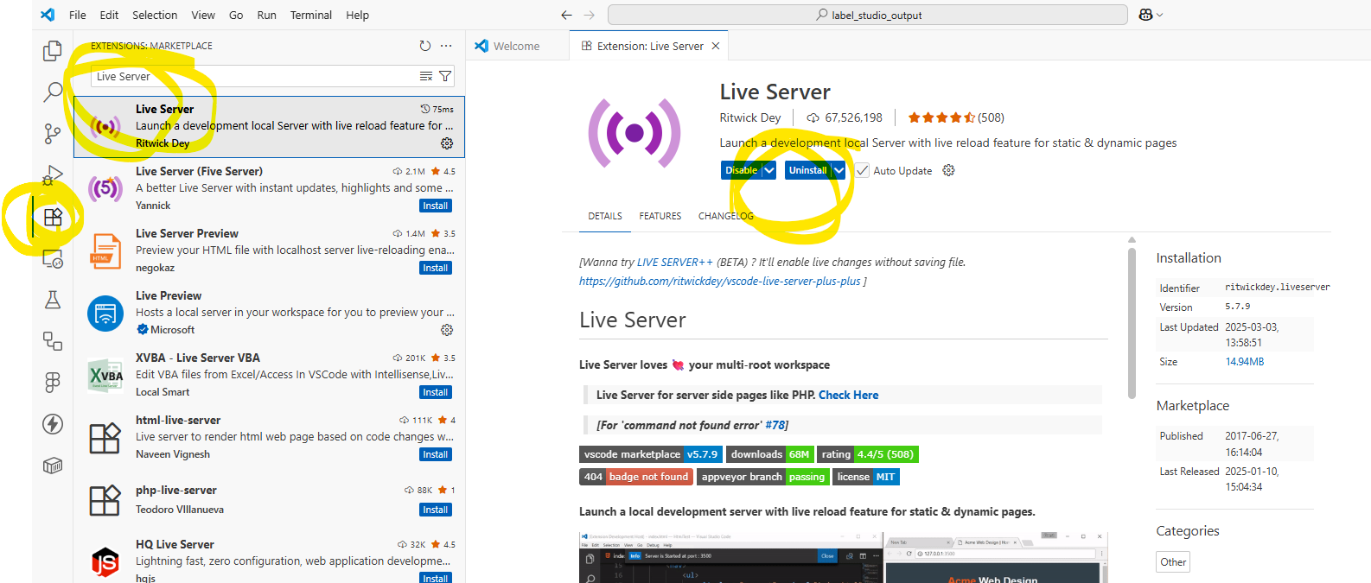
- Download and unzip the archive containing these files:
  - Translation-evaluations.html
  - scripts.js
  - styles.css
  - config.json
  - [yourlastnames]_[text-name]-evaluation.json
- Open the folder containing these files in Visual Studio Code
- Right click on the texto1-evaluation.html file and click Open with Live Server
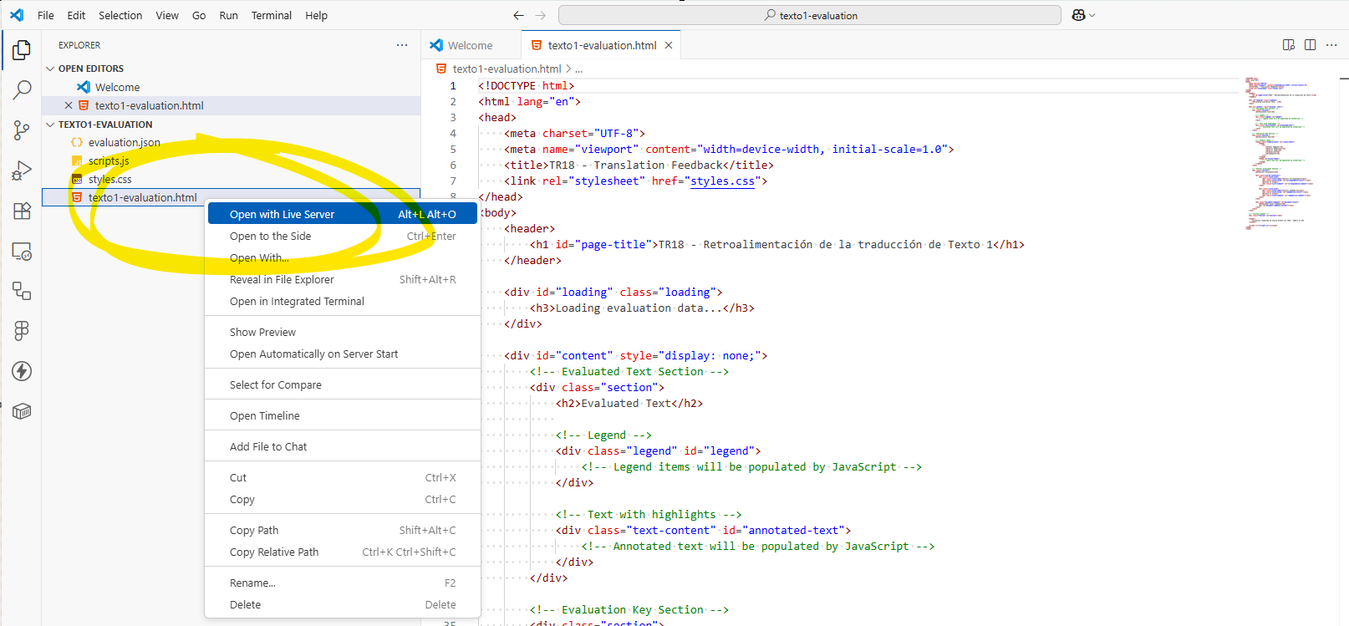
- View your results on the local webpage that opened
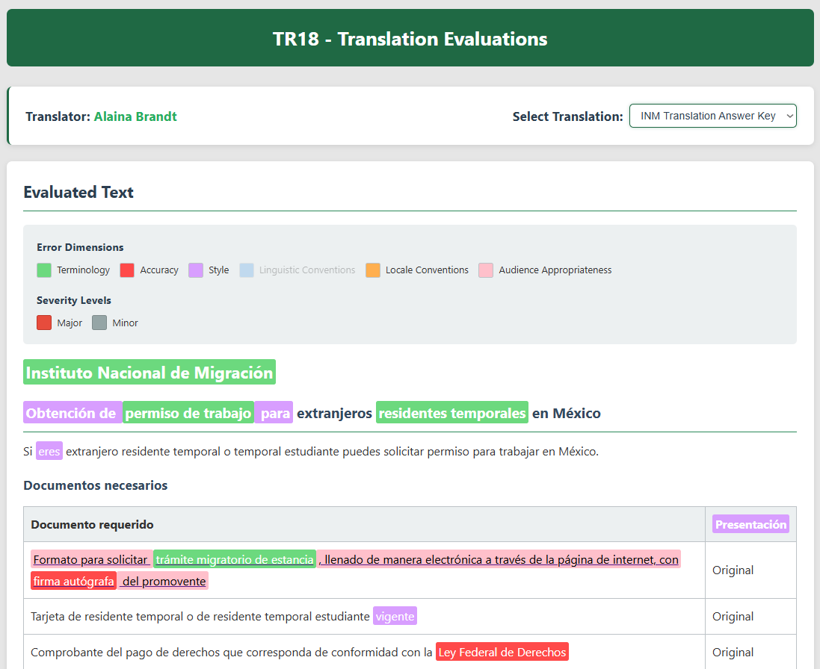
- Please let me know of any display issues that you encounter so that I can troubleshoot the code as necessary!

