## FPT ACADEMY INTERNATIONAL FPT – APTECH COMPUTER EDUCATION



### Centre Name: ACE-HCMC-2-FPT.

**Address: 590 Cach Mang Thang 8, District 3, Ho Chi Minh City, Viet Nam.**

Clarins Cosmetics

|  |  |  |
| --- | --- | --- |
| **Supervisor:** | Ms. Le Mong Thuy | |
| **Semester:** | 1 | |
| **Batch No:** | T1.2406.M1 | |
| **Group No:** | 5 | |
| **Order:** | **Name** | **Student ID** |
| 1. | Than The Loc | Student1571994 |
| 2. | Le Thanh Hoang | Student1574888 |
| 3. | Vo Dinh Duy | Student1571992 |

Date: September - 2024

### This is to certify that

**Mr.** Than The Loc

**Mr.** Le Thanh Hoang

**Mr.** Vo Dinh Duy

### have successfully designed & developed:

eProject: Clarins Cosmetics

### Submitted by:

Ms. Le Mong Thuy

**Date of issue:** September 14th 2024

### Authorized Signature:

**Table of Contents**

ACKNOWLEGMENT 3

SYNOPSIS 3

ANALYSIS 3

1. Purpose of the Website 3
2. Design and Interface 3
3. Technical Requirements 4

CUSTOMER'S REQUIREMENTS SPECIFICATIONS 4

1. Business/Project Objective 4
2. Hardware/ Software Requirements 5
   1. Hardware 5
   2. Software 5

SCOPE OF THE WORK (IN BRIEF) 6

1. HOME 6
2. FACE 6
3. BODY 6
4. SUNSCREAM 6
5. HAIR 6
6. ABOUT US 6
7. CONTACT 6

ARCHITECTURE AND DESIGN OF THE SYSTEM 7

. 7



DIAGRAM OF THE WEBSITE 8

TASK SHEET REVIEW 1 9

SITE MAP 10

MOCK OF THE WEBSITE 11

1. HOME 11
2. FACE 12
3. BODY 13
4. BEST SALE 14
5. LIBRARY 15
6. ABOUT US 16
7. CONTACT 17

TASK SHEET REVIEW 2 19

WEBSITE DESCRIPTION 20

1. HOME 20
2. FACE 21
3. BODY 24
4. BEST SALE 25
5. LIBRARY 26
6. ABOUT US 27
7. CONTACT 28

TASK SHEET REVIEW 3 30

## ACKNOWLEGMENT

On behalf of team members. I would like to thank everyone who supported my team to successfully complete this eProject report. Especially, our teacher, she has supported us a lot since we started studying at FPT Aptect. With this eProject, she guided us very meticulously, enthusiastically and strictly. With her guidance, we were able to successfully complete this project. Besides, I also want to thank all the team members, each of whom worked hard to complete the eProject in earnest during the month of working together. Finally, our group would like to say thank you to my classmates and family for sharing and creating for the group the best environment to focus on the project, motivating the members to achieve their goals.

## SYNOPSIS

Clarins is a French brand of skincare for the face and body. With a genuine passion to deliver real and natural beauty solutions, the brand started with a beauty spa and its own product line. With more than 60 years in the industry and close communication with consumers, Clarins is a reference in premium beauty - with a wide catalog that offers skincare solutions for the face and body, makeup and fragrances. There are some iconic products that stand from the catalog, such as the face oils, the unique Double Serum and also body treatments that represent the essence of the brand - every product conveys expertise and top performance of Clarins beauty solutions.

Clarins has been providing botanical-based and innovative solutions. The aim remains the same: to search for one of a kind solutions for unique clients. Clarins is a way to simultaneously achieve great results and a sensorial experience in itself. To that end, the formulas embody the best of what the botanical world has to offer.

Apart from providing their own range of products, they also offer products from various other brands on their website. This helps their customer to find one place solution for all SkinCare and Beauty products available in the market.

## ANALYSIS

### Purpose of the Website.

The portal will be designed as a Single-Page-Application and responsive Website with a set of pages and menus that represent choice of activities to be performed. The pages, menus, and other visual elements must be designed in a visually appealing manner with attractive fonts, colors, and animations.

All of these should also be laid out in a responsive manner

### Design and Interface.

* + The website features a user-friendly environment and navigation. Key menus are positioned at the top for easy access to information.
  + The interface and color scheme are harmoniously combined to create a visually appealing and engaging experience for users.

### Technical Requirements

* + The website must perform well across all major browsers including Chrome, IE, Firefox, etc., ensuring accessibility from various devices and platforms.
  + It utilizes a Single-Page-Application (SPA) approach to deliver a seamless and fast web browsing experience.
  + Features are designed to meet technical requirements, facilitating quick and accurate loading and display of information.

## 

## CUSTOMER'S REQUIREMENTS SPECIFICATIONS

### Client: Clarins Cosmetics Co.

### Business/Project Objective

The portal will be designed as a Single-Page-Application and responsive Website with a set of pages and menus that represent choice of activities to be performed. The pages, menus, and other visual elements must be designed in a visually appealing manner with attractive fonts, colors, and animations.

All of these should also be laid out in a responsive manner

The Web site is to be created based on the following requirements.

1. The Top of the Page should be presented with a suitable logo and images of beauty products.
2. The site must contain various sections like FACE, BODY, SUNSCREEN, HAIR, MAKEUP, PERFUMES etc. with products displayed in these sections.
3. Clicking on a product should open pop-up window with details and price of the product along with scrollable images.
4. Filters on brands, price, type of products etc. should be provided.
5. Section on various offers on the product should also be provided.
6. Top Selling products should be provided on the Top Section.
7. Gallery can be added for viewing different images.
8. Site map, Gallery, About us, Contact us link must be added.
9. About Us and Contact Us: This menu option should display Email id, address, and contact number of the organization.

Over and above this, the portal should implement the following functionalities:

* Display a continuous scrolling ticker at the bottom of the page with current date, time, and location (hint: Use geolocation features of HTML5).
* Display a visitor count at the top right corner of the page beside a logo image.
* The menu options should change color on hover and also after clicking.
* Fade in and fade out options can be used for the menus.

### Hardware/ Software Requirements

### Hardware

* + - Intel Core i3/i5 Processor or higher
    - 8 GB RAM or above
    - Color SVGA
    - 500 GB Hard Disk space
    - Mouse
    - Keyboard

### Software

Technologies to be used:

* + - Frontend: HTML5, CSS, Bootstrap, JavaScript, jQuery, React/AngularJS, Figma, XML
    - Data Store: JSON files or TXT files Other Requirements:
    - Operating Portal: Windows
    - Browsers: Edge, Chrome, Mozilla Firefox, Safari

# SCOPE OF THE WORK (IN BRIEF)

### Home:

* + Displays an overview of cosmetics and the website's logo.

### Face

* + **Skincare:** A list of different skincare products
  + **Make-up:** Lists different types of cosmetics used for face.

### Body

* + **Skincare:** A list of mountaineeri ng-related videos.
  + **Perfume:** A list of different perfumes

### Galery

### The place shows all pictures of my products

1. **About us**

Introducing about my process when Clarins Cosmetics Co. was established

1. **Contact :** All Clarins Cosmetics Co. ‘s informations .

## ARCHITECTURE AND DESIGN OF THE SYSTEM

Webpage request

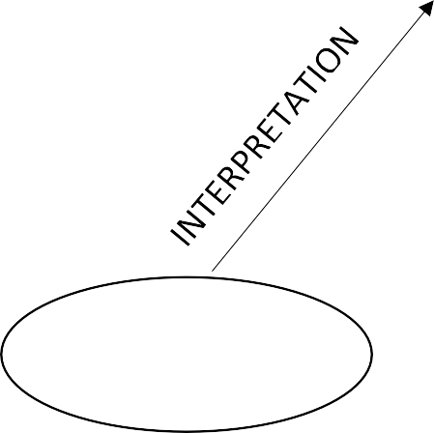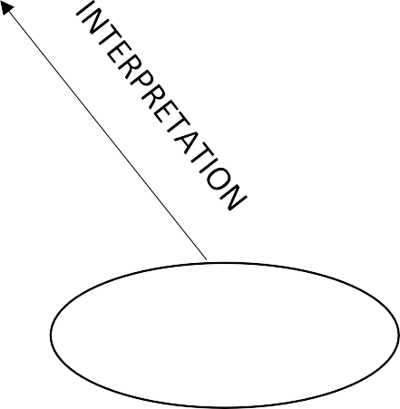

**CLIENT**

**WEB BROWSER**

Requested Page

**RENDERING**

**ENGINE**

**CSS CODE**

**HTML CODE**

**SERVER**

**WEB SERVER**



**DIAGRAM OF THE WEBSITE**

HOME

ABOUT

GALLERY

FILLTERS

BEST SELLERS

BODY

PERFUME

SCREAMS

SKINCARE

MAKE-UP REMOVE

CLEANSER

FACE



**TASK SHEET REVIEW 1**

|  |  |  |  |  |  |  |  |
| --- | --- | --- | --- | --- | --- | --- | --- |
| **Project Ref. No.: eP/Advertisement Portal Management System/01** | | **Project Title:** | **Activity Plan Prepared By:** | **Date of Preparation of Activity Plan:** | | | |
| **Sr.No** | **Task** | **Actual Start Date** | **Actual Days** | **Team Mate Names** | **Status** |
| 1 | Synopsis | Alpine Ascents | Loc | 21/09/24 | 1 | Hoang | Completed |
| 2 | Analysis | 21/09/24 | 1 | Loc | Completed |
| 3 | The scope of the work (in brief) | 21/09/24 | 1 | Duy | Completed |
| 4 | Architecture and design of the system | 23/9/24 | 1 | Hoang | Completed |
| 5 | Diagram of the website | 23/9/24 | 1 | Loc | Completed |
| 6 | Task Sheet Review | 23/9/24 | 1 | Duy | Completed |

|  |  |
| --- | --- |
| **Date:** | |
| Signature of Instructor:  **Le Mong Thuy** | Signature of Team Leader:  **Than The Loc** |



**SITE MAP**

HOME

ABOUT

GALLERY

FILLTERS

BEST SELLERS

BODY

PERFUME

SCREAMS

SKINCARE

MAKE-UP REMOVE

CLEANSER

FACE

|  |  |  |  |  |  |  |  |
| --- | --- | --- | --- | --- | --- | --- | --- |
| **Sr.No.** | **Tak** |  |  | **Actual Start Date** | **Actual Days** | **Team Mate Names** | **Status** |
| 1 | Home | Alpine Ascents | Loc | 1/7/24 | 3 | Loc | Completed |
| 2 | Face |
| 3 | Body |
| 4 | SunScream | 1/7/24 | 3 | Hoang | Completed |
| 5 | Hair |
| 6 | makeup |
| 7 | Promotion | 1/7/24 | 2 | Duy |  |
| 8 | About |

|  |  |
| --- | --- |
| **Date:** | |
| Signature of Instructor:  **Ms. Le Mong Thuy** | Signature of Team Leader:  **Than The Loc** |