

# FPT ACADEMY INTERNATIONAL FPT – APTECH COMPUTER EDUCATION

**Centre Name:** ACE-HCMC-2-FPT.

**Address:** 590 Cach Mang Thang 8, District 3, Ho Chi Minh City, Viet Nam.

Clarins cosmetics

|  |  |  |
| --- | --- | --- |
| **Supervisor:** | Ms. Le Mong Thuy | |
| **Semester:** | 1 | |
| **Batch No:** | T1.2406.M1 | |
| **Group No:** | 5 | |
| **Order:** | **Name** | **Student ID** |
| 1 | Than The Loc | Student1571994 |
| 2 | Le Thanh Hoang | Student1574888 |

Ho Chi Minh, Sep - 2024

## This is to certify that

**Mr.** Than The Loc

**Mr.** Le Thanh Hoang

## have successfully designed & developed:

eProject: Clarins cosmetics

**Submitted by:**

Ms. Le Mong Thuy

**Date of issue:** Oct 14th 2024

## Authorized Signature:

**Table of Contents**

ACKNOWLEGEMENT 3

SYNOPSIS 3

ANALYSIS 4

1. Purpose of the website 4
2. Design and interface 4
3. Technical requirements 4

CUSTOMER’S REQUIREMENTS SPECIFICATIONS 4

1. Business/Project Objective 5
2. Hardware/Software Requirements 6
   1. Hardware 6
   2. Software 6

SCOPE OF THE WORK (IN BRIEF) 7

1. Homepage 7
2. Face 7
3. Body 7
4. Sunscream 7
5. Hair 7
6. Perfume 7
7. Promotion 7
8. Filter 7
9. About…………………………………………………………………………………………..7

ARCHITECTURE AND DESIGN OF THE SYSTEM 8

DIAGRAM OF THE WEBSITE 9

TASK SHEET REVIEW 1 10

SITE MAP 11

MOCK OF THE WEBSITE 12

1. Homepage 12
2. Face 13
3. Body 14
4. Sunscream 15
5. Hair 16
6. Perfume 17
7. Promotion 18
8. Filter 19
9. About……………………………………………………………………………………….19

TASK SHEET REVIEW 2 20

WEBSITE DESCRIPTION 21

1. Homepage 21
2. Face 22
3. Body 23
4. Sunscream 24
5. Hair 25
6. Perfume 26
7. Promotion 27
8. Filter 28
9. About……………………………………………………………………………………….28

TASK SHEET REVIEW 3 29

# ACKNOWLEGEMENT

On behalf of all team members, we would like to express our heartfelt gratitude to everyone who supports us throughout the completion of this **Car Breezy** eProject. Special thanks to our supervisor, Ms. Le Mong Thuy, whose enthusiastic and dedicated guidance was instrumental in our success. Her continuous support and mentorship provided us with the direction and motivation needed to complete this project.

We also extend our sincere thanks to all team members for their hard work and dedication throughout the month-long effort. Your commitment and earnest contributions were crucial to our success.

Finally, we are grateful to our classmates for creating an encouraging environment that allowed us to focus on our project and achieve our goals. Your support and motivation were greatly appreciated.

# SYNOPSIS

Clarins, a renowned French skincare and beauty brand, has been a staple in the beauty industry for decades. Founded in Paris in 1954 by Jacques Courtin-Clarins, the brand is celebrated for its commitment to using high-quality, plant-based ingredients. Clarins offers a comprehensive range of skincare products, makeup, and fragrances, designed to cater to diverse skin types and concerns. With a focus on efficacy and luxury, Clarins has earned a loyal following worldwide for its ability todeliver visible results and a sensorial experience.

# ANALYSIS

## Purpose of the Website

The website is developed to provide a seamless and efficient cosmetics viewing experience. It offers comprehensive information about products, pricing, and deals, along with tools that guide users through the entire purchasing process.

## Design and Interface

* The website is designed as a Single-Page Application (SPA) with a responsive layout.
* Key features include a user-friendly navigation menu, visually appealing design, and consistent color scheme.
* The interface incorporates modern design elements like animations, hover effects, and interactive components.

## Technical Requirements

* This website must perform well across all major browsers including Chrome, IE, Firefox, etc., ensuring accessibility from various devices and platforms.
* It utilizes a Single-Page-Application (SPA) approach to deliver a seamless and fast web browsing experience.
* Features are designed to meet technical requirements, facilitating quick and accurate loading and display of information.

# CUSTOMER'S REQUIREMENTS SPECIFICATIONS

Client: **Clarins cosmetics**

## Business/Project Objective

The portal will be designed as a Single-Page-Application and responsive Website with a set of pages and menus that represent choice of activities to be performed. The pages, menus, and other visual elements must be designed in a visually appealing manner with attractive fonts, colors, and animations. All of these should also be laid out in a responsive manner.

The Website is to be created based on the following requirements:

1. The Top of the Page should be presented with a suitable logo and images of beauty products.
2. The site must contain various sections like FACE, BODY, SUNSCREEN, HAIR, MAKEUP, PERFUMES etc. with products displayed in these sections.
3. Clicking on a product should open pop-up window with details and price of the product along with scrollable images.
4. Filters on brands, price, type of products etc. should be provided.
5. Section on various offers on the product should also be provided.
6. Top Selling products should be provided on the Top Section.
7. Gallery can be added for viewing different images.
8. Site map, Gallery, About us, Contact us link must be added.
9. About Us and Contact Us: This menu option should display Email id, address, and contact number of the organization.
10. Color combination must be uniform throughout the project.
11. Navigation must be smooth.

Over and above this, the portal should implement the following functionalities:

* + Display a continuous scrolling ticker at the bottom of the page with current date, time, and location.
  + Display a visitor count at the top right corner of the page beside a logo image.
  + The menu options should change color on hover and also after clicking.
  + Fade in and fade out options can be used for the menus.

## Hardware/ Software Requirements

## Hardware

* + - Intel Core i3/i5 Processor or higher
    - 8 GB RAM or above
    - Color SVGA
    - 500 GB Hard Disk space
    - Mouse
    - Keyboard

## Software

Technologies to be used:

* + - Frontend: HTML5, CSS, Bootstrap, JavaScript, jQuery, React/AngularJS, Figma, XML
    - Data Store: JSON files Other requirements:
    - Operating Portal: Windows
    - Browsers: Edge, Chrome, Mozilla Firefox, Safari

**SCOPE OF THE WORK (IN BRIEF)**

## Homepage:

Displays an overview of Clarins cosmetics, navigation, footer..

## Face:

Including make-up and skincare

## Body:

Show list of products for body

## Sunscream:

Show list of products for sunscream

## Hair:

Show list of products for hair.

## Perfume:

Show list of products for body.

## Promotion

Show list of products for bodyt.

## Filter:

Go to filter page.

1. **About**:

Including introduction and contact

# ARCHITECTURE AND DESIGN OF THE SYSTEM

**CLIENT**

**SERVER**

Webpage request

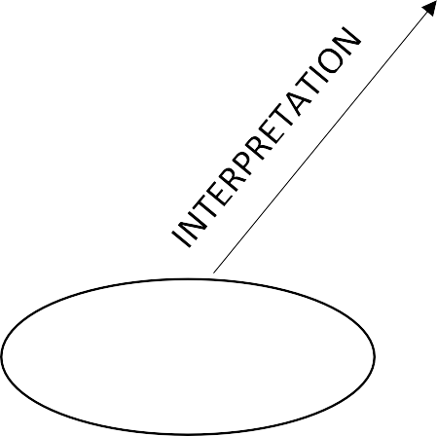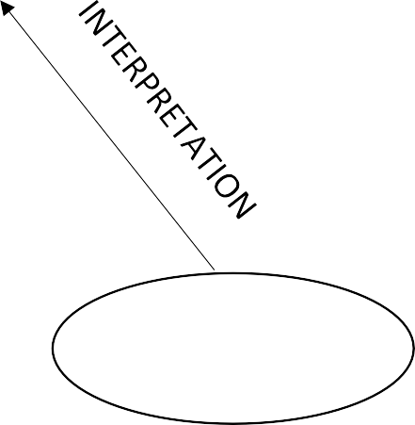

Requested Page

**RENDERING**

**ENGINE**

**CSS CODE**

**HTML CODE**

|  |  |  |
| --- | --- | --- |
| **WEB BROWSER** |  | **WEB SERVER** |
|  |



**DIAGRAM OF THE WEBSITE**

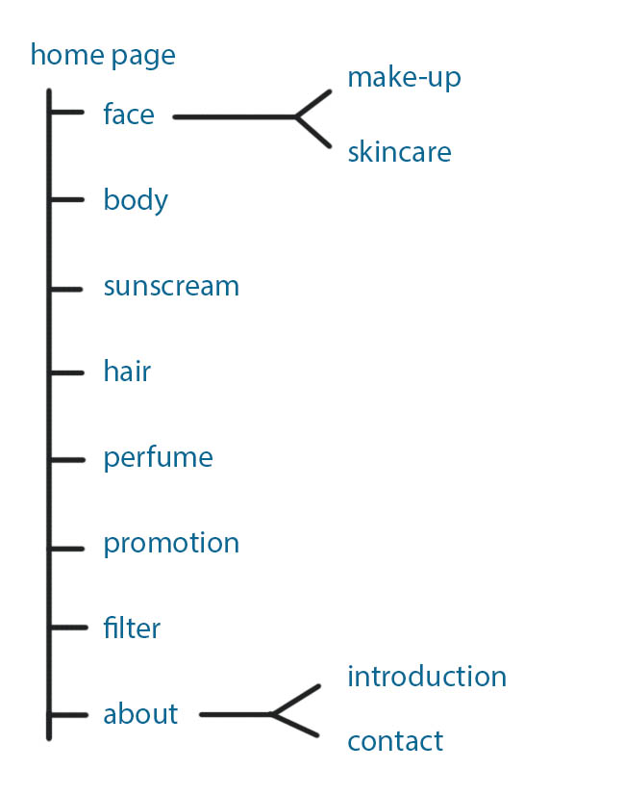



**TASK SHEET REVIEW 1**

|  |  |  |  |  |  |  |  |
| --- | --- | --- | --- | --- | --- | --- | --- |
| **Project Ref. No.: eP/Advertisement Portal Management System/01** | | **Project Title:** | **Activity Plan Prepared By:** | **Date of Preparation of Activity Plan:** | | | |
| **No.** | **Task** | **Actual Start Date** | **Actual Days** | **Team Mate Names** | **Status** |
| 1 | Synopsis | Clarins  cosmetics | Loc | 14/09/24 | 1 | Loc | Completed |
| 2 | Analysis | 14/09/24 | 1 | Hoang | Completed |
| 3 | The scope of the work (in brief) | 14/09/24 | 1 | Loc | Completed |
| 4 | Architecture and design of the system | 14/09/24 | 1 | Hoang | Completed |
| 5 | Diagram of the website | 14/09/24 | 1 | Loc | Completed |
| 6 | Task Sheet Review | 14/09/24 | 1 | Hoang | Completed |

|  |  |
| --- | --- |
| **Date:** | |
| Signature of Instructor:  **Le Mong Thuy** | Signature of Team Leader:  **Than The Loc** |



**SITE MAP**



# MOCK OF THE WEBSITE

## Homepage

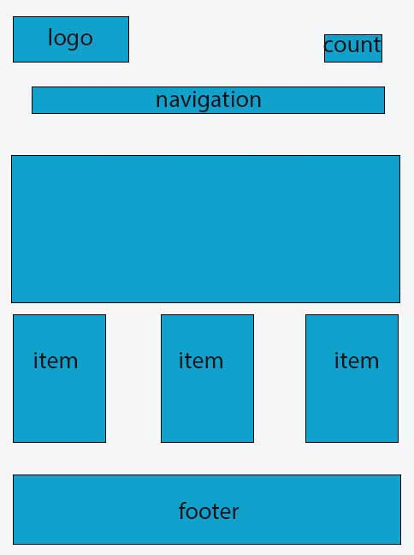

## Face/ Make-up

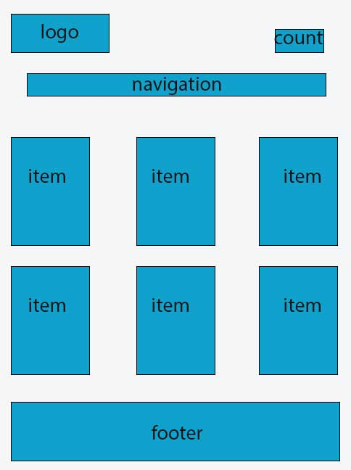

## Face/ Skincare



1. **Body**



1. **Sunscream**



1. **Hair**



1. **Perfume**



1. **Promotion**



1. **Filter**

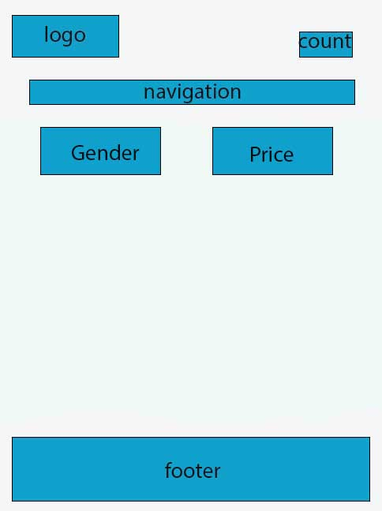

1. Introdution

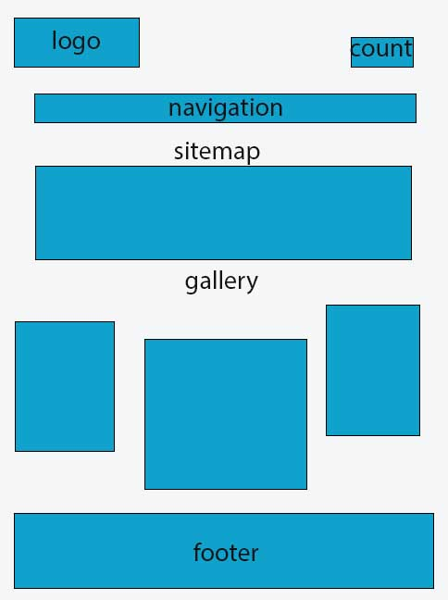

1. Contact

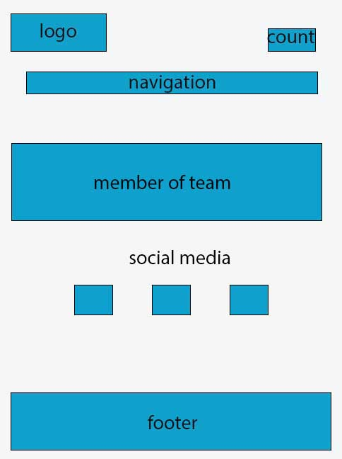

**TASK SHEET REVIEW 2**

|  |  |  |  |  |  |  |  |
| --- | --- | --- | --- | --- | --- | --- | --- |
| **Project Ref. No.: eP/Advertisement Portal Management System/01** | | **Project Title:** | **Activity Plan Prepared By:** | **Date of Preparation of Activity Plan:** | | | |
| **No.** | **Task** | **Actual Start Date** | **Actual Days** | **Team Mate Names** | **Status** |
| 1 | Site map | Clarins cosmetics | Loc | 17/9/24 | 1 | Loc | Completed |
| 2 | Mock of website | 17/9/24 | 1 | Loc | Completed |
| 3 | Task Sheet Review | 17/9/24 | 1 | Hoang | Completed |

|  |  |
| --- | --- |
| **Date: 17/09/2024** | |
| Signature of Instructor:  **Ms. Le Mong Thuy** | Signature of Team Leader:  **Than The Loc** |

**WEBSITE DESCRIPTION**

1. **Homepage**
   1. Description:

* This is a website programmed about Clarins, and here are some detailed guideline for using the website.
  1. Screenshot:

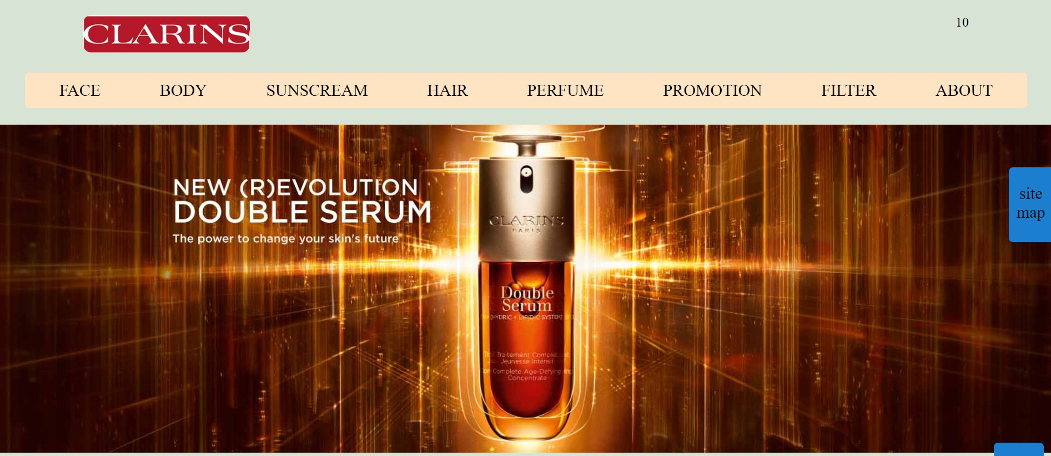

Header:

1. Description:

* This section will be on top of all pages of the website.
* From here users can easily jump into any categories at any time or return to the homepage by clicking on the name of the elements in the menu which they are interested in.
* Clicking on the according buttons will take you to the named sites.

1. Screenshot:



Footer:

1. Description:

* This section will always be at the bottom of all pages of the website.
* The section will show all the date and time at the time logging in and on the right side will always have to scroll to top arrow.

1. Screenshot:

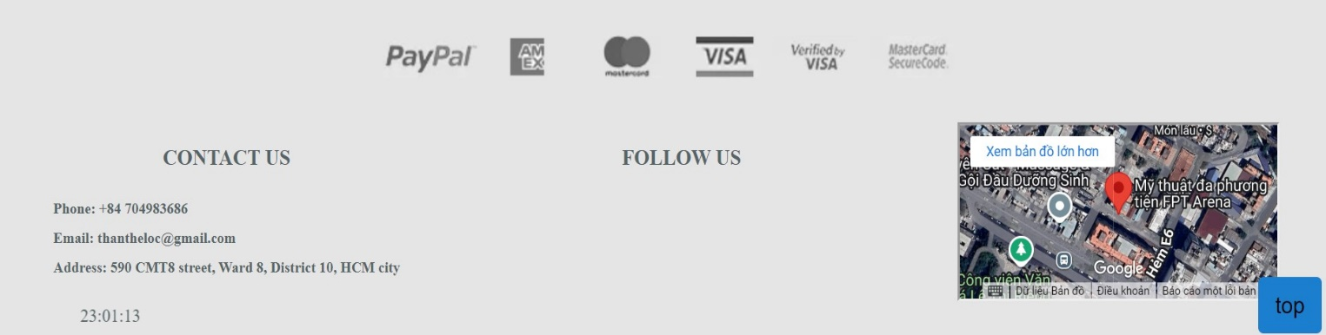

1. **Make-up**
   1. Description:

- This page lists makeup products, when you click on a product, the product image and details will appear.

* 1. Screenshot:

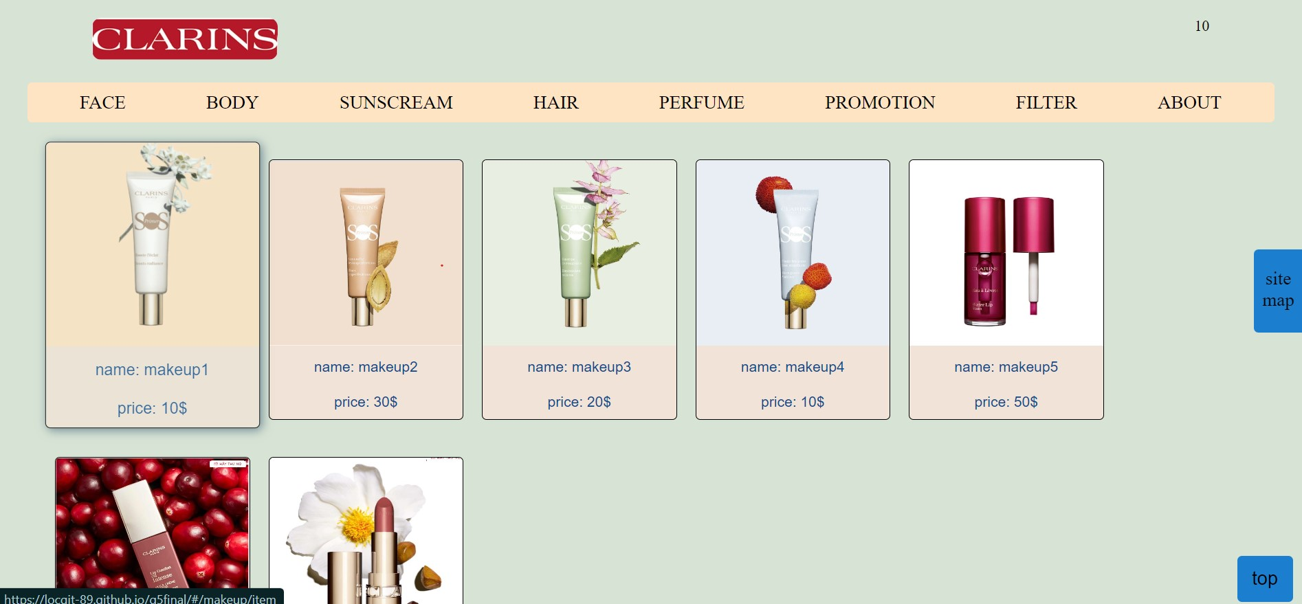

1. **Skincare**
   1. Description:

This page lists skin care products, when you click on a product, the product image and details will appear.

* 1. Screenshot:

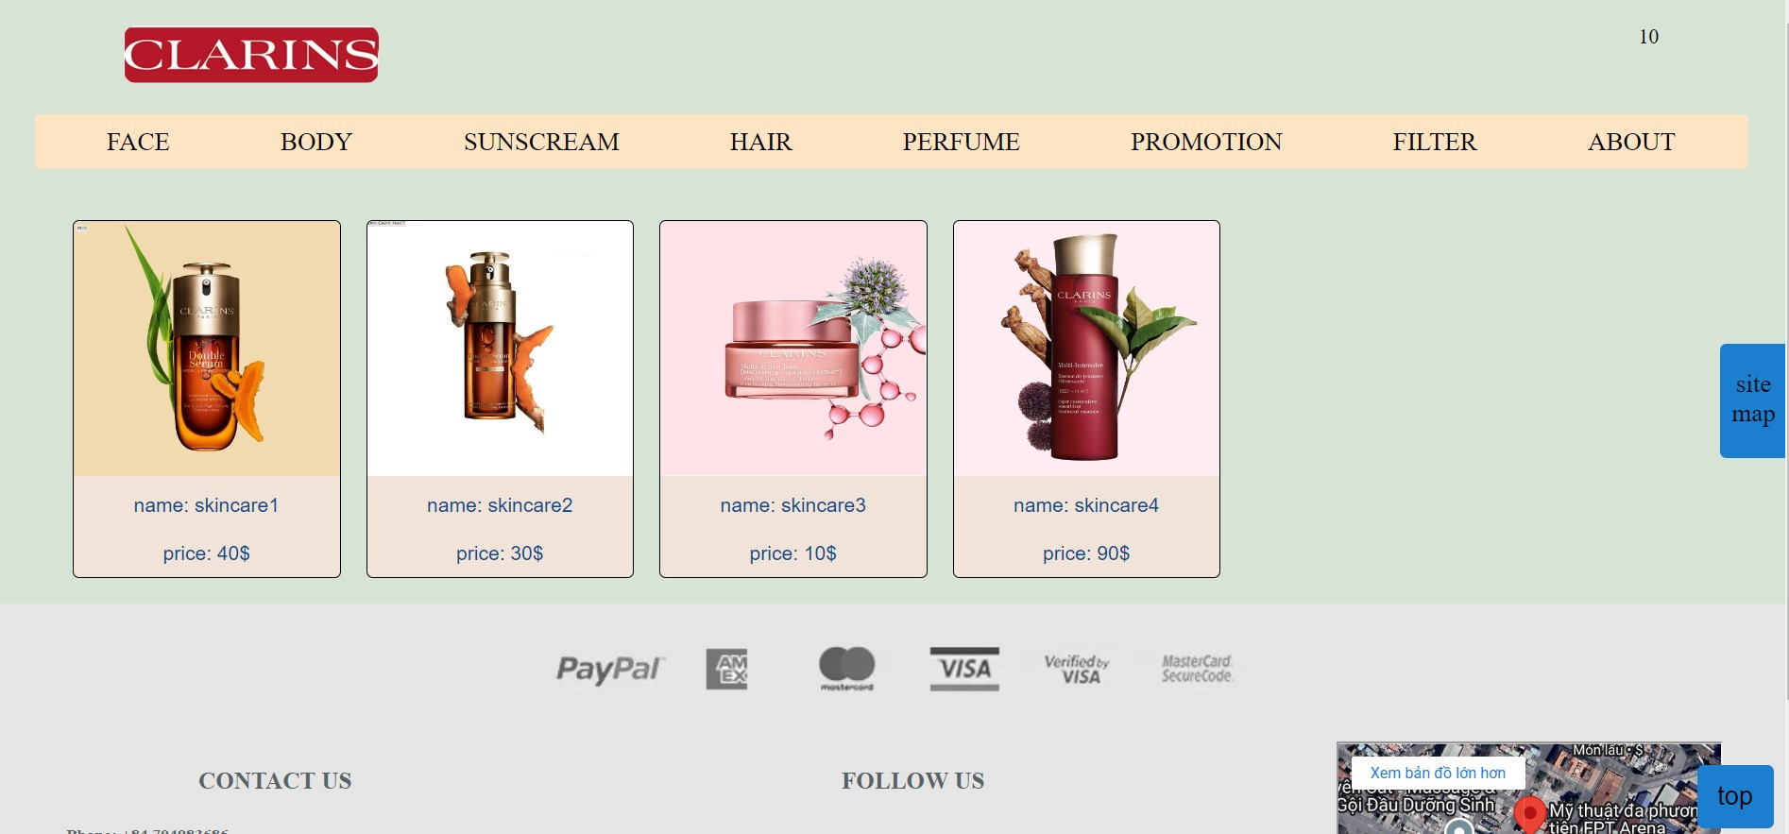

1. **Body**
   1. Description:

* This page lists body care products, when you click on a product, the product image and details will appear.
  1. Screenshot:

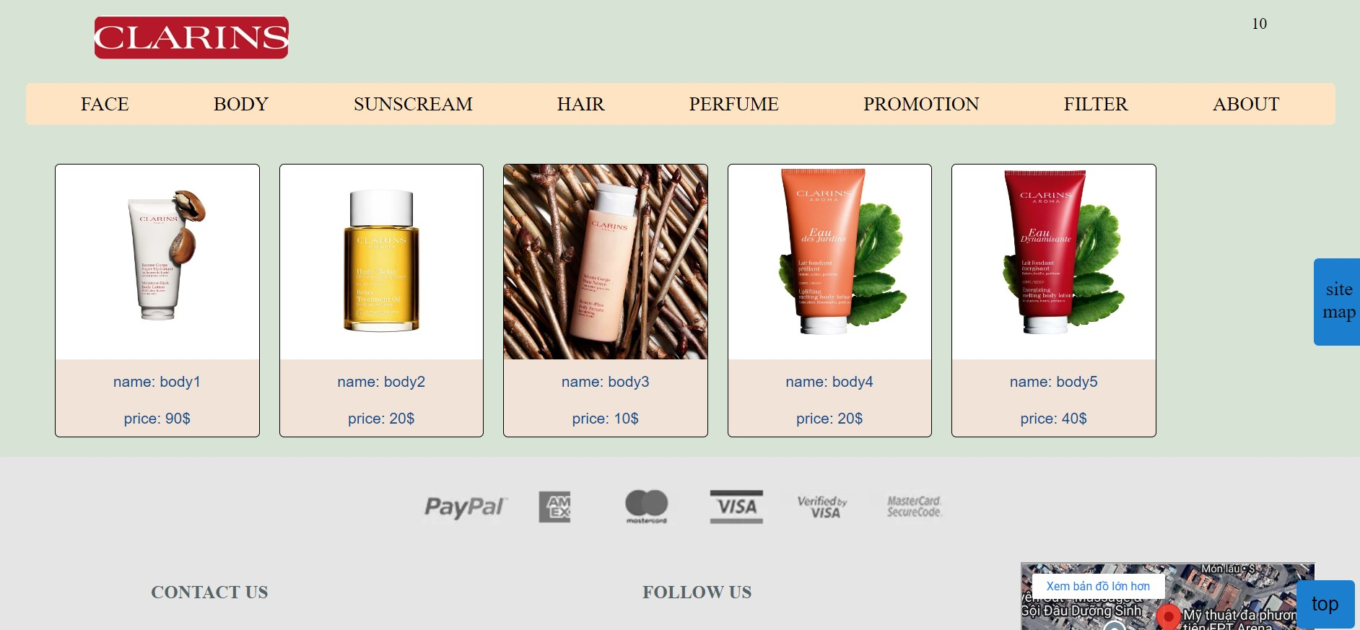

## Sunscream

* 1. Description:

- This page lists sunscreen products, when you click on a product, the product image and details will appear.

* 1. Screenshot:



## Hair

* 1. Description:
* This page lists hair care products, when you click on a product, the product image and details will appear.
  1. Screenshot:

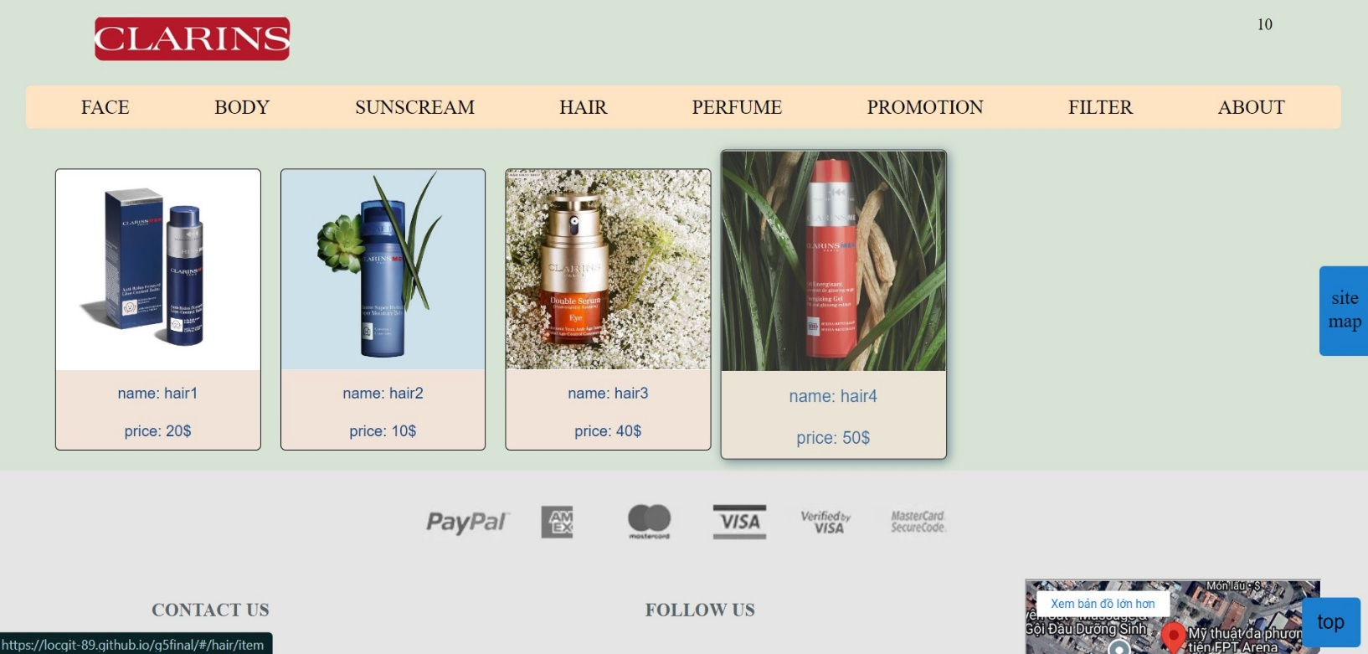

## Perfume

* 1. Description:
* This page lists perfume products, when you click on a product, the product image and details will appear.
  1. Screenshot:

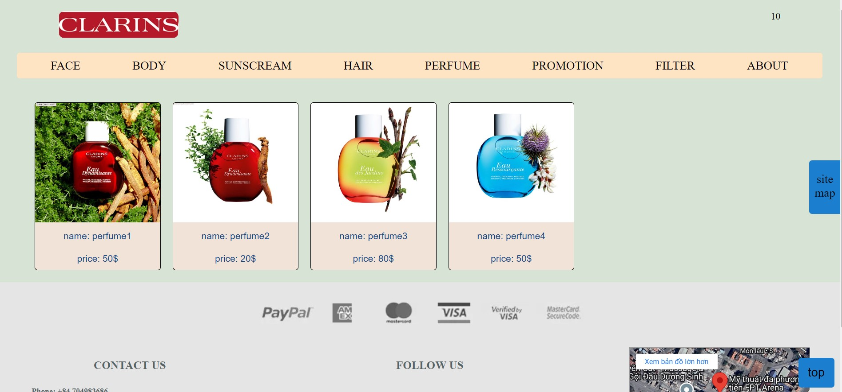

1. **Promotion**
   1. Description:

- This page lists promotional products. When you click on a product, the product image and details will appear.

* 1. Screenshot:

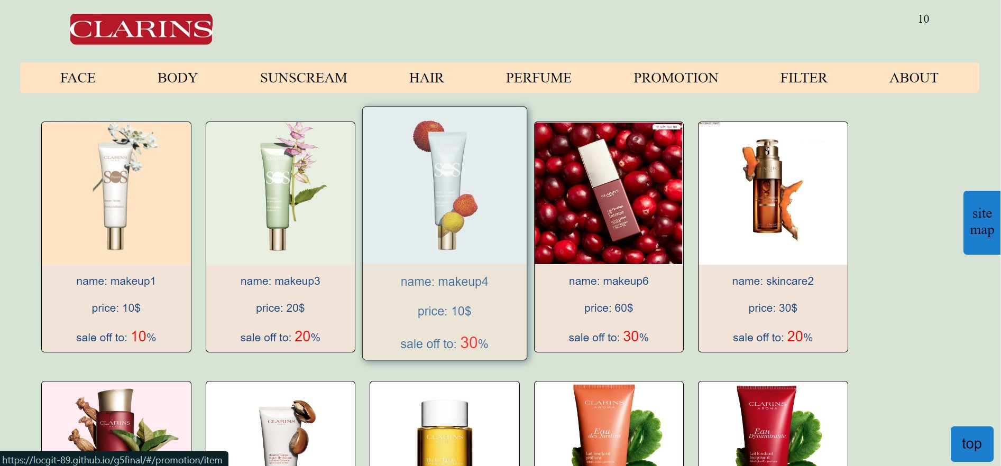

1. **Promotion**
   1. Description:

- This page leads to 2 subpages, allowing you to filter by gender or by product price

* 1. Screenshot:

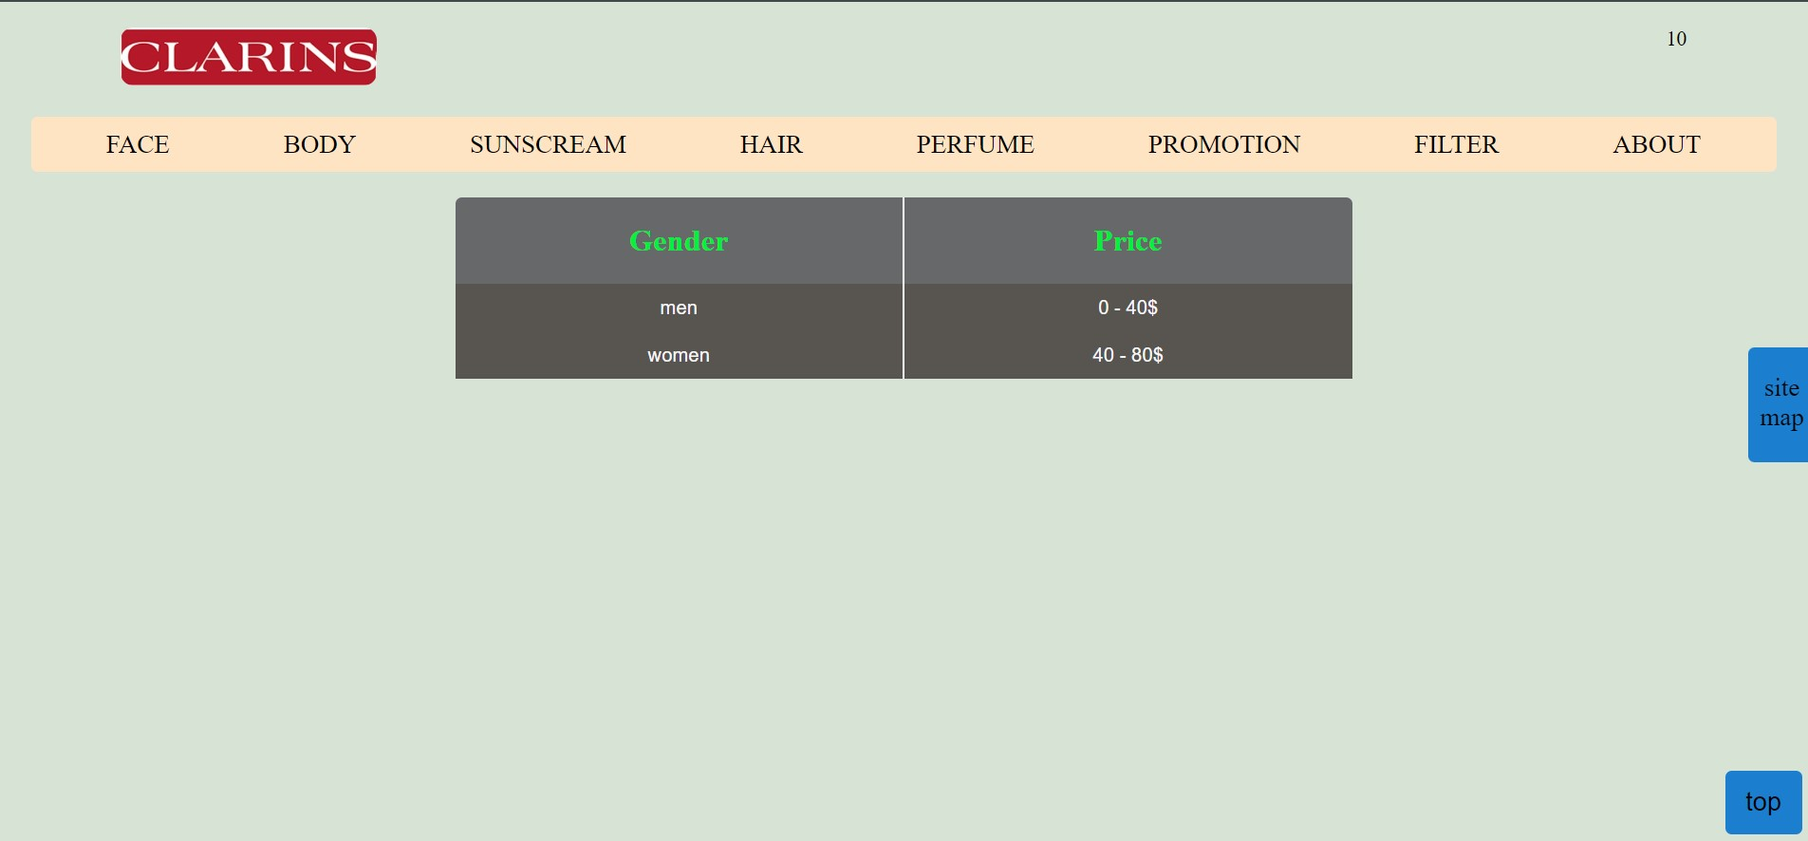

1. **Introduction**
   1. Description:

- This page lists the sitemap and image gallery.

* 1. Screenshot:

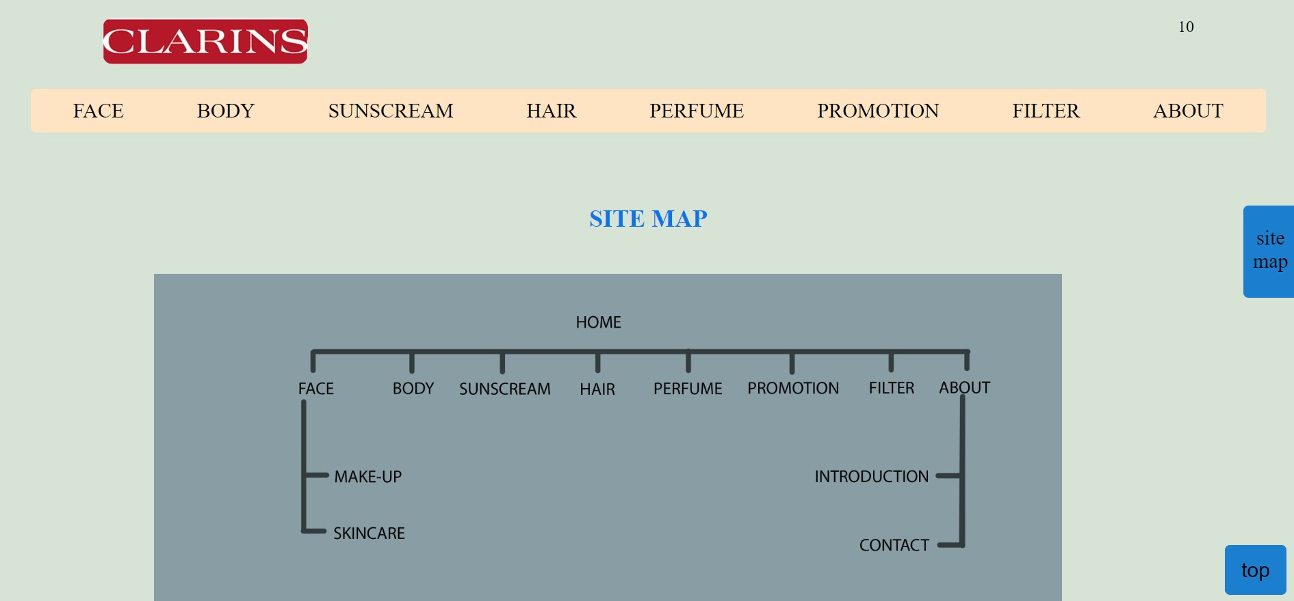

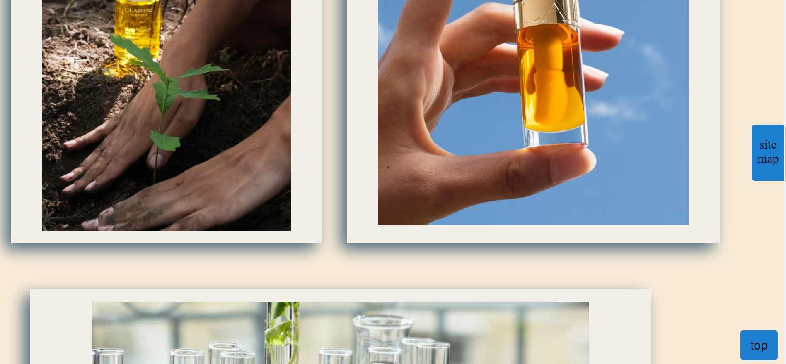

1. **Contact**
   1. Description:

- This page lists team members and social networks.

* 1. Screenshot:

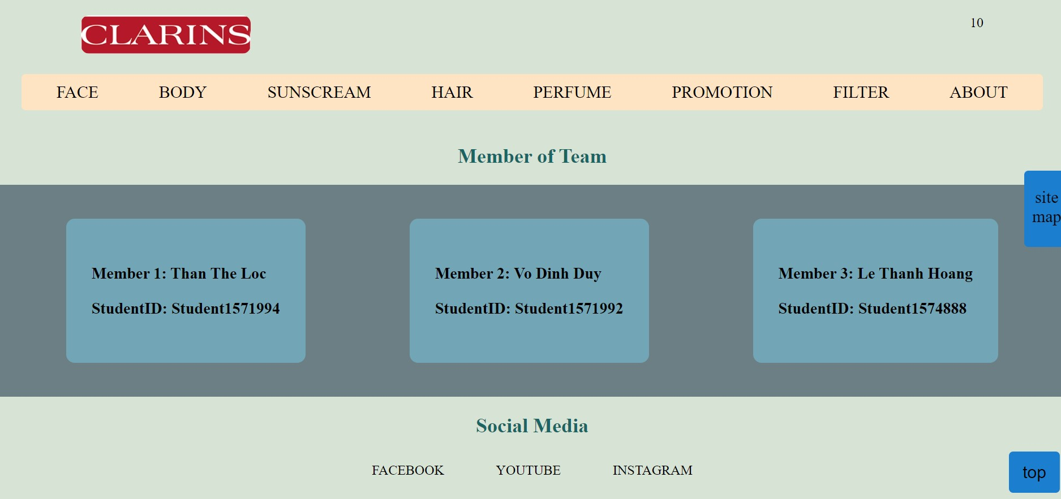

*eProject:* ***Car Breezy***



**TASK SHEET REVIEW 3**

|  |  |  |  |  |  |  |  |
| --- | --- | --- | --- | --- | --- | --- | --- |
| **Project Ref. No.: eP/Advertisement Portal Management**  **System/01** | | **Project Title:** | **Activity Plan Prepared By:** | **Date of Preparation of Activity Plan:** | | | |
| **No.** | **Task** | **Actual Start**  **Date** | **Actual Days** | **Team Mate**  **Names** | **Status** |
| 1 | Home | Clarins  cosmetics | Loc | 1/10/24 | 3 | Loc | Completed |
| 2 | Face |
| 1/10/24 | 3 | Loc | Completed |
| 3 | Body |
| 4 | Sunscream | 1/10/24 | 2 | Loc | Completed |
| 5 | Hair | 1/10/24 | 3 | Loc | Completed |
| 6 | Promotion | 1/10/24 | 3 | Hoang | Completed |
| 7 | Filter | 1/10/24 | 3 | Hoang | Completed |
| 8 | About | 1/10/24 | 3 | Hoang | Completed |

|  |  |
| --- | --- |
| **Date:** | |
| Signature of Instructor:  **Ms. Le Mong Thuy** | Signature of Team Leader:  **Than The Loc** |