# WEEK-7 REACT HANDS-ON

## Exercise 9:

## App.js

import React from "react";  
import ListofPlayers from "./components/ListofPlayers";  
import Scorebelow70 from "./components/Scorebelow70";  
import OddPlayers from "./components/OddPlayers";  
import EvenPlayers from "./components/EvenPlayers";  
import ListofIndianPlayers from "./components/ListofIndianPlayers";  
  
function App() {  
 const players = [  
 { name: "Kohli", score: 92 },  
 { name: "Dhoni", score: 88 },  
 { name: "Rohit", score: 45 },  
 { name: "Pant", score: 62 },  
 { name: "Bumrah", score: 33 },  
 { name: "Hardik", score: 75 },  
 { name: "Surya", score: 95 },  
 { name: "KL Rahul", score: 60 },  
 { name: "Shreyas", score: 80 },  
 { name: "Ashwin", score: 71 },  
 { name: "Siraj", score: 68 },  
 ];  
  
 const T20Players = ['First Player', 'Second Player', 'Third Player'];  
 const RanjiTrophyPlayers = ['Fourth Player', 'Fifth Player', 'Sixth Player'];  
 const IndianPlayers = [...T20Players, ...RanjiTrophyPlayers];  
  
 const flag = false;  
  
 if (flag === true) {  
 return (  
 <div>  
 <h1>List of Players</h1>  
 <ListofPlayers players={players} />  
 <hr />  
 <h1>List of Players with Score &lt; 70</h1>  
 <Scorebelow70 players={players} />  
 </div>  
 );  
 } else {  
 return (  
 <div>  
 <h1>Indian Team</h1>  
 <OddPlayers players={IndianPlayers} />  
 <EvenPlayers players={IndianPlayers} />  
 <hr />  
 <h1>Merged List of Indian Players:</h1>  
 <ListofIndianPlayers IndianPlayers={IndianPlayers} />  
 </div>  
 );  
 }  
}  
  
export default App;

## EvenPlayers.js

import React from "react";  
  
export default function EvenPlayers({ players }) {  
 const evenPlayers = players.filter((_, index) => index % 2 === 0);  
  
 return (  
 <div>  
 <h2>Even Indexed Players</h2>  
 <ul>  
 {evenPlayers.map((player, index) => (  
 <li key={index}>{player}</li>  
 ))}  
 </ul>  
 </div>  
 );  
}

## OddPlayers.js

import React from "react";  
  
export default function OddPlayers({ players }) {  
 const oddPlayers = players.filter((_, index) => index % 2 !== 0);  
  
 return (  
 <div>  
 <h2>Odd Indexed Players</h2>  
 <ul>  
 {oddPlayers.map((player, index) => (  
 <li key={index}>{player}</li>  
 ))}  
 </ul>  
 </div>  
 );  
}

## ListofIndianPlayers.js

import React from "react";  
  
export default function ListofIndianPlayers({ IndianPlayers }) {  
 return (  
 <ul>  
 {IndianPlayers.map((player, index) => (  
 <li key={index}>{player}</li>  
 ))}  
 </ul>  
 );  
}

## ListofPlayers.js

import React from "react";  
  
export default function ListofPlayers({ players }) {  
 return (  
 <div>  
 {players.map((item, index) => (  
 <div key={index}>  
 <li>  
 Mr. {item.name} <span> {item.score} </span>  
 </li>  
 </div>  
 ))}  
 </div>  
 );  
}

## Scorebelow70.js

import React from "react";  
  
export default function Scorebelow70({ players }) {  
 const players70 = [];  
 players.map((item) => {  
 if (item.score <= 70) {  
 players70.push(item);  
 }  
 });  
  
 return (  
 <div>  
 {players70.map((item, index) => (  
 <li key={index}>  
 {item.name} - {item.score}  
 </li>  
 ))}  
 </div>  
 );  
}

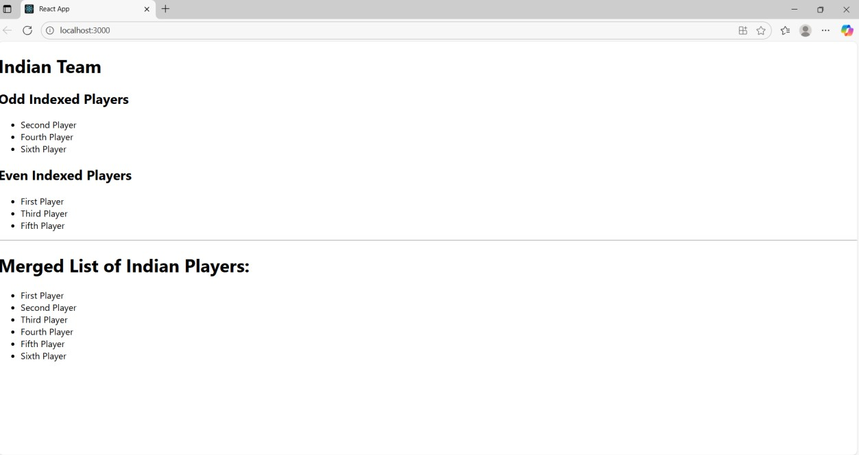**OUTPUT:**

## Exercise 10: App.js

import React from "react";  
import "./App.css";  
  
function App() {  
 const singleOffice = {  
 name: "Tech Park Suite",  
 rent: 55000,  
 address: "123 IT Highway, Chennai",  
 image:"./image.png",  
 };  
  
 const officeList = [  
 {  
 name: "Innovate Hub",  
 rent: 45000,  
 address: "Downtown Business Center, Bengaluru",  
 image:"./image.png",  
 },  
 {  
 name: "Startup Space",  
 rent: 65000,  
 address: "Tech Valley, Hyderabad",  
 image:"./image.png",  
 },  
 {  
 name: "Prime Corporate",  
 rent: 70000,  
 address: "Cyber City, Gurugram",  
 image:"./image.png",  
 },  
 ];  
  
 return (  
 <div className="App">  
 <h1>Office Space Rental App</h1>  
 <div className="office-card">  
 <h2>{singleOffice.name}</h2>  
 <img src={singleOffice.image} alt={singleOffice.name} width="300" />  
 <p>Address: {singleOffice.address}</p>  
 <p style={{ color: singleOffice.rent < 60000 ? "red" : "green" }}>  
 Rent: ₹{singleOffice.rent}  
 </p>  
 </div>  
  
 <hr />  
  
 <h2>Available Office Spaces</h2>  
 <div className="office-list">  
 {officeList.map((office, index) => (  
 <div key={index} className="office-card">  
 <h3>{office.name}</h3>  
 <img src={office.image} alt={office.name} width="300" />  
 <p>Address: {office.address}</p>  
 <p style={{ color: office.rent < 60000 ? "red" : "green" }}>  
 Rent: ₹{office.rent}  
 </p>  
 </div>  
 ))}  
 </div>  
 </div>  
 );  
}  
  
export default App;

## App.css

.App {  
 text-align: center;  
 font-family: Arial, sans-serif;  
 padding: 20px;  
}  
  
.office-card {  
 border: 1px solid #ccc;  
 border-radius: 10px;  
 padding: 15px;  
 margin: 15px auto;  
 width: 350px;  
 box-shadow: 0 2px 8px rgba(0, 0, 0, 0.1);  
}  
  
.office-list {  
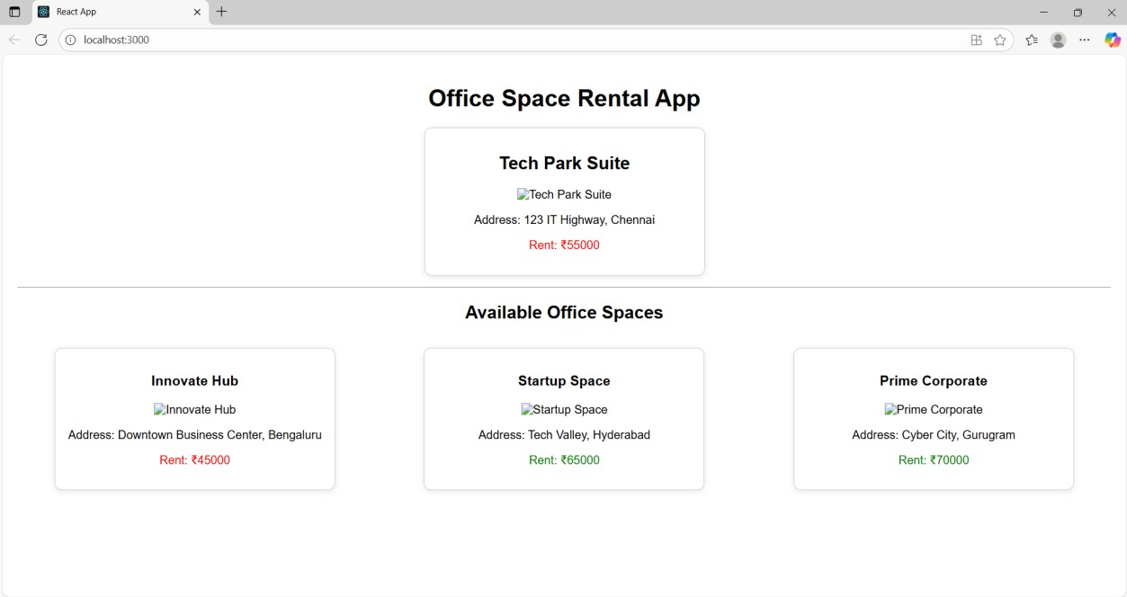 display: flex;  
 justify-content: center;  
 flex-wrap: wrap;  
 gap: 20px;  
}  
**OUTPUT:**

## Exercise 11: App.js

import React from "react";  
import Counter from "./components/Counter";  
import WelcomeButton from "./components/WelcomeButton";  
import ClickMessage from "./components/ClickMessage";  
import CurrencyConvertor from "./components/CurrencyConvertor";  
  
function App() {  
 return (  
 <div>  
 <h1>Event Examples App</h1>  
 <Counter />  
 <WelcomeButton />  
 <ClickMessage />  
 <CurrencyConvertor />  
 </div>  
 );  
}  
  
export default App;

## Counter.js

import React, { useState } from "react";  
  
export default function Counter() {  
 const [count, setCount] = useState(0);  
  
 const sayHello = () => {  
 console.log("Hello! Keep clicking...");  
 };  
  
 const handleIncrement = () => {  
 setCount(count + 1);  
 sayHello();  
 };  
  
 const handleDecrement = () => {  
 setCount(count - 1);  
 };  
  
 return (  
 <div>  
 <h2>Counter: {count}</h2>  
 <button onClick={handleIncrement}>Increment</button>  
 <button onClick={handleDecrement}>Decrement</button>  
 </div>  
 );  
}

## WelcomeButton.js

import React from "react";  
  
export default function WelcomeButton() {  
 const showWelcome = (message) => {  
 alert(message);  
 };  
  
 return (  
 <div>  
 <button onClick={() => showWelcome("Welcome!")}>Say Welcome</button>  
 </div>  
 );  
}

## ClickMessage.js

import React from "react";  
  
export default function ClickMessage() {  
 const handleClick = (event) => {  
 alert("I was clicked");  
 };  
  
 return <button onClick={handleClick}>Click Me</button>;  
}

## CurrencyConvertor.js

import React, { useState } from "react";  
  
export default function CurrencyConvertor() {  
 const [rupees, setRupees] = useState("");  
 const [euros, setEuros] = useState("");  
  
 const handleSubmit = () => {  
 const rate = 0.011; // example rate  
 setEuros((parseFloat(rupees) * rate).toFixed(2));  
 };  
  
 return (  
 <div>  
 <h2>Currency Converter</h2>  
 <input  
 type="number"  
 value={rupees}  
 onChange={(e) => setRupees(e.target.value)}  
 placeholder="Enter INR"  
 />  
 <button onClick={handleSubmit}>Convert</button>  
 {euros && <p>EUR: €{euros}</p>}  
 </div>  
 );  
}

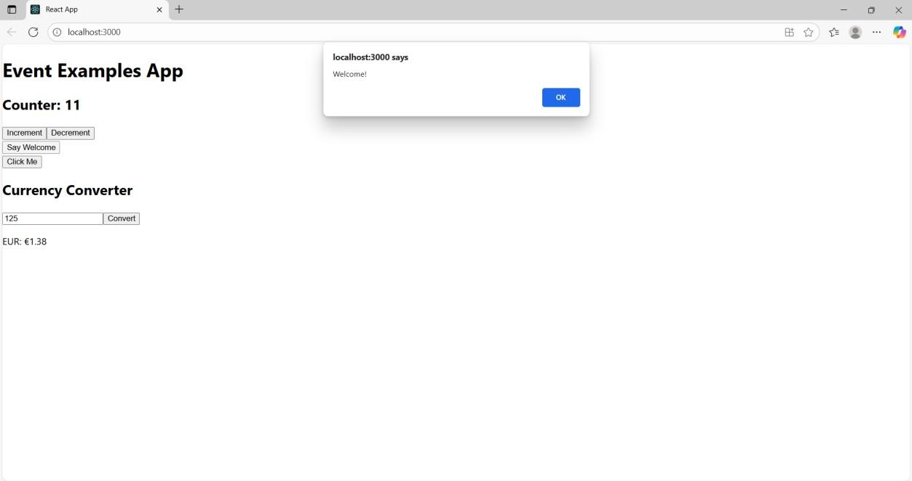**OUTPUT:**

## Exercise 12: App.js

import React, { useState } from 'react';  
import GuestPage from './components/GuestPage';  
import UserPage from './components/UserPage';  
import LoginControl from './components/LoginControl';  
  
function App() {  
 const [isLoggedIn, setIsLoggedIn] = useState(false);  
 const handleLogin = () => setIsLoggedIn(true);  
 const handleLogout = () => setIsLoggedIn(false);  
  
 return (  
 <div>  
 <h1>Ticket Booking App</h1>  
 <LoginControl isLoggedIn={isLoggedIn} onLogin={handleLogin} onLogout={handleLogout} />  
 {isLoggedIn ? <UserPage /> : <GuestPage />}  
 </div>  
 );  
}  
  
export default App;

## LoginControl.js

import React from 'react';  
  
export default function LoginControl({ isLoggedIn, onLogin, onLogout }) {  
 return (  
 <div>  
 {isLoggedIn ? (  
 <button onClick={onLogout}>Logout</button>  
 ) : (  
 <button onClick={onLogin}>Login</button>  
 )}  
 </div>  
 );  
}

## GuestPage.js

import React from 'react';  
  
export default function GuestPage() {  
 return (  
 <div>  
 <h2>Welcome Guest! </h2>  
 <p>Here are the available flights:</p>  
 <ul>  
 <li>Chennai to Delhi - ₹4500</li>  
 <li>Mumbai to Bangalore - ₹3500</li>  
 <li>Kolkata to Hyderabad - ₹4000</li>  
 </ul>  
 <p>Please login to book tickets.</p>  
 </div>  
 );  
}

## UserPage.js

import React from 'react';  
  
export default function UserPage() {  
 return (  
 <div>  
 <h2>Welcome User! </h2>  
 <p>You can now book your tickets:</p>  
 <ul>  
 <li>Chennai to Delhi - ₹4500 <button>Book</button></li>  
 <li>Mumbai to Bangalore - ₹3500 <button>Book</button></li>  
 <li>Kolkata to Hyderabad - ₹4000 <button>Book</button></li>  
 </ul>  
 </div>  
 );  
}

**OUTPUT:**

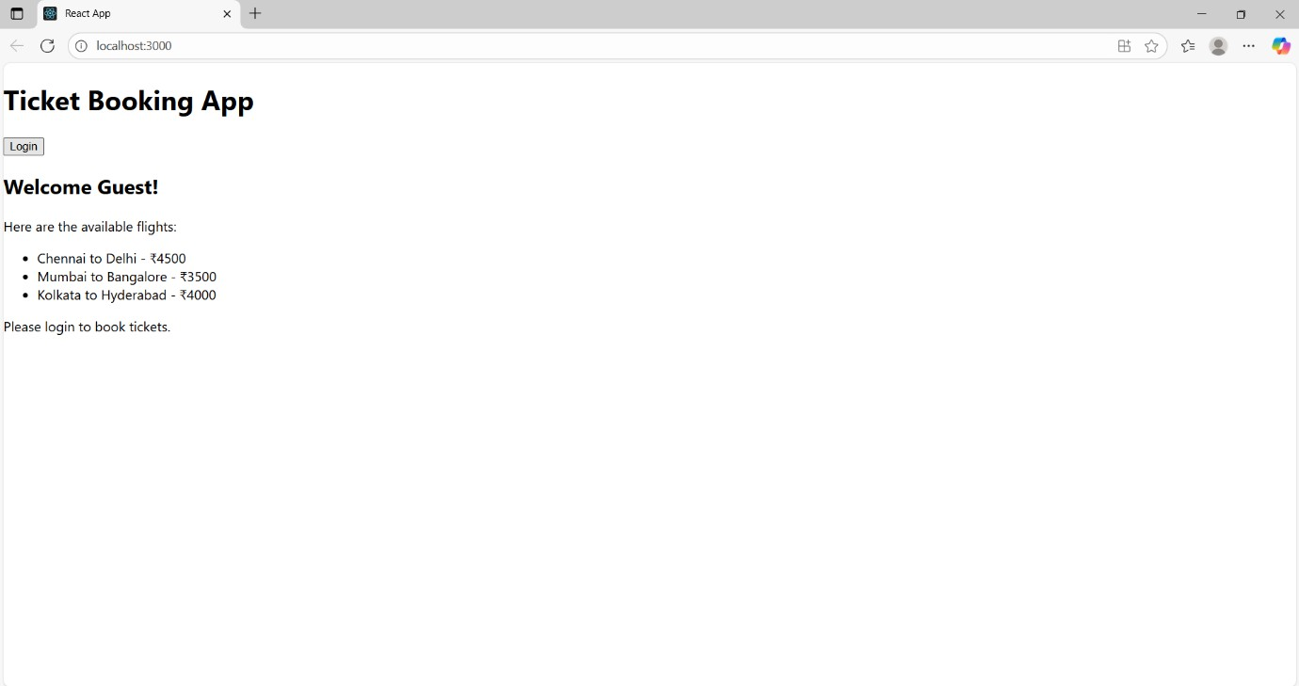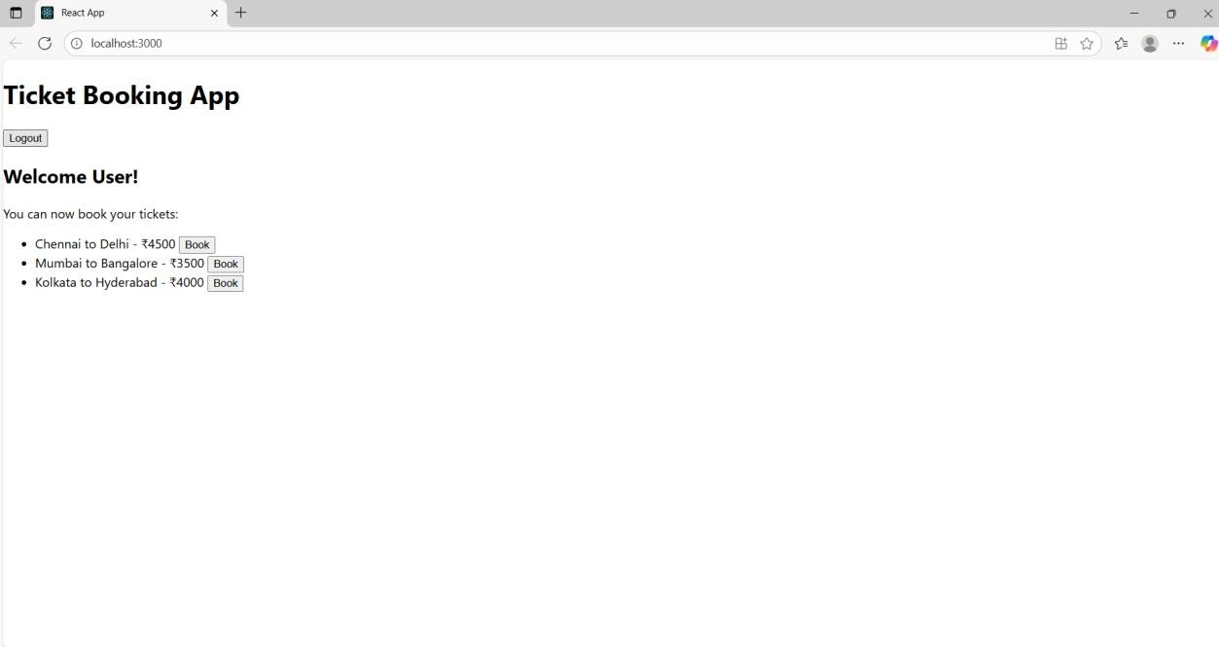

**Exercise 13 App.js**

import React, { useState } from "react";

import BookDetails from "./components/BookDetails"; import BlogDetails from "./components/BlogDetails"; import CourseDetails from "./components/CourseDetails"; function App() {

const [view, setView] = useState("books"); return (

<div>

<h1>Blogger App</h1>

<button onClick={() => setView("books")}>Show Books</button>

<button onClick={() => setView("blogs")}>Show Blogs</button>

<button onClick={() => setView("courses")}>Show Courses</button>

{view === "books" && <BookDetails />}

{view === "blogs" && <BlogDetails />}

{view === "courses" && <CourseDetails />}

</div>

);

}

export default App;

## BlogDetails.js

import React from 'react'; function BookDetails() { const books = [

{ id: 1, title: 'The Alchemist', author: 'Paulo Coelho', rating: 85 },

{ id: 2, title: 'Atomic Habits', author: 'James Clear', rating: 92 },

{ id: 3, title: 'The Subtle Art of Not Giving a F*ck', author: 'Mark Manson', rating: 68 },

{ id: 4, title: 'Think and Grow Rich', author: 'Napoleon Hill', rating: 55 },

];

const lowScoreBooks = books.filter(book => book.rating < 70);

const indianBooks = [

{ id: 5, title: 'Wings of Fire', author: 'A.P.J. Abdul Kalam' },

{ id: 6, title: 'The Guide', author: 'R.K. Narayan' },

];

const allBooks = [...books, ...indianBooks]; return (

<div>

<h2>All Books</h2>

<ul>

{allBooks.map(book => (

<li key={book.id}>

{book.title} by {book.author}

</li>

))}

</ul>

<h2>Books with Rating &lt; 70</h2>

<ul>

{lowScoreBooks.map(book => (

<li key={book.id}>

{book.title} by {book.author} — Rating: {book.rating}

</li>

))}

</ul>

</div>

);

}

export default BookDetails;

## BookDetails.js

function BookDetails() {

return <h2>Book Details Page</h2>;

}

export default BookDetails;

## CourseDetails.js

import React from 'react'; function CourseDetails() { const courses = [

{ id: 1, name: "Frontend Development", duration: "6 weeks" },

{ id: 2, name: "Data Structures in Java", duration: "8 weeks" },

];

return (

<div>

<h2>Course Details</h2>

<table border="1" cellPadding="8">

<thead>

<tr>

<th>Course Name</th>

<th>Duration</th>

</tr>

</thead>

<tbody>

{courses.map((course) => (

<tr key={course.id}>

<td>{course.name}</td>

<td>{course.duration}</td>

</tr>

))}

</tbody>

</table>

</div>

);

}

export default CourseDetails;

**Output:**

