6TH EXPERIMENT
Basic Code
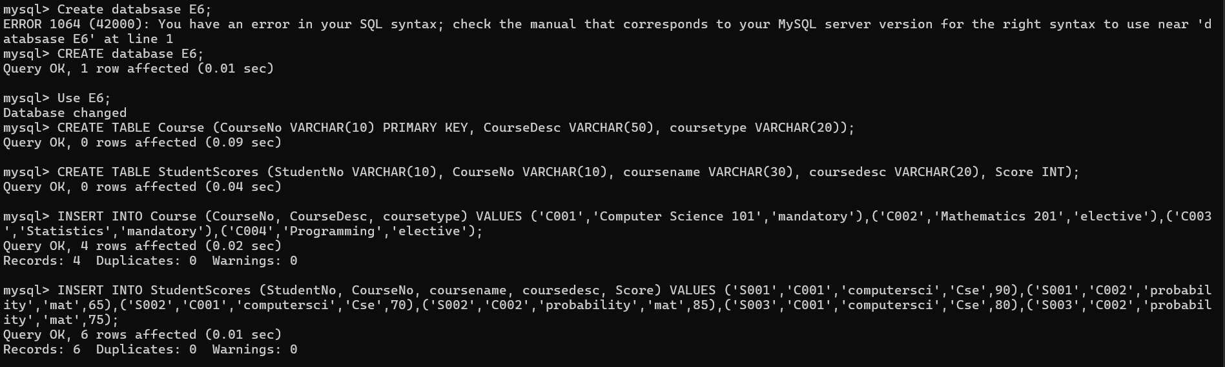
QUESTION AND ANSWERS
IN & BETWEEN
1.
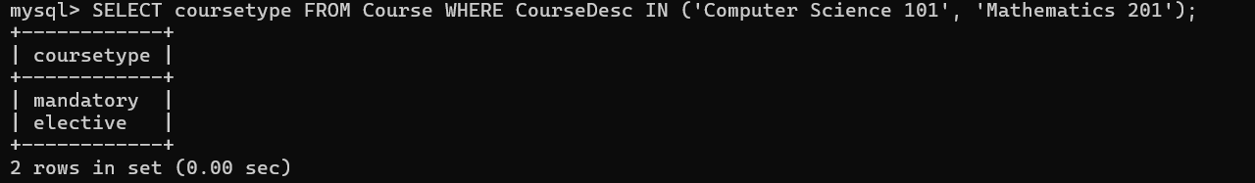
2.
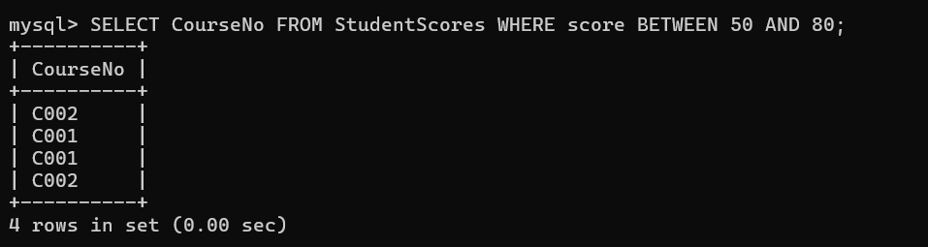
AGGREGATE
1.
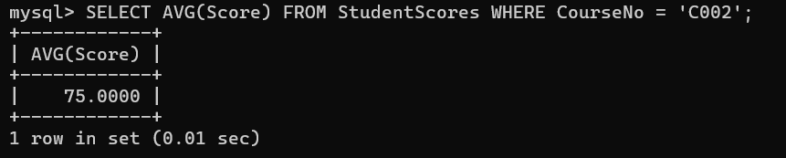
2.
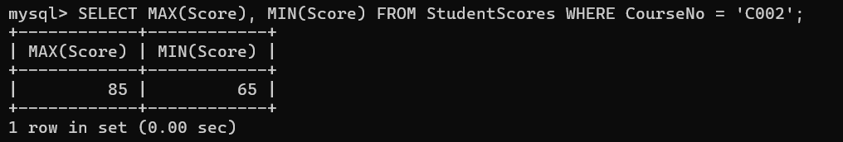
3.
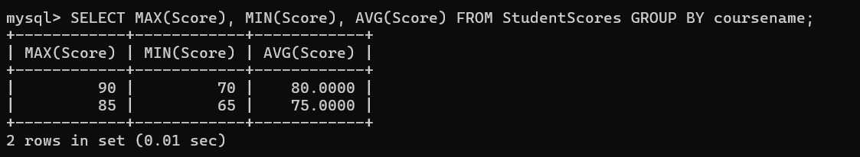
4.
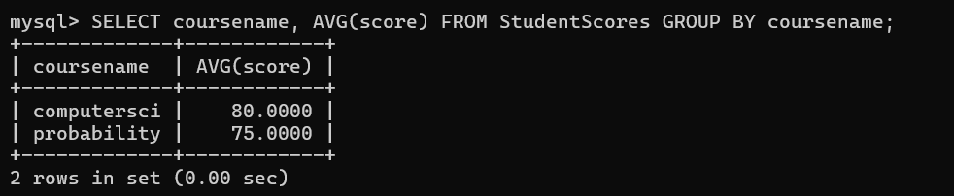
5.
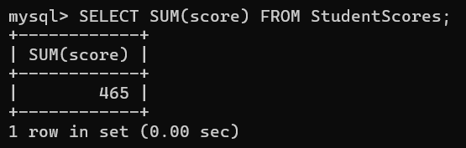
6.
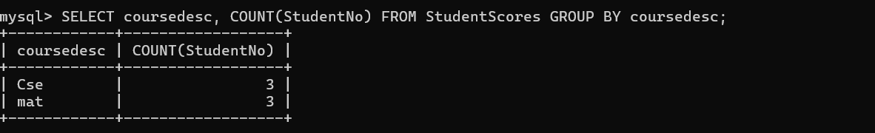
7.
