7TH EXPERIMENT
Basic Code
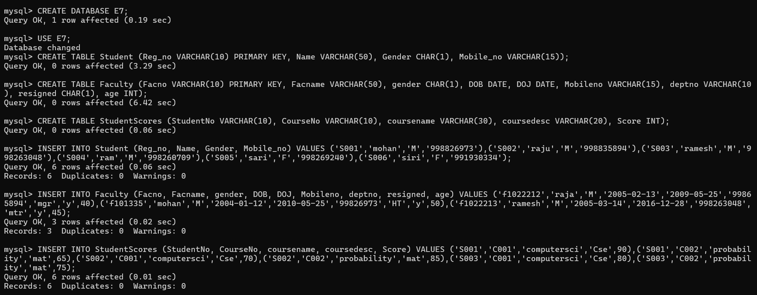
QUESTION AND ANSWERS
GROUP BY - HAVING
1.
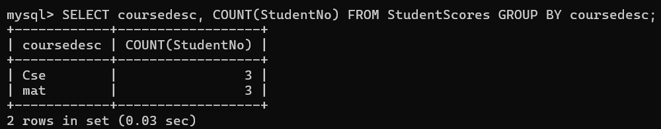
2.
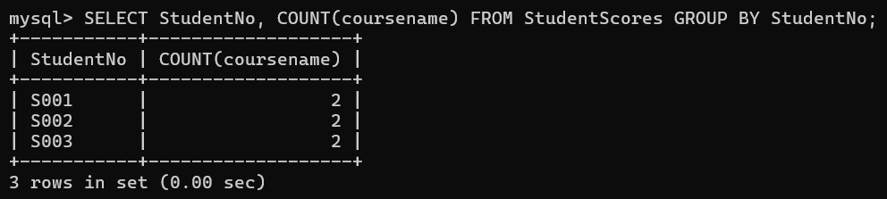
ORDER BY
1.
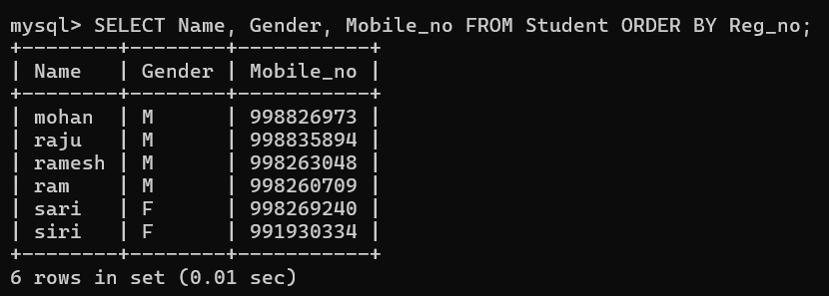
2.
