Project Report — TransitIQ
Skill Lab · Web Design and Development · L&T EduTech
Project 2 of 2

1. Group Member Details
# | Member Name | Email ID
1 | Lochan Gowda T M | lochangowda.ad25@bmsce.ac.in
2 | Hanamaraddi Kanakannavar | hanamaraddi.ad25@bmsce.ac.in
3 | N. Pavan | pavan.ad26@bmsce.ac.in
4 | Ganapathi Sai Srinivas | ganapathisai.ad25@bmsce.ac.in

GitHub repository: <https://github.com/lochangowda10/transitIQ>

2. Project Overview
TransitIQ is a browser-only journey planner for Bengaluru's Namma Metro Purple and Green corridors. It loads a static dataset of 69 real stations in true corridor order, builds a weighted graph in the browser, and finds the fastest path with Dijkstra's algorithm using a binary min-heap. Each leg is priced at km × 2.5 minutes of ride time, line changes at the single interchange (Majestic) cost a 4-minute transfer buffer, and a peak-hours toggle adds 5-minute platform waits instead of 2-minute ones. The summed route distance maps onto six fare slabs (₹10–₹60), matching the disclosure on the fares panel.
The chosen route is drawn on an interactive SVG schematic map — click the origin, then the destination — and the full trip (legs, distance, time, fare) appears in a results panel. Up to five recent trips persist in localStorage. A companion page, network.html, is a complete station register: both corridors in order, per-station segment distances, live-computed summary chips, and interchange annotations. No servers, no APIs, no build step; all libraries vendored locally.

3. Objectives
- Model a real transit network faithfully: correct station sequences for both Namma Metro corridors and one shared interchange node (not two duplicated ones).
- Demonstrate graph search over a hand-built weighted graph, with a transfer penalty so the route is "fastest" in the practical sense, not just shortest in stops.
- Keep pricing transparent: posted fare slabs, posted wait and transfer constants, and a "How it works" panel that shows the algorithm used — no black-box numbers.
- Make a complex SVG visualization keyboard- and screen-reader-friendly, with a text-alternative station list outside the map.
- Practice disciplined pure-frontend engineering: vanilla JavaScript and jQuery over Bootstrap scaffolding, everything computed client-side.

4. Expected Outcomes
- The same origin–destination always yields the same fastest path, travel time, and fare for a given peak setting — results are deterministic and explainable from the constants.
- Cross-line journeys (e.g. Whitefield → Silk Institute) pay exactly one 4-minute transfer and switch lines at Majestic, shown leg-by-leg.
- Peak vs off-peak visibly changes the time estimate on the same route while the fare stays distance-based.
- The network page recomputes its summary chips (69 stations, 2 corridors, 1 interchange, network km) from the dataset rather than hardcoding them.
- Both pages load with zero console errors and zero network requests beyond their own vendored assets.

5. Design Sections

5.1 Layout and information architecture
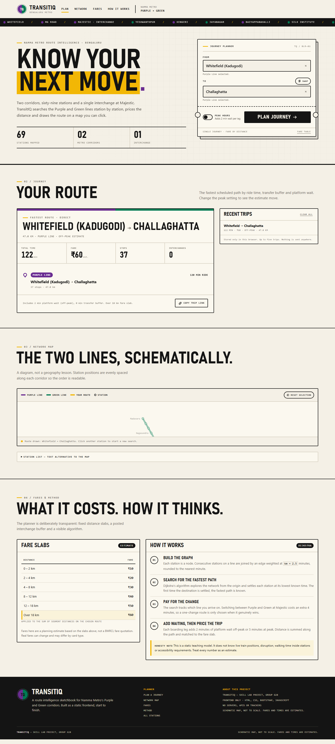
Journey planner
index.html is a single scrolling page in numbered sections: hero with the journey-planner ticket, journey results, network map, then fares and method. network.html is a reference page with one block per corridor. The planner ticket frames the search like a metro ticket — notches, a reference number, and fields for From/To — which anchors the whole visual identity.

5.2 Visual design
An ink-and-paper transit aesthetic: warm off-white stock, near-black text, and the two corridor colours (Purple #6A2C91, Green #007A53) used as the only accents. A station-name ticker runs under the header. The logo is an inline SVG roundel split half-purple, half-green. Typography leans dense and condensed, in the spirit of metro signage.

5.3 Data design
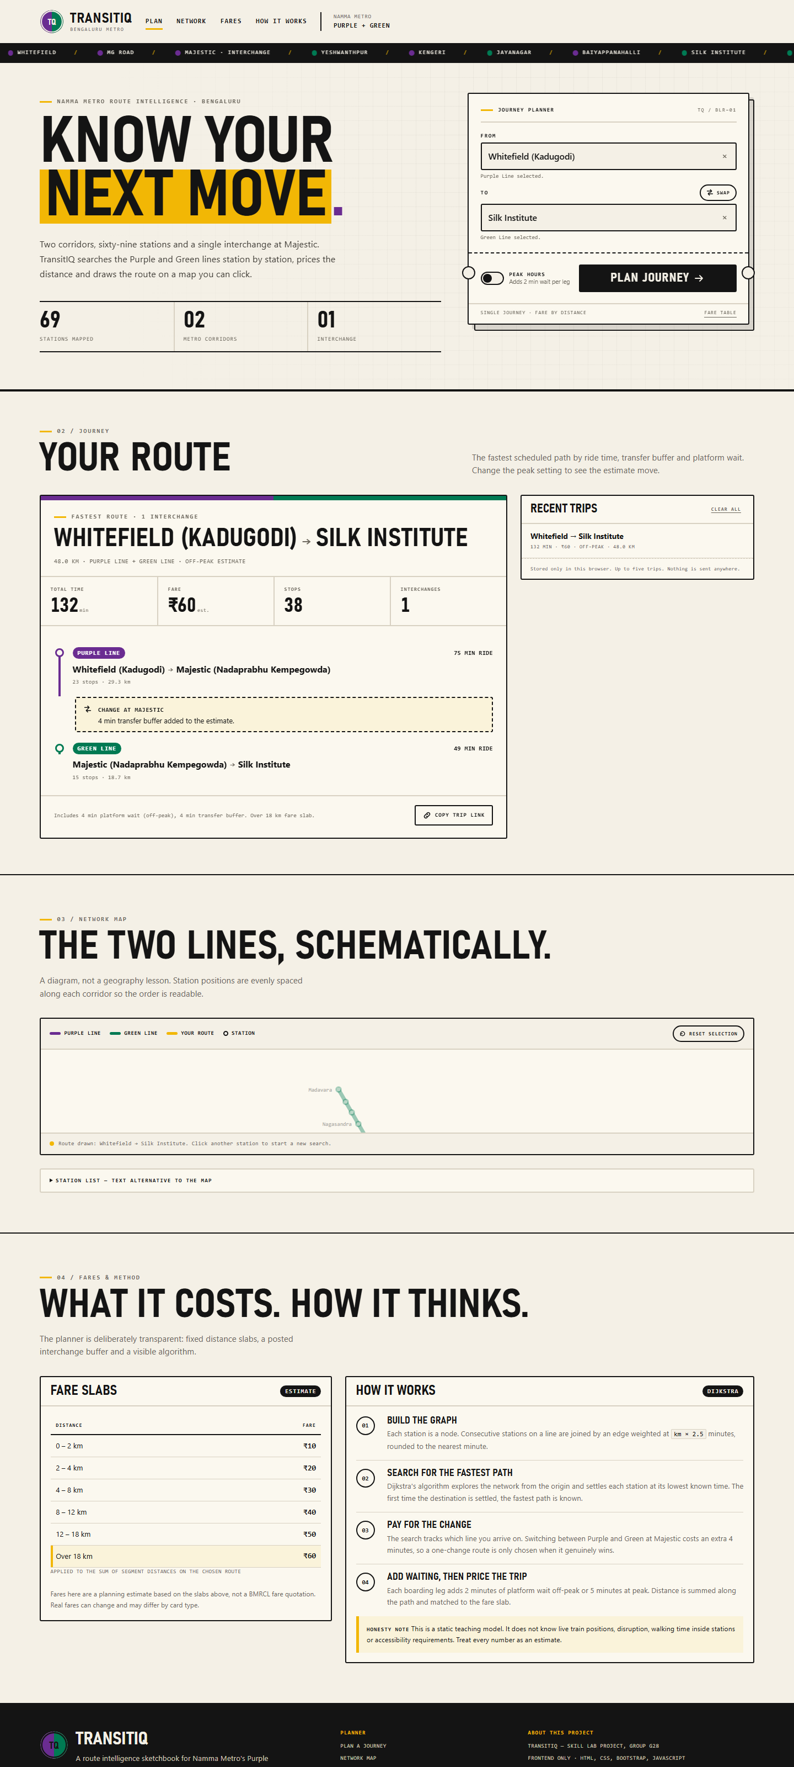
Cross-line route
js/data.js holds each corridor as an ordered list of stations with an approximate kmToNext (≈1.0–1.6 km, explicitly labelled as project estimates, not official BMRCL figures). A builder assigns order numbers and totals; a registry merges Majestic into a single node flagged interchange: true so both sequences share one graph node. Six fare slabs and the model constants (ride rate, transfer penalty, waits) ship with the dataset in one place.

5.4 Search design
js/app.js builds an adjacency list keyed by a (station, line) state pair, which is what lets the search track which line you arrive on and charge the transfer penalty only on an actual line change. Dijkstra runs from the origin, relaxing edges through a MinHeap; when the destination settles, the path is reconstructed and sorted into consecutive legs marked Purple / Green / Transfer. Waits are added per boarding leg, then distance is summed and matched to a slab.

5.5 Map and interaction design
The SVG map distributes stations evenly along each corridor (readable order, not geography), with interchange bridges at Majestic. Stations are focusable; hover/focus shows a tooltip (also aria-describedby-linked), click sets origin then destination, and a "Reset selection" returns to neutral. A details/summary text list provides a full non-visual alternative. Both station fields are ARIA comboboxes with keyboard filtering, arrow navigation, and a clear button.

5.6 State and accessibility
Recent trips (max five) persist under the localStorage key transitiq.recent.v1 with a graceful degrade if storage is blocked, plus a "Clear all" action. ARIA-wise: role="alert" errors, aria-live results, aria-expanded comboboxes, aria-current navigation, skip link, focus rings, and reduced-motion support. Errors are inline, never alert() popups. A noscript notice explains that the planner requires JavaScript.

6. Code Snippets
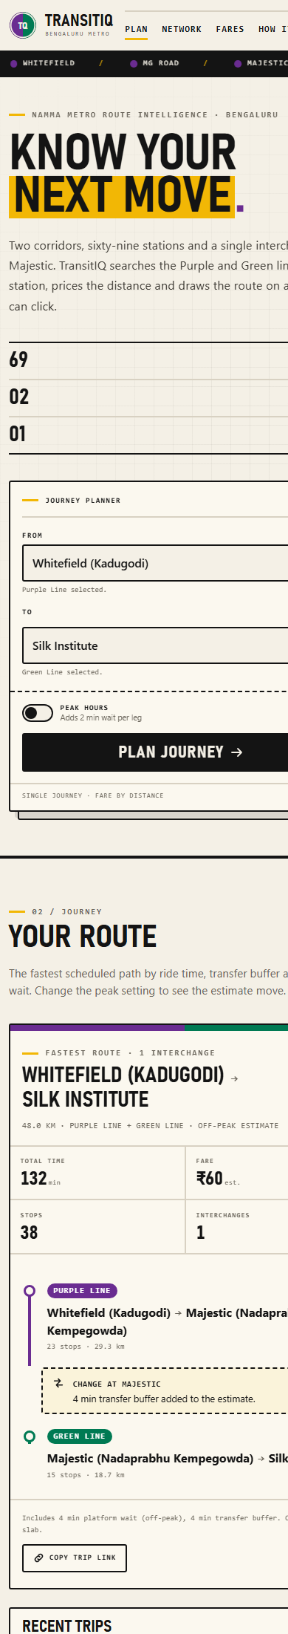
Mobile layout
The min-heap that keeps Dijkstra at polling time:
function MinHeap() {
var a = [];
this.push = function (node, priority) {
a.push({ node: node, p: priority });
var i = a.length - 1;
while (i > 0) {
var p = (i - 1) >> 1;
if (a[p].p <= a[i].p) break;
/* swap and continue up */ i = p;
}
};
/* ...pop() mirrors it downward... */
}
The transfer penalty is a property of arrival state, so a turnback that must change lines pays only once:
var stateKey = stationId + '|' + lineId; // explicit (station, line) state
addEdge(from, to, minutes, fromLineId, km);
/* switching line at Majestic costs DATA.transferPenaltyMin (4 min) */
Fare lookup over the slabs:
function getFareSlab(km) {
for (var i = 0; i < DATA.fareSlabs.length; i++) {
if (km >= DATA.fareSlabs[i].min && km < DATA.fareSlabs[i].max)
return DATA.fareSlabs[i];
}
}

7. Screenshots
Screenshot | View
assets/screenshots/01-home.png | Planner hero with journey ticket
assets/screenshots/02-crossline.png | Cross-line route rendered leg-by-leg
assets/screenshots/03-network.png | Station register (network page)
assets/screenshots/04-mobile.png | Mobile layout

8. Technology Used
- HTML5, CSS3, Bootstrap 5.3.3, jQuery 3.7.1 — all vendored locally, no CDN
- Vanilla JavaScript (ES5 style): weighted graph + Dijkstra with a binary min-heap, inline SVG rendering, ARIA combobox pattern, localStorage, URL state cleanup via history.replaceState
- No servers, trackers, or build steps

9. Testing Performed
- node --check on js/app.js and js/data.js
- Both pages served locally and loaded in headless Chrome: no console errors, no failed/external requests
- DOM checks: 69 .map-station nodes rendered, both station tables fully populated, summary chips computed live, 3 sample journeys present
- Encoding hygiene verified byte-level after a repair: the network page now renders — – ₹ → · correctly with no residual mojibake
- All passenger-facing text mirrors the model constants, so displayed math and applied math agree

10. Limitations
- A static teaching model: no live train positions, disruptions, in-station walking time, accessibility requirements, or real BMRCL timetables.
- Segment distances and ride times are estimates; the schematic map is not to scale.
- Recent trips live only in one browser's localStorage; nothing syncs or leaves the machine.
- Fares track the posted slab model, not an official BMRCL quotation.

11. How to Run
cd projects/transitiq
python -m http.server 8125
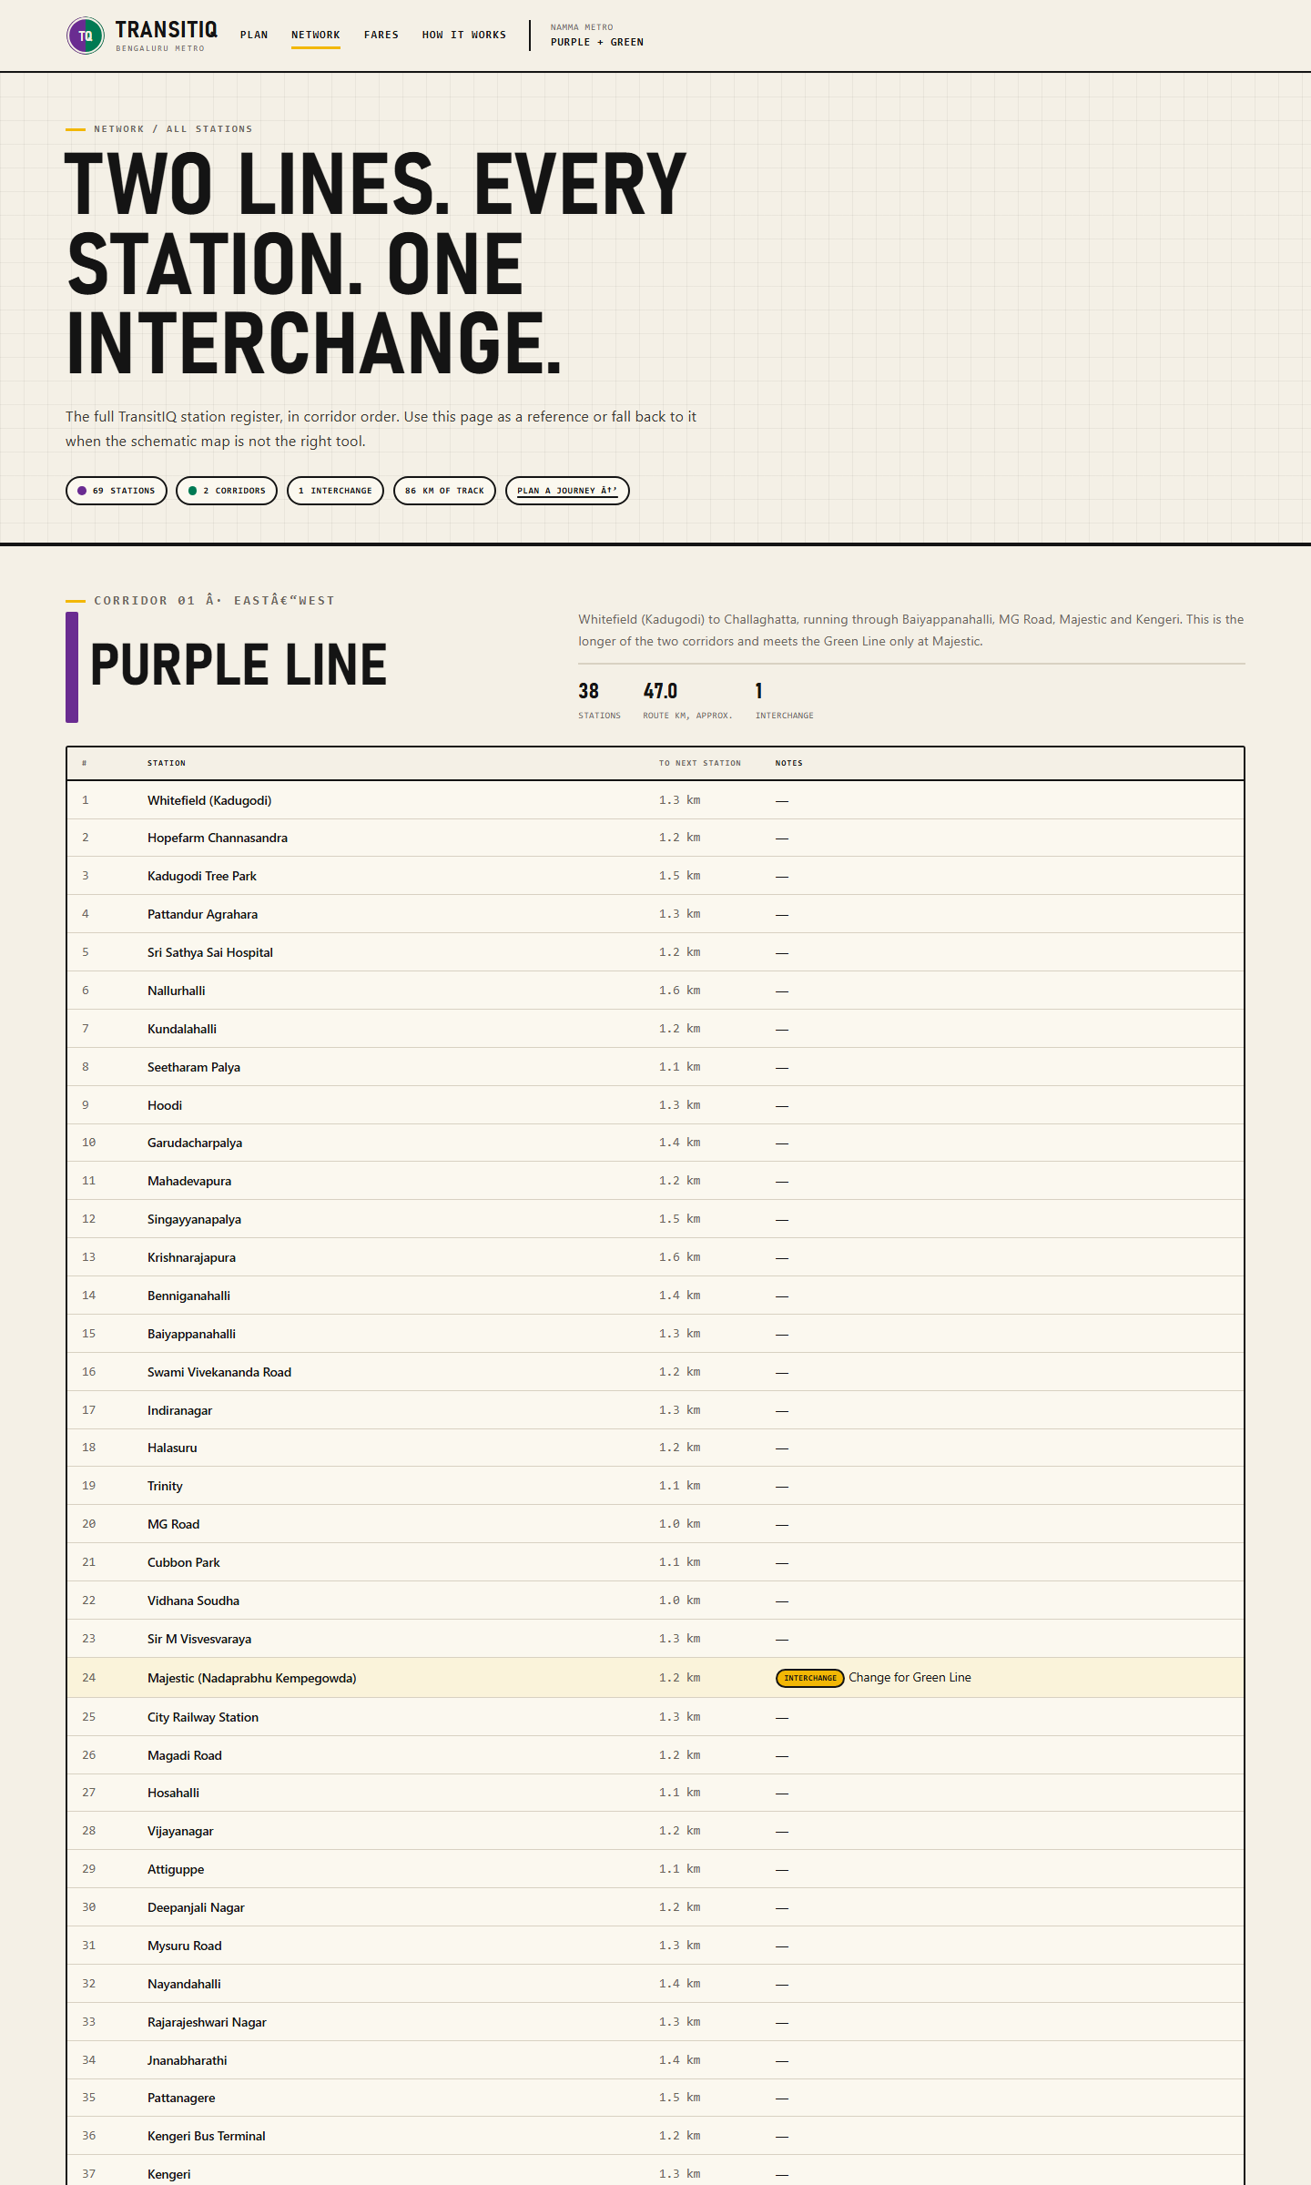
Station register
Open <http://localhost:8125/>. (Opening index.html directly also works.)
TransitIQ — a Skill Lab project. Built with HTML, CSS, Bootstrap 5.3.3, and jQuery 3.7.1. All libraries are local.

