Game dev project design document.

# Chapter 1 – Left unsupervised

GitHub - <https://github.com/lochlannoneill/SOFT8009-Game-Development>

# Collaborators

# Lochlann O’Neill(R00175741)

# Daniels Pikurs(R00166279)

# Eric O’Shea (R00122087)

# Ruaidhri Mulgrew(R00180288)

# Chapter 2 – StorY and gameplay

Two brothers discover a treasure chest at the start of the narrative.  
Both heroes in this game are reliant on one another.  
They must traverse a few levels of an abandoned multi-story facility to locate this treasure.  
They involve ballistic turrets, hazards, and possibly creepy crawlies. These aren't your typical facility rooms.  
Finding the secret keys to each doorway in each room while avoiding dangerous hazards is the goal for the players.

Once they uncover the treasure, they will be granted an unpredicted event awaiting them.

# Chapter 3 – Game Flow

1. This is a two-player game, and the player growth will be because of the players working together to overcome each level.
2. To do this each player will have to collect keys that are unique to them. These keys can then open doors that, for example, might allow the other player to progress further and find their own unique key.
3. We could implement a time counter in each level that would incentivise the players to better work together so that they could complete the level in a shorter time.
4. Will the players be able to pick up any items? Power ups to jump higher, invulnerability, etc.
5. Both players will have to collect keys so that they can complete each level.

Chapter 4 – Character and controls  
The players take control of one of two brothers who have been led to this location in order to steal what they think is inside for themselves.

The brothers were born with the aptitude to always be agile.   
They have little convergence with superheroes and only possess typical human abilities such as running, climbing and jumping.  
Therefore the strength of the two brothers will come from collaboration to conquer the challenges ahead.

In this adventure the pair must traverse swiftly and vault exceptionally high while surviving the stages until they reach the desired treasure.

# Chapter 5 – main gameplay concepts and platform specific features

A scrolling platformer game that consists of 2 players, where both players have to work together to overcome obstacles.

Each sequence of play is separated by a separate unique level (either horizontal-scrolling or vertical-scrolling).

Each character has to collect a key in each level to unlock their doors simultaneously in order to progress to the next level.

Level 1 - Introduces the players to the general concept of the game. This level is not intended to be difficult. Each player simply has to jump on a pressure plate to open the cage to the opposite player’s key. Once both keys are collected, they can progress to the next level.

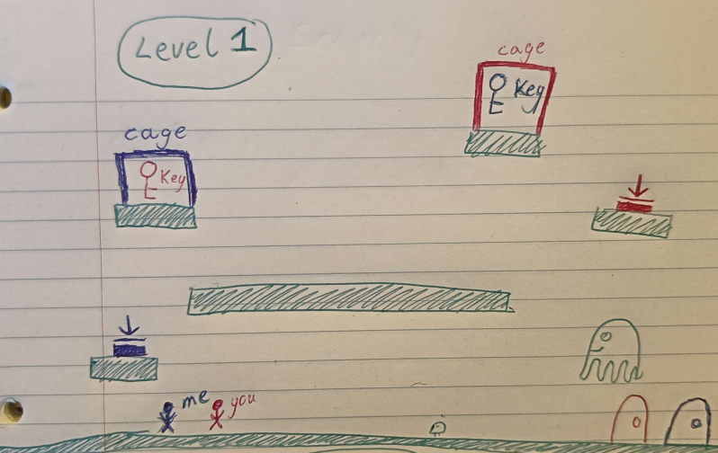  
Level 2 - Now locked rooms are introduced. One player has to step on a pressure plate to temporarily open a door to allow the other player to enter the room.

Level 3 - This level is intended to be difficult. It combines the previously learned concepts. There are locked doors, key cages, traps, turrets, saws, ghosts, etc.

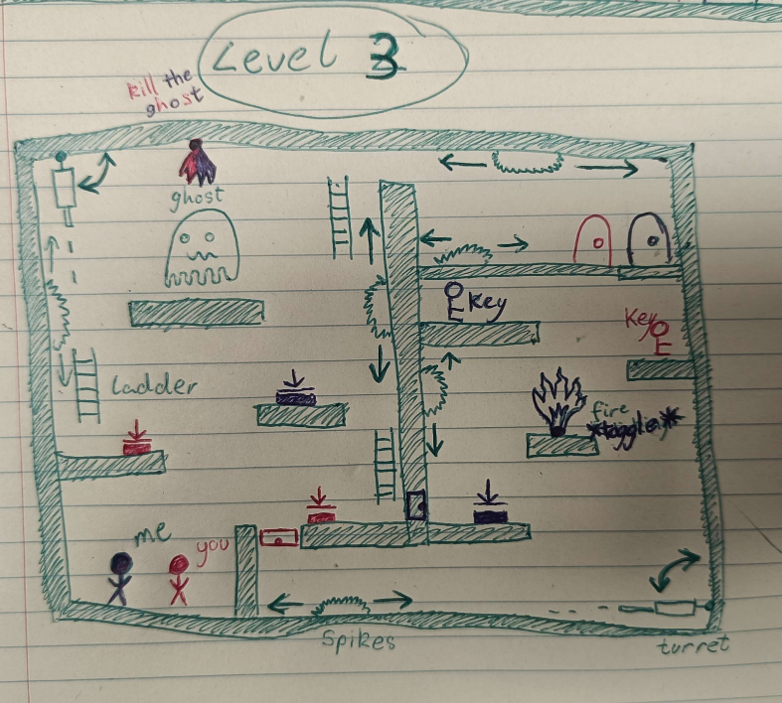

Level 4 - Boss level – This level is the final level of the game. The players are rewarded for their past successes with a boss level that

# Chapter 6 – Game world

The world of Left Unsupervised is inspired by the surge of 2-D action-adventure games that have been released since the renaissance era of 2-dimensional games began on the Xbox Live Arcade platform of the 2010s. Some notable games from this era include super meat boy, hollow knight, inside and others.

The game world will take inspiration from medieval-themed games like a hollow knight and include a simple art style to emphasize critical elements of the game world, such as ladders, doors, walls, and the environmental hazards that exist in the world.

The game takes place on a 2-Dimensional plane and players will be travelling through levels both through horizontal and vertical exploration.

The players will work independently of each other and so the world will have to allow for this.

Obstacles and challenges coming from the game world will come in the form of environmental obstacles that aim to hinder or kill the player.

Cooperation is needed to progress through the game so the world will include environmental puzzles that require cooperation from both players to solve and proceed through the levels of the game.

# chapter 7 – interface

1. The main menu.
2. The players navigate the game with a total of 3 keys, either “A”, “W”, “D” or Left-Arrow, Up-Arrow, and Right Arrow. “A” and Left-Arrow move the player to the left. “W” and Up-Arrow make the player jump and “D” and Right-Arrow move the player to the right.
3. The mood of the interface will be one of adventure and exploration, enticing the player to progress through the game. The music will be similar, emphasising a “call to adventure”.
4. On the heads up display (HUD) it will display the player’s lives and possibly a timer, counting how long they have been on the current level.

Start -> Movement -> Navigate the Level -> Avoid Traps/Obstacles -> Unlock the Doors -> Reach the End

# chapter 8 – mechanics

Gameplay Mechanics -

1. Key cages that require both players to open
2. Locked Doors that only one player can temporarily open to give access to the other player
3. Fire traps that can be temporarily disabled by one player to let the other player through
4. Turrets that fire projectiles at the players
5. Saw blades with predictable movements that the players need to dodge.

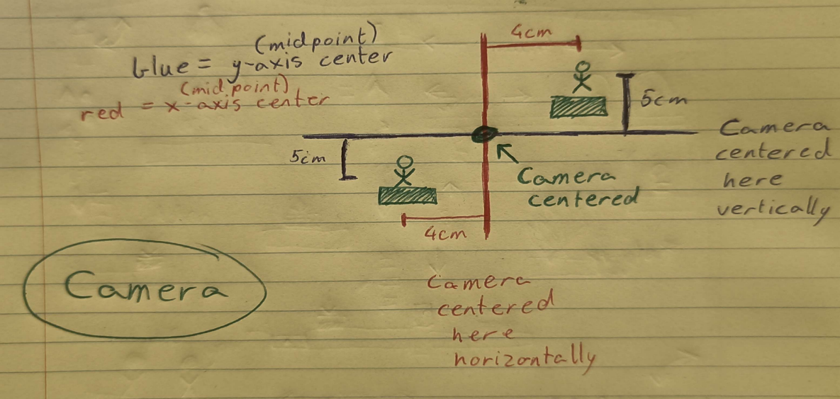Since the game is a scroller (either horizontal-scrolling or vertical-scrolling), the camera must follow the players as they move throughout the game. The position of the camera is calculated as the midpoint between the two characters, on both the x and y axes.

# chapter 9 – enemies and bosses

Enemies come in the form of environmental hazards in this game. The players will have to dodge multiple environmental hazards such as spike traps, rotating saws, acid pools and turrets that shoot in fixed directions that aim to give a level of challenge in the game.

The hazardous obstacles will be used to impede the player’s progress through the levels, in doing this the players are presented with a problem to solve leading to a source of challenge and an opportunity for skill expression.

# Chapter 10: Unknown – cut scenes, bonus material and comps