Task 1.2 – Linux & System Security Exercises

- Background Concepts

- Linux File Permissions
Every file/directory in Linux has three permission sets: “Owner”, “Group”, and
“Others”. Each set can have:
- “r (read)” — view file contents / list directory
- “w (write)” — modify file / add-remove files in directory
- “x (execute)” — run file as a program / enter a directory

Permissions are shown as a 10-character string, e.g. `-rwxr-x---`:
- 1st character: file type (`-` = file, `d` = directory)
- Next 3: Owner permissions
- Next 3: Group permissions
- Last 3: Others permissions

They can also be represented numerically (e.g., `750`):
- Read = 4, Write = 2, Execute = 1 — added together per group
(7 = rwx, 5 = r-x, 0 = no access)

“Why it matters for security:” Overly permissive files (e.g., `777`, allowing
everyone full access) are a common vulnerability — attackers or malware can
read/modify sensitive files. The principle of “least privilege”(giving only the
minimum access needed) is a core hardening practice.

- Users and Groups
Linux is a multi-user system. Each user has a unique ID (UID) and belongs to at
least one group (GID). Groups let administrators manage permissions for multiple
users at once instead of setting them individually.

“Why it matters for security:” Proper user/group management limits the "blast
radius" if one account is compromised — a well-segmented system prevents a
low-privilege account from accessing sensitive resources meant for another group.

- Basic Hardening Practices
Hardening means reducing a system's attack surface. Simple examples include:
- Locking/disabling unused accounts (`passwd -l`)
- Enforcing least-privilege file permissions
- Restricting access to sensitive system files like `/etc/shadow` (which stores
password hashes) to root only

“Why it matters:” These are foundational SOC/sysadmin practices — small
misconfigurations here are frequently exploited in real breaches (e.g., leftover
test accounts with weak/no passwords being an easy entry point for attackers).

- Practical Work

1.1 File Permissions
- Ran `ls --format=long test_folder` to view permission strings.
- Default file permissions were `-rw-rw-r--` (owner: read/write, group: read/write, others: read-only). After running `chmod 750 testfile.txt`, permissions changed to `-rwxr-x---` (owner: read/write/execute, group: read/execute, others: no access).
- This demonstrates how `chmod` restricts file access to reduce exposure — a basic hardening step, since files with overly broad permissions are a common vulnerability.

1.2 Users & Groups
- Created a new user account with `sudo adduser testuser`. Verified the account and its group membership with `groups testuser`.
- In Linux, every user belongs to at least one group, and group membership determines shared access to files/resources.

1.3 Basic Hardening
- Locked the test account using `sudo passwd -l testuser` — this disables password-based login for the account without deleting it, a common practice for service accounts or accounts that shouldn't be used interactively.
- Also viewed `/etc/shadow` (a restricted, root-only file) which stores password hashes rather than plaintext. Sample output showed entries like ‘root::20620:0:99999:7:::` — the `*` indicates no valid password is set for direct login, and the trailing numbers represent password aging policy (max days before password change, etc.).
- Restricting access to this file is critical since exposure would let an attacker attempt to crack password hashes offline.

- Screenshots

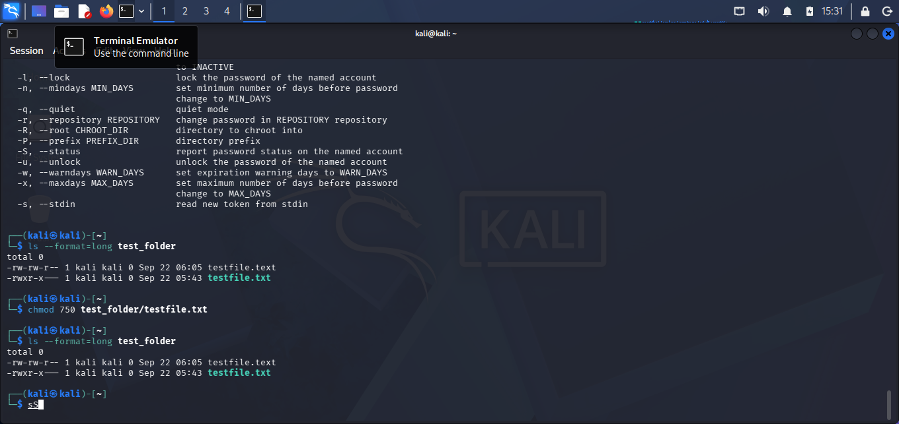
1.1 Permissions

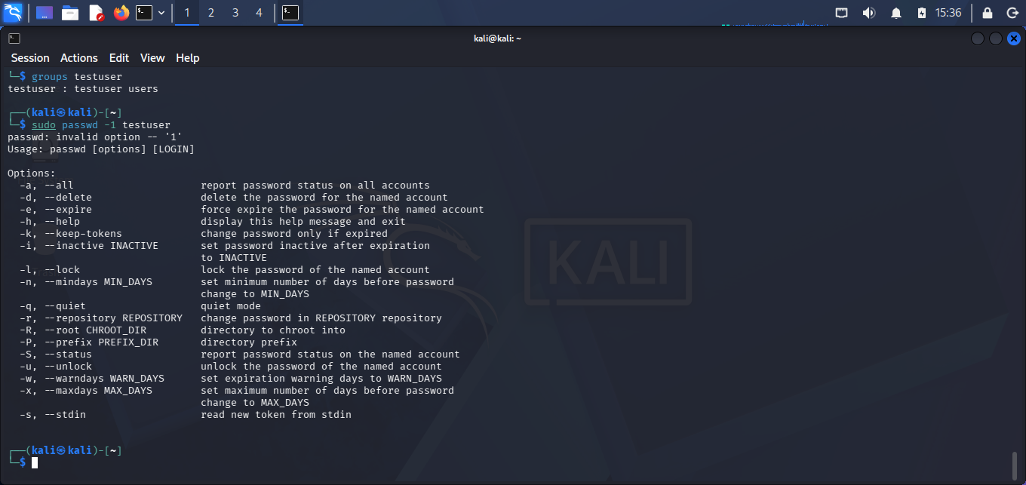
1.2 Gropus and Account Lock

